|  |  |
| --- | --- |
|  |  |

**Valuing the Deep:**

**Marine Genetic Resources in Areas Beyond National Jurisdiction**

Contract Reference: MB0128 – A review of current knowledge regarding marine genetic resources and their current and projected economic value to the UK economy.

Report Number: Final Version One

July 2014

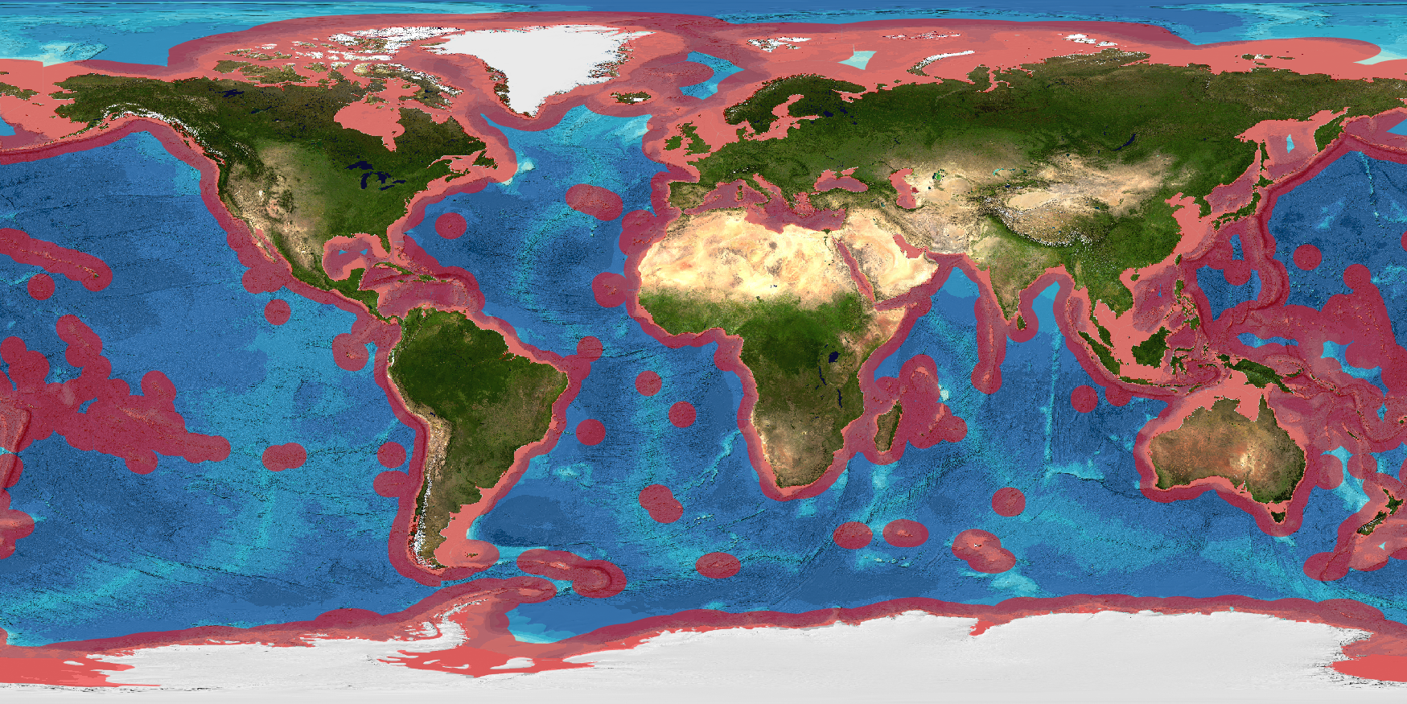

Project Title: A review of current knowledge regarding marine genetic resources and their current and projected economic value to the UK economy.

Report No. Final. Title: Valuing the Deep: Marine Genetic Resources in Areas Beyond National Jurisdiction.

Project Code: MB0128

Defra Contract Manager: Carole Kelly, Marine Evidence Team

Funded by:

Department for Environment Food and Rural Affairs (Defra)

Marine Directorate

Nobel House

17 Smith Square

London SW1P 3JR

Authorship: Paul Oldham (Lead Author), Stephen Hall, Colin Barnes, Catherine Oldham, Mark Cutter, Natasha Burns, Leonie Kindness

Disclaimer: The content of this report does not necessarily reflect the views of Defra, nor is Defra liable for the accuracy of information provided, or responsible for any use of the reports content.

Acknowledgements.

We thank Dr. Andreas Kroh and Dr. Sabine Stohr and the WoRMS Data Management Team for making the World Register of Marine Species (WoRMS) available for patent searches. We thank Dr. Maria Baker and the International Network for Scientific Investigation of the Deep-Sea (INDEEP) for their invaluable assistance in the realisation of the *Valuing the Deep* Delphi Study. We thank the Patent Landscaping Group at the WIPO Secretariat for providing WIPO patent data on PCT applications with sequence listings. We thank Dr. Marjo Vierros at United Nations University for providing access to personal research results that assisted with cross-checking computational approaches. Responsibility for the contents of this report and any errors or omissions rests entirely with the authors.

Suggested Citation: Oldham, P; Hall, S; Barnes, C; Oldham, C; Cutter, AM; Burns, N; Kindness, L (2014) *Valuing the Deep: Marine Genetic Resources in Areas Beyond National Jurisdiction*. Defra Contract MB0128 Final Report Version One. London: Defra.

Glossary

**ABNJ** Areas Beyond National Jurisdiction. The term deep-sea is used in this report in place of this acronym and means the water column (the High Seas) and the seabed (the Area) in ABNJ as defined by UNCLOS.

**Abyssal Plain** The vast flat sediment plains in the abyssal depths.

**Abyssopelagic (Abyssal)** The deep open sea between 4000 m and 6000 m.

**AUV** Autonomous Underwater Vehicle.

**Bathypelagic** ‘The Midnight Zone’, the pelagic zone from 1000 m to 4000 m.

**Benthic** The ecological zone of the seabed including sediments.

**Benthos**  The organisms living on and in the benthic habitat.

**Bioactive** A substance that has an effect on living tissue.

**Biogeography**  The study of geographical distribution of species and ecosystems.

**Biomass**  The total weight of living organisms.

**CBD** United Nations Convention on Biological Diversity.

**CeDAMar** Census of the Diversity of Abyssal Marine Life.

**Chemosynthetic** The oxidation of inorganic molecules or methane as a source of energy, rather than sunlight.

**CIESM** The Mediterranean Science Commission.

**Cold Seep** An area where reduced sulfur and methane emerge unheated from the seafloor.

**Community** All of the organisms sharing a given habitat.

**Cosmeceuticals** Cosmetics with biologically active ingredients.

**Dense shelf**

**water-cascading events** When continental shelf waters, cooled by winter climate, become denser than surrounding ocean waters and flow downslope into the deep-sea.

**Delphi Study** A structured series of questionnaires and consultation with experts.

**Ecology** The study of relationships between organisms and their physical environment.

**EEZ** Exclusive Economic Zone.

**Epipelagic** The layer of the ocean where enough sunlight reaches to enable photosynthesis.

**EMEA** European Medicines Agency.

**EP** European Patent Office patent publication under the European Patent Convention. Taken from the two level country code appearing at the beginning of a patent publication number.

**EPO** European Patent Office.

**Eutrophication** The nutrient over-enrichment of a waterbody.

**Family (patent)** This refers to counts of the first filings or priority patent applications. This ensures that applications that are submitted in multiple countries are only counted once. We use the INPADOC system for linking patent family members to their parent or priority filing.

**Family Members** Patent applications and grants published anywhere in the world that link back to the same first filing or priority application as their parent based on the INPADOC system.

**First Filing** We use this term to describe the priority filing that forms the basis for a patent family.

**FDA** United States Food and Drug Administration.

**GBIF** Global Biodiversity Information Facility.

**GEBCO** The General Bathymetric Chart of the Oceans.

**GenBank** National Institutes of Health Genetic Sequence Database.

**Georeferenced** Biological record associated with geographic coordinates.

**Hadopelagic (Hadal)** The pelagic zone of the deep trenches below about 6000 m.

**Hydrothermal Vent** A seafloor vent emitting geothermally heated water.

**HOV** Human Operated Vehicle.

**Infauna** Animals which live in the seabed sediment.

**INPADOC** International Patent Documentation Center. INPADOC established the widely used family linking system and is part of the European Patent Office.

**InterRidge** Non-profit organisation promoting mid-ocean ridge research.

**Kind codes** These are two letter codes that describe the type of patent document and allow trends in applications and grants to be mapped. However, considerable care is required as the use of the same code may vary across patent offices and over the course of time. With the exception of US publications prior to 2001 we assume that kind code A means an application and kind code B means a patent grant. This provides an approximation of trends in applications and grants. We exclude administrative republications (i.e. A3) from trends analysis.

**Manganese Nodules** Polymetallic nodules found scattered in fields on the Abyssal Plain.

**Marine Snow** Organic matter descending through the water column.

**Mesopelagic** ‘The Twilight Zone’ where sunlight can reach but not sufficiently strongly to allow photosynthesis (about 200 m-1000 m).

**Microbe** Any microscopic organisms.

**MNP** Marine Natural Product.

**MGR** Marine Genetic Resource.

**MSR** Marine Scientific Research.

**Mid Ocean Ridge** Deep-sea mountain ranges formed by tectonic activity.

**Mid Water** A loose term describing water well below the surface but not at the seabed, often used to describe trawling which is not bottom trawling.

**Mud Diapir** Where mud in a cold seep environment is forced through the surrounding rocky material.

**Nutraceuticals** A food product containing bioactive ingredients.

**OBIS** Ocean Biogeographic Information System.

**OSPAR Convention** Convention for the Protection of the Marine Environment of the North-East Atlantic**.**

**Patent Publications** Patent publications consist of publications of applications and grants and may also include administrative publications (corrections, search reports). Type of patent documents can be identified by ‘kind codes’ such as A1 or B1 but their use varies across patent offices.

**PATSTAT** The EPO World Patent Statistical Database published by the European Patent Office. The report used the October 2013 version of PATSTAT.

**PCT** Refers to patent publications from the international Patent Cooperation Treaty administered by WIPO.

**Pelagic** Any area of the water column away from the shore or the seabed.

**ROV** Remote Operated Vehicle.

**Species Abundance** The number of individual organisms in a given area.

**Species Richness** The number of different species in a given area.

**UNCLOS** The United Nations Convention on the Law of the Sea.

**Water Column** An overview term incorporating all the different depth zones.

**US** Mainly used to denote the country code for the United States as it appears in a patent publication number.

**USNSF** United States National Science Foundation.

**Whale Fall** The carcass of a whale which provides temporary nutrient hotspots.

**WIPO** The World Intellectual Property Organization and administrator of the Patent Cooperation Treaty.

**WoRMS** World Register of Marine Species.

**WoRDSS** World Register of Deep-Sea Species.

Table of Contents

Acknowledgements. 3

Glossary 4

List of Figures and Tables 10

Non-Technical Summary 12

Executive Summary 16

1. Introduction 26

2. Understanding the Deep-Sea 37

2.1 The Legal Context 37

2.2 Deep-Sea Habitats 39

2.3 Human Impacts on Deep-Sea Habitats 57

2.4 Conclusions 66

References 67

3. Deep-Sea Marine Scientific Literature 73

3.1 Introduction 73

3.2 Research Trends 73

3.3 Research Collaboration and Funding 77

3.4 Research Topics and Locations 80

3.5 Conclusions 83

4. Deep-Sea Species in the Patent System 85

4.1 Introduction 85

4.2 Methodology 87

4.3 Trends in Patent Activity 89

4.4 Identifying Species from the Deep-Sea 96

4.5 Sequence Data and New Species in Patent Data 104

4.6 Top Species 109

4.7 Countries 118

4.8 Technology Areas 121

4.9 UK Patent Activity 121

4.10 Conclusions 133

References 135

5. Origins and Sources 138

5.1 Introduction 138

5.2 Methodology 139

5.3 Mapping Places in the Scientific Literature and Patent Data 141

5.4 New Species and Strains in the Patent Data 145

5.5 Conclusions 147

References 149

6. The Value of Marine Genetic Resources 150

6.1 Introduction 150

6.2 Marine Biotechnology and Potential Value 154

6.3 From Potential to Actual Value 167

6.4 Conclusions 182

References 184

7. Valuing the Deep – Expert Perspectives 187

7.1 Introduction 187

7.2 Participation 189

7.3 Results 192

7.3.1 Context 195

7.3.1.1 Economic Interest and Potential 195

7.3.1.2 Habitats and Human Impacts 199

7.3.2 Governance 202

7.3.2.1 Access to Marine Genetic Resources 202

7.3.2.2 Benefit Sharing 206

7.3.2.3 Capacity Building and Technology Transfer 210

7.3.2.4 Monitoring and Indicators 211

7.3.2.5 Research Priorities 213

7.4 Conclusions 214

References 216

Annex 1 217

Annex 2 227

List of Figures and Tables

Figure 2.1: The EEZ extends 200 nautical miles beyond the coast 3

Figure 2.2: The Pelagic Zones 3

Figure 2.3: The Depth Distribution of OBIS Records of Global Marine Biodiversity 3

Figure 2.4: Vertical Section of the Seabed and Seafloor Structures 3

Figure 2.5: Section of Typical Oceanic Crust showing Layers 3

Figure 2.6: Distribution Map of Large Seamount Areas in ABNJ 3

Figure 2.7: Current Global Distribution of Reef Framework-forming Cold-water Corals 3

Figure 2.8: Hydrothermal Circulation in a Mid-oceanic Ridge System 3

Figure 2.9: Summary of the Principal Habitat Types found in the Deep Sea 3

Figure 2.10: Key Threats and Impacts for Marine Habitats 3

Figure 2.11: Marine Protected Areas in British waters 3

Figure 2.12: Scientific criteria used to identify a potential EBSA 3

Figure 2.13: Global distribution of EBSAs and EEZs 3

Figure 2.14: Marine Ecosystem Services 3

Figure 3.1: Trends in Marine Scientific Literature 3

Figure 3.2: Trends by Journal Subject Category 3

Figure 3.3: Top Countries in Deep-Sea and Marine Natural Products Research 3

Figure 3.4: Cross-country collaboration network (Author country) 3

Figure 3.5: Funding Organisation Network Deep-sea and Marine NPR 3

Figure 3.6: Top Research Organisations (Publication Counts) 3

Figure 3.7: Top Terms and Phrases in the Scientific Literature 3

Figure 3.8: Global Concentration of Research Effort in the Deep-Sea 3

Figure 4.1: Species Appearing in Patents By Occurrence Data 3

Figure 4.2A: Marine Species Appearing in Patent Documents 3

Figure 4.2B: Marine Species Appearing Only in the Title, Abstract or Claims 3

Figure 4.3: Trends in Patent Activity Referencing Marine Organisms 3

Figure 4.4: Trends in Applications and Grants at the Major Offices 3

Figure 4.5: Top Species (all marine organisms) 3

Figure 4.6: Top Applicants Referencing Marine Species Ranked on Family Count 3

Figure 4.7: Depth Records for Marine Species in GBIF 3

Figure 4.8: Species and Patent Data by Geographic & Depth Zone 3

Figure 4.9: Species and Patent Data by Geographic & Depth Zone (TAC) 3

Figure 4.10: Trends in Filings Referencing Species Outside the EEZ 3

Figure 4.11: Patent Trends for Traditional Medicines from Plants 3

Figure 4.12: Patent Trends in Biotechnology (Key Indicator C12N) 3

Figure 4.13: Deep-Sea Species in Titles, Abstracts or Claims 3

Figure 4.14: Trends for Patent Filings with DNA Sequences 3

Figure 4.15: Patent Documents with DNA Sequences in the Claims 3

Figure 4.16A: Trends in New Marine Species in Patent Data (Outside EEZ) 3

Figure 4.16B: Trends in New Marine Species in Patent Data (Outside EEZ) (TAC) 3

Figure 4.17: Species Outside the EEZ by Depth and Family Count. 3

Figure 4.18: Species occurring Outside the EEZ in Patent Data at minus 200 metres 3

Figure 4.19: Top Species in Patents Occurring Outside the EEZ by Citation Counts 3

Figure 4.20: Patent Applicants Referencing Species Outside the EEZ 3

Figure 4.21: Applicants Ranked by Occurrence of Deep-Sea Marine Species (TAC) 3

Figure 4.22: Applicants by Citation Count 3

Figure 4.23: Applicant Breakout by Species and Citation 3

Figure 4.24A: Marine Genetic Resources in General 3

Figure 4.24B: Marine Genetic Resources in ABNJ 3

Figure 4.25: Applicant Co-Application Network for First Filings 3

Figure 4.26: Technology Areas Marine Species Outside the EEZ 3

Figure 4.27: International UK Patent Activity Referencing Marine Organisms 3

Figure 4.28: UK Technology Areas for all Marine Species: 3

Figure 4.29: UK Patent Activity Referencing Marine Species (Family Counts) 3

Figure 4.30: UK Top Applicant Referencing Marine Species 3

Figure 4.31: UK Activity with Marine Species in the Title, Abstract or Claims 3

Figure 4.32: UK Patent Activity for Marine Species by Geographic Zone and Depth 3

Figure 4.33: Displays the Same Data for Titles, Abstracts and Claims 3

Figure 4.34: Trends in International UK Activity Referencing Deep-Sea Species 3

Figure 4.35 UK Activity Referencing Species Outside the EEZ 3

Figure 4.36: Top Species from GB Innovation (Outside the EEZ) 3

Figure 4.37: UK Patent Activity (Outside the EEZ) 3

Figure 4.38: UK Patent Activity with Species in the Title, Abstract or Claims 3

Figure 5.1: Tagged First Filings 3

Figure 5.2: Named places in the Scientific Literature 3

Figure 5.3: Named Places in the Patent Literature 3

Figure 5.4: References to New Species or Strains in Patent Data 3

Figure 6.1: Key Points of Marine Biotechnology Reports 3

Figure 6.2: Summary of some Key Marine Biotechnology Sectors. 3

Figure 6.3: Trends in Natural Products from Invertebrates 3

Figure 6.4: New Natural Products from Invertebrates by EEZ 3

Figure 6.5: Approved Commercial Marine Pharmaceutical Products 3

Figure 6.6: A Selection of Commercially Available Enzymes 3

Figure 6.7: Other Commercial Marine Natural Resources 3

Figure 7.1: Distribution of Delphi Participants by Country 3

Figure 7.2: Participants by Organisation Type 3

Table 1: Search Results Web of Science 1900-2014 3

Non-Technical Summary

*Valuing the Deep* presents the results of independent research on economic activity involving marine genetic resources from Areas Beyond National Jurisdiction (ABNJ). Areas Beyond National Jurisdiction are located beyond the 200 nautical mile boundaries of national Exclusive Economic Zones (EEZs) and subject to the provisions of the United Nations Convention on the Law of the Sea (UNCLOS).[1]

UN Member States are debating a possible new international instrument on the conservation and sustainable use of marine biodiversity in ABNJ including questions relating to benefit-sharing arising from the exploitation of marine genetic resources. Member States have expressed a range of views on these issues. At the UN Conference on Sustainable Development in 2012 (Rio+20), it was agreed that a decision will be taken by the UN General Assembly during its 69th session in 2015 on whether there should be a new implementing agreement.

Marine genetic resources include biochemical compounds and the genetic components of marine organisms. Scientific research into these organisms and habitats in ABNJ is limited by remoteness and depth, as well as requiring expensive equipment and international cooperation. UK deep-sea research ranks second in international standings on scientific publications and UK researchers collaborate with researchers from 97 countries.

Access and benefit-sharing involving marine genetic resources from ABNJ raises two main questions. Should there be new conditions on access to genetic resources in ABNJ for non-commercial and commercial research purposes? Should a mechanism be created for the sharing of the monetary and non-monetary benefits arising from the utilization of marine genetic resources from ABNJ?

Answers to these questions are based on expectations about the actual or potential economic value of marine genetic resources from ABNJ. Very little research has been carried out on the uses and economic value of these resources. *Valuing the Deep* addresses this issue through large-scale analysis of scientific publications and patents, and a review of literature on market values. This has been complemented by an anonymous online multi-round consultation, known as a Delphi Study, with 52 marine experts from 18 countries.

The main findings of the research are:

1. *There is growing interest in marine genetic resources in general but research mainly takes place inside national jurisdictions*. This is demonstrated through mapping of deep-sea research locations from the scientific literature. Research in ABNJ is concentrated in a limited number of locations such as the East Pacific Rise and Mid-Atlantic Ridge;

2. *Marine organisms from ABNJ that appear in patents often occur elsewhere*. Patents are an indicator of commercial research and development. Many deep-sea marine organisms from ABNJ that appear in patent documents also occur inside national jurisdictions and terrestrial aquatic environments. There are very limited references to actual field collections of organisms from ABNJ. It is likely that patent applicants mainly obtain marine genetic material or data from commercial sources, public collections or databases;

3. *Marine natural product research mainly concentrates on marine invertebrates from inside national jurisdictions*. Marine natural product research focuses on marine invertebrates, such as sponges and tunicates, but displays growing interest in microorganisms. Interest in organisms from ABNJ is best described as emergent;

4. *Marketed products are mainly derived from organisms inside national jurisdiction with limited exceptions*. The exceptions are mainly enzymes from extremophiles and oils from Antarctic krill for nutraceutical products;

5. *Widely quoted market estimates for marine genetic resources lack methodological transparency and should not be relied upon* *in the absence of peer review*.

We conclude that:

1. *United Nations debates on ABNJ are focused on the potential economic value of marine genetic resources rather than actual economic value*;

2. *Measures on access and benefit-sharing under any implementing agreement will be directed to the anticipatory governance of marine genetic resources.*

**On Access Regulations**:

* *Research in ABNJ is difficult, expensive and there is not enough of it*. Marine experts agree that, while care is required, research on marine genetic resources has very limited environmental impacts;
* *Any access measures should be strictly limited and build upon existing reporting practices*. Existing practices include cruise reporting procedures, codes of conduct and guidelines from within the research community.

**On Benefit-Sharing:**

* *Any benefit-sharing measures or mechanism should be built from the bottom up with the deep-sea research community and directed to promoting deep-sea research*;
* *Benefit sharing options could include a central repository of exploration needs and gaps, improved cruise coordination, and improved access to raw and published data;*
* *A common inter-funding agency road map for deep-sea research could promote research for the wider benefit of humanity with limited transaction costs*;
* *A venture or exploration fund to promote deep-sea research.* A venture fund would promote international cooperation in deep-sea research as part of any implementing agreement. Elements of such a fund could include:
  + *A common pool of research funds*. Funds would be administered by existing funding agencies building on experience with bi-lateral and multi-lateral research funding programmes. This option would not require a new institution and would limit administrative costs. The common pool would be linked to an agreed common road map for research;
  + *An agreed common road map for deep-sea research*. The road map would be based on priorities identified in consultations between funding agencies and the deep-sea research community;
  + *Contribution based participation in the venture fund*. Countries with researchers wishing to benefit from the fund would be required to contribute to the common pool as a condition of access. Contribution criteria would take into account the varying economic circumstances of countries that may wish to participate and prioritise expanding the deep-sea research base;
  + *International collaboration as a condition for access to the venture fund*. International collaboration, including researchers from developing countries, would be a fundamental condition for applications to the fund;
  + *Non-discrimination between commercial and non-commercial research*. In principle the venture fund would be open for applications for non-commercial, commercial or mixed research without discrimination. However, applicants would be required to return a proportion of any income arising from commercial products or intellectual property assets to the fund to support its sustainability as a condition of support from the venture fund;
  + *The unique purpose of the venture fund would be the promotion of deep-sea research in Areas Beyond National Jurisdiction for the wider benefit of humanity*.

**On Capacity Building and Technology Transfer:**

* *There is a need for more infrastructure and access to financial resources to enable training and research exchanges between developed and developing countries*;
* *Improved coordination of research cruises and capacity building measures similar to the Nagoya Protocol are desirable*;
* *Deep-sea research requires national level facilities and requires national research programmes*;
* *Deep-sea research requires Remote Operated Vehicles (ROVs), Human Operated Vehicles (HUVs) and unmanned tethered and untethered Autonomous Underwater Vehicles (AUVs)*. *In situ sea bed observatories with a suite of biological and genomic sensors can overcome the limitations of access to the deep-sea in ABNJ*;
* *An agreed long-term strategy for capacity building and technology transfer is required to overcome short-termism in support for deep-sea research*.

**On Monitoring and Indicators:**

* *Low impact cost effective monitoring is desirable*. Trust should be placed in cruise leaders to report findings along with self reporting by scientists and companies as part of environmental impact assessments along with sample collection reporting;
* *Improve disclosure of the origin of material in patent applications*. Improved disclosure would enhance awareness of the contribution of marine genetic resources to innovation.

Executive Summary

The following represent the key findings of the *Valuing the Deep* project on economic activity relating to marine genetic resources from Areas Beyond National Jurisdiction (the deep-sea) and their relevance to debates on access to genetic resources and benefit-sharing within the framework of the United Nations Convention on the Law of the Sea (UNCLOS).

The *Valuing the Deep* project consisted of four main components:

1. Quantitative analysis and mapping of the scientific literature on the deep-sea;

2. Quantitative analysis of patent data on marine genetic resources from the deep-sea;

3. An expert Delphi study consultation to examine scientific and stakeholder perspectives on an implementing agreement (or agreements) on the conservation and sustainable use of marine biodiversity and access and benefit-sharing in Areas Beyond National Jurisdiction (ABNJ);

4. A review of the literature on the actual and potential market value of marine genetic resources with a focus on marketed products.

The main objective of the project was to inform UK and wider European and international policy debates on the need for an implementing agreement (or agreements) on the conservation and sustainable use of marine biodiversity in Areas Beyond National Jurisdiction under UNCLOS and, specifically, the possible inclusion of an access and benefit-sharing mechanism for marine genetic resources. The results of the research are also relevant to the programme of work on marine biodiversity under the United Nations Convention on Biological Diversity, regional agreements and the work of the World Intellectual Property Organisation.

Main Findings

The main finding of the report is that there is growing interest in marine genetic resources including from deep-water locations. However, the majority of scientific research and commercial research and development, including deep-water locations, focuses on marine organisms from habitats inside national jurisdictions demarcated by Exclusive Economic Zones (hereafter, the EEZ). The available evidence suggests that marine scientific research in Areas Beyond National Jurisdiction concentrates around a limited number of sites relative to the scale of the deep-sea.

Analysis of patent data reveals growing references to deep-sea marine organisms but that these organisms also occur inside the EEZ and in terrestrial aquatic environments. This makes it difficult to determine with precision whether a sample originated from Areas Beyond National Jurisdiction or within national jurisdictions. Geographical mapping of references to species from Areas Beyond National Jurisdiction produced limited results focusing on the East Pacific Rise and Mid-Atlantic Ridge. In the majority of cases it appears likely that applicants referencing deep-sea locations obtained genetic material or data from commercial sources, public collections or databases rather than field collections.

Analysis of the scientific literature on trends in marine natural compounds revealed a growing interest in marine natural compounds that is primarily concentrated in marine invertebrates distributed inside national jurisdictions. However, a focus on invertebrates as a source of compounds is giving way to growing interest in microorganisms that live in a symbiotic relationship with these organisms. Deep-sea organisms from Areas Beyond National Jurisdiction can be classified as an emerging area of interest in marine natural products research in the context of the dominant existing focus on invertebrates.

A review of the recent literature on marketed products from marine organisms revealed that the majority of products derive from organisms from inside national jurisdictions with limited exceptions for enzymes from extremophiles and Antarctic krill as a source of nutraceutical products. As such, growing interest in marine genetic resources as a source of products does not necessarily correlate with increasing interest in marine organisms from the deep-sea. This reflects the considerable costs and logistical difficulties involved in accessing genetic material from the deep-sea, particularly below 200 metres, relative to other potential sources and the difficulties of keeping deep-sea organisms alive for further research. We therefore conclude that debates on the economic value of marine genetic resources are focused on potential economic value rather than actual economic value.

The *Valuing the Deep* Delphi study provided a rich source of information from deep-sea marine scientific researchers and stakeholders. Expert views confirm that the majority of existing research and commercial interest in marine genetic resources occurs inside national jurisdictions and support the view that biological prospecting outside national jurisdictions is presently limited. Experts suggest that where industry does become involved this takes place following initial discovery and analysis by publicly funded researchers. Experts narrowly agreed that there is increasing interest in deep-sea organisms from industry but that this does not necessarily translate into investment. While recognising the variety of views expressed by experts we therefore conclude that commercial interest in deep-sea marine genetic resources is emergent but limited.

Experts generally agreed that policy-makers believe that there is increasing commercial interest in marine genetic resources arising from a combination of a perception of the “blue gold of marine biotech”, a “fear of missing out” and a desire for their own scientists to participate in the emerging field of deep-sea research on an equal footing with other countries. National and regional blue growth strategies, notably from the European Union, were identified as key drivers towards commercial exploitation with more general academic pressures towards demonstrating commercially useful results also being noted by experts.

Experts generally agreed that the environmental impacts of both marine genetic research in the deep-sea and bioprospecting were likely to be limited while emphasising the need for caution in fragile habitats. Experts held the view that the environmental impacts of research on marine genetic resources and bioprospecting pale into insignificance compared with commercial fishing and mining and described this as the equivalent of “comparing apples and oranges”. There was a strongly held view among participants that action was needed within the framework of UNCLOS to address the conservation and sustainable use of biodiversity in Areas Beyond National Jurisdiction. This extended to a need to address access and benefit-sharing for genetic resources under any implementing agreement (see below).

In considering these findings we therefore conclude that current interest in marine genetic resources from Areas Beyond National Jurisdiction is emergent. It therefore follows that the negotiation of any implementing agreement within the legal framework of UNCLOS will focus on the potential economic value of marine genetic resources from the deep-sea. Clarity on this issue will facilitate discussion on the purpose of any implementing agreement on access and benefit-sharing and the appropriate means through which this purpose can be realised. In our view, the long term strategic purpose of such an agreement should be to promote investment in deep-sea research directed to advancing human knowledge and understanding of the deep-sea for the wider long term benefit of humanity.

We now turn to potential elements of any implementing agreement involving access and benefit-sharing taking into account the results of the *Valuing the Deep* Delphi Study.

Habitats and Environmental Impacts

* Expert participants in the Delphi study expressed the general view that the environmental impacts of deep-sea research on marine genetic resources are likely to be limited. However, they also emphasised a need for caution and noted the role of codes of conduct, such as the InterRidge, OSPAR Commission and Mediterranean Science Commission (CIESM) codes, in connection with issues such as re-sampling. This suggests that existing codes of conduct and guidelines for research on marine genetic resources and in marine habitats could be reviewed and incorporated within any implementing agreement;
* With respect to the wider environmental impacts of human interventions, such as commercial fishing or mining, some experts expressed concern that important habitats, notably cold-water coral reefs, are ignored in existing debates despite their key role as fisheries nurseries. This suggests that any measures proposed under any implementing agreement relating to environmental impacts should take account of the full range of habitats in Areas Beyond National Jurisdiction.

Access to Marine Genetic Resources

* It is widely recognised that research in deep-sea environments outside national jurisdiction is difficult, expensive, and there is not enough of it. Research on marine genetic resources, as opposed to commercial harvesting, has limited known environmental impacts and we find limited evidence of economically important commercial products that are on the market and originate from deep-sea environments in ABNJ;
* For this reason we do not advocate strong regulation of access to marine genetic resources in Areas Beyond National Jurisdiction. The Delphi study suggests that any access measures should recognise and build upon existing reporting practices within the deep-sea research community and that responsibility for initial reporting could be allocated to research cruise leaders;
* Information on research taking place in ABNJ could be improved through a simple system of notification that research is taking place [1]. However, care would be needed in the negotiation process to ensure that such a notification system does not become a vehicle for restricting access for marine scientific research.

Benefit-Sharing:

* Based on the outcomes of the Delphi study it is our view that benefit-sharing measures should be built from the bottom up based on existing research practices in the deep-sea research community and directed to the purpose of promoting deep-sea research. In particular, experts highlighted issues such as enhanced coordination of cruises, participation from developing countries, collaboration in sample collection and data access as areas for benefit-sharing with a significant emphasis on non-monetary benefit-sharing.
* Potential options for benefit-sharing could include:
  + Creating a centralised repository of exploration needs and gaps;
  + Promoting increased access to raw and published data from research by creating a common Clearing House Mechanism style interface for dispersed deep-sea research data while taking into account existing initiatives such as the Ocean Biogeographic Information System (OBIS) and the Global Biodiversity Information Facility;
  + Consulting with the deep-sea research community to identify measures that might facilitate greater international cooperation and coordination in the planning and execution of research on the deep-sea taking into account needs for access to ship time, specialist vehicles, laboratories, technicians and data;
  + Promoting greater communication and coordination between funding agencies supporting deep-sea research to reduce duplication of effort and enhance synergies. A common inter-agency framework road map directed to enhancing coverage of deep-sea research could facilitate coordination with limited transaction costs;
  + Considering a venture or exploration fund to promote research to advance knowledge and understanding of the deep-sea beyond existing areas of research concentration – such as the middle of the water column, seamounts, the oceanic crust etc. – in consultation with the deep-sea research community. Elements for developing a venture fund could include:
    - A fund that consists of a pool of funds linked to a common road map and administered by existing funding agencies. A venture fund consisting of a pool of funds linked to an agreed road map would not require a new institution and would limit transaction and administrative costs;
    - An agreed road map based on consultation on priorities for research and cooperation with the deep-sea research community (see above);
    - A requirement for countries that wish their researchers to participate in the venture fund to contribute financial resources to the venture fund as a condition of access, while taking into account the varying economic circumstances of countries that may wish to participate;
    - A requirement for international collaboration as a condition for applications to the venture fund including participation of researchers from developing countries that contribute to the venture fund;
    - Access to the venture fund would not discriminate by the type of marine genetic research (non-commercial or commercial). However, applicants to the venture fund would be required to return a portion of income from any commercial products or intellectual property assets arising from research to the venture fund as a contribution to the longer term sustainability of the fund.
* The proposals on benefit-sharing outlined above share some common features with existing proposals, such as promoting access to data. However they also differ in significant respects:
  + In our view the main and indeed only focus of any type of benefit-sharing measures should be the promotion of research on the deep-sea to enhance knowledge and understanding of the deep-sea for the wider long term benefit of humanity;
  + Any proposals on access or benefit-sharing measures should be developed in direct consultation with members of the deep-sea research community and build on, enhance and strengthen existing practices and international collaboration;
  + The promotion of a pool of funds linked to a common road map involving existing funding agencies could draw on existing experience and not involve creating new institutions. We would note that Delphi study participants were very sceptical about the potential role of institutions such as the International Seabed Authority. Some participants in the Delphi study mentioned the Global Ocean Commission as a credible and transparent institution with respect to a possible institutional mechanism on benefit-sharing;
  + The Multi-lateral Benefit-sharing Mechanism established under the International Treaty on Plant Genetic Resources for Food and Agriculture (the Plant Treaty) has been presented as a potential model for marine genetic resources from the deep-sea. This model clearly merits further discussion. However, experience demonstrates that in the early years, and for the foreseeable future, such benefit-sharing funds will depend on financial contributions from governments because of the long lead in times for the development of commercial products [2]. This suggests a need for governments to recognise that in the initial years, and possibly for the foreseeable future, in reality any benefit-sharing mechanism would depend on financial investments by states.
* Benefit-sharing and intellectual property rights. There was general agreement among Delphi study participants that there should be equitable sharing of the benefits arising from marine genetic resources. Experts also generally agreed that a requirement for benefit-sharing from commercial users would not impose undue burdens on innovation and that clarity on benefit-sharing could contribute to the creation of certainty and a level playing field for industry.
* A range of views were expressed on intellectual property rights with a prevailing view that the pursuit of intellectual property should clearly be permitted while raising recognition of issues of access to data and the potential obstruction of scientific progress.
* The need to improve the quality of information on marine genetic resources in patent data was highlighted by Delphi study participants with a general view to improving the availability of information. Based on a review of patent data we propose that in the first instance patent applicants could be encouraged to provide more information in patent applications on the origins of marine genetic resources, where known, on a voluntary basis, and without prejudice to the processing of applications. This measure would improve knowledge and understanding of the role of marine genetic resources in innovation as a contribution to evidence based decision making over time.

Capacity Building and Technology Transfer

Within the *Valuing the Deep* Delphi study the discussion of capacity building merged with discussion of technology transfer and technology needs. This perhaps reflects the fundamental dependence of research in the deep-sea on ships, specialist laboratories, and the equipment necessary to operate at depth.

* There is general agreement among experts on the need for more infrastructure and access to financial resources to enable training and research exchanges between developed and developing countries.
* There is also general agreement on the need for improved coordination of research cruises to provide and share knowledge and training similar to the capacity building measures under the Convention on Biological Diversity and its Nagoya Protocol.
* Other proposals include:
  + Coordination of research cruises so that adequate coverage is provided of biodiversity in Areas Beyond National Jurisdiction (see above);
  + A centralised repository of exploration needs and gaps (see above);
  + A recognition that deep-sea research requires national level facilities and that this should be the main focus for targeted action through the development of national research programmes.

In connection with specific technologies:

* An emphasis on unmanned autonomous tethered and untethered vehicles as the future of sampling (rather than simply more ships);
* A continuing need for Remote Operated Vehicles and Human Operated Vehicles;
* A need to develop *in situ* observatories with a suite of biological and genomic sensors to overcome limitations of access to the deep-sea;
* The development of cheaper and faster sampling devices;
* A need to develop pressure resistant and corrosion resistant materials for research at hydrothermal vents and the oceanic crust;
* Enhanced telecoms capabilities to enable ship to shore communications with research teams.

Above all, in considering capacity building and technology related issues, an emphasis emerged on the need for an “agreed long-term strategy for this area” rather than “chasing money from government every few years in fire-fighting fashion”.

Monitoring and Indicators

In connection with monitoring and indicators, expert participants in the Delphi study expressed a range of views including the view that this could be extremely difficult due to the scale of the deep-sea. However, a number of concrete proposals emerged that build on existing practices and extend to new technologies. These include:

* Placing trust in cruise leaders to report findings accurately as a low impact cost effective monitoring system;
* The use of self reporting by scientists and companies as part of Environmental Impact Assessment applications, sample collection reporting and benefit-sharing mechanisms as an indirect means of gaining an overview of activity;
* Improvements in the disclosure of origin or source of material in patent applications.

Anticipatory Governance

In considering the outcomes of the quantitative and qualitative components of the *Valuing the Deep* study we conclude that the development of any implementing agreement with respect to access and benefit-sharing would be *anticipatory* in nature in so far that it addresses the potential economic value of marine genetic resources from Areas Beyond National Jurisdiction. We therefore propose that lessons be drawn from the emerging literature on the concept of anticipatory governance in the fields of climate change adaptation and new and emerging technologies that focus on foresight, the development of flexible adaptation strategies, monitoring and action in the development of any implementing agreement on access and benefit-sharing [3-6]. This approach would allow for a flexible and incremental approach to the governance of marine genetic resources in Areas Beyond National Jurisdiction that would promote marine scientific research and facilitate the realisation of the potential economic value of marine genetic resources from the deep-sea.

References

1 Broggiato A, Arnaud-Haond S, Chiarolla C, Greiber T (2014) Fair and equitable sharing of benefits from the utilization of marine genetic resources in areas beyond national jurisdiction: Bridging the gaps between science and policy. *Marine Policy*. http://dx.doi.org/10.1016/j.marpol.2014.02.012.

2 Moeller N, Stannard C (2013) Identifying Benefit Flows: Studies on the Potential Monetary and Nonmonetary Benefits Arising from the International Treaty on Plant Genetic Resources for Food and Agriculture. Rome: International Treaty on Plant Genetic Resources for Food and Agriculture of the Food and Agriculture Organization.

3 Guston DH (2014) Understanding 'anticipatory governance'. *Social Studies Of Science* 44: 218-242.

4 Fuerth LS, Faber EMH (2013) Anticipatory Governance: Winning the Future. *Futurist* 47: 42-4+.

5 Fuerth LS (2009) Foresight and anticipatory governance. *Foresight* 11: 14-32.

6 Quay R (2010) Anticipatory Governance. *Journal of the American Planning Association* 76: 496-511.

1. Introduction

The world’s oceans cover approximately 70% of the planet’s surface and are home to a wide range of organisms and specialist habitats. The oceans and the biodiversity that they sustain also provide ecosystem services that are vital to the function of the Earth’s climate and to human welfare. There is a broad consensus within the scientific community that we know remarkably little about these environments but that we need to do more to conserve and understand these environments and to promote research that generates benefits for human welfare. This is particularly true for areas that fall outside the boundaries of countries in the deep seas known as Areas Beyond National Jurisdiction (ABNJ).

Member States of the United Nations are presently debating a potential implementing agreement (or agreements) on the conservation and sustainable use of marine biodiversity and access to genetic resources and benefit-sharing in Areas Beyond National Jurisdiction within the framework of the United Nations Convention on the Law of the Sea (UNCLOS). Areas Beyond National Jurisdiction are the parts of the oceans and seabed that fall outside the 200 nautical mile boundary of state Exclusive Economic Zones (hereafter, the EEZ). Areas Beyond National Jurisdiction (ABNJ) encompass approximately two thirds of the world’s oceans (the High Seas) and 60% of the seabed (known as the Area) [1]. In this report we simply call these areas the deep-sea. The deep-sea includes oceanic ridges such as the Mid-Atlantic Ridge, seamounts and knolls, deep-sea trenches and troughs, hydrothermal vents, cold seeps and mud volcanoes and vast abyssal plains stretching from ocean ridges to tectonic subduction zones at the continental margins where the jurisdictions of states begin. Governments are debating a range of potential options addressing topics such as protected areas and area based management tools, environmental impact assessments, capacity building, the transfer of marine technologies and access and benefit-sharing for marine genetic resources.

One of the challenges confronting governments is the significant gap in scientific knowledge and understanding of marine biodiversity in the deep-sea and wider human uses of marine genetic resources. The recently completed *Census of Marine Life* has greatly improved knowledge and understanding of marine biodiversity while at the same time emphasising how much more there is still to know [2]. *Valuing the Deep* sets out to advance knowledge and understanding of current research on marine genetic resources in the deep-sea and focuses on investigating human uses of marine genetic resources from the deep-sea and their actual and potential economic value. In particular, we set out to contribute to understanding the implications of potential measures on access to marine genetic resources and benefit-sharing under debate at the UN. To our knowledge, this is the first systematic effort to understand the uses and potential economic value of marine genetic resources from the deep-sea on a global scale. Given the scale of this task, much remains to be done to advance methodological development and improve the knowledge base to inform evidence-based decision-making. *Valuing the Deep* is simply one more step in that process.

Marine genetic resources can be broadly understood as the genetic components of organisms, biochemical compounds that are expressed through the interactions between these components, the organisms themselves, and the communities of which they form a part. Organisms form part of complex ecosystems characterised by a wide range of distinct and overlapping habitats. An organism’s role or position within these ecosystems may be confined to a specific niche or they can be generalists able to live in a variety of conditions. Life in the deep-sea extends from pore spaces in the oceanic crust and layers of sediment through to specialised habitats such as hydrothermal vents, cold seeps and cold water reefs to different levels in the water column (pelagic zones) from depths ranging up to 11,000 metres.

Basic genetic material and expression products are transformed into a resource through the combination of the material itself and human knowledge of its properties and potential uses. Many serious challenges remain in the basic ability of scientists to observe, collect and culture organisms from the deep-sea. The majority of research in the deep-sea is directed to advancing basic knowledge of these environments aided by new technological developments such as ocean floor observatories, Remote Operated Vehicles (ROVs), Autonomous Underwater Vehicles (AUVs) and manned submersibles supported by ships, specialists, teams of technicians and laboratories backed by scientific funding agencies from multiple countries. This research is expensive and underfunded relative to the enormity of deep-sea. However, the results of biological research increasingly become available in informational form (*in silico*) as specific DNA, RNA and amino acid sequences. These resources may ultimately find applications and form part of products across a range of economic sectors such as pharmaceuticals, cosmetics, foodstuffs and industrial enzymes that contribute to economic growth and job creation.

Countries such as the UK and the wider European Union have placed considerable emphasis on the potential of advances in science and technology to promote long-term economic growth through biotechnology. This increasingly finds form in the concept of the bioeconomy and strategies to advance the creation of a bioeconomy [3,4]. The bioeconomy is directed to realising the benefits of advances in biotechnology in areas such as agriculture, health and industry and encompasses sectors such as pharmaceuticals and emerging areas of science and technology such as synthetic biology, systems biology, metabolic engineering and bionanotechnology.

Marine genetic resources increasingly form part of future visions of the emerging bioeconomy and wider strategies focusing on the importance of marine and maritime resources to national and regional economies. In the European Union marine or blue biotechnology forms part of the *Blue Growth* strategy that focuses on the marine and maritime dimensions of the *Europe 2020* strategy [5]. One of the main challenges in addressing the value of marine genetic resources is that economic value is commonly presented in terms of potential rather than actual value. The Marine Board of the European Science Foundation has also emphasised the importance of marine biotechnology and set out a strategy focusing on developments in relation to food, energy, health, environmental health, new enzymes and biomaterials. Thus, the Marine Board estimated that in 2010 the global market for marine biotechnology was Euro 2.8 billion and displayed a cumulative annual growth rate of 4-5% [6].They argue that: “Less conservative estimates predict an annual growth in the sector of up to 10-12% in the coming years, revealing the huge potential and high expectations for further development of the Marine Biotechnology sector at a global scale” (Querellou 2010: 9).

Expectations regarding the potential economic value of marine genetic resources spill over into debates on marine genetic resources from Areas Beyond National Jurisdiction. In particular, a series of reports and academic articles focusing on Areas Beyond National Jurisdiction have emphasised the growth of scientific and commercial interest in marine genetic resources over the last decade [1,7-11]. This extends to research on patent activity as an indicator of commercial research and development. Recent research identified 558 distinct named marine species in a set of patents containing DNA sequences suggesting strong interest in commercial research and development involving marine organisms [11].

However, while a growing body of literature indicates increasing research and commercial interest in marine genetic resources in general and the deep-sea in particular, it is widely recognised that the knowledge base for decision-making involving deep-sea marine genetic resources is presently very limited. *Valuing the Deep* aims to contribute to the evidence base to inform decision-making in five ways.

1. We conducted a large-scale empirical review of the scientific literature on the deep-sea, marine natural products and marine biotechnology to clarify the who, what and where of deep-sea research and commercial research and development;

2. We text mined 14,038,743 patent documents for 402,540 marine species from the World Register of Marine Species (WoRMS) in order to identify the who, what and where of international patent activity involving marine species;

3. In order to distinguish between marine genetic resources from inside Exclusive Economic Zones and Areas Beyond National Jurisdiction we combined the patent data with available taxonomic information on the geographic distribution of species and depth data using the Global Biodiversity Information Facility (GBIF) and Ocean Biogeographic Information System (OBIS) to identify and map marine organisms appearing in patent data in the deep seas with corresponding depths in the water column;

4. We reviewed recent literature on marine natural products in relation to pharmaceuticals, cosmetics, enzymes, nutraceuticals and other technology sectors to identify products from deep-sea organisms;

5. With generous assistance from the International Network of Scientific Investigation of Deep-Sea Ecosystems (INDEEP) we carried out a three-month expert Delphi study to identify key issues and potential options on conservation, sustainable use and access and benefit-sharing from deep-sea marine genetic resources to inform wider debates on any implementing agreement under UNCLOS.

*Valuing the Deep* provides a detailed empirical analysis of the uses of marine genetic resources, their economic value (where known) and their potential value including detailed information on the main actors engaged in the utilisation of marine genetic resources across a range of economic sectors. In particular, we provide a global overview of available data on economic activity and consider the relevance of this activity to the UK economy and scientific community.

Our main focus is the implications of potential measures on access to genetic resources and benefit-sharing in ABNJ. We find support for the argument that there is growing scientific interest in the deep-sea and establish that the UK research community forms a very important part of wider international networks of researchers focusing on marine organisms from the deep-sea from 150 countries. However, our research also strongly suggests that research is concentrated in a small number of locations relative to the geographic scale of the deep-sea. This reflects the formidable financial and logistical costs and challenges involved in conducting research in the deep-sea. We conclude that the introduction of regulations on access to marine genetic resources in the deep-sea for research purposes would impose undue and unnecessary burdens on the research community at the expense of enhancing knowledge and understanding of these environments. We propose that voluntary codes of conduct and guidelines provide the most sensible way forward for ensuring that research on marine genetic resources does not result in negative environmental impacts and that members of the deep-sea research community will be best placed to advise on existing codes of conduct and potential future needs [1]. However, we also argue that improvements are desirable in understanding where deep-sea research is taking place and that this need could perhaps be met through a simple system of notification that research has taken place [1]. Any such notification system should not include restrictions on access.

With respect to potential options on benefit-sharing, we argue that improved communication and coordination between the networks of funding agencies involved in supporting deep-sea research could contribute to reducing duplication of effort and form the basis of a strategic approach to improving research coverage for the deep-seas to advance human knowledge and understanding. Building on the results of the Delphi study we recommend that the deep-sea research community and research networks should directly participate in decision-making on research priorities and development of wider strategies or a road map for improving knowledge and understanding of the deep-sea. We further argue that expanding knowledge and understanding of the deep-sea requires additional incentives to encourage researchers to move outside existing areas of concentration to higher risk research areas such as the middle of the water column, the abyssal plain or oceanic crust. The existing literature on debates at the UN focuses on potentially using the multi-lateral benefit-sharing fund under the International Treaty on Plant Genetic Resources for Food and Agriculture as a model for benefit-sharing for the deep-sea [1,12–14]. We propose that a venture fund to promote exploratory research on marine genetic resources outside existing areas of research concentration coupled with the promotion of international collaboration could contribute to improving the knowledge base for the wider benefit of the international community. To reduce overheads and transaction costs such a venture fund could be administered through coordination between existing funding agencies rather than the creation of a new institution or transfer of authority to an existing institution.

Our review of the patent data from the main patent jurisdictions (the European Patent Office, the United States Patent and Trademark Office, and the Patent Cooperation Treaty) between 1976 and October 2013 identified references to 4,759 marine species in patent documents. The majority of species were identified as being distributed inside the Exclusive Economic Zone (2,959 species) with 1,800 being distributed in the deep-sea. With very few exceptions species identified in the deep-sea are also distributed inside the EEZ. Available depth data suggests that deep-sea species are predominantly located in the epipelagic zone (0–200 metres) with 1,461 species located in the epipelagic zone and 339 from the deep-sea zone (below 200 metres) in the water column. However, the ability to map species by depth in the deep-sea is seriously affected by a lack of depth data for bacteria and archaea in taxonomic databases.

With respect to patent trends for documents that make reference to marine organisms as a whole, first filings of new inventions rose steadily to a peak of 1,703 filings in 2008 but are relatively stable at +/- 1,500 filings per year. However, there is increasing demand for protection in multiple countries signifying that applicants believe that the cost of patent protection in multiple markets will ultimately be beneficial for their products. UK international patent activity in the period 1976-2013 made reference to a total of 708 marine species with 241 species appearing in the titles, abstracts or claims. Unilever, Syngenta (UK), AstraZeneca, the Medical Research Council, Astex Therapeutics, the University of London and Oxford University led patent activity.

For global patent activity outside the EEZ we divided the data into two zones, the epipelagic zone (0-200 m in depth) and deep-sea zone (below 200 m in depth). Because of limitations in the availability of depth data for bacteria and archaea, the data is not presently sufficiently robust to draw clear conclusions on trends by depth in the water column. In total, we identified 8,039 first filings of patent applications referencing species known to occur in Areas Beyond National Jurisdiction with activity peaking in 2008 at 629 filings before declining between 2009 and 2010. Patent trends for deep-sea species appearing in the titles, abstract or claims of patent filings provide an indicator of patent applications that are in some important sense about these species. Trends in this area displayed a much lower filing rate with 1,358 filings peaking at 93 filings in 2008. In practice, patent filing trends for species will rest somewhere between the total number of documents referencing a marine species occurring outside the EEZ and documents referencing a species in the title, abstract or claims. Further methodological refinement is therefore desirable in future work.

While interest in marine species as a whole is increasing, our data suggests that this interest mainly focuses on species from inside the EEZ. In our view, and taking into account the difficulties of separating organisms by geo-political boundaries, patent activity involving deep-sea species as a whole is more limited than might be assumed in debates in the context of UNCLOS. These findings are consistent with statements from expert participants in the Delphi study that deeper does not necessarily mean more novelty and that considerable biodiversity exists in coastal areas. Furthermore, these findings are consistent with the general observation that it is difficult and expensive to access, collect and culture organisms from the deep-sea.

A third aspect of our research focused on reviewing the recent literature on products based on marine genetic resources. In particular, the natural products literature has emphasised growing interest in marine derived compounds. For example an authoritative review of marine natural compounds for 2011 found a total of 1,152 new compounds described in 352 articles representing a 15% increase over 2010 when the corresponding figure was 1003 new compounds [15,16]. Between 2009 and 2011 an estimated 262 marine compounds formed part of the preclinical pharmaceutical pipeline [17]. However, research interest does not directly equate with successful product development. Thus, between 2004 and 2013 28 marine natural products were in clinical trials but 18 of the trials were discontinued [18]. A total of 7 marine based pharmaceuticals are presently on the market (with an additional approved pharmaceutical having been withdrawn) [18].

Our research also reviewed available data on industrial enzymes where we were able to identify at least six marketed enzymes from marine organisms, including well known proteins such as Green Fluorescent Protein. Of these four are from the deep-sea, one lacks a species name, while Squalene from shark liver oil lacks information on the specific shark species. Based on the literature at least four cosmeceuticals (cosmetics with medical benefits) on the market are based on marine natural products. Of these two species were drawn from the deep-sea, one from inter-tidal Antarctic waters and one deep-sea organism from within the EEZ of Portugal. Additional products, such as fish oils and krill oils are also available on the market. Growing interest is also reported in the scientific literature in marine microorganisms as sources of nutraceuticals and functional foods [19]. However, the data is limited to potential products and development is likely to be affected by safety standards for microbial strains for foods for human consumption. Expert participants in the Delphi study expressed significant concerns about the environmental impacts of consumptive use of marine organisms for the nutraceuticals market.

In considering this data it becomes clear that debates on marine genetic resources in general, and deep-sea marine genetic resources in particular, are primarily directed towards the realisation of potential economic value rather than actual economic value. In the case of the pharmaceuticals sector it appears reasonable to assume that increased interest in marine natural compounds will translate into more compounds entering the pharmaceutical pipeline. However, this does not inevitably mean that more marine based products will win approval relative to other sources of compounds. The available data suggests these compounds will mainly come from organisms inside the EEZ and thus fall within the scope of the Convention on Biological Diversity and the 2010 Nagoya Protocol on Access to Genetic Resources and the Fair and Equitable Sharing of Benefits Arising from their Utilization.

In considering the data presented in this report and its implications for the UK economy in the context of debates on any implementing agreement within the framework of UNCLOS it will be important to maintain the distinction between the actual economic value of marine genetic resources from the deep-sea and the potential economic value of these resources. In particular, the conflation of potential value with actual value could lead to unfounded expectations around “blue gold” and demands for strong regulation of both access to genetic resources and benefit-sharing for marine genetic resources from the deep-sea. This will mimic earlier debates on “green gold” and “biopiracy” under the Convention on Biological Diversity. The regulation of access to marine genetic resources for research, as opposed to harvesting for consumption, could stifle what is already an extremely challenging area of research. Furthermore, in connection with benefit-sharing, the evidence available to us does not suggest that research on marine genetic resources from Areas Beyond National Jurisdiction (ABNJ) generates significant income for researchers, companies or countries from the sale of commercial or other products. In fact, deep-sea research mainly generates costs.

This suggests a need to think carefully about benefit-sharing. The existing literature highlights options such as a global multilateral benefit-sharing fund drawing on similarities with the multilateral system established under the International Treaty on Plant Genetic Resources for Food and Agriculture [1,12-14]. A second option includes creating a common pool of sampled marine genetic resources that draws on an open source approach in which access to samples and data is central [13]. Other options include regional approaches that focus on the role of regional bodies and programmes such as the Regional Seas Programme supported by UNEP and involving 140 States that could potentially address access and benefit-sharing issues in ABNJ [20]. The present research has identified a range of other issues that need to be considered in debating benefit-sharing.

As is increasingly recognised, international research in the deep-sea involves international collaborations in sharing and coordinating access to ship time, research equipment such as submersibles, ROVs (Remote Operated Vehicles), AUVs (Autonomous Underwater Vehicles), sea floor observatories and specialist laboratories. International cooperation in deep-sea research constitutes a network through which both monetary and non-monetary benefits flow. In our view, the starting point for debates on benefit-sharing should be the existing practices of researchers and funding agencies with a view to strengthening international cooperation, capacity building and monetary and non-monetary benefit-sharing for deep-sea marine research. We adopt the view that:

a) The aim of any benefit-sharing measures for marine genetic resources should be to promote and extend deep-sea research in Areas Beyond National Jurisdiction to advance human knowledge and understanding of the deep-sea;

b) The approach to addressing a) should be to build upon and strengthen existing practices within the deep-sea research community and enhance synergies in international research funding through the promotion of communication and coordination between funding agencies, such as a joint road map;

c) The promotion of exploratory research is central to enhancing human knowledge and understanding of the deep-sea. However, additional incentives in the form of a cooperative venture fund are likely to be needed to support risky exploratory research beyond existing areas of research concentration;

d) The pursuit of commercial innovation should not be a pre-condition of venture funding in order to promote basic research. However, a portion of any financial benefits from commercial products or intellectual property assets arising from venture funding should be reinvested in the venture fund to promote the longer-term sustainability of the venture fund for deep-sea research.

The approach outlined above shares similarities with existing proposals. However, it differs in emphasis and orientation. In this view the only legitimate purpose for introducing benefit-sharing measures for marine genetic resources is to promote and extend research in the deep-sea for the wider long-term benefit of humanity. The types of benefit-sharing that are required to advance this aim should be based upon the practices and priorities identified by members of the deep-sea research community themselves and involve existing research networks such as INDEEP. The promotion of communication and coordination between funding agencies should build on existing experiences (e.g. bilateral and multilateral research programmes) and, with the participation of the deep-sea research community, establish a framework road map for deep-sea research in ABNJ. The proposed venture fund for exploratory research could be administered through existing funding agencies as a distributed pool of funds and would not require a new administrative institution or transfer of authority to an existing institution. Countries participating in the venture fund would agree that international collaboration, including developing country participation, would be an eligibility requirement to access the fund.

In considering these options, the most common point of reference in existing debates is the multi-lateral benefit-sharing fund established under the Plant Treaty. One of the most important lessons learned from the Plant Treaty is that governments will be the primary contributors to these types of funds in the short to medium term [21]. In our view, given the lack of products on the market, it is highly likely that this experience would be repeated for a benefit-sharing mechanism forming part of any implementing agreement. It is therefore prudent to anticipate that governments would be the primary contributors to such a fund. For this reason we propose focusing on enhancing communication and coordination between existing funding agencies. Furthermore, given the lack of funding for deep-sea marine research in our view it is reasonable to argue that countries seeking to access any venture fund should be required to contribute to the venture fund as a condition of participation by their researchers. Recognising the varying abilities of countries to contribute funding, these contributions could be tiered. Contributions to the venture fund from private sources should be encouraged, including companies working on technology development for deep-sea exploration, but should not be allowed to determine the strategic purpose of the venture fund.

The remainder of this report is divided into seven chapters. Chapter 2 provides an overview of deep-sea habitats and up to date information on the status of scientific knowledge about deep-sea habitats and threats to these habitats. This chapter assumes no prior knowledge of the deep-sea and is intended to provide an up to date introductory guide based on the latest scientific research. Chapter 3 examines the ‘who, what and where’ of deep-sea marine scientific research and research on marine natural products and biotechnology. Using scientometric approaches the chapter identifies key actors, research themes, funding agencies and geographical places that are the focus of research activity. Chapter 4 examines international and UK patent activity involving marine genetic resources from the deep-sea. Chapter 5 explores available information about the origins of the organisms and genetic material appearing in patent documents. Chapter 6 reviews available information about marine natural products that are on the market building on existing research and reports. Chapter 7 presents the results of the expert Delphi study. Annex 1 provides details of the search strategy for the scientific literature. Annex 2 provides details of patent documents containing references to deep-sea marine species.

References

1 Broggiato A, Arnaud-Haond S, Chiarolla C, Greiber T (2014) Fair and equitable sharing of benefits from the utilization of marine genetic resources in areas beyond national jurisdiction: Bridging the gaps between science and policy. *Marine Policy*. http://dx.doi.org/10.1016/j.marpol.2014.02.012.

2 McIntyre, A (ed.) (2011) *Life in the World's Oceans: Diversity, Distribution, and Abundance*. London: John Wiley & Sons.

3 OECD (2009) *The Bioeconomy to 2030: Designing a Policy Agenda*. Paris: Organisation for Economic Co-operation and Development.

4 European Commission (2012) *Innovating for Sustainable Growth: A Bioeconomy for Europe*. Brussels: European Commission.

5 European Commission (2012) *Blue Growth: Opportunities for marine and maritime sustainable growth*. Brussels: European Commission.

6 Querellou J (2010) *Marine Biotechnology: A New Vision and Strategy for Europe*. Marine Board- ESF Position Paper 15. Ostend: European Science Foundation.

7 Fedder D (2013) Marine Genetic Resources, Access and Benefit Sharing. Legal and Biological Perspectives. London: Earthscan Routledge

8 Arico S, Salpin C (2005) *Bioprospecting of genetic resources in the deep seabed: scientific, legal and policy aspects*. Yokohama: United Nations University, Institute of Advanced Studies.

9 Leary D, Vierros M, Hamon G, Arico S, Monagle C (2009) Marine genetic resources: A review of scientific and commercial interest. *Marine Policy* 33: 183-194.

10 Arrieta JM, Arnaud-Haond S, Duarte CM (2010) What lies underneath: Conserving the oceans' genetic resources. *Proceedings of the National Academy of Sciences of the United States of America* 107: 18318-18324.

11 Arnaud-Haond S, Arrieta JM, Duarte CM (2011) Marine Biodiversity and Gene Patents. *Science* 331: 1521-1522.

12 Leary D (2012) Moving the Marine Genetic Resources Debate Forward: Some Reflections. *International Journal of Marine And Coastal Law* 27: 435-448.

13 Tvedt M, Jorem A (2013) Bioprospecting in the High Seas: Regulatory Options for Benefit Sharing. *The Journal of World Intellectual Property* 16: 150-167.

14 Druel E, Gjerde KM (2014) Sustaining marine life beyond boundaries: Options for an implementing agreement for marine biodiversity beyond national jurisdiction under the United Nations Convention on the Law of the Sea. *Marine Policy*. doi: 10.1016/j.marpol.2013.11.023

15 Blunt JW, Copp BR, Keyzers RA, Munro MHG, Prinsep MR (2012) Marine natural products. *Natural Product Reports* 29: 144-222.

16 Blunt JW, Copp BR, Keyzers RA, Munro MH, Prinsep MR (2013) Marine natural products. *Natural Product Reports* 30: 237-323.

17 Mayer AM, Rodríguez AD, Taglialatela-Scafati O, Fusetani N (2013) Marine pharmacology in 2009-2011: marine compounds with antibacterial, antidiabetic, antifungal, anti-inflammatory, antiprotozoal, antituberculosis, and antiviral activities; affecting the immune and nervous systems, and other miscellaneous mechanisms of action. *Marine Drugs* 11: 2510-2573.

18 Martins A, Vieira H, Gaspar H, Santos S (2014) Marketed marine natural products in the pharmaceutical and cosmeceutical industries: tips for success. *Marine Drugs* 12: 1066-1101.

19 Dewapriya P, Kim S-K (2014) Marine microorganisms: An emerging avenue in modern nutraceuticals and functional foods. *Food Research International* 56: 115-125.

20 Rochette J, Unger S, Herr D, Johnson D, Nakamura T, *et al.,* (2014) The regional approach to the conservation and sustainable use of marine biodiversity in areas beyond national jurisdiction. *Marine Policy*. doi: 10.1016/j.marpol.2014.02.005

21 Moeller N, Stannard C (2013) Identifying Benefit Flows: Studies on the Potential Monetary and Nonmonetary Benefits Arising from the International Treaty on Plant Genetic Resources for Food and Agriculture. Rome: International Treaty on Plant Genetic Resources for Food and Agriculture of the Food and Agriculture Organization.

2. Understanding the Deep-Sea

Until relatively recently the deep-sea was thought to be a lifeless desert. The last thirty years of deep ocean exploration have transformed our understanding of the deep seas, deep-sea habitats and the diversity of marine organisms.

This chapter focuses on introducing the diversity of deep-sea marine habitats and marine organisms. The chapter assumes no prior knowledge of the deep-sea but also seeks to bring readers more familiar with these issues up to date on the latest scientific research on deep-sea habitats, threats and issues. We begin with a brief overview of the legal context of debates on research on marine genetic resources in Areas Beyond National Jurisdiction before moving into discussions of specific habitats and threats.

2.1 The Legal Context

Two main legal instruments are relevant to marine genetic resources. In the case of marine genetic resources inside the territorial boundaries of states and Exclusive Economic Zones (EEZs), the United Nations Convention on Biological Diversity is an important instrument. However, for the marine environment as a whole and Areas Beyond National Jurisdiction (ABNJ) the main instrument is the United Nations Convention on the Law of the Sea (UNCLOS). The 1982 United Nations Convention on the Law of the Sea is the foundation of international law for the marine environment and has been ratified by 166 states.[2] UNCLOS enshrines the principle of freedom of the high seas and sets out states’ rights and responsibilities with respect to issues such as state limits, navigation, Exclusive Economic Zones (EEZs), the continental shelf, deep-seabed mining, the environment, Marine Scientific Research (MSR) and transfer of technology.

Areas Beyond National Jurisdiction are divided into two categories having specific legal regimes. These are the water column, subject to the freedom of the high seas and addressing navigation, fishing and Marine Scientific Research (MSR) under Part II of UNCLOS [1], and the seabed in Areas Beyond National Jurisdiction, known as “the Area”, addressed under Part XI of UNCLOS [1].

UNCLOS is silent on the subject of marine genetic resources although Article 136 of UNCLOS establishes that the seabed and its resources are the common heritage of mankind [1,2]. However, it is important to note that these resources are described as “all solid, liquid and gaseous resources in situ in the Area at or beneath the seabed, including polymetallic nodules” (Article 133) [1,2]. In the early years of debate on marine genetic resources under UNCLOS the concept of common heritage of humankind sparked considerable debate about whether marine genetic resources could, or should, be considered to legally fall under the concept of common heritage [1,3,4]. This chapter is not concerned with the legal interpretation of UNCLOS or recent debates on marine genetic resources. A growing literature provides guidance on this topic [5-8]. Instead, our purpose is to consider available data on biodiversity, habitats and threats in Areas Beyond National Jurisdiction. For ease of use we use the generic term deep-sea to refer to Areas Beyond National Jurisdiction. Our use of this term encompasses both the water column (the High Seas) and the seabed (the Area) in Areas Beyond National Jurisdiction. Figure 2.1 displays the areas covered in this chapter and the wider report.

It is important to note that the limits of Exclusive Economic Zones may be a subject of disputes between states. Given that the limits of particular EEZs are not an issue addressed by this report we use the term “the EEZ” in the singular throughout this report and display the EEZ in maps simply as a global outline based on data from the Global Bathymetric Chart of the Oceans (GEBCO).



Figure 2.1: The EEZ extends 200 nautical miles beyond the coast (red shaded area). ABNJ encompasses the high seas and the seabed (the Area). (Source: GEBCO)

2.2 Deep-Sea Habitats

The scientific exploration of the high seas began in earnest with the expedition of HMS Challenger between 1872 and 1876 when the ship sailed 69,000 miles taking samples and readings from all of the world’s oceans apart from the Indian Ocean [9]. Yet today, 140 years later, we have still only explored a tiny fraction of this vast area. Understanding the deep oceans has proved to be a great challenge requiring new technological developments to enable each exploratory step forward, and even today new discoveries are made with almost every scientific cruise. The complex interactions of ecology, geomorphology, ongoing geologic processes, hydro-dynamics, light levels, chemical composition, temperature and pressure as well as remoteness and inaccessibility mean that the deep oceans remain the last great wilderness on the planet.

The deep-sea begins at about 200 m depth at the break of the continental shelf. At the time that UNCLOS was agreed our understanding of the deep-sea considered it to have low biodiversity, no seasonality and an unvarying environment. This began to change in the late 1970s and 1980s when habitats such as hydrothermal vents, cold seeps and chemosynthetic ecosystems were discovered. Prior to these discoveries, the deep-sea outside of national jurisdiction was often perceived as being of utility either for waste disposal or as a source of potential mineral wealth. While understanding has grown of the importance of biodiversity in the deep-sea there is significant concern within the scientific literature and among participants in our expert Delphi study that exploitation is advancing faster than the acquisition of scientific knowledge. With this exploitation comes the risk of damaging the deep sea before we have adequate knowledge of how best to protect it. In particular the scientific literature and our expert Delphi study participants highlight the risks posed by commercial fishing, mining and pollution that far outweigh the dangers of marine scientific research.

Scientific knowledge and understanding of biodiversity in the deep-sea now extends from life near the surface of the oceans through the water column, to the sea-bed and deep into ocean sediment and the oceanic crust that makes up the deep biosphere. In debates on access to genetic resources and benefit sharing attention has tended to focus on the most charismatic of the deep-sea habitats, hydrothermal vents. However, it is important to gain a wider view of the full spectrum of deep-sea habitats in considering possible options for any implementing agreement under UNCLOS. For ease of explanation we begin with the water column.

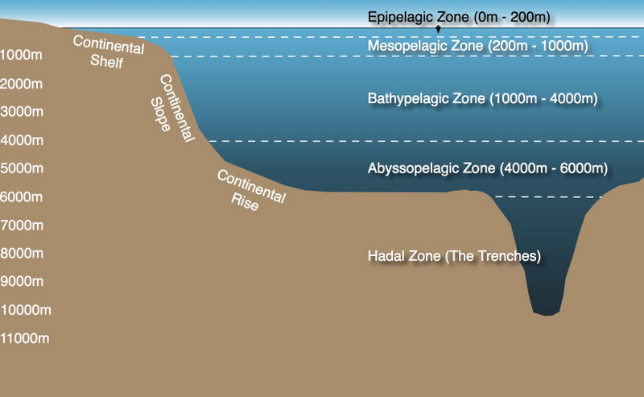

Figure 2.2: The Pelagic Zones

The Water Column

The water column comprises all the open ocean waters and is divided into sections known as pelagic zones at different depths (Figure 2.2). In the context of the *Census of Marine Life* a team of researchers reviewed 7 million georeferenced marine records from the Ocean Biogeographic Information System to assess current scientific coverage of organisms in the water column [10]. In a paper entitled ‘Biodiversity’s Big Wet Secret’, the research team revealed the deep pelagic ocean below 200 metres to be the most under-represented sphere in global marine biology databases [10]. The research demonstrated that the majority of our knowledge of marine biodiversity is derived from shallow seas and that our knowledge of other regions of the ocean is often disproportionate to its geographical area. For instance, “more than 50% of all records come from the continental shelf which constitutes 10% of the ocean whereas less than 10% of records come from the abyssal plain which constitutes 50% of the ocean area” (Webb *et al.,* 2010: 3). Figure 2.3 demonstrates that most records have come from a narrow band of water at the ocean surface or at the sea bed and that there is a paucity of data relating to the pelagic “mid water” zone. As we discuss in the next chapter, this concentration of research produces major gaps in our knowledge and understanding of biodiversity that need to be filled.

Historically, it was believed that the pelagic region was lower in biomass than the surface and floor of the ocean. However, it has recently been argued that it is lack of sampling and limitations in sampling techniques that have created this void in knowledge and understanding rather than an absence of biodiversity. Long term *in situ* sampling is beginning to reveal the true extent of biodiversity in the water column (Webb *et al.,* 2010). However, participants in the expert Delphi study highlight that the middle of the water column represents a neglected area of research activity. The same can also be said of the second dominant area of the oceans: the abyssal plain.

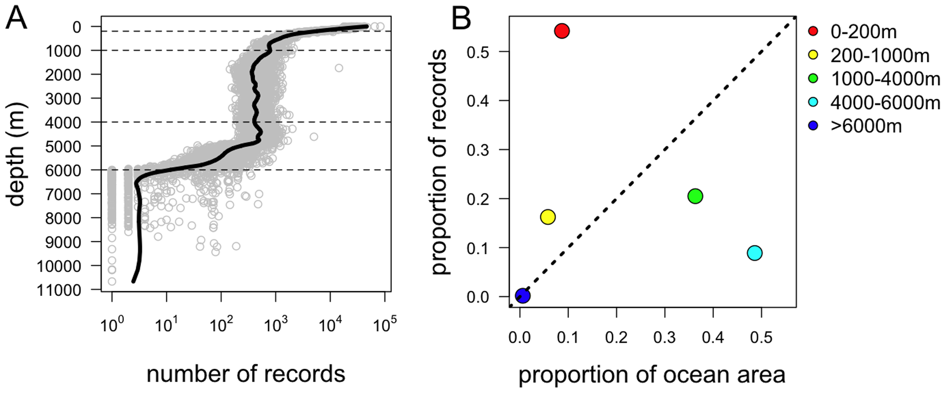

Figure 2.3: The Depth Distribution of OBIS Records of Global Marine Biodiversity. doi:10.1371/journal.pone.0010223.g001.[3]

The Abyssal Plain

Abyssal plains are vast areas of flat sediment covered seabed stretching between continental margins and mid-ocean ridge systems. They are usually found at depths of 3000–6000 m and cover approximately half of the Earth’s surface [11]. Abyssal plains result from the blanketing of the basalts of the oceanic crust by fine-grained sediments. Due to their great area these sediments are quantitatively important for the global carbon cycle and the primary ecosystem services provided by the deep-sea (see below) [12].

The sheer sizes of the abyssal plains are the greatest barriers to their exploration. In early studies of abyssal infauna (animals living in marine sediment), regardless of location, roughly 90% of infaunal species collected were new to science [11]. CeDAMar (the Census of the Diversity of Abyssal Marine Life) was designed to sample previously under-explored areas through a programme of expeditions. In summarising results from these expeditions, Ebbe *et al.,* 2010 put forward two main observations: (1) extreme is normal; (2) rare is common. In other words, what we anthropocentrically consider extreme conditions are in fact normal conditions and highly hospitable for a range of organisms, and the abundance of species thus far identified is actually based on a relatively small number of records. Thus, based on our current knowledge, nearly all species from the abyss can be considered rare and there are no species dominating any sampled areas [11]. These general results must, however, be viewed in the context of the vast area of the abyss. Species currently considered rare or endemic to a particular location, may simply not have been found elsewhere yet [11].

Species abundance on the abyssal plains was found to be directly related to the availability of food in the form of ‘marine snow’ (organic matter descending through the water column). Researchers are concerned about how potential changes to this primary organic matter will impact on benthic (seafloor) communities. A 24 year project measuring changes in food supply and utilisation by benthic communities at 4,000 m in the north east Pacific has recently ended, revealing significant connectivity between changing surface ocean conditions and benthic communities which ultimately impact on the global carbon cycle [13]. The amount of marine snow has been shown to vary according to seasonal changes in shallow water biomass (such as surface diatoms) and that organic material incorporated into abyssal sediments provides a larder for times of reduced marine snowfall. It is uncertain whether the amount of available primary organic matter is stable and how climate change might affect this [13].

Manganese nodules are small polymetallic nodules of iron and manganese hydroxides found scattered in large fields across the abyssal plain [11]. These rocky nodules provide what is often the only hard substratum in the sediment dominated plains and thus add habitat variety enabling sessile fauna to gain a foothold, thereby increasing ecological complexity [11]. Manganese nodules are a long-standing focus of potential for sea floor mining activity [14,15].

Seafloor and sub-seafloor sediments

Microbes dominate life in seafloor sediments and measures of abundance of microbial life typically use cell counts as the primary measure. As reported by Orcutt *et al*.*,* (2013) it is generally assumed that metabolic rates in the deep biosphere are low, yet potentially capable of influencing important global biogeochemical cycles (involving elements such as C, H, O, N, Fe, Mn and S). For example, drawing on the work of Reeburgh *et al.*, Orcutt *et al*., (2013) highlight that “sedimentary microbial processes account for oxidation of 95% of the methane that exists in marine sediment, reducing the amount of methane flux to the water column” [16]. This indicates the important role played by microorganisms in this biosphere.

Studies of microbial life in subseafloor sediment have found strong correlations between the availability of organic matter and cell abundance, with buried organic matter inferred to be the primary source of energy for microbes in most subsea floor sediment [17]. Using measurements of the concentration of intact phospholipids (IPLs) as a proxy for microbial biomass, cell abundance was found to be greatest at continental margins, where approximately 33% of total subseafloor cells live in just 7% of the total oceanic area, and lowest in mid ocean gyres (large systems of rotating currents) where 10% of the total cells live in about 42% of the total oceanic area [17]. Estimates suggest a subseafloor microbial abundance, which is roughly equal to that in seawater and that in soil. It also approximates with the lower estimates of microbial abundance in the terrestrial subsurface [17].

In seeking to distinguish types of microbial life in this realm there is an ongoing debate about whether archaea or bacteria dominate life in sediments. Studies have generally found archaea to be more dominant than bacteria in subseafloor sediments [18,19]. However, more recently, Xie *et al*., (2013) concluded that a substantial portion of archaeal IPLs found in subseafloor sediments are probably fossil products of past cell generations and that previous estimates of microbial life based on IPLs were probably too high [20]. Xie’s results cast doubt on Kallmeyer’s estimates and highlight the challenges of distinguishing between bio and geo molecules [20]. The results also offer the possibility that life in the subseafloor sediment is dominated by bacteria [20].

Further studies have sought to distinguish the types of organisms present in sediments from different sites on the deep seafloor, notably organic falls (predominantly whale carcasses fallen to the seabed on migration routes), hydrothermal vents and cold seeps [21]. Most studies at these sites have focused on the macro fauna. Each of these three soft sediment habitats is fuelled by oxidation of reduced chemicals. Results show that these environments are heterogeneous, sharing dominant taxa but being distinct at family level. The authors conclude that: “although the macrofaunal structure (family level) of vents, seeps and falls exhibit some commonalities such as low diversity and high dominance of a few polychaete (‘bristle worm’) taxa, community level analyses reveal strong differences. These differences are due to stresses (e.g. high temp, high sulfides, low oxygen) and poorly known depth trends, biogeographic isolation and evolutionary divergence” (Bernardino 2012: 15).

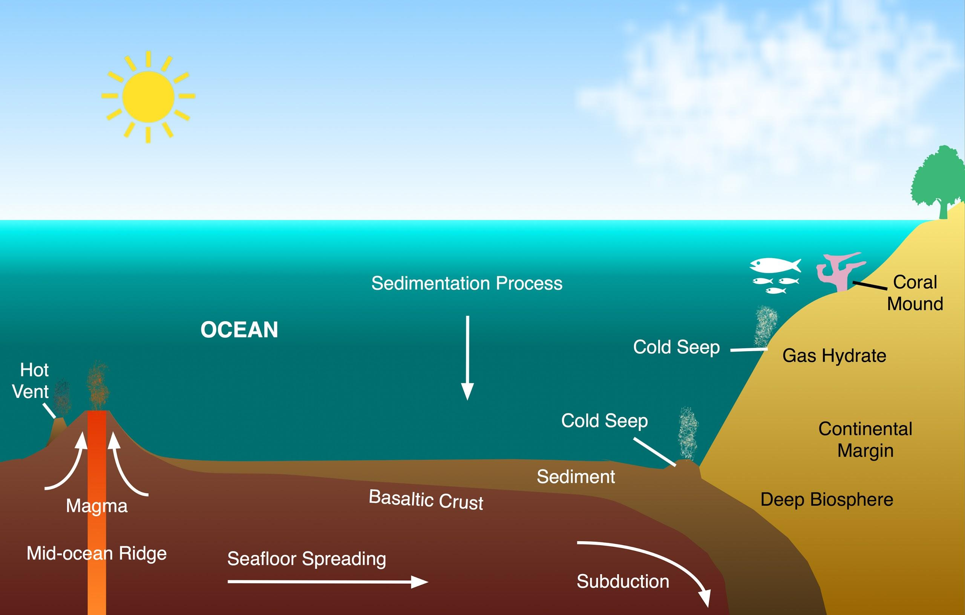

Figure 2.4: Vertical section of the seabed and seafloor structures. Adapted from Jørgensen & Boetius 2007.

Oceanic Crust:

If there exists this deep, hot biosphere, it will become a central item in the discussion of many, or indeed most, branches of the Earth sciences. How much of the biological imprint of material in the sediments is due to surface life and how much to life at depth? (Gold 1992, cited in Orcutt *et al*., 2013)

Beneath the seafloor lie habitats that may prove to be of major importance for their unique biodiversity. Slow progress in ocean drilling techniques has hampered the ability to sample directly from the deep subsurface. However, the 1977 discovery of hydrothermal venting at the Galapagos mid-ocean ridge (MOR) spreading centres drew significant scientific attention to hydrothermal systems that came to be considered as “windows to a subsurface biosphere” [23,24]. These hydrothermal systems, and the ability of their microbiology to survive extreme conditions, have remained a focus for exploration of novel enzymes, genes and microorganisms. In considering these systems as windows where volcanic activity ‘throws up’ microbial life from below, scientists have used activity at hydrothermal sites to estimate life in the underlying deep biosphere. Hydrothermal vents have received significant attention in debates on access and benefit-sharing in Areas Beyond National Jurisdiction. However, the role of hydrothermal vents as windows into the deep biosphere has tended to be lost in discussions of these charismatic locations and their unusual fauna. This is unfortunate because it limits policy understanding of what is ultimately at stake.

In practice, there is significant debate about estimates of the total biomass contained within the ocean subsurface biosphere [25]. This debate can be difficult for an interested observer to understand because it is not entirely clear whether participants are talking about exactly the same thing (e.g. only sediments or sediments and oceanic crust) or using the same measures. In 1998 Whitman estimated that the marine subsurface contains between 27 and 33% of the Earth’s total biomass, a figure much greater than the total estimated biomass in the overlying ocean [26]. Later studies display a trend of reducing this estimate with the most recent studies taking greater account of diverse subsurface environments i.e. those further from hydrothermal activity at mid-ocean ridges or continental margins. Kallmeyer *et al*., (2012) found that total microbial abundance varies between sites by five orders of magnitude and estimated that the marine subsurface biomass is less than 1% of the Earth’s total [17,27]. However, as Hinrichs and Inagaki point out in debating these findings, it may be that the “the biomass pool below the seafloor may be ‘only’ as large as the pool above…” [25]. In short, biodiversity in the subsea floor remains highly significant and neglected in debates on marine genetic resources. Greater clarity on this diversity and debates about levels of biodiversity could be achieved through direct engagement with researchers working in this area.

Our ability to directly observe and sample this deep biosphere is limited. However, ocean crust drilling and seafloor observatories increasingly provide a route to insights into the deep biosphere. The key factors in defining habitable zones in the subsurface are temperature, pore space and the availability of energy. A recent study based on ocean drilling shows that microbial life is present not only directly beneath hydrothermal activity, but also at a range of temperatures, crustal age, fluid compositions and redox conditions [28].

The oceanic crust is 5-6 km thick and is composed of several layers, not including the overlying sediment. In a typical cross section (see Figure 2.5) the topmost layer is comprised of basalt lavas ranging between 500 m and 1 km thick. Below the lavas is a layer of sheeted dikes [29]. These are tabular rock formations, about a metre wide, standing side by side, and are created by periodic bursts of molten rock. The gabbro layer consists of coarse-grained basaltic igneous rock formed from the cooling of molten lava at mid-ocean ridges.

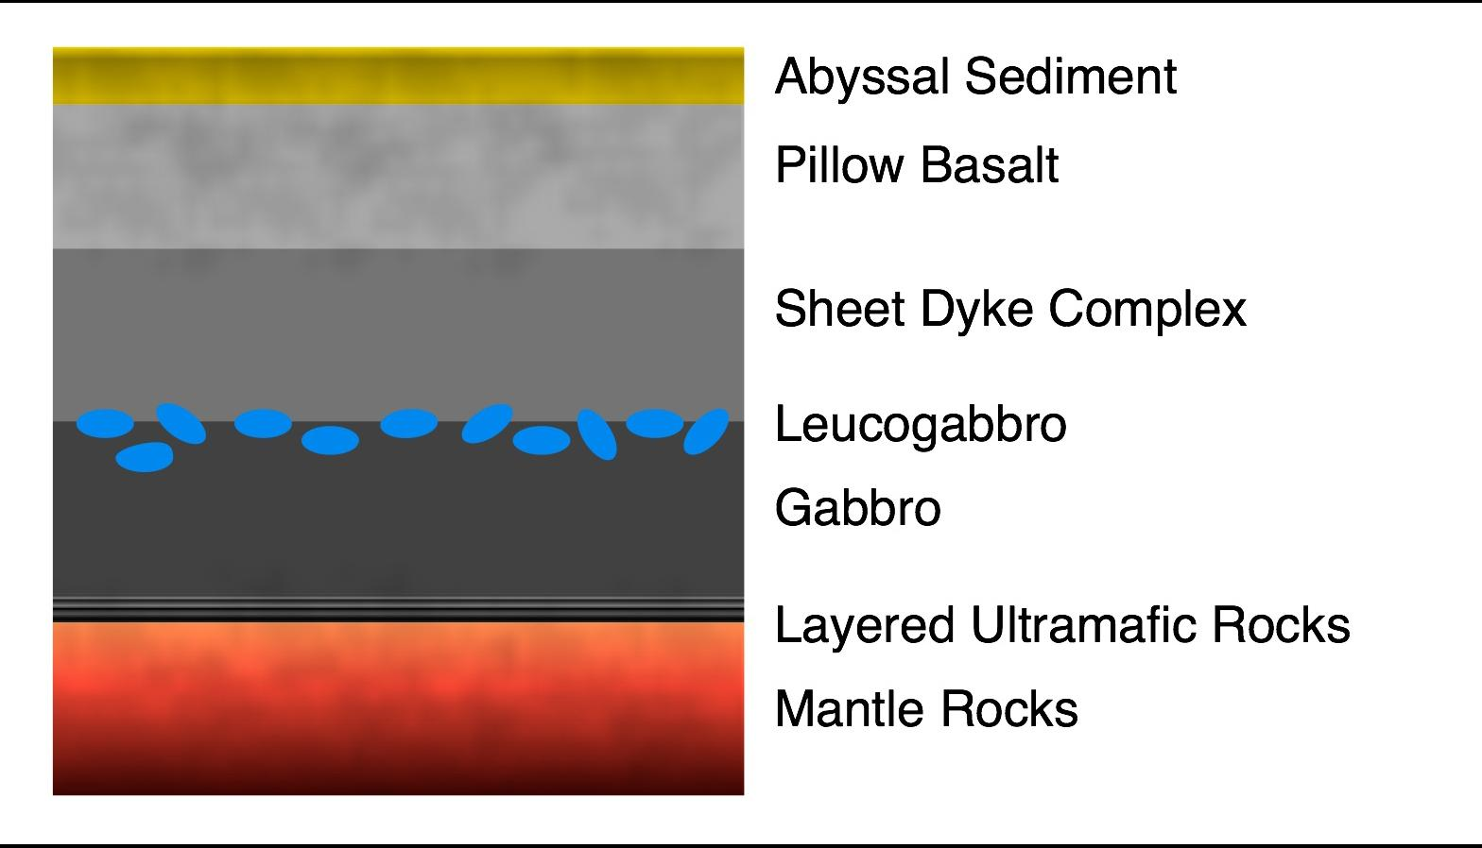

Figure 2.5: Section of typical oceanic crust showing layers as described above (adapted from Heberling 2010)

Inevitably, studies of life in igneous rock have been more difficult than those of life in more accessible seafloor sediments and our understanding of life in the igneous crust is mainly based on samples collected where crustal fluids discharge at the seafloor. Most sampling devices are operated by human-occupied submersibles and remotely operated vehicles (ROVs) although improved sampling devices are allowing more *in situ* filtration, preservation and isolation of samples. Ocean crust observatories are a key development in this area of research (see below).

While oceanic crust may typically be thought of as a pure solid, in practice igneous crust contains an estimated 2% of the ocean fluid volume and the potentially habitable oceanic crust fluid reservoir is approximately ten times the size of the sedimentary reservoir [28]. Heberling *et al*., (2010) estimate a biomass of approximately 2 x 1017 g, 90% of which occurs in the extrusive basalt layer [29].

There have been only few successes in isolating organisms directly from the oceanic crust, mainly due to the difficulty of obtaining uncontaminated samples and the low sample biomass. Orcutt *et al*., (2011) reported the first results from *in situ* ocean crust observatories known as CORKs (Circulation Obviation Retrofit Kit) in young (3.5 million years old) basaltic crust in the Juan de Fuca Ridge [30]. The study was based on obtaining 16S ribosomal RNA (rRNA) sequences for comparison with known sequences to identify types of organism [30]. 16S bacterial sequences were prevalent and many were not closely related to previously cultivated microorganisms. Archaeal communities had relatively low diversity and sequences were often grouped closely with known cultivated species. This research revealed that contrary to previous opinion, subsurface microbial populations are dynamic, changing over a relatively short time frame [30]. This suggests the need for time-series observations. As of 2011, there were 34 borehole observatories in basaltic crust established during ocean drilling expeditions [16,28]. As Edwards *et al*., (2011) have argued, the future of research in the deep biosphere lies with these deep ocean observatories but requires a new mind set in terms of research timeframes:

Conducting decade-long studies in experimental field microbiology requires fundamental new approaches to the way that microbiologists conduct science; this effectively represents a paradigm shift from, for example, our typical training in the laboratory using well-characterized model isolates for which an experiment can be constructed and conducted over-night. By contrast, microbiological research in the oceanic crust requires long-term planning and demands multidisciplinary approaches and collaborations. This research must approach the scientific endeavor from an Earth–system-science perspective, in which experiments and observations are used to formulate conceptual and numerical models that can inform further iterations of experiments and observations. Such approaches are well established in fields such as geophysics, but are far from commonplace in the microbiological sciences. (Edwards *et al*., 2011: 710)

In our view the question of the extent of biodiversity in the deep biosphere is far from settled. Rather, as the work of Orcutt and Edwards ably demonstrates, a serious rethink of the time-frames and technologies required for investigating life in the deep biosphere is required. Supporting such research will also require a longer-term strategy beyond short-term expeditions and more closely resembles the requirements for the exploration of space than typical terrestrial research. We highlight this here because it indicates the need for long-term government investment and international interdisciplinary collaboration rather than the short-term imperatives that frequently drive commercially oriented research and existing debates on access and benefit sharing.

Seamounts and Knolls

Seamounts are underwater mountains rising above 1000 m but not reaching the ocean surface. Knolls are their smaller counterparts, rising between 500 m–1,000 m. In 2011, 33,452 seamounts and 138,412 knolls had been mapped with total area of habitat being 17.2 million km2 and 59 million km2 respectively [31].

Seamounts are one of the most important marine ecosystems due to their abundance and the diversity of life they sustain. With such wide geographic and bathymetric variety, it is difficult to generalise about benthic communities either within or between seamounts, although it has been generally accepted that they are significant ‘hotspots’ of activity for a diverse range of species. Recent studies suggest that seamounts host communities similar to those in their surrounding environments with little endemism but significantly elevated abundance [32]. However, these observations must be tempered by the realisation that only around 300 seamounts have been studiedin sufficient biological detail to consider their specific populations and existing surveys remains biased towards larger organisms [32]. In short, as the scientific literature consistently points out, we remain remarkably ignorant of biodiversity in the deep-sea.

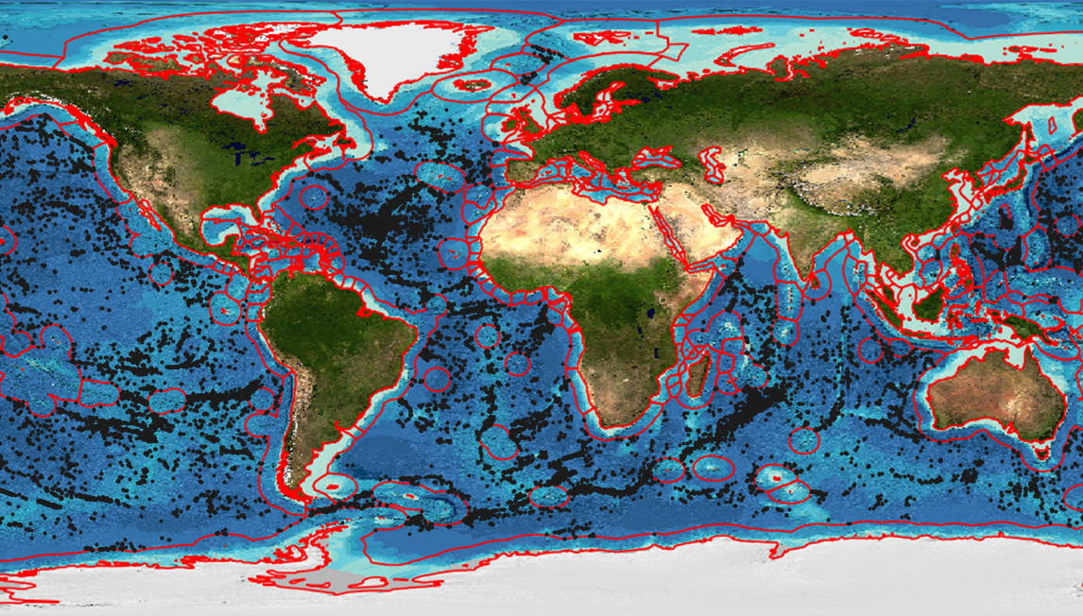

Figure 2.6: Distribution map of large seamount areas in ABNJ (Source data: Yesson 2011)

The abundance of life at seamounts may be due to upwelling currents formed where they disrupt water flow at the seafloor leading to above-average plankton populations where fish aggregate and attract predators higher up the food chain. In addition, the substrate of seamounts is much harder than the surrounding sedimentary deep-sea floor as they are formed from volcanic rock. This surface supports high populations of suspension feeders, especially those from the phylum Cnidaria that includes corals, sea anemones, sea pens and hydroids [33]. These are long-lived slow-growing invertebrates with low tolerance to physical disturbances [33]. Soft sediments dominate some seamounts, notably those with flat tops known as guyots. Here communities are dominated by deposit feeders such as the polycheates found in other deep-sea sediments.[4]

Due to large aggregations of fish at seamounts they are under significant threat from over-fishing by commercial fishing trawlers [31]. Over-fishing has had a huge impact on stocks of demersal (bottom feeding) species and trawling equipment has inflicted significant damage on seamount habitats of which only 1.5% fall within Marine Protected Areas (MPAs) [31]. This figure is even lower at 0.7% for knolls [31].

Mineral extraction poses an additional emerging threat to seamount environments. In addition to Seafloor Massive Sulfide (SMS) mining activity proposed at deposits on seamounts with hydrothermal venting (see below), there is interest in mining cobalt-rich crusts on seamounts in the central Pacific Ocean [33,34]. In studying fauna on the central North Pacific Hawaiian Seamount Chain, research concluded that benthos of sites inside cobalt-rich crust areas differs significantly in terms of species composition from that outside the cobalt-rich crust area, with each area having a comparable number of unique taxa and comparable richness [33].

Cold-Water Coral Reefs

Coral ecosystems, although normally associated with shallow, tropical seas, can be found in a wide range of deep-sea locations ranging across continental shelves, seamounts and ridge systems. Deep-sea cold-water corals can be found in small isolated colonies as well as in ancient reefs, sometimes as massive carbonate mounds up to 300 m high [35]. Corals are Cnidarians that often form structures supported by their skeletons, which grow over time to form bank and reef structures. These structures consist of a cap of living coral on top of a framework of dead skeletons. These structures provide habitats for other species that form the communities of the ecosystems [36].

Cold-water corals can be found in waters between 50 m and 1000 m at higher latitudes, but as deep as 4000 m at low latitudes beneath warm waters. Global distribution of cold-water corals is thought to be linked to seawater carbonate chemistry [35]. Despite their importance as habitat creators, the actual number of records available to develop a true understanding of global distribution remains patchy and distribution probabilities are derived from habitat suitability models [37]. Figure 2.7 shows the distribution of known reefs based on the UNEP–WCMC dataset for the Global Distribution of Cold-water Corals (2005) [38,39]. Colonies and reefs are established over long time periods after coral larvae settle on hard substratum where strong underwater currents prevent the deposition of sediments yet enable a supply of food to reach the corals [36].

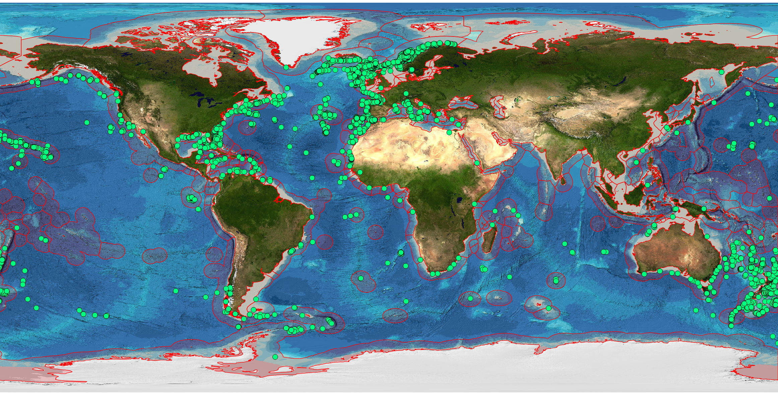

Figure 2.7: Current global distribution of reef framework-forming cold-water corals. [38,39]

Coral reefs have enormous longevity with dating of reefs off NW Africa and along the Mid-Atlantic Ridge suggesting that there has been continual coral growth for 50,000 years at some locations [35]. This longevity and the skeletal structure built up by corals enables them to be used as ‘paleo-environmental archives’, revealing past conditions of the oceans.

Murray Roberts identified three principal threats to coral ecosystems: bottom trawling, deep-sea hydrocarbon mining and acidification [35]. There is evidence that trawling has physically damaged and destroyed reefs [35]. Future mining activities will also have potential to physically destroy the reefs and their communities. Acidification of the seas will lead to areas currently occupied by corals becoming inhospitable as their calcification processes are disrupted [35].

Ocean Trenches and Troughs

Oceanic trenches are long, narrow, steep-sided depressions which occur from 7,300 metres to around 11,000 metres below sea level. They typically form in tectonic plate subduction zones and, according to a Delphi study participant, with few exceptions are normally inside the EEZ. Oceanic troughs are characteristically shallower, shorter, narrower, and topographically gentler than oceanic trenches, occurring at a depth range between 2,300 m and 7,440 m although typical maximum depths lie between 4 and 5 km below sea level. Unlike trenches, oceanic troughs probably owe their origins to a wide variety of geologic mechanisms. Deep-sea trenches and troughs can contain a variety of habitats such as abyssal plains, seamounts, hydrothermal vents and cold seeps.

Research in deep-sea trenches is constrained by some of the most extreme conditions the ocean presents. Nevertheless, the attraction of exploring the deepest known part of our oceans has led to a number of expeditions at Challenger Deep in the Mariana Trench, central west Pacific, which having a maximum known depth of almost 11,000 m, is the deepest known place on Earth. Recent sampling has shown that although the presence of macrofauna is restricted at Challenger Deep, rates of biological consumption of oxygen are high, exceeding rates at a nearby 6,000 m deep site by a factor of two [12]. In addition, “analyses of sediments collected from the two sites consistently reveal higher concentrations of microbial cells at Challenger Deep.” The authors of this study conclude “that the elevated deposition of organic matter at Challenger Deep maintains intensified microbial activity” [12].

Mostly being situated along continental margins, most deep trenches are in close proximity to coastal oceans and transport routes allowing substantial deposition of matter [12]. Ocean currents, landslide and debris flows ensure that sediments and other materials are transported throughout the troughs and canyons, and these processes enable the dispersal of marine organisms. However, it also provides a means for human-made litter to be deposited far from its source. Research at Monterey Canyon has studied the potential impact of pollution over a 22 year period. The authors found that the highest frequency of metal and plastic debris occurred at below 2000 m and that over a third of the observations showed megafauna in close contact with debris [40].

Cold Seeps and Mud Volcanoes

Dr. Charles Paull first discovered cold seeps in the Gulf of Mexico in 1983 [41]. They are now known to exist in all oceans, being patchily distributed and occurring most frequently near ocean margins and along continental margins in areas of high tectonic activity where crustal deformation and compaction drive emissions of methane rich fluid. Topographic features may be depressions (pockmarks) or, equally common, highs such as mounds, mud diapirs and mud volcanoes [41].

At cold seeps, reduced sulfur and methane emerge from the sea floor unheated by volcanic activity. Thiotrophic (sulfur oxidising) and methanotrophic symbiotic bacteria (Euryarchaea) fuel most of the megafauna at these sites which is dominated by tube-worms, mussels and clams with cladorhizid sponges, gastropods and shrimp sometimes abundant [41].

Seep habitats have greater macrofaunal abundance than background sediments, particularly at lower depths. Seep infauna (fauna living in sediment) includes organisms tolerant of high sulfide or with behaviours that avoid the toxicity of sulfide. Within the Polychaeta (worms), Dorvilleide are particularly abundant at some sites (the Gulf of Mexico and the Norwegian margin) with Ampharetids dominant at New Zealand and Costa Rica study sites. While these Polychaeta were widespread at all seep habitats, other groups dominated at just one or a few locations. Less sulfidic cold seep habitats tend to exhibit the greatest biological diversity with features such as clam beds [41].

Mud volcanoes are specific cold seep structures where emissions emerge as gas-fluidised mud and the methane may escape as gas bubbles or remain stored as gas hydrates [42]. There are an estimated 100,000 mud volcanoes in the deep-sea [43]. Studies of specific mud volcano systems have considered the positive contribution of biodiversity in oxidising methane as well as the effects of methane emissions on biodiversity. In a complex system of mud volcanoes in the Mediterranean Sea, it was found that there was lower macro and meiofaunal diversity where there is highest fluid emission, with nematodes being the most abundant taxa at all sites, accounting for 85-94% of taxa, followed by copepods accounting for 5-12% [42]. Types of nematodes vary across different systems of mud volcanoes suggesting that cold seep systems may differ significantly in their biodiversity and indicating the need to protect the contribution of nematodes to marine ecology [42].

Research at the Haakon Mosby mud volcano in the Barents Sea found that methane oxidation was the main source of energy for microbial organisms across the mud volcano’s various habitats and that methanotrophs play an important part in methane removal that is affected by flows of sulfate and oxygen-free fluids [44]. These methanotrophic organisms form part of a wider “benthic filter for methane” signalling their importance in influencing methane entering the wider hydrosphere and atmosphere [45]. Seeps along the global continental margins have been estimated to contribute between 1 and 5% of global methane emissions to the atmosphere [45]. Because of their relevance for oceanic emissions of climate-relevant methane and their biological richness Boetius and Wenzhöfer (2013) argue that cold seeps should be considered key candidates for ecosystem monitoring and protection [45].

Mud volcanoes are also of significant interest for their commercial potential as reserves of gas hydrates. Gas hydrates form when fluids rise from the deep subsurface and crystallise on meeting the cooler temperatures of the surrounding sediments. Based on Milkov’s estimates the approximate total volume of gas hydrate in mud volcanoes is 1010 - 1012 m3 [43]. There is significant interest in exploiting marine gas hydrates for energy, with estimates of its economic value varying widely from 50 times greater than the world’s conventional gas resource to around half of the conventional gas resource (estimates taken from Milkov and Sassen 2002) [46-48]. With the first full production scheduled to start in 2016-18 at the Nankai Trough (Japan) and recovery of marine gas hydrates being economically feasible in a number of other regions, there is major business potential in extracting gas hydrate reserves in the near future [48]. Alongside this economic potential lie the possible negative impacts on the biologically valuable chemosynthetic communities that inhabit these habitats.

Hydrothermal Vents

Hydrothermal vents can reasonably be described as the functional equivalent of the charismatic megafauna that are the icons of international conservation. That is, they receive most of the attention in debates on the deep-sea. In approaching deep-sea biodiversity from the perspective of the water column, the abyssal plain and marine sediment, the oceanic crust, sea mounts, cold seeps and mud volcanoes we have sought to widen the discussion of deep-sea biodiversity and habitats in discussions under UNCLOS.

However, it is undoubtedly the case that the discovery of hydrothermal vents in 1977 provided a new perception of the ocean floor as a dynamic environment with rich benthic communities and radically expanded scientific understanding of the origins and limits for life [23]. Extremophile organisms, thriving at conditions considered to be at the known limits for life in terms of pressure, temperature, pH and chemical composition, have been a major focus of investigation not only in defining these limits but also in the potential for harnessing these properties.

Hydrothermal vents in the deep ocean typically form along the mid-ocean ridges such as the East Pacific Rise and the Mid-Atlantic Ridge. These are locations where twotectonic plates are diverging and new crust is being formed. The geochemistry of vent fluids and deposits varies. Those at fast-spreading ridges such as the East Pacific Rise are dominated by sulfide while those at slow-spreading ridges such as the Mid-Atlantic Ridge are dominated by hydrogen and methane [22]. More unusual are the iron dominated Loihi vents in Hawaii and the carbon dioxide dominated vents of the Okinawa trough [22]. The geochemical composition of vents is dynamic, and the microbial life forms inhabiting these systems are likely to differ not only between vent systems but also within a vent. Differences in chemical composition at spatial scales as small as centimetres and temporal scales of minutes will have an impact on microbial communities and make research more complex, highlighting the need for more long term *in situ* programmes [22].

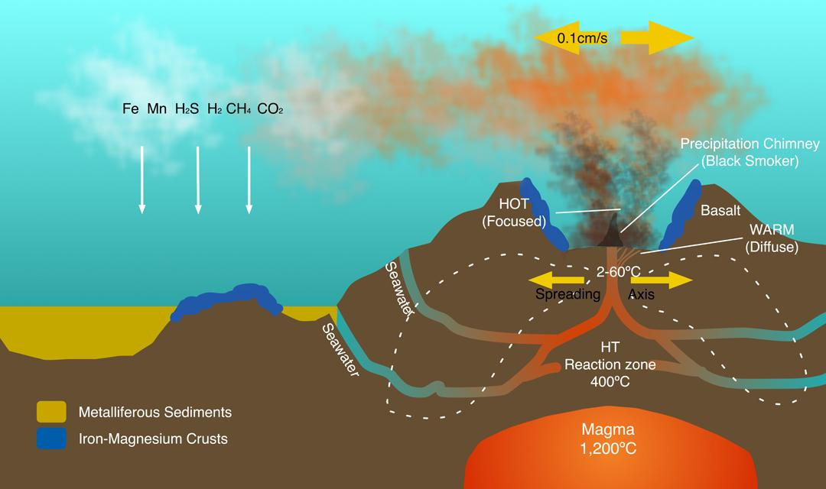

Figure 2.8: Hydrothermal circulation in a mid-oceanic ridge (MOR) system[5]

Some hydrothermal vents form chimney like structures known as black or white ‘smokers’. A black smoker is found typically in the abyssal and hadal zones. The black smokers typically emit dark particles with high levels of sulfides. Black smokers are formed in fields hundreds of metres wide when superheated sulfide rich water from below the crust comes through the ocean floor (see Figure 2.8). When the heated fluid comes into contact with cold ocean water, many minerals precipitate, forming a black chimney around each vent. The deposited metal sulfides can become massive sulfide ore deposits in time. White smoker vents emit lighter-hued minerals, such as those containing barium, calcium and silicon and tend to have lower temperature plumes.

Many microorganisms at hydrothermal vents are chemoautotrophic, using the oxidation of inorganic molecules or methane as a source of energy. The chemoautotrophic bacteria grow into a thick mat that attracts organisms that Jorgensen describes as the ‘icons of vent life’: tubeworms, molluscs and shrimps [22]. Studies of fauna at geographically distant vents reveal significant heterogeneity. For example, research on the East Scotia Ridge in the Southern Ocean discovered that fauna was dominated by a new type of yeti crab, Kiwa n. sp., stalked barnacles, limpets, peltospiroid gastropods, anemones and a predatory sea star [49]. Taxa common in other vent systems were often entirely absent; indicating that the influences of the Antarctic environment on vent system communities is significant [49].

Some hydrothermal vents have led to the formation of exploitable mineral resources via deposition of Seafloor Massive Sulfide (SMS) deposits that are of significant interest to mineral exploration companies. Seafloor Massive Sulfides are areas of hard substratum with high base metal and sulfide content along with commercially exploitable concentrations of gold and silver [34]. The most concentrated SMS deposits are found at high intensity hydrothermal systems, typically 200–400 degrees centigrade, and there are now 165 known deposits recorded on the InterRidge database [34]. Recent estimates of global SMS deposits suggest that they occur on average every 100 km along the ocean plate boundaries with approximately 900 modern deposits globally (Hannington *et al*., 2011, cited in Boschen *et al*., 2013).

In closing this discussion of important deep-sea habitats we provide a table summarising the key features of the habitats discussed above in Figure 2.9. We now turn to analysis of the existing state of knowledge of the impacts of human activity on deep-sea biodiversity and habitats.

Figure 2.9: Summary of the Principal Habitat Types Found in the Deep-Sea.

|  |  |  |
| --- | --- | --- |
| Habitat | Distribution | Status |
| The Water Column | | |
| Open waters from the surface to the seafloor. | All open waters are a part of the water column divided into different pelagic zones based on depth. | 50% of biodiversity records are from the continental slopes. The deep pelagic zone (below 200 m) is the most under-represented area in databases. |
| The Abyssal Plain | | |
| The vast, flat, sediment covered plains between continental margins and mid-ocean ridge systems. | Most of the deep-seafloor is comprised of abyssal plains. They cover approximately 50% of the Earth’s surface. | Understanding of biodiversity limited to relatively few samples due to scale of area and inaccessibility. Location of manganese nodule fields. |
| Seafloor and Sub-seafloor Sediments | | |
| The sediment layer covering much of ocean floor. | Can be found on any of the seafloor habitats and vary in thickness from a few centimetres to 4 km. | Sediments are dominated by microbial life that plays an important role in oxidising methane. |
| Oceanic Crust | | |
| The rocky crust of the ocean floor beneath sediment layers. | Up to 6 km thick contains several volcanic rock and mineral layers. | Estimates of the microbial biomass vary and our ability to sample is extremely limited. |
| Seamounts and Knolls | | |
| Seamounts are underwater mountains rising >1000 m from the seafloor (knolls are smaller rising up to 1000 m). | Found across all the oceans and form the longest mountain chains on the planet. | Considered hotspots of biodiversity due to upwelling of nutrient rich water and a diverse range of habitats. Only 350 seamounts (out of 30,000) have been studied. Massive sulfide deposits attracting mining interest. |
| Cold Water Corals | | |
| Often ancient reefs and colonies of corals forming complex habitats in deep waters. | Found in a wide range of locations including ridge systems, seamounts and continental shelves. | At risk of destruction by bottom trawling and acidification due to their calcification being disrupted. |
| Ocean Troughs and Trenches | | |
| Trenches are long, deep depressions between 7300 m and 11000 m deep. Troughs are shallower and gentler. | Trenches are found at tectonic subduction zones. Troughs are caused by a variety of geological mechanisms. | The deepest places on Earth. Macrofauna is limited but microfauna can thrive due to organic matter deposits. |
| Cold Seeps and Mud Volcanoes | | |
| Where reduced sulfur and methane emerge unheated from the seafloor. In mud volcanoes it emerges as fluidised mud. | Found frequently near ocean margins and along continental margins where there is tectonic activity. | Thiotrophic and methanotrophic symbiotic bacteria fuel adapted megafauna.  Gas hydrate deposits below mud volcanoes are of commercial interest. |
| Hydrothermal Vents | | |
| A feature from which super-heated water rich in chemicals from the sub seafloor crust emerges. | Typically found at the mid-ocean ridges where tectonic plates are diverging. | Extremophiles dominate fauna. Black & white smokers deposit minerals, which have potential commercial value. |

2.3 Human Impacts on Deep-Sea Habitats

The discussion above has highlighted some of the main potential and actual human impacts on the deep-sea. In the context of the *Census of Marine Life* the SYNDEEP project team led by Ramirez-Llodra has provided the most comprehensive overview to date of the main impacts of human activity [50]. Figure 2.10 provides a brief summary of the main findings of this research.

Figure 2.10: Key Threats and Impacts for Marine Habitats [50]

|  |  |  |
| --- | --- | --- |
| Litter and Waste Disposal | | |
| Plastics, metals etc. | Accumulate in trenches. Plastics dispersed as micro-particles in the water column. | Consumed by marine organisms. |
| Scientific survey waste | Submersible ballast dumped at survey sites. | Pollutes survey sites. |
| Large structures | Wrecks and lost shipping containers resting on seafloor. | Can create new hard strata habitats; corrosion and leaking can release pollutants. |
| Low level radioactive waste | Historic systematic dumping of barrels of waste in deep ocean. Lost nuclear powered submarines. | Leaking of radionuclides into open waters. |
| Persistent organic chemicals | Industrial waste and sewerage carried down into the deep-sea by dense shelf water cascading events and currents. | Chemical contaminants found in high trophic level organisms. |
| Discarded fish carcasses | By-catch and other animal parts dumped overboard from fishing vessels. | Provides feed for gulls & seals. Reduces oxygen levels in deeper waters. |
| Dead livestock | Animals in transit dumped from vessels when they die. | May provide nutrient hotspots similar to whale falls. |
| Storage of CO2 | Proposed storage of CO2 in deep-sea sediments. | Likely to increase acidification of oceans and create toxic plumes. |
| Resource Exploitation | | |
| Fisheries | Technological advances allowing fisheries to harvest from deeper waters. | Damage to habitats by trawls; depletion of cold water (slow breeding) species; stock collapse. |
| Mining | Extraction of manganese nodules, mining of cobalt-rich crust and massive sulfide deposits. | Destruction of abyssal plain and seamount habitats; death of organisms in biogeographically isolated sites; pollution from machinery and slurry. |
| Oil & Gas | Established industry and potential for gas hydrate extraction. | Potential for spills which can destroy deep-sea communities as plumes cover large areas. |
| Bioprospecting | Possible harvesting and sampling of marine life for novel products. | Potential for damage to habitats and marine communities. |
| Climate Change | | |
| Acidification | Lowering pH reduces the ability of water to hold calcium carbonate. | Vital structural corals and other calcifying fauna are unable to survive. |
| Temperature Rise | Warmer waters are less able to hold oxygen. | Vertical habitat compression will change ecosystem functions. Productivity falls. Methane hydrate deposits destabilised. |
| Invasive Species | | |
| Species transported to new locations (e.g. in ballast water tanks) | Invasive species outcompete native and endemic species. | Structures of deep-sea communities changed. |

We now turn to a brief discussion of marine protected areas and Ecologically or Biologically Significant Areas (EBSAs).

Marine Protected Areas and Ecologically or Biologically Significant Areas

Marine Protected Areas (MPAs) are zones of the seas and coasts where wildlife is protected from damage and disturbance. MPA is a broad umbrella term for a range of protected areas that serve as the principal vehicles for marine conservation efforts. They are an integral aspect of a country’s environmental policy and are normally managed and monitored by an appropriate government body.

Taking the UK as an example, responsibility for the management of MPAs is held by Natural England; Scottish Natural Heritage; Natural Resources Wales and the Northern Ireland Environment Agency. The UK Government has expressed a commitment to establishing a well-managed ecologically coherent network of MPAs in its seas.

Natural England defines its role in MPAs in English waters with the following five statements, and this gives a sense of the diverse reasons a country may have for establishing an MPA.

1. Protect and restore the ecosystems in our seas and around our coasts.

2. Ensure that the species and habitats found there can thrive and are not threatened or damaged.

3. Maintain a diverse range of marine life that can be resistant to changes brought about by physical disturbance, pollution and climate change.

4. Provide areas where the public can enjoy a healthy marine environment learn about marine life and enjoy activities such as diving, photography, exploring rock pools and coastal walking.

5. Provide natural areas for scientific study.[6]

MPAs are also established in order to fulfil international obligations, including those in the Convention on Biological Diversity and the EU Marine Strategy Framework Directive. The range of protected areas in UK waters can be seen in Figure 2.11

Figure 2.11: Marine Protected Areas in British waters.

|  |  |
| --- | --- |
| Designation | Type of Protection |
| Special Area Of Conservation | Protected Marine Habitat or Species of Marine Importance. |
| Special Protection Area | Protection of Birds of European Importance. |
| Marine Conservation Zones | Protecting nationally important habitats, species and geology. |
| Site of Special Scientific Interest | Most SSSIs are terrestrial but some extend into the marine environment. |
| RAMSAR sites | Protected international sites for wetland birds. |
| Particularly Sensitive Sea Areas (PSSAs) | An area recognised for its ecological or socio-economic or scientific importance given protection by the International Maritime Organisation. |

At a regional level, a key part of the Convention for the Protection of the Marine Environment of the North-East Atlantic’s (OSPAR) biodiversity strategy for example, is to establish a network of MPAs which is both ecologically coherent and well-managed by 2016. In the period 2005–2012 OSPAR Contracting Parties bordering the North-East Atlantic have selected and nominated sites as components of the OSPAR Network of MPAs. Reflecting that the OPSAR maritime area is composed of areas within and beyond national jurisdiction, MPAs have also been designated in the high seas. Similarly, the Commission for the Conservation of Antarctic Marine Living Resources (CCAMLR) is also establishing MPAs outside of EEZs and continental shelf areas.

Globally, there are at least 4,435 MPAs [51]. There is much guidance available concerning the management of MPAs with individual governments determining the management and governance of their own MPAs.[7] The IUCN provides guidelines for the application of management categories to MPAs for which their definition reads, “A protected area is a clearly defined geographical space, recognised, dedicated and managed, through legal or other effective means, to achieve the long-term conservation of nature with associated ecosystem services and cultural values”.[8] The governance of MPAs is discussed in the UNEP 2011 report ‘Governing Marine Protected Areas – Getting the Balance Right’ which concludes that there are three perspectives that need to be considered in decision making about governance. The three perspectives are: state regulations, providing a legal framework; community based approaches to ensure decentralization and local empowerment; and market incentives to ensure alternative livelihoods and that an economic value is attached to biodiversity. The effectiveness of these approaches in managing and governing MPAs is of importance as, to date, MPAs in areas under national jurisdiction are the primary areas given biodiversity protection and the knowledge and methods acquired at these locations will be of use in determining approaches to protecting Areas Beyond National Jurisdiction.

Ecologically or Biologically Significant Marine Areas (EBSAs)

Historically, marine conservation initiatives around the world have been focused on coastal areas within EEZs, as seen with the UK example above. Far less attention has been paid to the open waters and deep seas beyond national jurisdiction. To date, the classification and management of deep-sea habitats with the objectives of protecting biodiversity and maintaining resilience has not been adequately enacted. A major step in rectifying this imbalance is the identification of Ecologically or Biologically Significant Areas (EBSAs).

In the UK, the Government supports the principle of designating MPAs in international waters, and specifically supported the call in 2010 by governments of the States party to the Convention on Biological Diversity (CBD) to strive for MPA and other area based mechanisms covering 10% of our oceans by 2020. The UK has therefore made a commitment to the identification of EBSAs, which are areas of the oceans that are recognised as being of greater scientific importance than other areas. EBSAs have been defined by the Conference of the Parties (COP) to the CBD as:

...geographically discrete areas that provide important services to one or more species/populations of an ecosystem as a whole, compared to other surrounding areas or areas of similar ecological characteristics, or otherwise meet the criteria as identified in annex 1 to decision IX/20 (decision IX/20, Annex II)

A set of criteria to identify EBSAs was agreed at the 9th CBD COP in Bonn in 2008 (decision IX/20). The aim of the criteria was to identify the areas of the oceans in need of protection and to provide the scientific guidance required, using the precautionary approach and the ecosystem approach, and to establish a network of representative marine protected areas across the world. Seven key criteria were agreed by the Conference of the Parties for selecting EBSAs as provided in Figure 2.12.

At the 10th Conference of the Parties to the CBD, governments reiterated the central role of the United Nations General Assembly in addressing conservation and sustainable use of biodiversity in marine areas beyond national jurisdiction and the universal character of the United Nations Convention on the Law of the Sea (decision X/29). The COP also promoted collaboration between the CBD and other relevant agencies in the provision of scientific and technical advice to ensure that the best scientific studies were used to identify these priority areas and to work to develop databases to further increase knowledge of these areas (decision X/29).

Figure 2.12: Scientific Criteria Used to Identify a Potential EBSA, adapted from decision IX/20, Annex I.[9]

|  |  |
| --- | --- |
| Criteria | Definition |
| Uniqueness or rarity. | Area contains either (i) unique, rare or endemic species, populations or communities, and/or (ii) unique, rare or distinct habitats or ecosystems; and/or (iii) unique or unusual geomorphological or oceanographic features. |
| Special importance for life history of species. | Areas that are required for a population to survive and thrive. |
| Importance for threatened, endangered or declining species and/or habitats. | Areas containing habitat for the survival and recovery of endangered, threatened, declining species or areas with significant assemblages of such species. |
| Vulnerability, fragility, sensitivity, or slow recovery. | Areas that contain a relatively high proportion of sensitive habitats, biotopes or species that are functionally fragile (highly susceptible to degradation or depletion by human activity or by natural events) or with slow recovery. |
| Biological productivity. | Areas containing species, populations or communities with comparatively higher natural biological productivity. |
| Biological diversity. | Areas containing comparatively higher diversity of ecosystems, habitats, communities or species, or which have higher genetic diversity. |
| Naturalness. | Areas with a comparatively higher degree of naturalness as a result of the lack of, or low level of, human-induced disturbance or degradation. |

In 2009 The Global Ocean Biodiversity Initiative (GOBI), a collaboration between intergovernmental organisations, NGOs and academic institutions, was established to provide further technical assistance to states and other regional and global organisations in identifying ecologically significant areas and how they could be effectively managed, developed and monitored to create a network of representative marine protected areas.

The process of identifying an EBSA begins with the selection of a potential site either by the recommendation of experts or by a systematic approach. In 2010 an identification process based on regional workshops was adopted in order to facilitate the description of EBSAs. The summary reports of these regional workshops, once endorsed by the CBD COP, are forwarded to the UN General Assembly, which is recognized as being the competent arena to discuss any future policy implications with respect to EBSAs identified in Areas Beyond National Jurisdiction.

EBSAs are a scientific tool which provide an important starting point for future research and monitoring. Thus far 63 areas have been described as meeting the EBSA criteria with additional EBSAs proposed in areas such as the NE Atlantic. Figure 2.13 illustrates these areas based on information provided by the EBSA website of the Secretariat of the CBD and Defra in the UK.[10]

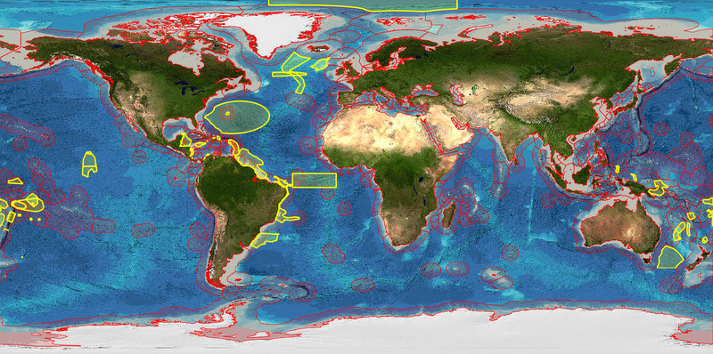

Figure 2.13: Global distribution of EBSAs (yellow) and EEZs (red).

Other models for EBSAs have been developed outside of the CBD. The most notable are those of Fisheries and Oceans Canada (DFO) and the FAO whose model is known as Vulnerable Marine Ecosystems and focuses on the impact of deep-sea fisheries. In considering whether the three systems can be reconciled, Gregr *et al*., (2012) discuss the complexity of classification of marine environments and the lack of a single universal methodology [52]. Gregr *et al*., (2012) examined 16 classification methods (using physical, biological and ecological approaches) to determine a new best approach. They argue that an integrated methodology, combining data of both biological origin and physical features, can be created to be more successful in encompassing biologically sensitive areas and important marine features and which is practicable for use in a repeatable manner. More than anything their research demonstrates that the process of classifying areas of the ocean based on the EBSA criteria is both complex and is still developing.

In a similar vein, Gerald Taranto *et al*., (2012) seek to develop a methodology for the identification of individual seamounts for which an EBSA designation would be appropriate [53]. They argue that many deep-sea habitats are dynamic, and in the case of pelagic habitats are not geographically fixed. Seamounts, having such an important role for pelagic species, would therefore be excellent candidates for special protection. In a series of studies of named seamounts, EBSA criteria were applied looking at features such as vents and their communities, cold-water coral reefs and threatened visiting pelagic fauna as indicators. The paper concludes that the identification and protection of important seamounts would achieve the conservation goals of the CBD when combined with spatial analysis of human activities such as mining and fishing.

As this brief discussion makes clear, EBSAs are an emerging instrument for the conservation and sustainable use of marine biodiversity in Areas Beyond National Jurisdiction. One question that we will contribute to addressing in the course of this report is the extent to which existing EBSA coverage correlates with known areas of scientific research and patent activity.

Marine Ecosystem Services

Ocean ecosystems are a complex web of habitats and organisms. The communities of organisms are often highly diverse and provide a wide range of ecosystem goods, services and benefits to human society. Collectively these benefits are known as ecosystem services and they provide an inclusive means of engaging economically, culturally, and scientifically with the oceans [54].

The following is taken from the UK National Ecosystem Assessment Technical Report chapter on Marine ecosystem services [55]. Ecosystem Services can be grouped into four main areas: provisioning, regulation, cultural and supporting, as illustrated in figure 2.14 below.

A wide range of provisioning, regulating and cultural services are provided by the deep oceans. Nutrient recycling by deep-sea fauna provides the necessary foods to fuel surface productivity and thereby maintain fisheries, and microbial metabolic activity is responsible for breaking down toxic compounds, which find their way into the oceans from human activities.

Carbon from the atmosphere is transported by biological processes into the deep-ocean water where it can remain for very long periods of time, compensating for the immediate impact of anthropogenic carbon release. Microbial oxidation of methane prevents much of this even more potent greenhouse element from entering the atmosphere. This indicates the capacity of the oceans to provide a measure of security in the face of climate change.

The deep-sea contains a number of resources that may be extracted or harvested for the benefit of society. At present this is dominated by fish stocks, but in the future there is likely to be a diverse range of products emerging from the oceans’ depths if the potential for bioprospecting activity becomes apparent and achievable. Large amounts of minerals, metals and other elements upon which modern technologies are dependant can be found in the deep seas on seamounts, at hydrothermal vent systems and on the abyssal plains.

Finally there are the cultural, often non-quantifiable, aspects of the seas and our relationship with them. Society benefits from the mystery and the history of its struggle with the seas. It is the largest environment on the planet and yet one where we cannot go without danger and the aid of technology. It contains life forms which are all but alien to us and remind us how little we know of our home planet.

Figure 2.14: Marine Ecosystem Services [55]

|  |  |
| --- | --- |
| Provisioning | Regulating |
| Food:  Finfish; shellfish; seaweed; fish oil and fishmeal.  Bait for sea angling  Aquaculture:  Farming, with salmon and shellfish being most important to the UK and seaweed being a growing area of aquaculture.  Blue biotechnology:  Pharmaceuticals and biomedical research tools; biocatalysts; fertiliser (seaweed); foulants and anti-foulants; nutritional supplements; personal care products.  Energy:  Wave and tidal power.  Biofuels from macro and micro algae. | Climate regulation:  Regulation of biogases such as carbon, organic halides, ozone, oxygen, dimethyl sulfide.  Flood, storm and coastal protection:  Species bind and stabilise sediments and create natural sea defences to dampen the effects of surges, storms and floods (e.g. biogenic reefs, seagrass beds, mudflats and saltmarshes).  Pollution control:  Waste breakdown and detoxification of human and agricultural waste; chemical and industrial waste (including nanoparticles, pharmaceuticals, nitrogen and phosphorus); oil (natural seepage and routine release from shipping). |
| Cultural | Supporting |
| Tourism  Education  Recreation  Well being  Heritage  Philosophical and inspirational  Wild species (including ‘flagship species’) | Nutrient recycling:  Within seabed sediments, water columns; between trophic levels and in the course of bacterial breakdown of detritus.  Biologically mediated habitat:  Organisms provide living habitats and/or refuge for other organisms through their normal growth, examples in UK being maerl ground (calcified red seaweed), mussel patches and cold water coral reefs. |

2.4 Conclusions

The purpose of this chapter has been to introduce the reader to the diversity of marine habitats in Areas Beyond National Jurisdiction drawing on the latest literature on biodiversity and threats to biodiversity. In the process we have introduced instruments such as Marine Protected Areas and new developments such as Ecologically or Biologically Significant Areas (EBSAs) as well as the application of ecosystem services to the valuation of services provided by the marine environment.

In presenting this overview our purpose has also been to highlight the problem that, in our view, existing debates on access and benefit-sharing in Areas Beyond National Jurisdiction have been too narrowly focused on charismatic locations such as hydrothermal vents. We do not raise this point because hydrothermal vents are lacking in importance. Rather, a broader understanding is required of the scale of marine habitats, the diversity of organisms within those habitats, and the important – if at times neglected – research that is taking place in the middle of the water column, involving cold water corals or exploring the deep biosphere in the oceanic crust. There is life in all of these habitats and any proposed implementing agreement within the framework of UNCLOS will benefit from increasing attention to these diverse locations.

A second and striking feature of this overview is the fundamental problem of human ignorance of the largest environment on this planet. The *Census of Marine Life* at once expanded our knowledge of the marine environment and at the same time emphasised the profound human ignorance of an environment that is already threatened by human intervention. In the context of debates on a possible new agreement within the framework of UNCLOS involving access and benefit-sharing for marine genetic resources this raises the simple question of what should such an agreement be for? Our answer is simple. Any implementing agreement within the framework of UNCLOS on access to genetic resources and benefit-sharing should be directed to advancing human knowledge and understanding of biodiversity in the deep-sea and no other purpose. Improving human understanding of this environment will involve significant investments in research, international research cooperation and a research programme with a time scale measureable in decades.

We now turn to analysis of trends in research on marine genetic resources involving the deep-sea.

References

1 Arico S, Salpin C (2005) *Bioprospecting of genetic resources in the deep seabed: scientific, legal and policy aspects*. Yokohama: United Nations University, Institute of Advanced Studies.

2 Salpin C, Germani V (2007) Patenting of Research Results Related to Genetic Resources from Areas beyond National Jurisdiction: The Crossroads of the Law of the Sea and Intellectual Property Law. *Review of European Community & International Environmental Law* 16: 12-23.

3 Leary D, Vierros M, Hamon G, Arico S, Monagle C (2009) Marine genetic resources: A review of scientific and commercial interest. *Marine Policy* 33: 183-194.

4 Leary D (2012) Moving the Marine Genetic Resources Debate Forward: Some Reflections. *International Journal of Marine and Coastal Law* 27: 435-448.

5 Tvedt M, Jorem A (2013) Bioprospecting in the High Seas: Regulatory Options for Benefit Sharing. *The Journal of World Intellectual Property* 16: 150-167.

6 Broggiato A, Arnaud-Haond S, Chiarolla C, Greiber T (2014) Fair and equitable sharing of benefits from the utilization of marine genetic resources in areas beyond national jurisdiction: Bridging the gaps between science and policy. *Marine Policy*. doi: 10.1016/j.marpol.2014.02.012

7 Druel E, Gjerde KM (2014) Sustaining marine life beyond boundaries: Options for an implementing agreement for marine biodiversity beyond national jurisdiction under the United Nations Convention on the Law of the Sea. *Marine Policy*. doi: 10.1016/j.marpol.2013.11.023

8 Rochette J, Unger S, Herr D, Johnson D, Nakamura T, *et al*. (2014) The regional approach to the conservation and sustainable use of marine biodiversity in areas beyond national jurisdiction. *Marine Policy*. doi: 10.1016/j.marpol.2014.02.005

9 Corfield R (2003) *The Silent Landscape - In the Wake of HMS Challenger 1872-1876*. London: John Murray.

10 Webb TJ, Vanden Berghe E, O'Dor R (2010) Biodiversity's Big Wet Secret: The Global Distribution of Marine Biological Records Reveals Chronic Under-Exploration of the Deep Pelagic Ocean. *PLOS ONE* 5 (8). doi:10.1371/journal.pone.0010223

11 Ebbe B, Billett DS, Brandt A, Ellingsen K, Glover A, *et al*. (2010) Diversity of abyssal marine life. In: *Life in the Worlds Oceans: Diversity, Distribution, and Abundance*, edited by: McIntyre, A. London: John Wiley & Sons. pp. 139-160.

12 Glud RN, Wenzhöfer F, Middelboe M, Oguri K, Turnewitsch R, *et al*. (2013) High rates of microbial carbon turnover in sediments in the deepest oceanic trench on Earth. *Nature Geoscience* 6: 284-288.

13 Smith KL, Ruhl HA, Kahru M, Huffard CL, Sherman AD (2013) Deep ocean communities impacted by changing climate over 24 y in the abyssal northeast Pacific Ocean. *Proceedings of the National Academy of Sciences of the United States of America* 110: 19838-19841.

14 Grupe B, Becker HJ, Oebius HU (2001) Geotechnical and sedimentological investigations of deep-sea sediments from a manganese nodule field of the Peru Basin. *Deep-Sea Research Part II-Topical Studies in Oceanography* 48: 3593-3608.

15 Collins PC, Croot P, Carlsson J, Colaco A, Grehan A, *et al*. (2013) A primer for the Environmental Impact Assessment of mining at seafloor massive sulfide deposits. *Marine Policy* 42: 198-209.

16 Orcutt BN, Larowe DE, Biddle JF, Colwell FS, Glazer BT, *et al*. (2013) Microbial activity in the marine deep biosphere: progress and prospects. *Frontiers in Microbiology* 4: 189.

17 Kallmeyer J, Pockalny R, Adhikari RR, Smith DC, D'Hondt S (2012) Global distribution of microbial abundance and biomass in subseafloor sediment. *Proceedings of the National Academy of Sciences of the United States of America* 109: 16213-16216.

18 Lipp JS, Morono Y, Inagaki F, Hinrichs KU (2008) Significant contribution of Archaea to extant biomass in marine subsurface sediments. *Nature* 454: 991-994.

19 Biddle JF, Lipp JS, Lever MA, Lloyd KG, Sørensen KB, *et al*. (2006) Heterotrophic Archaea dominate sedimentary subsurface ecosystems off Peru. *Proceedings of the National Academy of Sciences of the United States of America* 103: 3846-3851.

20 Xie S, Lipp JS, Wegener G, Ferdelman TG, Hinrichs K-U (2013) Turnover of microbial lipids in the deep biosphere and growth of benthic archaeal populations. *Proceedings of the National Academy of Sciences of the United States of America* 110: 6010-6014.

21 Bernardino AF, Levin LA, Thurber AR, Smith CR (2012) Comparative Composition, Diversity and Trophic Ecology of Sediment Macrofauna at Vents, Seeps and Organic Falls. *PLOS ONE* 7: 17. doi: 10.1371/journal.pone.0033515

22 Jørgensen BB, Boetius A (2007) Feast and famine microbial life in the deep-sea bed. *Nature Reviews Microbiology* 5: 770-781.

23 Corliss JB, Dymond J, Gordon LI, Edmond JM, von Herzen RP, *et al*. (1979) Submarine thermal springs on the Galapagos rift. *Science* 203: 1073-1083.

24 Deming JW, Baross JA (1993) Deep-sea smokers: windows to a subsurface biosphere? *Geochimica et Cosmochimica Acta* 57: 3219-3230.

25 Hinrichs KU, Inagaki F (2012) Downsizing the deep biosphere. *Science* 338: 204-205.

26 Whitman WB, Coleman DC, Wiebe WJ (1998) Prokaryotes: the unseen majority. *Proceedings of the National Academy of Sciences of the United States of America* 95: 6578-6583.

27 Colwell FS, D’Hondt S (2013) Nature and extent of the deep biosphere. *Reviews in Mineralogy & Geochemistry* 75: 547-574.

28 Edwards KJ, Wheat CG, Sylvan JB (2011) Under the sea: microbial life in volcanic oceanic crust. *Nature Reviews Microbiology* 9: 703-712.

29 Heberling C, Lowell RP, Liu L, Fisk MR (2010) Extent of the microbial biosphere in the oceanic crust. *Geochemistry, Geophysics, Geosystems* 11. doi: 10.1029/2009GC002968

30 Orcutt BN, Bach W, Becker K, Fisher AT, Hentscher M, *et al*. (2011) Colonization of subsurface microbial observatories deployed in young ocean crust. *ISME Journal* 5: 692-703.

31 Yesson C, Clark MR, Taylor ML, Rogers AD (2011) The global distribution of seamounts based on 30 arc seconds bathymetry data. *Deep-Sea Research Part I: Oceanographic Research Papers* 58: 442-453.

32 Consalvey M, Clark MR, Rowden AA, Stocks KI (2010) Life on seamounts. In, *Life in the Worlds Oceans: Diversity, Distribution, and Abundance*, edited by: McIntyre, A: 123-139. London: Wiley.

33 Schlacher TA, Baco AR, Rowden AA, O'Hara TD, Clark MR, *et al*. (2013) Seamount benthos in a cobalt-rich crust region of the central Pacific: conservation challenges for future seabed mining. *Diversity and Distributions* 20: 491-502.

34 Boschen RE, Rowden AA, Clark MR, Gardner JPA (2013) Mining of deep-sea seafloor massive sulfides: A review of the deposits, their benthic communities, impacts from mining, regulatory frameworks and management strategies. *Ocean & Coastal Management* 84: 54-67.

35 Roberts JM, Wheeler AJ, Freiwald A (2006) Reefs of the deep: the biology and geology of cold-water coral ecosystems. *Science* 312: 543-547.

36 Freiwald A (2003) Reef-Forming Cold-Water Corals. In, Wefer G, Billet D, Hebbeln D, Jorgensen B, Schluter M, Tjeerd C, editors. *Ocean Margin Systems*. Heidelberg: Springer.

37 Worm (2010) The Future of Marine Animal Populations. In, *Life in the World's Oceans: Diversity, Distribution and Abundance*. Edited by McIntyre A. 315-330. London: Wiley.

38 Freiwald A, Fossa J, Grehan A, Koslow T, Roberts J (2004) *Cold-water Coral Reefs*. Cambridge (UK): UNEP World Conservation Monitoring Centre.

39 Freiwald A, Rogers J, Hall-Spencer A, T, J (2005) Global Distribution of cold-water corals (version 2). Update of the dataset used in Freiwald *et al*. (2004). Cambridge (UK): UNEP World Conservation Monitoring Centre.

40 Schlining K, von Thun S, Kuhnz L, Schlining B, Lundsten L, *et al*. (2013) Debris in the deep: Using a 22-year video annotation database to survey marine litter in Monterey Canyon, central California, USA. *Deep-Sea Research Part I: Oceanographic Research Papers* 79: 96-105.

41 Levin LA (2005) Ecology of cold seep sediments: Interactions of fauna with flow, chemistry and microbes. *Oceanography and Marine Biology* 40 43: 1-46.

42 Zeppilli D, Mea M, Corinaldesi C, Danovaro R (2011) Mud volcanoes in the Mediterranean Sea are hot spots of exclusive meiobenthic species. *Progress in Oceanography* 91: 260-272.

43 Milkov AV (2000) Worldwide distribution of submarine mud volcanoes and associated gas hydrates. *Marine Geology* 167: 29-42.

44 Niemann H, Duarte J, Hensen C, Omoregie E, Magalhaes VH, *et al*. (2006) Microbial methane turnover at mud volcanoes of the Gulf of Cadiz. *Geochimica et Cosmochimica Acta* 70: 5336-5355.

45 Boetius A, Wenzhöfer F (2013) Seafloor oxygen consumption fuelled by methane from cold seeps. *Nature Geoscience* 6: 725-734.

46 Kvenvolden KA (1999) Potential effects of gas hydrate on human welfare. *Proceedings of the National Academy of Sciences of the United States of America* 96: 3420-3426.

47 Soloviev VA (2002) Global estimation of gas content in submarine gas hydrate accumulations. *Russian Geology and Geophysics* 43: 609-624.

48 Milkov AV, Sassen R (2002) Economic geology of offshore gas hydrate accumulations and provinces. *Marine and Petroleum Geology* 19: 1-11.

49 Rogers AD, Tyler PA, Connelly DP, Copley JT, James R, *et al*. (2012) The discovery of new deep-sea hydrothermal vent communities in the southern ocean and implications for biogeography. *PLOS Biology* 10(1): e1001234. doi:10.1371/journal.pbio.1001234.

50 Ramirez-Llodra E, Tyler PA, Baker MC, Bergstad OA, Clark MR, *et al*. (2011) Man and the last great wilderness: human impact on the deep sea. *PLOS ONE* 6(8): e22588. doi:10.1371/journal.pone.0022588

51 Mora C, Sale PF (2011) Ongoing global biodiversity loss and the need to move beyond protected areas: a review of the technical and practical shortcomings of protected areas on land and sea. *Marine Ecology Progress Series* 434: 251-266.

52 Gregr EJ, Ahrens AL, Ian Perry R (2012) Reconciling classifications of ecologically and biologically significant areas in the world’s oceans. *Marine Policy* 36: 716-726.

53 Taranto GH, Kvile KØ, Pitcher TJ, Morato T (2012) An ecosystem evaluation framework for global seamount conservation and management. *PLOS ONE* 7 (8): e42950. doi: 10.1371/journal.pone.0042950

54 UK National Ecosystem Assessment UK (2011) The UK National Ecosystem Assessment Technical Report. Synthesis of the Key Findings. Cambridge (UK): UNEP World Conservation Monitoring Centre.

55 Austen M, Malcolm, SJ (2011) Marine. In: *The UK National Ecosystem Assessment Technical Report.* Cambridge (UK): UNEP World Conservation Monitoring Centre.

3. Deep-Sea Marine Scientific Literature

3.1 Introduction

This chapter provides empirical data on trends in deep-sea marine research and then focuses on the position of the UK in this data using scientometrics approaches.

Research on the scientific literature was carried out by conducting searches of Thomson Reuters *Web of Science*. We initiated research with a general scoping search on the deep-sea that produced 6,287 publications. The scoping search was reviewed using VantagePoint analytics and natural language processing software from Search Technology Inc. to identify key words and phrases for specialist topics such as methane seeps and mud volcanoes. To gain an overview of general trends in relation to marine literature we ran a search for terms such as marine, deep-sea, ocean and oceans.[11] In a series of iterative steps we progressively refined the search terms to target the deep-sea, hydrothermal vents, the sea floor and seabed and marine natural products to produce a working dataset with 24,259 distinct publications.[12] The aim of this exercise was not to produce a definitive dataset for deep-sea research and subjects such as marine natural products but to capture a large representative sample of data in a structured way (Annex 1).

3.2 Research Trends

Figure 3.1 displays overall trends in the scientific literature making reference to the terms marine, deep-sea, oceans or the seabed between 1990 and the end of 2013. It is important to note that this will capture a wide range of scientific and technology areas connected with marine issues. However, this data demonstrates an increasing trend in references to marine subjects across all areas of scientific research and provides a simple ball-park indicator for literature focusing on marine and deep-sea issues. Inset in Figure 3.1 is our calculation of trends in research publications based on key terms and phrases in our 24,259 publication dataset relating to the deep-sea and specialised habitats in Web of Science data including marine natural products research.[13] It can readily be seen that there has been a growing scientific interest in deep-sea related research with 799 publications recorded in 2000 and a peak of 1,654 publications in 2009 and 1,163 in 2010, around the time of the *Census of Marine Life*, before a declining trend from this peak to 1,480 in 2012 and a provisional 1,350 in 2013.

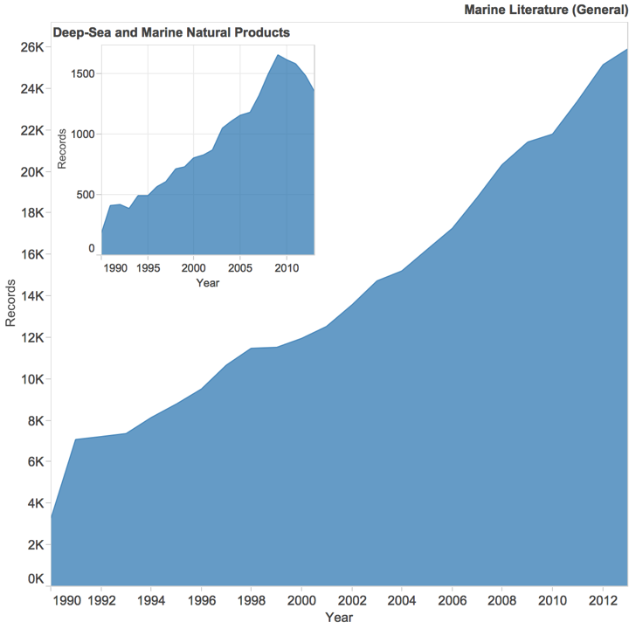

Figure 3.1: Trends in Marine Scientific Literature

This data can be further broken down into the Subject Categories used by Web of Science to categorise journals. Figure 3.2 shows the top journal subject categories across the dataset of 24,259 publications (inset) and trends in publications in journal categories linked to marine genetic resources and economic value.

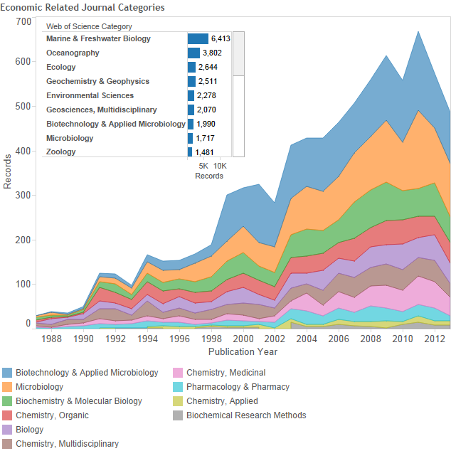

Figure 3.2: Trends by Journal Subject Category

This data appears to support the argument that there is an increasing interest in deep-sea marine related genetic resources within journals addressing biotechnology and applied microbiology along with microbiology and biochemistry and molecular biology. However, it is important to note that we are not in a position to directly confirm this through the analysis of deep-sea species appearing in the data.

Figure 3.3 displays the top countries with authors involved in publications including members of the European Union across the Web of Science dataset. To confirm these findings we also display the country rankings for a second dataset of 7,459 publications in two main deep-sea research journals known as Deep-Sea Research Part I–Oceanographic Research Papers and Deep-Sea Research Part II–Topical Studies in Oceanography published between 1979 and early 2014.

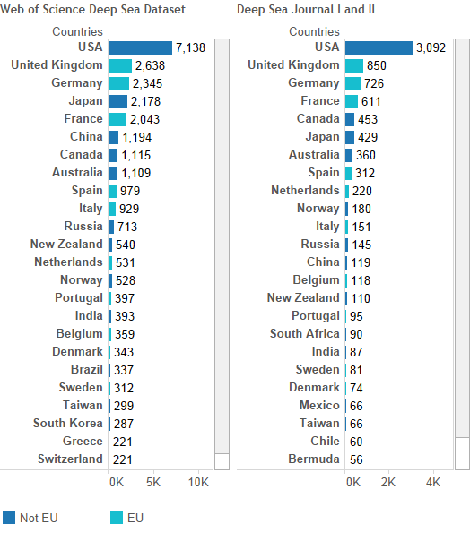

Figure 3.3 Top Countries in Deep-Sea and Marine Natural Products Research (Publication Counts)

Figure 3.3 demonstrates that the UK ranks second in our publication data after the United States and is the top ranking country for scientific publications in the European Union across both datasets. The importance of research published by researchers from EU member states is apparent in both cases with Japan, Canada, China, Australia and the Russian Federation also prominent in the data. The presence of India and Brazil is notable in the main dataset with South Africa also emerging in the top 25 in the Deep-Sea Research journals.

3.3 Research Collaboration and Funding

In practice, researchers increasingly work in networks characterised by collaboration between researchers from multiple countries. This reflects the international nature of modern scientific research and trends towards training and knowledge exchange between countries. The existence of such networks is likely to be particularly important in deep-sea research in ABNJ due to limitations in access to technologies such as ships, submersibles, remote and autonomously operated vehicles, sea-floor observatories and specialised laboratory equipment. Figure 3.4 provides a network map showing the main linkages between researchers by country based on co-publications.

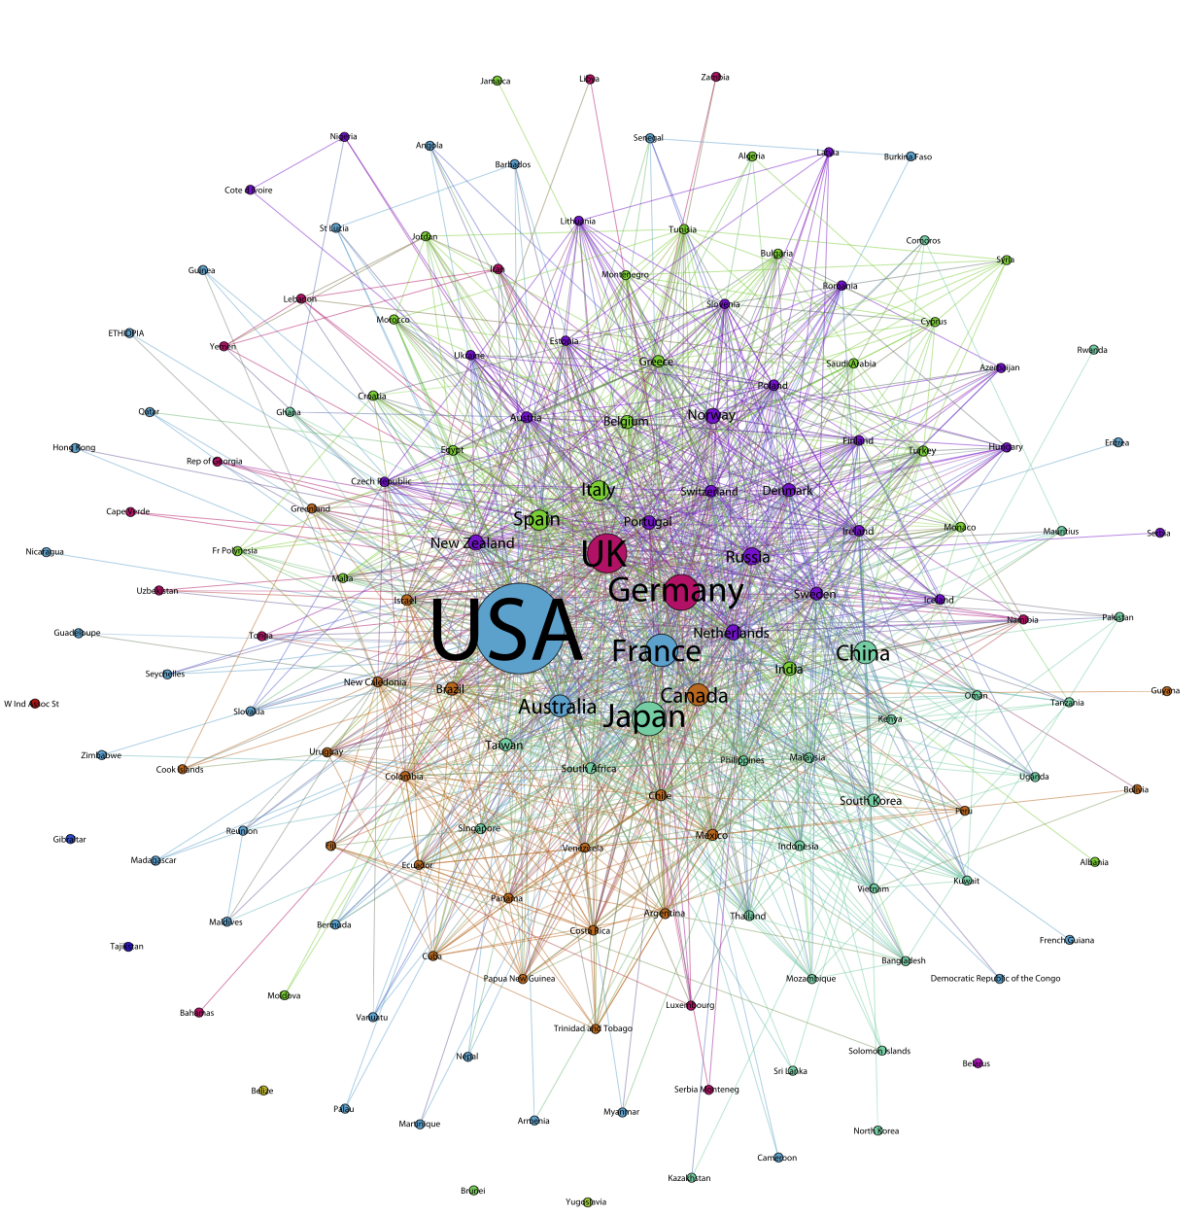

Figure 3.4: Cross-country Collaboration Network (Author country)

In the case of the UK, researchers have collaborated in publications with other researchers from a total of 97 countries. The top countries with which UK researchers collaborate are the USA, Germany, France, Australia, Canada, Spain, Portugal, Norway and the Netherlands. However, increasing regular collaboration with China is observed from 2008 onwards (41 publications), with Brazil from 2004 onwards (18 records) and South Africa from 2008 onwards (15 records). In addition significant collaboration is observed with researchers in Mexico (20), Chile (19), India (13), Malaysia (10), Panama (10), and Indonesia (9).

What is significant about this network of relations between researchers is that it reflects underlying investments by countries in the development of marine research capacity and collaborations. It is not presently possible to readily identify levels of investment in research and this remains a topic for future research. However, it is possible to gain an insight into some of the key agencies involved in supporting deep-sea related research. Figure 3.5 presents a network map of the top funding agencies for the overall marine dataset. Note that funding information is mainly confined to records published after 2008 and covers only 24% of the data. The acronym US NSF at the centre of Figure 3.5 stands for United States National Science Foundation.

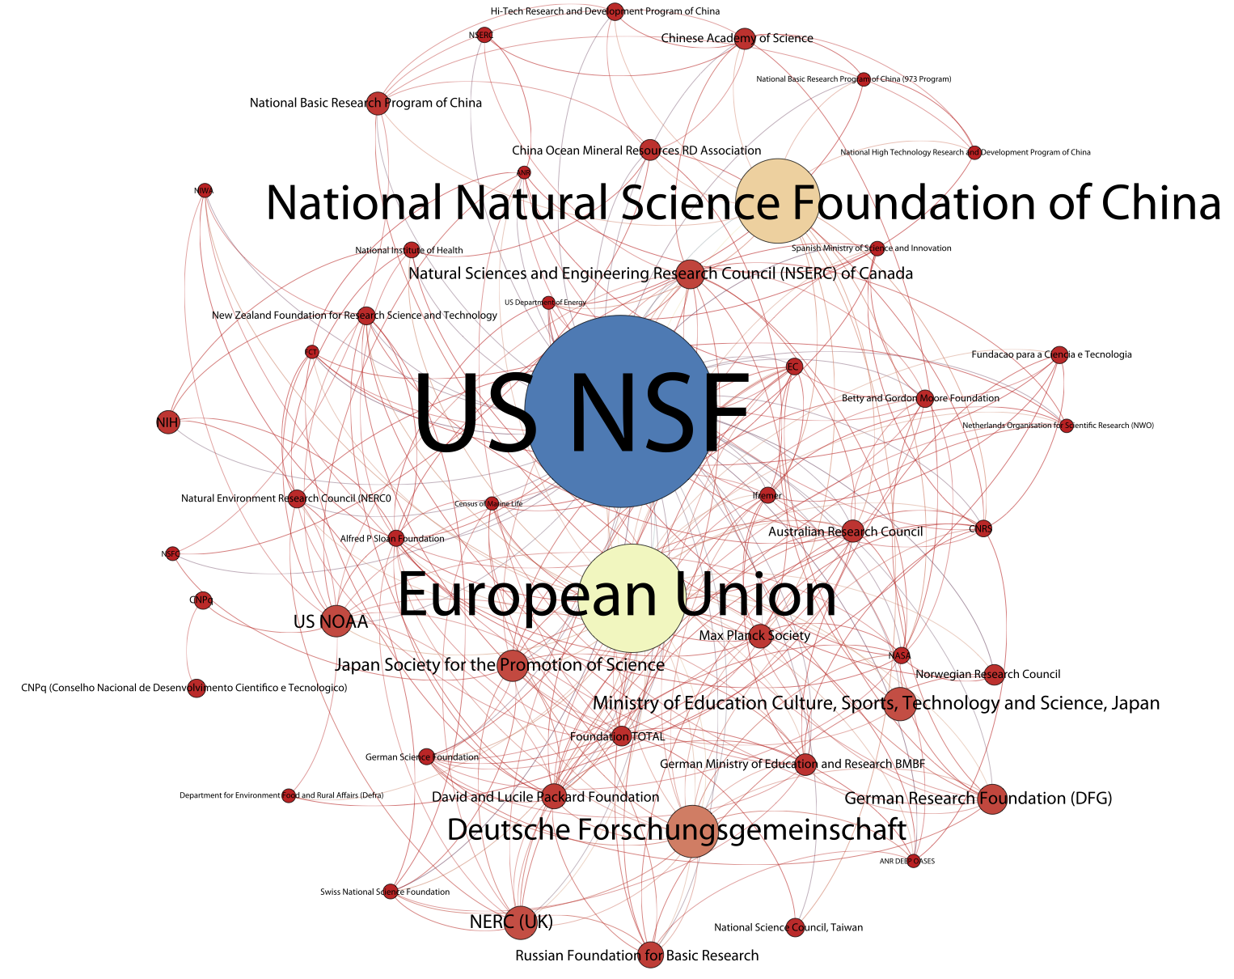

Figure 3.5: Funding Organisation Network Deep-Sea and Marine Natural Products Research

The visualization of this type of network is important because it reveals the main actors involved in funding deep-sea related research and the connections between funding agencies at the level of published outputs.

In debates on access to genetic resources and benefit-sharing this form of network analysis is relevant because the published outputs of deep-sea research ultimately reflect decision making on financial investments in research. It is here also that what may be considered as non-monetary benefits in the form of research collaborations, training, sharing equipment etc. begin to become evident.

In considering these networks, one possibility to develop benefit-sharing may be to promote greater communication and/or coordination between funding agencies in supporting deep-sea research to avoid unnecessary duplication of effort and also to promote collaboration between researchers in a number of countries. In international terms, across all areas of research, the European Framework Programmes (presently Horizon 2020) that finance consortiums of researchers from EU member states and other countries is probably the single most important example of this type of collaborative experience. One aspect of a potential implementing agreement on access and benefit-sharing in relation to deep-sea research and marine genetic-resources could be strengthened communication and coordination in research funding and establishing research priorities with the participation of deep-sea researchers. Further details on possible components of this idea are provided in the review of expert perspectives in chapter 7. Figure 3.6 presents the top ranking organisations involved in publications displaying the overall rankings and top UK organisations appearing in the data.

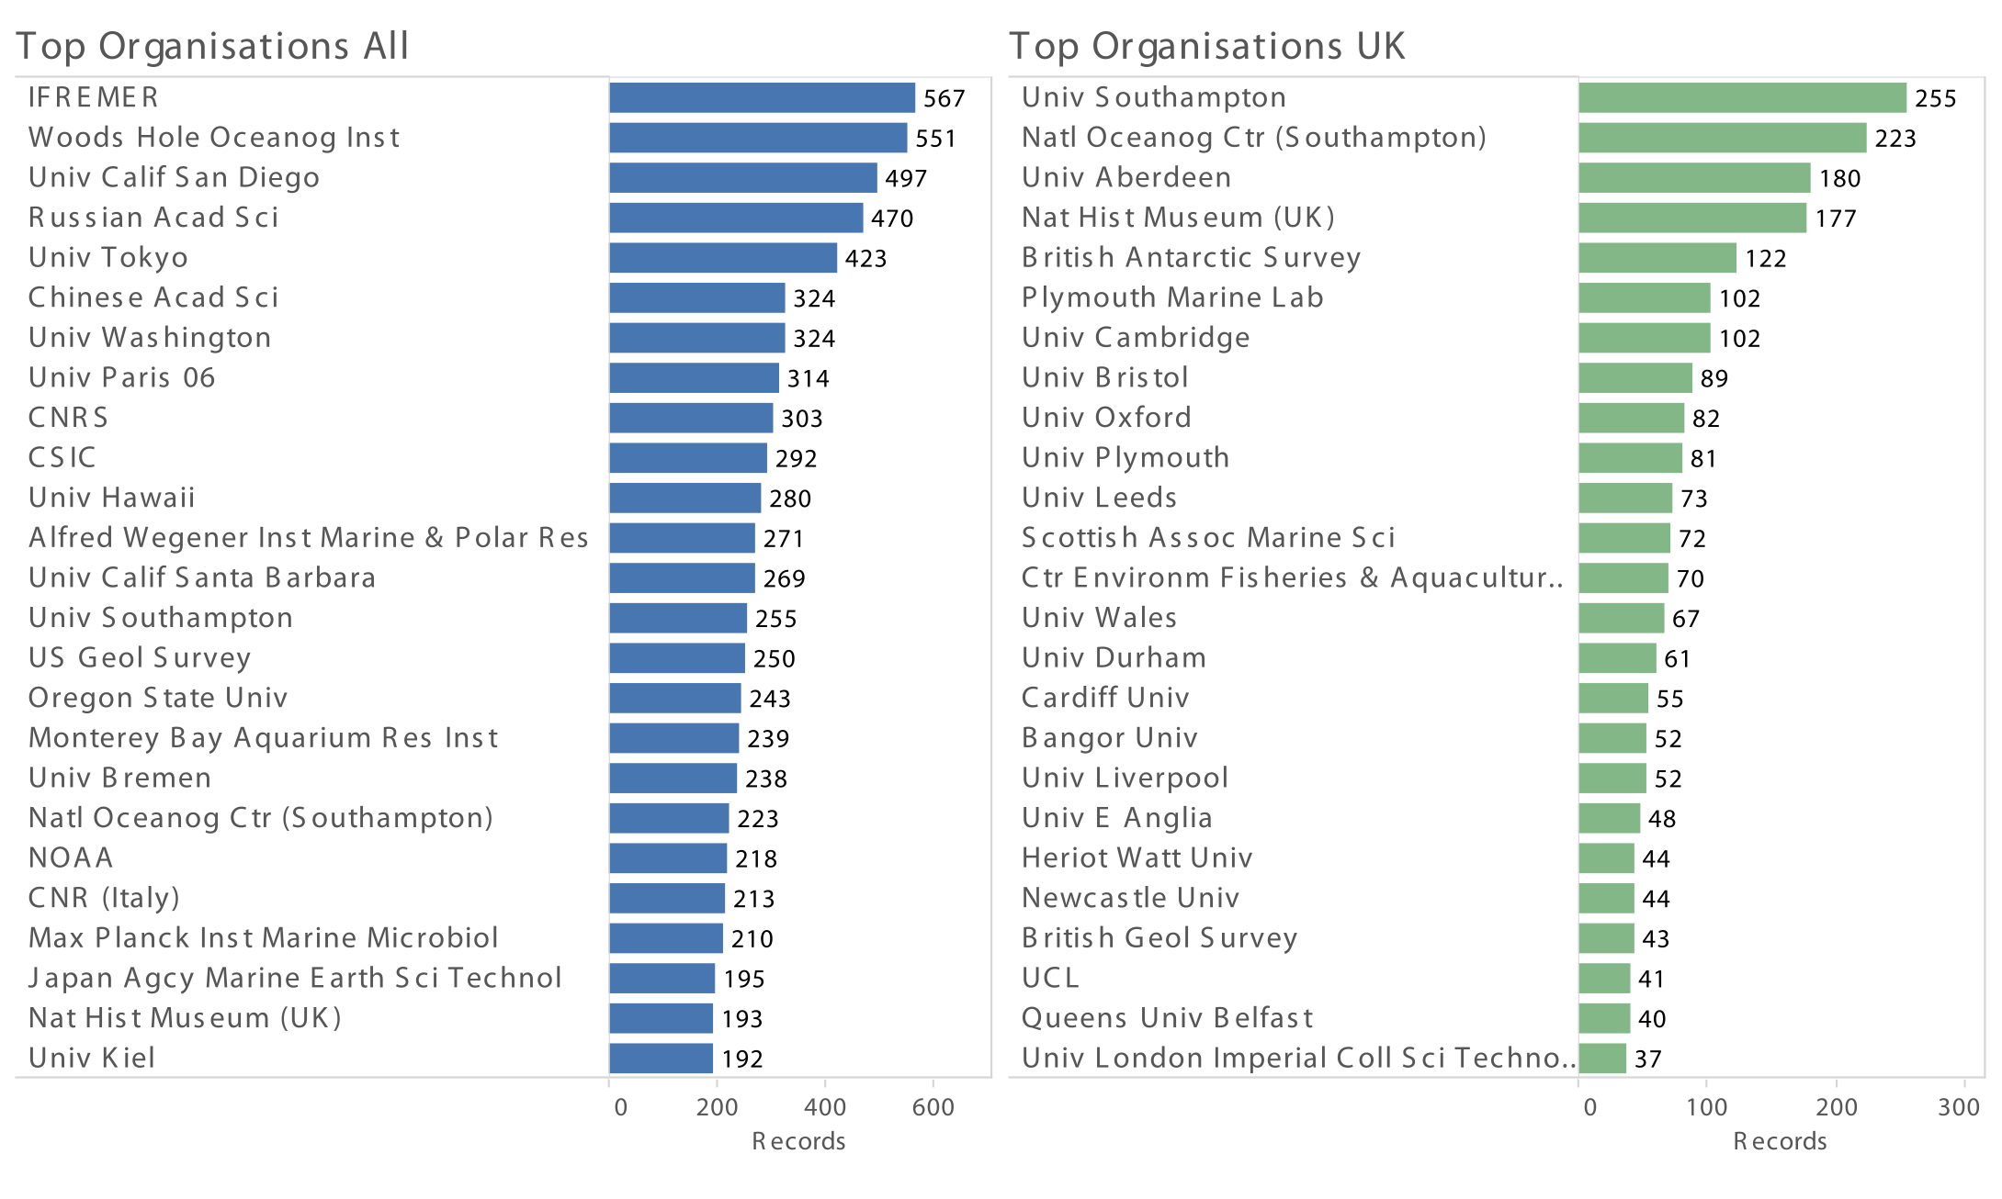

Figure 3.6: Top Research Organisations (Publication Counts)

In considering Figure 3.6 note that author organisations have been subjected to basic cleaning to capture name variants. In the overall data we can clearly see the presence of the University of Southampton, the National Oceanography Centre (Southampton), and the UK Natural History Museum in the top rankings. The UK appears prominently in global scientific publications relating to deep-sea research. This profile will reflect levels of funding for deep-sea research in the UK and the publication culture in UK research organisations.

The top organisations with whom UK researchers collaborate elsewhere in the world include IFREMER (France), the Woods Hole Oceanographic Institute (USA), researchers at CSIC centres in Spain, the Russian Academy of Sciences, the University of Paris 6 and the University of the Azores (Portugal) among other institutions in 97 countries.

We now turn to research most closely associated with genetic resources and research and development related to potential commercial products. The journal subject categories identified in Figure 3.6 (above) provide a basic rough guide to research publications with potential economic value.[14] The top ranking organisations include IFREMER, the University of California in San Diego, the Chinese Academy of Science, the Russian Academy of Science and CNRS (France). No UK organisation features in the top 20 for research publications in these categories with the University of Aberdeen and the University of Southampton emerging as the top UK organisations in the global rankings.[15] Within the data for the UK, the top organisations in these areas are the University of Aberdeen, and the Universities of Southampton, Bristol, Oxford, Kent, Newcastle and the British Antarctic Survey. However, this picture shifts depending on the subject category. For example, Heriot Watt University and the University of Stirling appear with greater prominence in the data for Biotechnology and Applied Microbiology while the Universities of Cambridge and London come increasingly to the fore in Chemistry subject categories.

3.4 Research Topics and Locations

An insight into the orientation of research can be provided by reviewing the top terms that appear in the title, abstracts or author keywords within the reference dataset. At the outset we would note that the presentation of the data is affected by our original choices of key words in performing the searches notably “deep-sea”, “marine natural products”, “hydrothermal vent” and “marine biodiversity” with a full list provided in Annex 1. Figure 3.7 provides a list of the top multi-word phrases in the data and the same data for UK related publications.

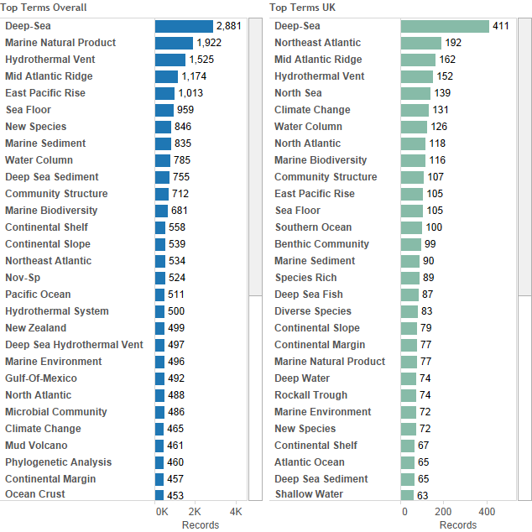

Figure 3.7: Top Terms and Phrases in the Scientific Literature

What is striking in Figure 3.7 is not the prominence of terms such as deep-sea or marine natural products that were introduced by our search criteria but the references to places. That is, this data highlights that researchers are concentrating in particular areas. In the case of the Mid-Atlantic Ridge, East Pacific Rise or Gulf of Mexico this is likely to involve specifics sites (e.g. the Lucky Strike Vent Field on the Mid-Atlantic Ridge). In other cases more general references are made to major oceans, or geographic sections of major oceans. In practice, we suspect, but cannot presently confirm, that further investigation would reveal clusters of research activity around specific places (e.g. the Juan de Fuca Ridge, Guaymas Basin) that would reveal that research effort is not evenly distributed but highly concentrated around specific places. Figure 3.8 displays the same data using the centre of geographical coordinates for large geographical features.

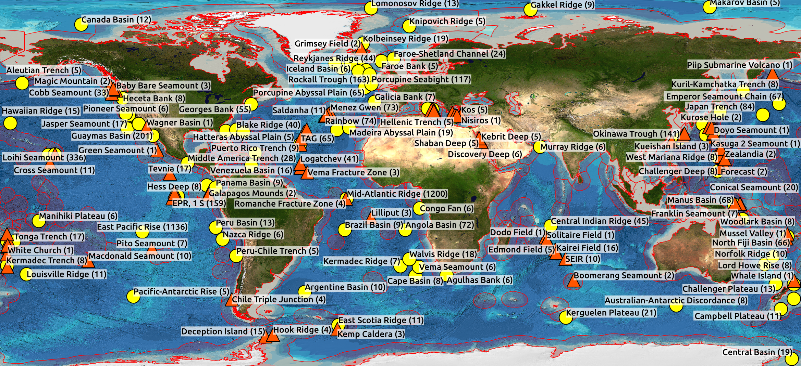

Figure 3.8: Global Concentration of Research Effort in the Deep-Sea

This tendency towards clustering arises because known sites rich in biodiversity are more likely to yield results, produce useful publications and attract more research funding, and because longitudinal studies at the same sites are important in understanding topics such as community structure, succession and environmental impacts over time. However, these same factors will favour charismatic locations, such as hydrothermal vents, and mitigate against wider exploration of unpromising or high-risk areas such as the abyssal plain (see below).

In the case of UK research within our data, the Atlantic, the Mid-Atlantic Ridge and the North Sea feature prominently as does the East Pacific Rise, presumably as a feature of research collaborations with researchers in the United States. Closer to the UK the Rockall Trough (also known as the Rockall Basin) also features prominently compared with the overall data.

In practice the available data suggests that researchers will concentrate research effort in specific areas and that these areas will logically be those that are in practical terms, the easiest to access on a regular basis. Furthermore, as in the case of UK activity at the East Pacific Rise, international research collaborations will be important, such as with the Woods Hole Oceanographic Institute. In other cases, such as the Southern Ocean, UK capacity in the form of the British Antarctic Survey is joined with capacity elsewhere in Europe, such as the Wegener Institute operating the ship Polarstem, or facilitates research by other researchers from institutions such as the University of Hamburg (Germany) or Ghent (Belgium). That is, international collaboration is of key importance in the planning and realisation of deep-sea marine research but deep-sea research tends to cluster around certain locations.

3.5 Conclusions

This chapter has focused on examining trends in marine scientific research in the deep-sea and trends in marine natural products research using a sample of over 24,000 marine scientific publications on the deep-sea and natural products as a guide. A number of observations can now be made regarding the characteristics of marine research in the deep-sea and Areas Beyond National Jurisdiction in connection with a potential implementing agreement within the framework of UNCLOS on access and benefit-sharing. These are as follows:

1. The available data strongly suggests that marine research in deep-sea locations is concentrated inside the EEZ and a more limited number of locations in Areas Beyond National Jurisdiction, notably the East Pacific Rise and Mid-Atlantic Ridge. The latter are large geographical features and further work is desirable to refine location analysis;

2. We believe that research will tend to concentrate in specific locations associated with research success (notably publications) at the expense of expansion into new areas in the absence of other incentives for expansion of research areas;

3. Strict regulations on access to genetic resources in Areas Beyond National Jurisdiction could promote research inside the EEZ at the expense of the expansion of research in Areas Beyond National Jurisdiction. This suggests that any access regulations for marine scientific research on genetic resources, as opposed to fishing or extractive industrial activity, should be light touch;

3. International collaboration between research teams and countries with deep-sea infrastructure is a key enabling feature of deep-sea research because of the complexities and costs involved. This suggests a need for greater cooperation and coordination between research teams from different countries as a key means of generating long term benefits for research under any implementing agreement on access and benefit-sharing;

4. The UK is a top ranking country for deep-sea research but is markedly less prominent in applied commercially oriented research in our data;

5. Research participation is a key benefit as is access to data. This area could be strengthened based on existing practices and proposals from the deep-sea research community;

6. The hidden network of cooperation between funding agencies supporting deep-sea research suggests a need for greater communication and coordination such as the creation of a possible road map for research in Areas Beyond National Jurisdiction in consultation with the deep-sea research community (see chapter 7);

7. Consideration should be given to a funding mechanism for ‘risky’ research ventures that provides incentives for exploratory research beyond existing areas of research concentration. Risky in this context does not mean physically dangerous but means dangerous for researchers in career terms based on publications and the ability to attract research funding.

4. Deep-Sea Species in the Patent System

4.1 Introduction

Patents provide an important indicator of research and development directed towards commercial applications and products that involve genetic resources. Patent activity for marine genetic resources has received significant attention within existing reports on the deep-sea and the scientific literature [1-5]. For example, using sequence data from the patent division of GenBank, Arrieta, Arnaud-Haond and Duarte (2010) estimate that “Since 1999, the number of marine species with genes associated with patents has been increasing at an impressive rate of about 12% species per year, which is more than 10 times faster than the rate of description of marine species” (Arrieta *et al*., 2010: 18319). In particular, the research identified non-redundant marine gene sequences from 558 distinct marine species in the sequence deposit for patent data at GenBank (Arrieta *et al*., 2010: 18319). In subsequent work the same research team focused on international patent activity at the World Intellectual Property Organization and identified 677 international claims for marine gene patents involving 520 species between 1991-2009 [4].

Existing research strongly suggests a growing interest in marine genetic resources [4]. As the quotes from participants in the *Valuing the Deep* Delphi study in chapter 7 highlight, for some experts patent activity can lead to a perception of a gold rush requiring urgent action. However, other experts take a more reflective stance recognising issues such as the distribution of organisms both in the deep-sea in Areas Beyond National Jurisdiction (ABNJ) and terrestrial environments.

We set out to address three main issues as a contribution to advancing knowledge and understanding of patent activity for marine genetic resources:

a) Clarifying the scale of patent activity for marine genetic resources in general using large scale text mining, and;

b) Establishing whether organisms appearing in patent documents are likely to originate from inside or outside Exclusive Economic Zones;

c) Investigating references to the origins or sources of species inside or outside the EEZ within patent documents.

In this chapter we address the first two issues and we consider the question of the origins or sources of species in the next chapter. To address the first two issues we used a combination of large-scale text mining of patent data from the main jurisdictions for references to marine organisms and mapping of the known occurrences of marine species inside or outside the EEZ and by pelagic zones in the water column.

We identified 4,759 marine species names in 61,045 patent publications from the main jurisdictions originating from 23,091 patent families (first filings) and linked to 250,309 family members world-wide. We identified a clear increase in first filings of patent applications (families) referencing marine organisms in the late 1990s with activity stabilising at approximately +/- 1500 new filings per year at the major offices between 2006 and 2010. Of these, 3,566 patent families (first filings) contained references to 2,714 marine organisms in the Title, Abstract or Claims indicating that the inventions are in some fundamental sense about the marine organism. While the number of first filings of new patent applications referencing marine species is relatively stable, trends in global demand for protection of inventions referencing marine species display a steep increase. This reflects the increasing willingness of applicants to pay to pursue protection for these inventions in multiple countries and the globalisation of demand for patent protection referencing marine species.

In conducting the research we used validated marine species names from the World Register of Marine Species (WoRMS). However, species may be found in terrestrial, terrestrial aquatic and marine environments. As such, species are not constrained by our expectations of where they should be occurring. Thus, top ranking marine species appearing in patent data include fungi that are more likely to originate from terrestrial environments but are also known to exist in marine environments. Furthermore, in some cases species that feature prominently in marine data and existing literature on the deep-sea, such as *Sulfolobus solfataricus*, were in fact originally isolated from terrestrial or terrestrial aquatic environments. The cosmopolitan nature of some species, including from deep-sea environments, complicates the ability to accurately analyse and assess patent activity involving marine organisms in general and deep-sea species in particular.

We used data on the known distribution of species and depth data from the Global Biodiversity Information Facility (GBIF) and the Ocean Biogeographic Information System (OBIS) to identify the location of species inside or outside the EEZ. We identified 1,800 marine species that are referenced in patent data that exist in Areas Beyond National Jurisdiction (ABNJ). A rising trend is observable in filings from the late 1990s with 369 filings records in 1999 rising to a peak of 731 filings in 2009 before declining to 643 in 2010.

Based on available taxonomic information, species are predominantly distributed inside the EEZ including at depths below 200 metres. Approximately 1,800 species were identified as occurring outside the EEZ. Only 42 of these species were identified as only occurring outside the EEZ. Available depth data suggests that species from the epipelagic zone are dominant (1,461 species) with 339 species recorded in the deep-sea zone below 200 metres outside the EEZ. However, because depth data is limited for certain kingdoms of organisms, notably bacteria and archaea, this data will underestimate species occurring in patents from the deep-sea zone below 200 metres. As such we do not presently regard the division of the data by depth as sufficiently robust. Rather, this highlights the need for greater attention to providing sample depth data across kingdoms in taxonomic databases and consultation with the research community to facilitate evidence based decision-making.

4.2 Methodology

We used the World Register of Marine Species (WoRMS) database of 402,540 species names, combined with the subsidiary World Register of Deep Sea Species (WoRDSS) as the taxonomic backbone for our research. Using advanced pattern matching techniques described in previous research we text mined 14,038,743 full text patents from the European Patent Office, the United States Patent and Trademark Office (USPTO) and the international Patent Cooperation Treaty (PCT) between 1976-2013 for species names from WoRMS and WoRDSS [6]. This allowed for the identification of species by document section such as the title, the abstract, description or the claims. The results from the text mining were then federated with the EPO World Patent Statistical Database (PATSTAT, October 2013 edition) for the development of statistics, identification of applicants and technology areas etc.

The results were federated with available occurrence data and depth data from GBIF and OBIS to facilitate geographic mapping and analysis by depth in the water column. We used the marine mark up in GBIF to validate marine species data. Species not identified as marine in GBIF but appearing in WoRMS were manually reviewed.

One of the key issues we sought to address was the availability of information on the geographic distribution of species. Data on geographic distribution in GBIF takes two main forms and it is important to understand the differences between them:

a) Geocoded coordinate data displaying the latitude and longitude for a known occurrence of a species;

b) General distribution data simply ascribing a record to one or more countries.

In addition, some of the marine data carries depth information for samples. However, the availability of depth data is variable and may be recorded as null or as zero. Figure 4.1 displays the results by kingdom and species counts for available data from GBIF and OBIS.

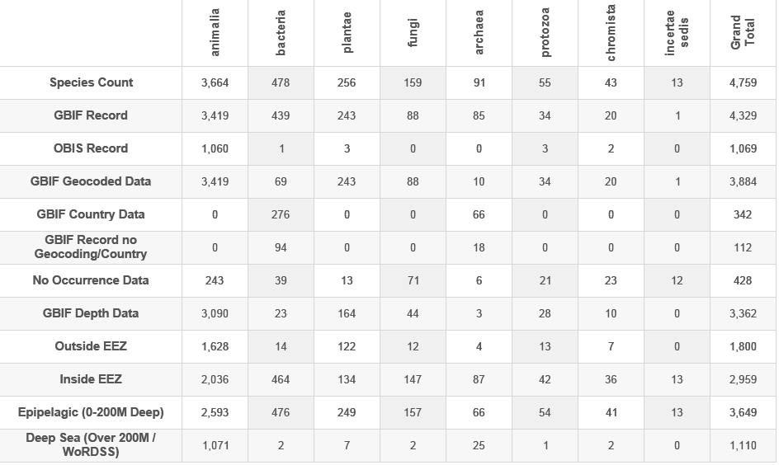

Figure 4.1: Species Appearing in Patents By Occurrence Data

In considering Figure 4.1 note that geocoded and distribution records vary across the major kingdoms. Furthermore, the availability of depth records also varies. The most significant variations in our view are for bacteria where geocoded data is limited as is depth data. This signifies that the bulk of bacteria will be allocated inside the EEZ based on the availability of geocoded and distribution data. Bacteria will also be allocated to shallower waters in the water column. Given the focus in the literature on the potential economic value of enzymes or compounds from bacteria and archaea from outside the EEZ and at deep sites such as hydrothermal vents, this presents a challenge. That is, until such time that more geocoded and depth data becomes available, the ability to identify bacteria and archaea according to their status inside the EEZ or in ABNJ will remain limited.

Figures 4.2A and 4.2B present a summary of the results divided by whether a species occurs inside or outside the EEZ. Note that a species may occur both inside and outside the EEZ.

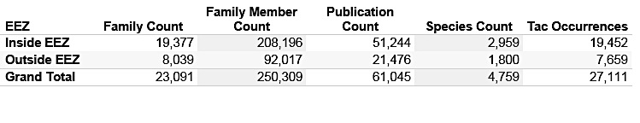

Figure 4.2A: Marine Species Appearing in Patent Documents

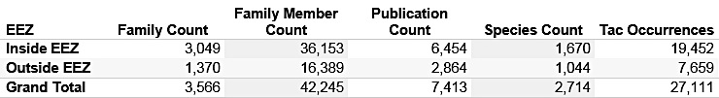

Figure 4.2B: Marine Species Appearing Only in the Title, Abstract or Claims

In later steps the raw data containing species names was searched for place and habitat names derived from analysis of the keywords and phrases from 484,999 words and phrases in the scientific literature (see chapter 3). This was followed by a search using the *General Bathymetric Chart of the Oceans Gazetteer* (GEBCO Gazetteer) of 3,762 undersea feature names and complemented by a search for the names of known hydrothermal vents using the InterRidge Vents database.[16]

To identify species that may not have been taxonomically described except through comparison with known sequences, additional searches were performed for references to 16S rDNA related terms in 1,455 documents containing references to a marine species. References to marine species in PCT applications containing a sequence listing were reviewed based on data provided by WIPO. The patent datasets of full texts were manually reviewed based on the intersections between species names, habitats, places and references to new or novel strains and new species and allocated weight scores. The results of this research are reported in chapter 5.

4.3 Trends in Patent Activity

In total we identified 4,759 Latin species names for marine species, including variant names, which resolved to 4,461 taxonomically accepted names based on GBIF data. Marine species appeared in 61,045 publications originating from 23,091 first filings and linked to approximately 250,309 family members worldwide.

The first and basic question that we can address in this data is whether in general terms references to marine species are increasing in the patent system. Secondly, we can identify patent trends based on whether these species are known to occur inside or outside the EEZ.

Patent data can be counted in a number of ways. Counts of *patent families* refer to counts of the first filings of a patent application anywhere in the world using the standard international INPADOC system. Counts of patent families have the advantage of counting a claimed invention only once and thus provide an indicator of innovative activity. However, because patent data only becomes available when an application is published – up to 2 years after filing – counts of patent families rapidly decline the closer we move to the present due to data availability issues. This produces a data cliff in patent statistics (see below). In the present research we regard the data on patent families to be robust until 2010 with data availability degrading from 2010 onwards in the October 2013 edition of PATSTAT.

In contrast, counts of *publications* refer to publications of applications and grants. These are confined to the three main jurisdictions covered by the research but are useful for mapping trends in applications and grants. Counts of *family members* refer to counts of all patent publications around the world that link back to a first filing as its parent or “priority”. Counts of family members are an indicator of global demand for patent rights that reference marine species.

Figure 4.3 displays trends in patent activity for documents referencing the 4,759 species in our data.

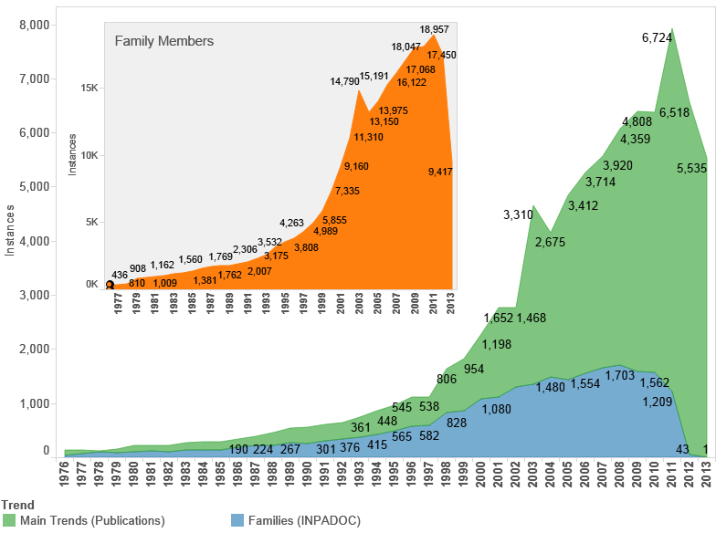

Figure 4.3: Trends in Patent Activity Referencing Marine Organisms

When approached from the bottom up, by focusing on patent families we can observe a steady rise from 2000 onwards with a peak of 1,645 filings in 2008. In the wake of the global financial crisis a temporary downturn was observed in patent filings in general and this is likely to be reflected in data for 2009–2010. Data from 2011 onwards will be affected by a lack of data arising from the delay in the publication of patent documents.

Trends based on publications display a steep increase that can be accounted for in two main ways. First, patent applications are typically published once as a patent application and also, if they meet the criteria, as a patent grant in one or more countries where the application is pursued. This introduces a multiplier effect into the data. Patent publication data also lags behind family count data because a document is published at least 2 years after filing. Second, prior to 2001 the United States Patent and Trademark Office (USPTO) only published granted patents. From 2001 the USPTO began publishing patent applications. This introduces a radical spike for 2001–2002 across patent statistics but is a reporting effect rather than a reflection of increased filings. In the case of increasing trends in publications after the decline of filings in 2008 this is likely to reflect the continued pursuit of patent rights by applicants where a filing had already been made. The data is also likely to be affected by repeat filings of variations of original filings (divisional or continuation filings) that enhance the multiplier effect. Data on global family members reflects global trends.

As this makes clear, there is a need for care in interpreting patent statistics. However, Figure 4.3 reveals that patent activity making reference to marine species measured on first filings has increased over the last decade but is not, as a measure of innovation, showing an exponential increase. In common with other areas of patent activity, patents referencing marine species was affected by the global financial crisis. However, trends based on patent publication counts in the main jurisdictions and global family members strongly suggest increasing demand for patent protection referencing marine species in multiple countries. This is significant because while first filings may be relatively stable, applicants are increasingly pursuing protection in multiple countries around the world. That is, they are willing to pay for protection in multiple markets based on the expectation of future income from products or the licensing of intellectual property [7].

Figure 4.4 displays levels of activity for the main patent offices based on the types of document for the European Patent Office, the United States Patent and Trademark Office and the Patent Cooperation Treaty.

In interpreting Figure 4.4 note that prior to 2001 the United States only published patent documents at the grant stage. For this reason applications only appear from 2001 onwards. In contrast, the Patent Cooperation Treaty does not award patent grants, which are awarded by national offices, and therefore the data is confined to patent applications.[17]

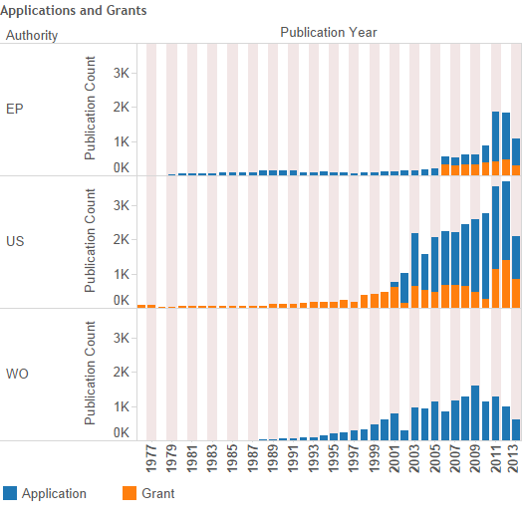

Figure 4.4: Trends in Applications and Grants Referencing Marine Species at the Major Offices

Figure 4.5 displays the top marine species appearing in patent documents. In approaching Figure 4.5 it is important to note that some species, notably fungi such as *Aureobasidium pullulans* and *Aspergillus terreus*, are cosmopolitan and distributed across multiple habitats. These species will therefore often appear at the top of the rankings. In other cases, such as *Thermotoga maritima*, members of Thermus and Thermococcus, a species may be found both in terrestrial hot springs and at hydrothermal vents. This may also hold true for less well known species isolated from core samples from marine ocean sediments or oceanic crust and those taken from oil wells or mines in terrestrial environments. In short, it is important to recognise that organisms, notably fungi and bacteria, may be distributed across multiple environments and a marine origin cannot simply be assumed. Lack of clarity on this issue can also introduce inadvertent errors into the literature on ABNJ. For example, *Thermus aquaticus, Thermoplasma acidophilum* and *Sulfolobus solfataricus* have been described as deep-sea marine species in the literature but were first recorded in terrestrial environments (see below). Conversely, while much attention in marine scientific research has focused on bacteria and archaea it is important to recognise that fungi are important in marine environments, including the sub-sea floor [8-10].

Figure 4.5 also displays counts of the number of times that a Latin species name occurs in the Title, Abstract or Claims section of a patent document (TAC Occurrences). Whereas references to a marine species in a patent document may take the form of a passing or casual reference, the appearance of a species in either the Title, Abstract or Claims strongly suggests that the patent document is fundamentally about material from this species or, in the case of a pathogen, is targeting this species. As we will see below, in other cases such as fish vaccines or fish feed, applicants may provide long lists of species in the patent claims where the invention can be applied in aquaculture.

Important species in Figure 4.5 include the jellyfish *Aequorea victoria* and the sea pansy *Renilla reniformis* as sources of Green Fluorescent Protein (GFP) that is widely used as a marker for reporting the expression of a desired outcome in genetic engineering and emerging areas of science and technology such as synthetic biology.

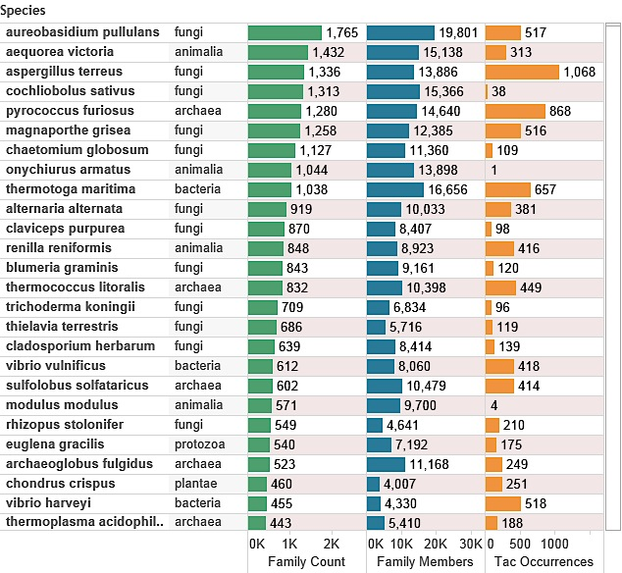

Figure 4.5: Top Species (all marine organisms)

In these cases, the discovery and development of Green Fluorescent Protein led to the joint award of the 2008 Nobel Prize in Chemistry to three researchers [11]. However, Green Fluorescent Protein is routinely produced in hosts such as *E. coli* and is not associated with repeated collection of the original organisms. A second major area reflected in Figure 4.5 are thermostable enzymes represented by *Pyrococcus furiosus* and *Thermococcus litoralis*. Both organisms possess enzymes that can be used in Polymerase Chain Reaction (PCR) for the transformation (amplification) of small samples of DNA into larger samples of identical DNA. PCR is most closely associated with the thermophilic bacterium *Thermus aquaticus*, originally isolated from Mushroom Pool in Yellowstone National Park. Until it was invalidated in 2004 the key patent protecting Taq DNA Polymerase was widely criticised for creating high costs for researchers and contributed to the development of guidelines on research tools by the National Institutes of Health (see below) [12]. In part, interest in other extremophile organisms from areas such as hydrothermal vents appears to have been spurred by growing interest in industrial enzymes and the quest to find alternatives to Taq DNA polymerase.

Figure 4.6 displays the top applicants that make reference to a marine species. The top-ranking applicant (based on the number of families) is Bayer Cropscience. However, it is here also that issues arise with the distribution of species. Thus, Bayer Cropscience records focus on fungi. While these species have been verified as marine species within WoRMS, and may include specialist marine strains, we anticipate that in many cases the species will be cosmopolitan and distributed in both terrestrial and marine environments. In short, species are under no obligation to comply with the neat categories into which we might choose to place them. As such, we need to bear in mind that marine species that appear in patent data may be located across multiple environments. As discussed below, uncertainty about the precise source of species also raises issues about the potential desirability of improved disclosure of geographic origin within patent applications.

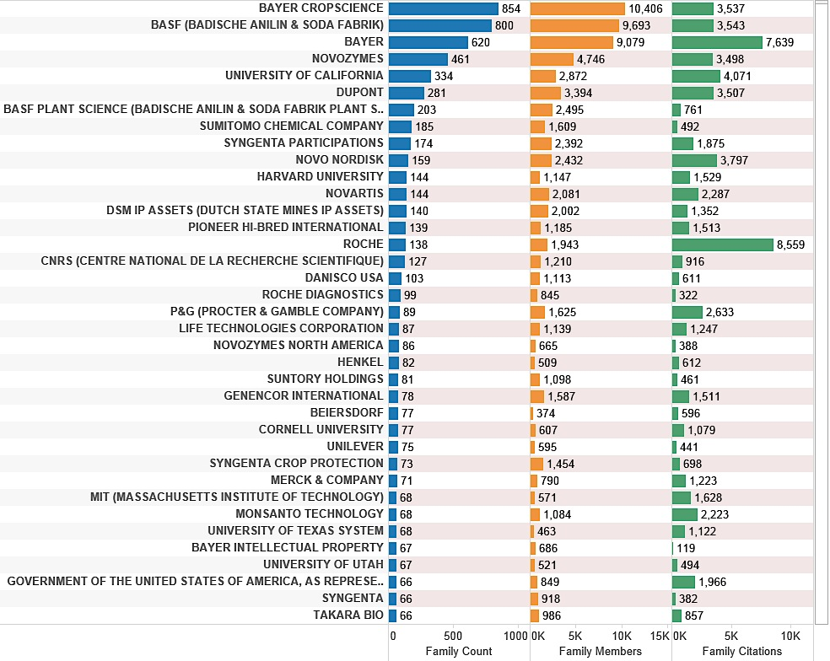

Figure 4.6: Top Applicants Referencing Marine Species Ranked on Family Count

This data raises the question of how to obtain a more accurate view of patent activity for marine species with a particular focus on the deep-sea.

4.4 Identifying Species from the Deep-Sea

To address the identification of species in patents by depth we used the available depth data from GBIF and OBIS to cluster the species by pelagic zones within the water column. Following experimentation with using latitude and longitude for mapping the occurrences of species inside and outside the EEZ within patent data we settled on the use of the country field in GBIF records to establish whether a species had been assigned to a country or occurs outside national jurisdiction. This was then cross-tested using actual coordinate data to test for the accuracy of GBIF country coding. Cross-testing revealed that GBIF coding is accurate but that actual coordinate data improves accuracy. We use the GBIF coding here because it is generally robust and provides a simpler method than the use of millions of coordinate records.

For the purpose of the clustering we divided the data into the epipelagic zone (0-200 metres in depth) and the deep-sea zone (pelagic zones below 200 metres in depth). Figure 4.7 displays the percentage of species records with depth data in GBIF where No refers to GBIF records with a null value, Zero is records assumed to be taken at sea level and Yes refers to actual depth records. In total 3,129 species possessed some form of depth record and 808 lacked a depth value representing 16.98% of the data. We also assume that depth values entered as zero will also in some cases be default values where no depth data is available. We also identified false positives in the data such as the extremely unlikely occurrence of a Tiger shark (*Galeocerdo cuvier*) in the Hadopelagic zone at 8,290 metres. At the time of writing the deepest recorded fish is *Pseudoliparis amblystomopsis* first identified in 1955 and recently documented at 7,700 m by a joint UK and Japanese team [13].

To supplement the data on deep-sea species we added records from the World Registry of Deep-sea Species (WoRDSS) and for the genus Thermococcus.[18] This added 36 species and 10% to the total number of identified deep-sea species. As this suggests, analysis of species by depth is constrained both by the *availability* of depth data and the *accuracy* of depth data. With the exception of the obvious false positive above we are obliged to accept the accuracy of depth data provided in the taxonomic record while recognising that this merits further work in collaboration with GBIF and the taxonomic community.

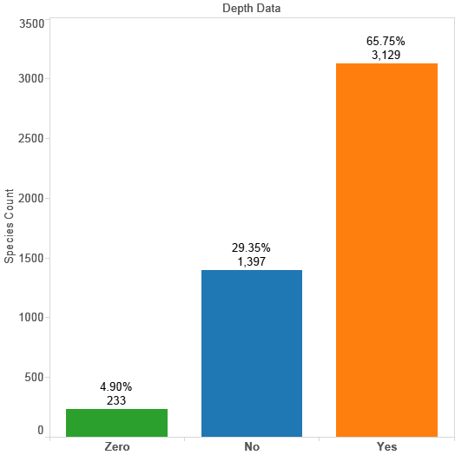

Figure 4.7: Depth Records for Marine Species in GBIF

Taking these data limitations into account, Figure 4.8 (see inset) demonstrates that the majority of species that appear in patent documents are from the epipelagic zone inside the EEZ and that the majority of deep-sea species also occur inside the EEZ. This pattern is repeated in Figure 4.8 based on counts of patent families (first filings). We use counts of patent families because it counts a claimed invention only once and therefore provides a more accurate measure of innovative activity than counts of later publications of the same application.

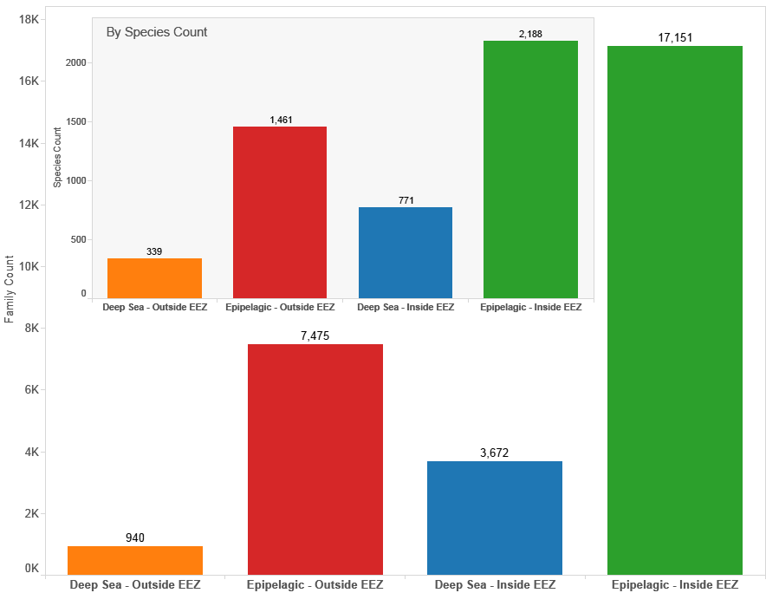

Figure 4.8: Species and Patent Data by Geographic & Depth Zone

Figure 4.9 displays the same data but confines the results to cases where a species name appears in the titles, abstracts or claims of patent documents. This data provides an insight into claimed inventions that are in some sense fundamentally about marine species. This reveals that 1,174 species appear in the title, abstract or claims for species inside the EEZ and 704 from outside the EEZ.

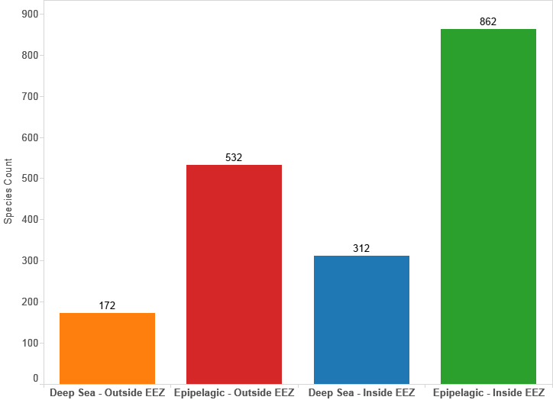

Figure 4.9: Species and Patent Data by Geographic & Depth Zone (Title, Abstracts, Claims, Species Count)

In considering these results we would note that in our view it is entirely logical that species inside the EEZ dominate the picture. In part this is because shallower water environments are more readily accessible but also because significant areas of deep-sea below 200 metres are found along continental margins and occur inside the EEZ. Given the major demands of research at depths below 200 metres it is also logical that activity will focus on more readily accessible sites within national jurisdiction.

Based on this data we now turn to more detailed analysis of activity based on records outside the EEZ. Figure 4.10 displays trends in activity by patent families (first filing) counts and the pelagic zone for records falling outside the EEZ based on counts of species references in documents (see Figure 4.1 above).

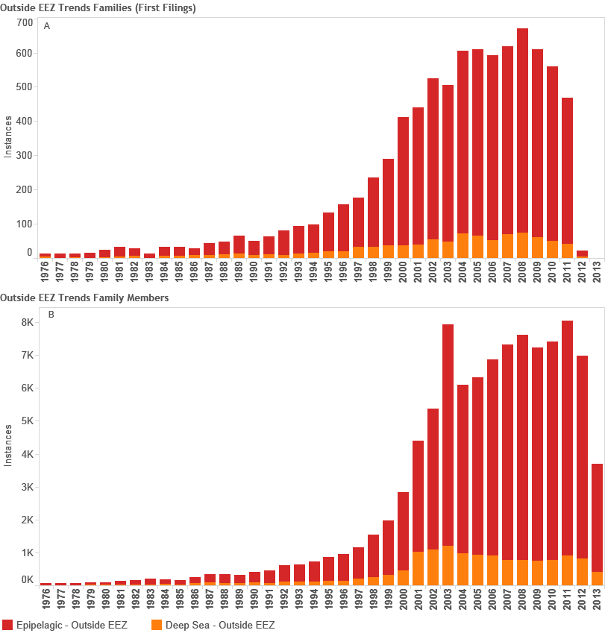

Figure 4.10: Trends in Filings Referencing Species Outside the EEZ

In total we identified 8,039 first filings (families) of patent documents that include references to species known to occur in Areas Beyond National Jurisdiction. Figure 4.10 Panel A suggests that based on trends in first filings epipelagic species dominate trends in activity with a peak of 596 filings in 2008 before declining in 2010. We are not able to make a judgement about trends in the period 2011–2013 because of the lack of available data on filings in PATSTAT (October 2013 edition). In the case of the deep-sea zone (-200 metres) the data is seriously constrained by a lack of depth data for bacteria and archaea that will appear in the epipelagic zone. The available information suggests that filings peaked at 74 families in 2008 before declining between 2009 and 2010. We would note that this decline could be reversed if more accurate depth data was available for bacteria and archaea. While recognising the limitations of depth data in our view it is nevertheless the case that the number of first filings of patent applications referencing marine species from Areas Beyond National Jurisdiction (ABNJ) is significant at between approximately 550–650 filings per year but would be quite modest if compared with other areas of activity. For the purpose of comparative analysis Figure 11 displays trends in patent filings for traditional or herbal medicines from plants based on data from PATSTAT October 2013 and International Patent Classification code A61K36. Figure 12 displays the same data but this time focuses on the key patent indicator for biotechnology and genetic engineering (C12N).

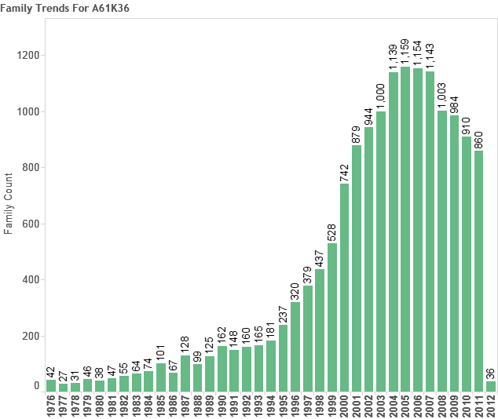

Figure 4.11: Patent Trends for Traditional Medicines from Plants

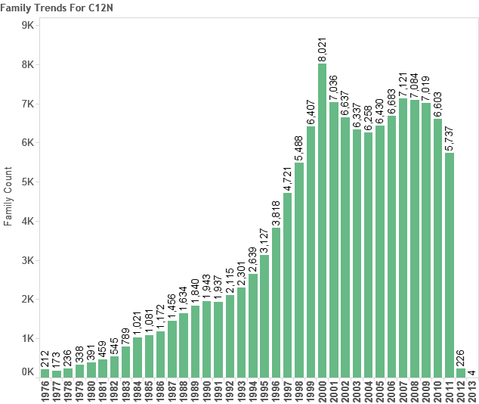

Figure 4.12: Patent Trends in Biotechnology (Key Indicator C12N)

As this data makes clear while the growth in patent filings referencing marine organisms from outside national jurisdiction is significant it is best classified as emergent. In particular, we make this observation because of uncertainties regarding the precise source of species outside the EEZ and because levels of activity for species references in the Titles, Abstracts or Claims are inevitably lower (see below).

However, a different picture emerges if we consider global demand for patent protection in multiple jurisdictions. Figure 4.10 Panel B (above) displays trends for global patent family members representing applications and grants in multiple countries that arise from the first filings, broken down by major pelagic zone. In this case a marked peak is observed in 2003 followed by a sharp decline. We believe that this possibly reflects the working through of the impacts of an economic downturn on biotechnology from 2001 onwards into the international system. Following a period of growth, activity peaks in 2008 (corresponding with the global financial crisis) before recovering to a fresh peak in 2011. Once again, data for 2011–2013 is incomplete.

In considering these trends it is important to emphasise that previous studies have not attempted to divide the data by pelagic zones and have relied on a more limited set of data. While significant difficulty remains, the present research moves analysis forward. Our data reveals that there has been an increase in patent activity making reference to marine species in general and this is partly reflected in trends for species known to occur outside the EEZ. However, it is important to distinguish between trends in first filings or families (as a proxy for new inventions) and trends in global demand for protection arising from those filings (family members). As a measure of inventions new filings referencing marine species known to occur in Areas Beyond National Jurisdiction (ABNJ) have been relatively stable at approximately 550–650 per year since 2004.[19] This figure would decrease if only those documents containing references to species in the Title, Abstracts or Claims were considered. Figure 4.13 displays these trends.

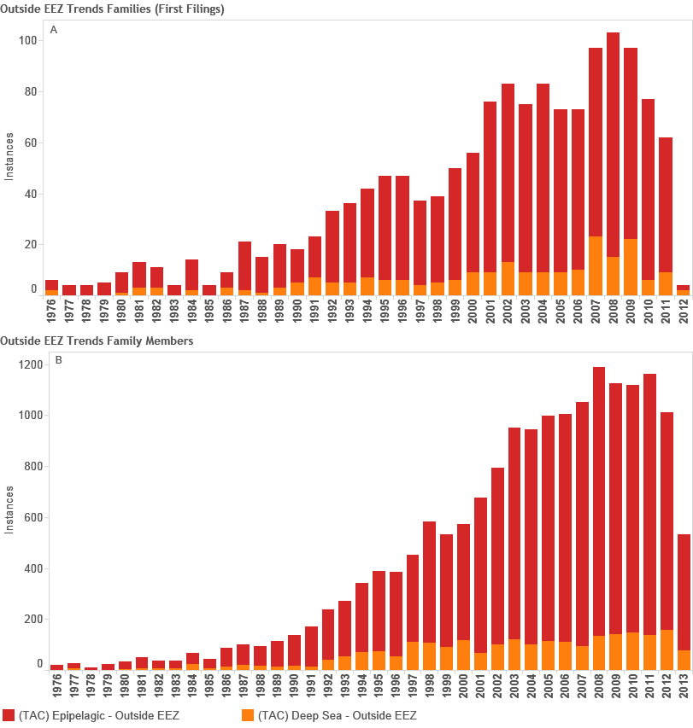

Figure 4.13: Deep-Sea Species in Titles, Abstracts or Claims

Figure 4.13 displays much lower frequencies on patent families and patent family members for deep-sea species with a peak of 93 filings in 2008. In practice, as noted above, an accurate indicator for marine genetic resources would lie somewhere between the data on patent documents referencing marine species and those referencing species in the Title, Abstract or Claims. What is interesting is that applicants are pursuing protection in multiple jurisdictions around the world suggesting that these species, or components from these species, are important to applicants in terms of their willingness to pay for protection in multiple countries. We now turn to other approaches to refining the analysis of marine genetic resources in patent data from Areas Beyond National Jurisdiction (ABNJ).

4.5 Sequence Data and New Species in Patent Data

Our analysis has focused on identifying named marine species in patent data with the purpose of identifying trends in patent activity. Previous research has focused on the analysis of sequence data in patent documents that contain a known gene from a marine species using patent sequence data from GenBank. The two approaches differ significantly in their methods and outcomes as follows:

1. Previous research focuses on counting the number of marine species associated with genes that appear in patent documents;

2. We focus on counting the number of patent documents that contain reference to a marine species.

The first approach highlights the number of marine species that are associated with genes listed in patent sequence data. In contrast the present report identifies patent trends as a proxy indicator for commercial research and development involving marine organisms. In short the two approaches are counting different things. This has important consequences for our understanding of commercial interest in marine genetic resources.

For the purpose of comparative analysis we used the raw patent data provided by Arnaud-Haond, Arietta and Duarte (2011) on sequences referencing genes from marine organisms in patent data from WIPO. Of a total of 594 patent documents listed in this research we were able to identify 588 in Thomson Innovation (99%).[20] We then obtained the latest list of Patent Cooperation Treaty documents containing sequences from WIPO. Rather than focusing on the identification of genes associated with a marine species in a patent document we focused on identifying references to marine species in a Patent Cooperation Treaty document containing a claimed sequence. Figure 4.14 displays the results in comparison with the earlier research.

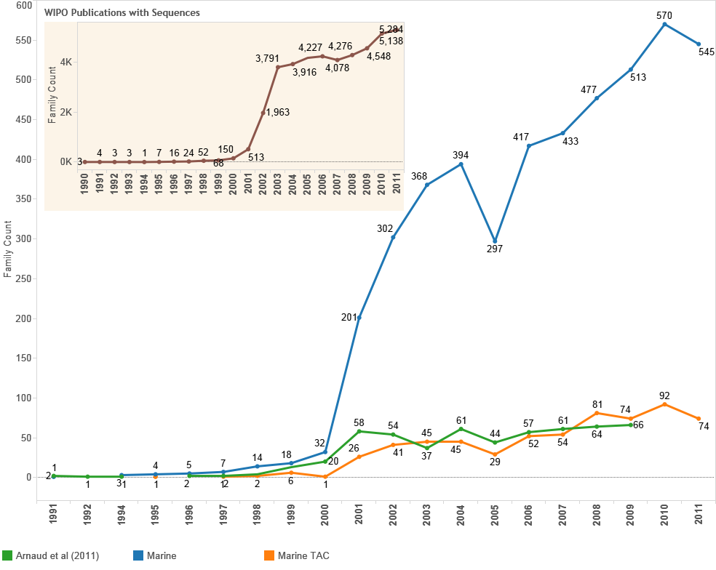

Figure 4.14: Trends for Patent Filings with DNA Sequences relevant to Marine Organisms under the Patent Cooperation Treaty

Figure 4.14 is based on counts of patent families based on the filing year. We can immediately see that patent filings containing a sequence listing that also reference a marine species (Marine) occur at much higher frequencies than in previous research. However, because a marine species may be referenced for a variety of reasons, notably as the source of an enzyme for use in PCR, rather than being material to the claimed invention, we further limit the data to documents where a marine species appears in the title, abstract or claims (Marine TAC). The most striking feature of this approach is that, with some variance, it closely follows the trend for the results of previous research using GenBank patent sequence data [4]. In short, we have made progress in bridging the gap between the two methodological approaches. However, further work is necessary to clarify whether claimed sequences are actually taken from organisms in marine environments or whether such sequences derive from terrestrial or aquatic members of a species.

Figure 4.15 displays the data on deep-sea marine species appearing in PCT patent applications with sequence data.

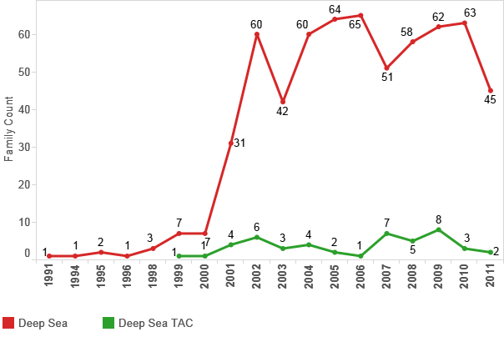

Figure 4.15: Patent Documents with DNA Sequences in the Claims referencing species from Outside the EEZ

We can immediately see that general references to deep-sea marine organisms in patent applications with sequences in the claims are significant but stable in the region of 60–65 filings per year. However, those that reference deep-sea marine species in the title, abstract or claims are minor. In considering this data we would note that closer attention is desirable to the way in which applicants construct patent claims. Our data focuses on the identification of binomial Latin species names in the patent data. However, applicants frequently construct claims on the family or genus level to capture any species with a corresponding sequence in that family or genus. This would increase the counts and merits further investigation in future research.

As noted above, previous research has highlighted that the number of patent claims associated with genes of marine organisms is growing at 12% per year. However, this is not the same as counting new filings of patent applications. As can clearly be seen from the data provided by Arnaud-Haond *et al*., (2011) and the present research on marine species in the Title, Abstract or Claims of patent filings with DNA sequences, when viewed from the perspective of patent filings the data is relatively stable.

An alternative approach to examining patent activity for marine organisms from Areas Beyond National Jurisdiction is to count species the first time they appear in the patent system. In this approach the first reference to a marine species in a filing is identified by filing year and then excluded in all later years so that it is counted only once. This allows trends in the appearance of species that are new to the patent system to be identified. We use the term ‘species new to the patent system’ to highlight that species may be new to the patent system but they are not necessarily new to science. Figure 4.16A presents the results of this exercise in the whole texts of patent documents and Figure 4.16B presents the results for references to marine species outside the EEZ in the Title, Abstract or Claims.

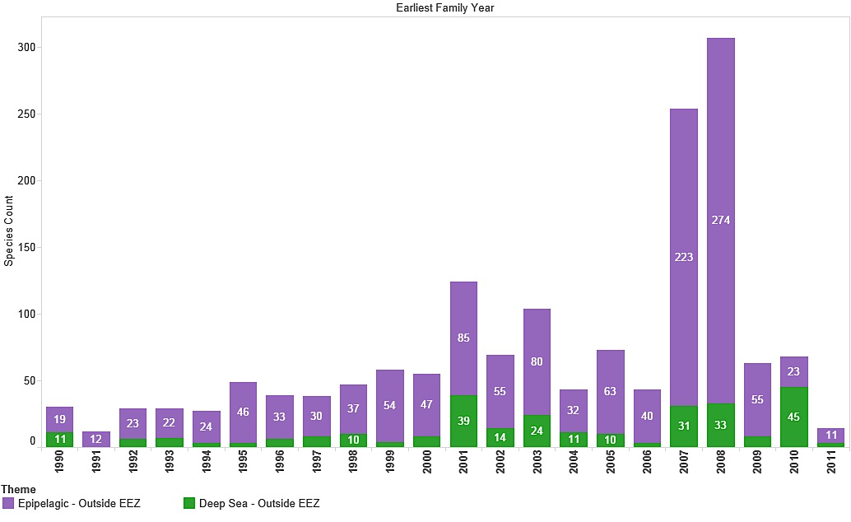

Figure 4.16A: Trends in New Marine Species in Patent Data (Outside EEZ)

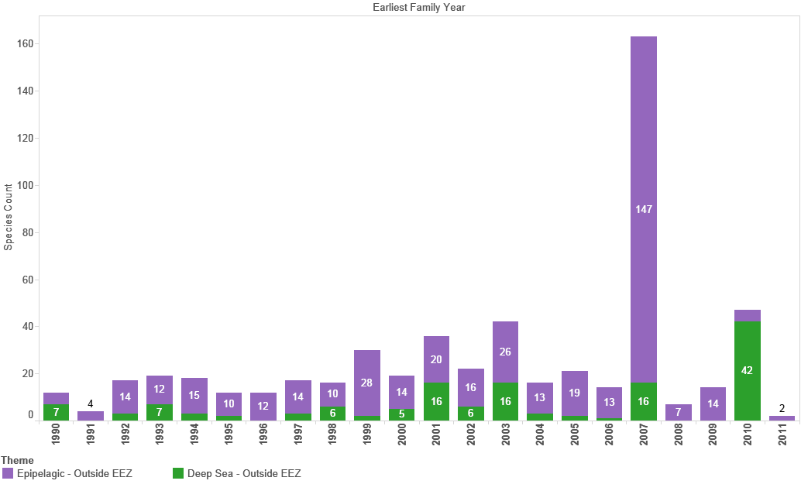

Figure 4.16B: Trends in New Marine Species in Patent Data (Outside EEZ) in Titles, Abstracts or Claims

Figure 4.16A and B reveal a variable picture in the entry of new marine species occurring outside the EEZ into patent data with an increasing trend observable in the data for the 1990s. As expected, species new to the patent system appear with lower frequency in the Title, Abstract or Claims of patent data. However, this also exposes the need for caution in the analysis of patent data. Thus, the spike in the appearance of species new to the patent system in 2007 in Figure 4.16A and B is due to a single application from Pharmaq in a patent application for Treatment of Parasite Diseases Using Vitamin K3 focusing on a fish feed composition (WO2009063044A1). The claims section of this application makes reference to over 100 fish species but the application is actually concerned with a Vitamin K3 composition that can be used to treat parasites in multiple fish species. In short, species new to the patent system may appear as the target for a claimed invention rather than being material to the invention.

In presenting this data our aim has been to clarify the issues involved in identifying and counting marine genetic resources from the deep-sea in patent data. It should now be clear that a variety of measures are available for counting marine species and deep-sea marine species in patent data. Each will have strengths and weaknesses.

In considering these results compared with earlier research it is important to note that growing trends in the sequencing of the genomes of organisms signifies that the same, or substantially similar, DNA sequences will be discovered in an increasing number of other organisms. It is therefore logical that the number of species associated with a particular gene sequence will expand over time as DNA database coverage improves. This is an outcome of the advancement of scientific knowledge. What we learn from this is that sequences or genes appearing in patent documents are associated with an increasing number of marine organisms. This performs the very useful service of highlighting that permitting claims over specific gene sequences may also provide patent protection for all matching sequences that are subsequently identified in other species in the context of debates on the patentability of DNA. However, this is not the same as attempting to identify whether interest in marine organisms is increasing in the patent system. That can only be measured by counting the number of new inventions that involve or utilize marine genetic resources in the claimed invention.

The problem here is that an emphasis on counting the number of marine species associated with genes that appear in patent document may become confused with measuring trends in the filing of patent applications. This could give rise to the perception that patent activity is increasing exponentially and will inevitably continue to do so. The present research reveals a more variable picture of activity using a variety of approaches. Furthermore, as discussed above, the appearance of marine species from outside the EEZ that are new to the patent system will also vary over time. Caution is required in interpreting quantitative data with respect to whether components of an organism are material to an invention or whether the organism is a target of the invention. Further work is clearly necessary to refine analysis in this area with respect to species from ABNJ.

In our view, it is more likely that what we will observe is the *intensification* of patent activity around the genetic components of a limited number of marine species rather than a dramatic increase in the number of new species, or strains, entering the patent system. This would be consistent with earlier research by the authors of this report, which found that patent applicants display herd-like tendencies [6]. This herd-like tendency involves applicants clustering around promising new species sometime after they are recognised as economically important. Examples of this type of effect include well-known species such as *Thermus aquaticus* (the source of the Taq DNA polymerase), *Taxus brevifolia* (the source of a best selling anti-cancer drug) and *Hoodia gordonii* (source of an initially promising weight loss compound and food ingredient). In the era of genomics and whole genome sequencing this is also more likely as genome sequence data becomes available through GenBank and other databases. However, in other cases a species may languish and become forgotten in the patent system. We now turn to analysis of species from the deep-sea in patent data.

4.6 Top Species

Figure 4.17 displays the top species appearing in the data outside the EEZ for the epipelagic and deep-sea zones ranked on family counts. The figures next to the kingdom provide the maximum available depth data from GBIF records. As we can see references to cosmopolitan fungi such as *Claviceps purpurea* and *Blumeria graminis* continue to appear in the data. However, this type of species no longer dominates the data with *Renilla reniformis* and *Sulfolobus solfataricus* moving up the rankings. Plant species, such as the seaweed *Chrondus crispus* will appear in the data because they are widely distributed including in Areas Beyond National Jurisdiction. For the deep-sea zone (below 200 m depth) entries for *Mytilus edulis* (the common mussel) and *Squalus acanthias* (the spiny dogfish) provide an indicator of significant deep-sea species in patent data.

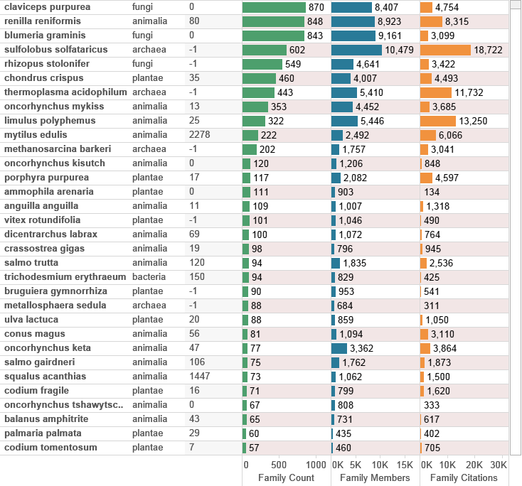

Figure 4.17: Species Outside the EEZ by Depth and Family Count.

Figure 4.18 (below) displays the data purely from species classified as occurring in the deep-sea zone (-200 m) and are clearly dominated by animal macrofauna based on the number of families with the exception of the diatom *Chaetocerus gracilis* as a member of the Chromista. As discussed above, this will reflect the absence of depth data for bacteria and archaea in taxonomic databases as an important constraint on analysis of species based on depth data.

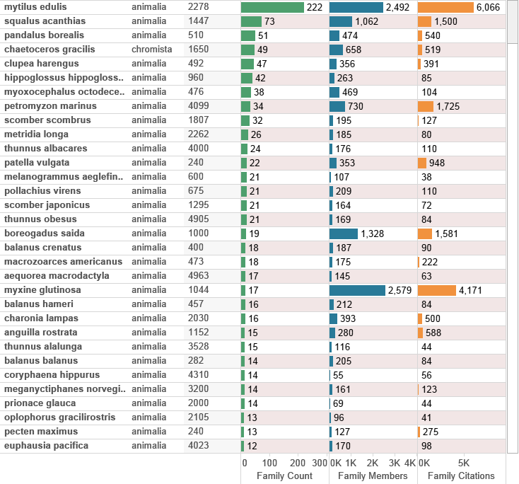

Figure 4.18: Species occurring Outside the EEZ in Patent Data Recorded Below 200 metres

In assessing this data, family counts provide an indicator of the number of inventions that make reference to the species in the text. Family members provide an indicator of global demand for inventions that contain a reference to the deep-sea marine species while family citations provide an indicator of the impacts of the patent families referencing the organism. Patent family members and citations are a key indicator of the economic importance of patents. Patent family size (based on counts of family members) provide an indicator of the willingness of applicants to pay for patent protection in multiple countries. In contrast, citation counts are an indicator of the impact that a filing, or set of filings, has on later applicants by *limiting later claims* to the same or similar invention. Because an application for an invention must be new (or novel) and involve an inventive step, applications are assessed in light of the prior art. Where prior patent or scientific art exists for the claimed invention or aspects of the claimed invention the applicants must either abandon the application or modify the claims to accommodate the prior art.

In interpreting this data we would reasonably expect species with large numbers of associated family members to generate more citations. Of greater interest however are relatively small family counts that generate large impacts in terms of citations such as *Myxine glutinosa* (the hagfish or Atlantic hagfish). Figure 4.19 displays the data for species outside the EEZ data ranked on family citation counts. We also introduce counts of the number of times a species name appears (occurs) in the Title, Abstract or Claims of a patent document (TAC Occurrences).

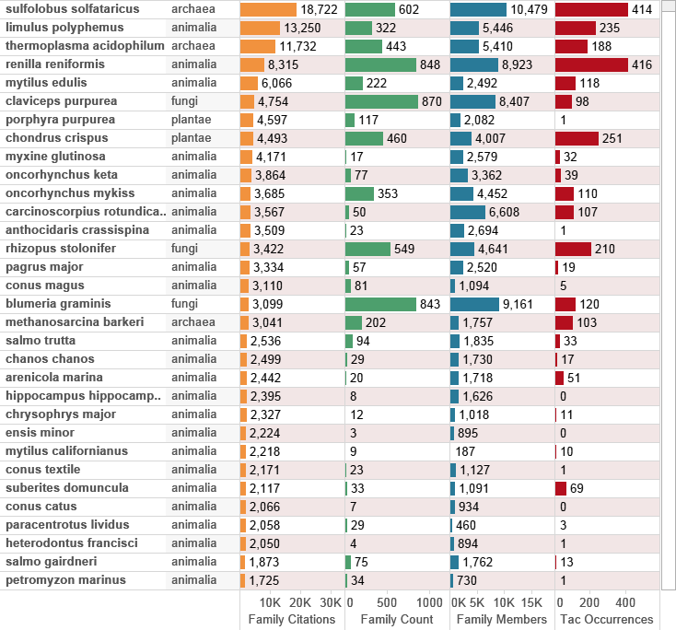

Figure 4.19: Top Species Appearing in Patents Occurring Outside the EEZ by Citation Counts

In considering Figure 4.19 it becomes clear that top species ranked by their impacts in the wider patent system are *Sulfolobus solfataricus* [14,15], *Limulus polyphemus* (the Atlantic Horseshoe crab) [16,17], *Thermoplasma acidophilum* [18,19] and the sea pansy *Renilla reniformis* [20]. In some cases, such as *Sulfolobus solfataricus*, a species was originally isolated in terrestrial hot-springs and subsequently discovered in deep-sea marine habitats [14] while *Thermoplasma acidophilum* was first identified in a coal refuse pile [18]. This once again highlights the obstinate refusal of species to conform to the geographical limits that humans may seek to impose upon them. More importantly, the introduction of the data on Titles, Abstracts and Claims illustrates that species appearing in high impact inventions are not necessarily referenced with high frequency in the title, abstract or claims. The reason for this will be either: a) that the reference to the species is purely general and not material to the invention or; b) the claims focus on a chemical compound or enzyme and do not directly reference the source species.

For the deep-sea data we are also able to focus on patent applicants using a variety of measures to interrogate the data. Figure 4.20 displays the deep-sea data ranked on counts of patent families. This closely mirrors the overall data for applicants referencing marine species with a reduction on family (filing) counts and movement in the rankings of applicants. This provides an indicator of global demand for protection by applicants making reference to a deep-sea species.

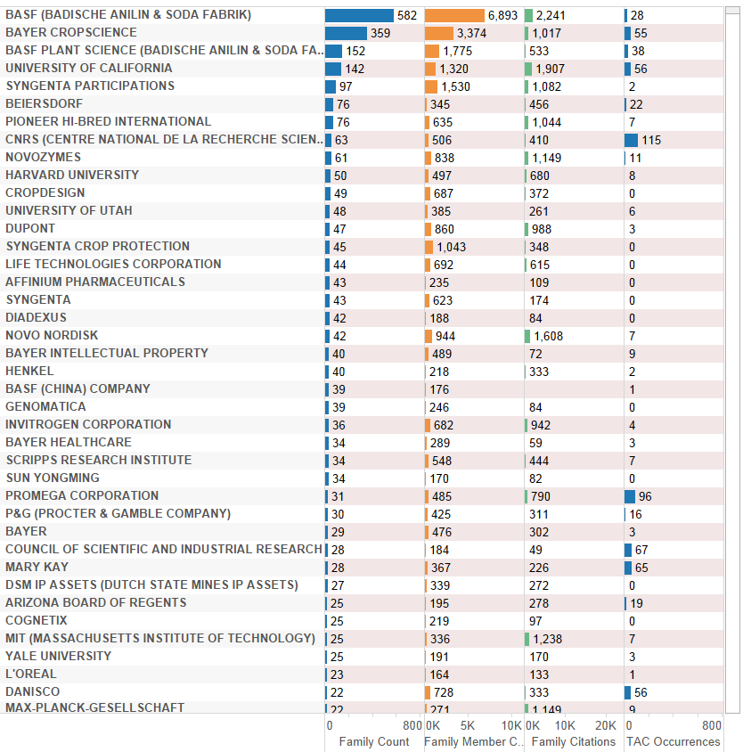

Figure 4.20: Patent Applicants Referencing Species Outside the EEZ Ranked by Family Members

An alternative measure of the rankings of applicants is to count the number of times that an applicant makes reference to a species in the Title, Abstract or Claims of a patent filing (TAC occurrences). While this method can be affected by difficulties in distinguishing between different sections in documents, notably the abstracts and description in older documents, it is a useful indicator of the intensity of an applicant’s activity around a species or group of species. Figure 4.21 displays applicants ranked by the occurrence of a deep-sea species in the Title, Abstract or Claims.

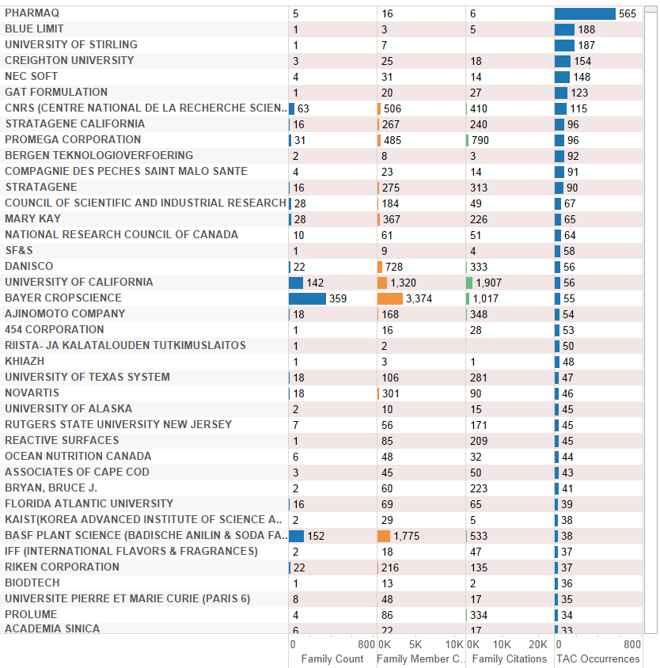

Figure 4.21: Applicants Ranked by Occurrence of Deep-Sea Marine Species in the Title, Abstract or Claims

The measurement of applicants by references to species in the Title, Abstract or Claims provides an indicator of applicants focusing on species. In the case of the top ranking Pharmaq the application refers to a Vitamin K3 composition for treating parasites in large numbers of fish species (see above) (WO2009063044A1). In the second case, the company Blue Limit has also filed for a feed composition for aquatic organisms (WO2008084074A2). In contrast with Pharmaq, this includes proteins from sources such as krill or squid to be fed to fish and they claim the use of the feed for a large number of fish species. Finally, the University of Stirling has filed for a DNA vaccine against *Aeromonas hydrophila* in fish and claims the application of the vaccine in a large number of different fish species. As this suggests, more detailed review of the data would be required to identify patent documents that claim the use of a genetic resource from a deep-sea organism in a claimed invention.

An alternative way to examine the data by is by citations counts. Figure 4.22 ranks the deep-sea data by citation count.

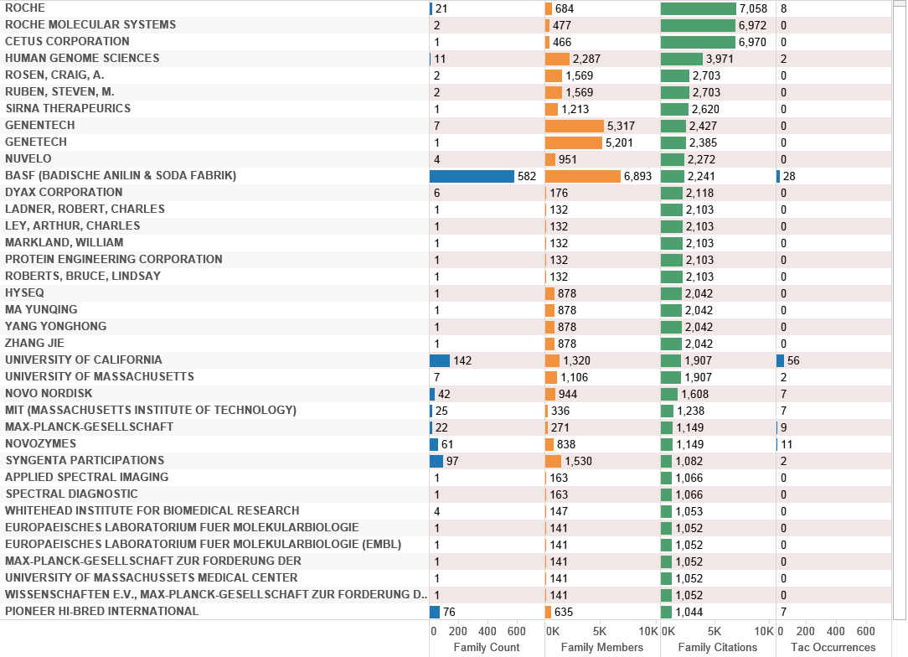

Figure 4.22: Applicants by Citation Count

Roche dominates the top ranking positions for patent filings linked with Polymerase Chain Reaction (see below) with individuals listed as co-applicants on filings also displayed. We can explore this data by displaying the records including species and accompanying citation counts by patent family. We illustrate this approach for Roche and Cetus (Figure 4.23).

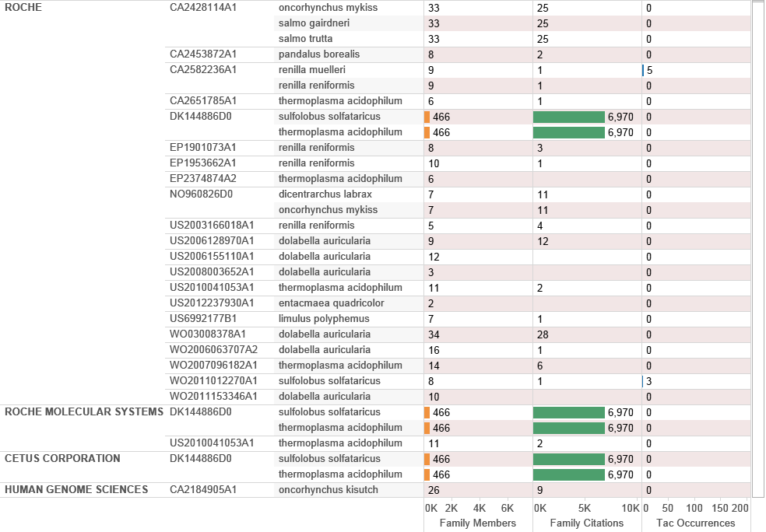

Figure 4.23: Applicant Breakout by Species and Citation

In considering this data note that the filing DK14486D0 dating to 1986 referencing *Sulfolobus solfataricus* and *Thermoplasma acidophilum* can be difficult to access in full-text because of its age.[21] In practice, this patent family containing 466 family members is one of the most important and influential in the history of biotechnology because it relates to the Nobel prize-winning Polymerase Chain Reaction (PCR). PCR allows small samples of DNA to be reproduced (amplified) in exact copies to radically increase sample size for research. The method essentially involves thermal cycling and enzymatic replication of DNA (where the polymerase is the enzyme). Cetus Corporation and later Roche submitted three key filings on PCR technology (US4683195A, US4683202 and US4889818A). The family members relating to this technology in the case of *Sulfolobus solfataricus* and *Thermoplasma acidophilum* relate to possible sources of the thermostable enzyme for potential use in the claimed invention as part of an indicative list where “The thermostable enzyme herein may be obtained from any source and may be a native or recombinant protein” (US5079352A). However, the applicants go on to state that: “The preferred thermostable enzyme herein is a DNA polymerase isolated from Thermus aquaticus,” and claim “A recombinant DNA sequence that encodes the thermostable DNA polymerase activity of Thermus aquaticus”. The key Roche patent in this family is in fact US4889818Afor a purified thermostable enzyme from *Thermus aquaticus.*

*Thermus aquaticus* was first isolated from Mushroom Pool in Yellowstone National Park in the United States in 1966 and deposited in the American Type Culture Collection [21]. The subsequent identification of the Taq DNA Polymerase (*Thermus aquaticus* = Taq) by the patent applicants proved to be the most stable and effective enzyme at that time for the PCR process. According to later court documents in 1991 the original Cetus patent was reportedly sold to Roche for US$300 million and generated annual revenue of US$100 million [12]. The literature reports that Roche had gained revenue of US$2 billion from control of PCR technology although this figure is difficult to confirm [12].

The success of the Taq enzyme also sparked interest in the potential for extremophile organisms to generate returns for access and benefit-sharing to promote conservation. In international debates on access and benefit-sharing a 1997 Cooperative Research and Development Agreement (CRADA) between the US National Parks Authority and the company Diversa (now Verenium) was advanced as a potential model for generating conservation benefits from bioprospecting in protected areas [12,22,23]. However, the patents relating to Taq DNA polymerase had also become a focus of concern in the scientific community owing to the high price of the polymerase for use in experiments. This example contributed to the development of guidelines on access to research tools by the National Institutes of Health in the United States [24]. The patent also sparked a major long-running patent infringement lawsuit that culminated with the invalidation of the US4889818A patent grant under the Clean Hands doctrine whereby the applicant was found to have misled the United States Patent and Trademark Office (USPTO) at the time of application by claiming to have performed an experiment that had not been performed [12].

This example is relevant to debates on patent activity for organisms from Areas Beyond National Jurisdiction for three reasons. First, it illustrates that organisms may be referenced for a variety of reasons including patent applicants seeking to ensure that others cannot readily work around an invention rather than actual use of the genetic component. Second, it highlights the problem that flagship cases demonstrating the value of a genetic resource may not prove to be what they seem. In this particular case a US Court found evidence of fraudulent behaviour leading to invalidation of the patent. However, researchers and companies had been paying high prices for the patented enzyme for many years and that was not recouped. Finally, the Polymerase Chain Reaction patents, along with the Cohen Boyer patents on recombinant DNA technology (e.g. US4237224), are truly foundational patents in that they provided the foundation for the entire field of biotechnology. The exceptional nature of foundational patents means that they are extremely bad examples to use as a foundation for international access and benefit-sharing policies. Most patents are far less valuable and it is widely recognized in the literature on patents that most patents are low value and go nowhere. As such, international policy debates on access and benefit-sharing would benefit from a subtle or nuanced understanding of the workings and economics of the patent system. This could best be achieved through the analysis of specific historic cases involving marine genetic resources to generate lessons learned and greater attention to the assessment of the economic value of patents.

4.7 Countries

The existing literature on patent activity involving marine genetic resources has highlighted that “claims associated with marine genes originate from only 31 of the 194 countries in the world” with ten countries dominating 90% of patents containing marine genes and 70% from three countries led by the United States, Germany and Japan [4].

In practice it is possible to map the portfolios of countries referencing marine species by the priority country (country of first filing). Figure 4.24A maps the country of first filing for patent applications referencing marine organisms in general. Figure 4.24B displays the same data for applications referencing marine organisms from ABNJ.

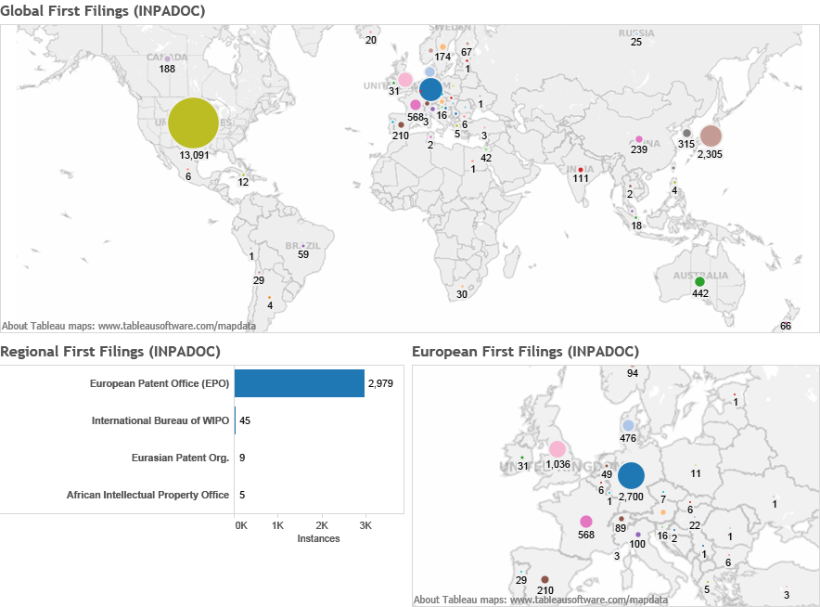

Figure 4.24A: Marine Genetic Resources in General

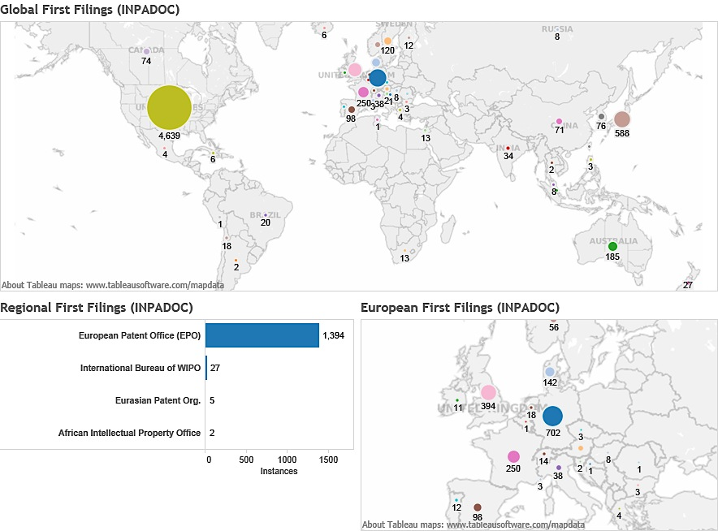

Figure 4.24B: Marine Genetic Resources in ABNJ

Within the underlying literature there has been a concern that a small number of countries are benefiting from the commercial exploitation of marine genetic resources leading to further investment in this kind of research that may broaden the gap between countries with capacity in this area and countries without this capacity [4]. This argument leads to support for the need for an international framework for marine genetic resources [4].

In our view this is a valid concern. However, in reality patent filings also reveal networks of collaboration between researchers and companies in different countries in a similar way to the collaboration networks discussed in the previous chapter. Figure 4.25 displays the network of collaboration between applicants based on country codes associated with each applicant.

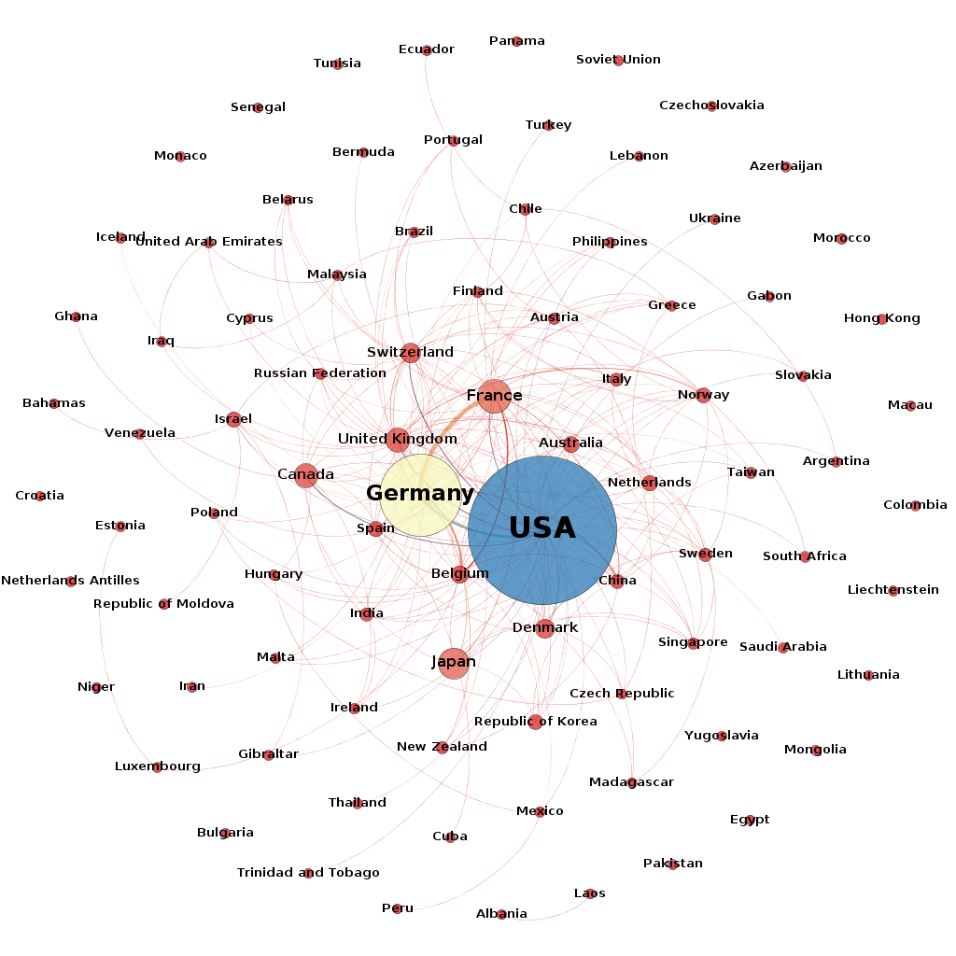

Figure 4.25: Applicant Co-Application Network for First Filings Referencing Species Outside the EEZ

What this data demonstrates is that while certain countries dominate the patent landscape for marine genetic resources, in practice we also observe networks of international collaboration across countries. This is significant because these networks provide indicators of technology and knowledge transfer across countries. What is less clear is the extent to which collaboration in patent activity results in rent transfers from revenue generated by patents across countries participating in patent filings. Nevertheless, while recognising the legitimacy of concerns about concentration in the existing literature it is also important to recognise that joint patent activity could be an important component in benefit-sharing under any implementing agreement in terms of technology and knowledge transfer and monetary benefit-sharing. We now turn to the analysis of patent data by technology area.

4.8 Technology Areas

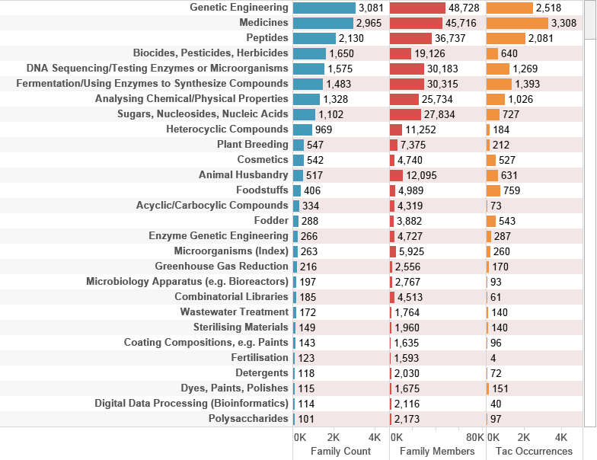

Figure 4.26: Technology Areas Marine Species Outside the EEZ

Figure 4.26 is based on International Patent Classification sub-class codes that describe the technical area of an invention. The code descriptions have been edited for display to capture the main technology areas. We can readily see that the data is dominated by genetic engineering and biotechnology followed by medicines (primarily pharmaceuticals), biocides (reflecting species that are a source and target of biocides). As we might expect, DNA sequencing and the chemical synthesis of enzymes using fermentation also feature prominently. In terms of sectors, references to plant breeding and cosmetics are likely to reflect the use of components of marine organisms in applications and products in these areas. Fuller consideration of the technology areas involving marine genetic resources from outside the EEZ is provided in chapter 6. We now turn to the analysis of patent activity involving marine organisms for the UK.

4.9 UK Patent Activity

UK patent activity is a subset of the international activity identified above. To calculate UK patent activity we count patent filings that contain a UK country code (GB) in the applicant field as the primary measure. We then add patent filings containing a UK country code in the inventor data where the record also includes the UK as a priority filing. This second restricted measure has the effect of removing records where a UK inventor is working for a non-UK company or organisation on the grounds that they are non-resident (e.g. working for a European or other company). Note that UK applicants often file patents with residents of other countries either as individual co-applicants or as joint applications with other companies. For this reason non-UK collaborating companies will appear in the data. Furthermore, where a UK subsidiary of an international company (e.g. Syngenta UK) files a patent application as a UK applicant they will also appear in the UK data.

In this discussion we begin with overall UK international activity for patent documents referencing marine species. We then turn to analysis of UK international activity for deep-sea organisms.

Figure 4.27displays trends in UK international activity making reference to a marine species inside or outside the EEZ with trends on publications reflecting activity at the European Patent Office, the USPTO and the Patent Cooperation Treaty.

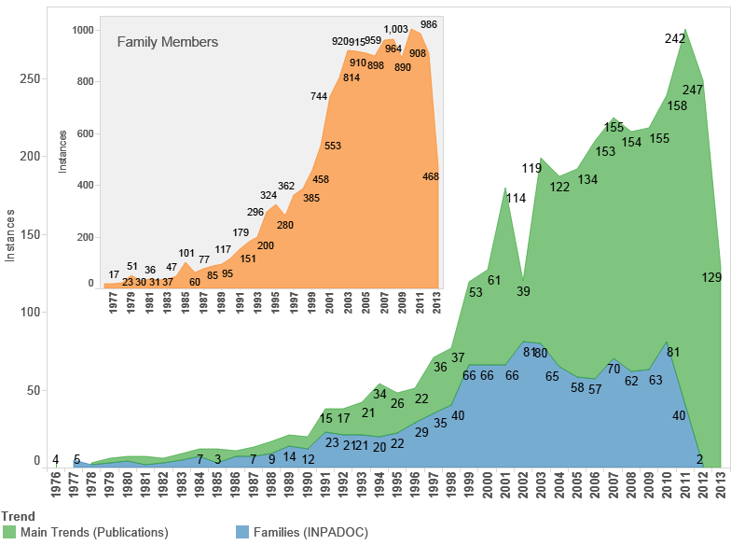

Figure 4.27: International UK Patent Activity Referencing Marine Organisms

We can immediately see that UK patent activity referencing marine species in general is a much more limited sub-set of the overall data with international filing levels in the region of 60-85 filings per year in the period between 2000-2010. As such we would not expect debates on marine genetic resources to have major implications for the UK except where the filings resulted in patent grants that proved to be economically important. Figure 4.28 displays the main technology areas for UK patent activity using International Patent Classification Codes.

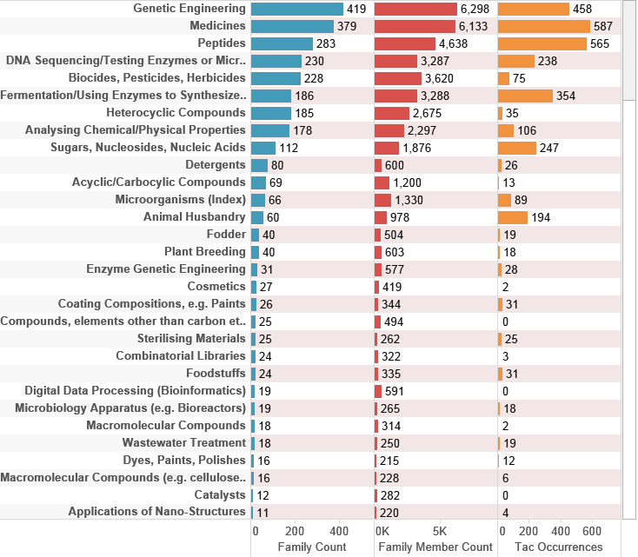

Figure 4.28: UK Technology Areas for all Marine Species:

Figure 4.29 displays the top applicants ranked on family count for references to marine species in UK data. Note that in some cases, such as the Spanish company PharmaMar, the data reflects the presence of a UK individual listed as a co-applicant.

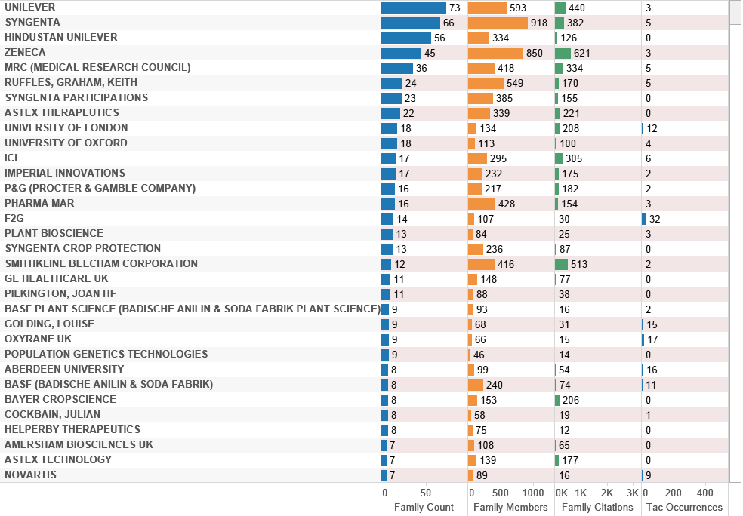

Figure 4.29: UK Patent Activity Referencing Marine Species (Family Counts)

UK data ranked on family counts by assignee reveals a relatively limited set of filings referencing a marine species. Figure 4.30 provides a breakout of the data by species for the top UK applicant, Unilever.

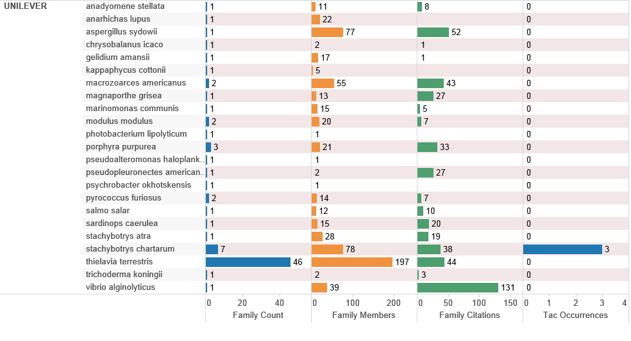

Figure 4.30: UK Top Applicants Referencing Marine Species

Figure 4.31 displays the same data but ranked on references in the Title, Abstract or Claims.

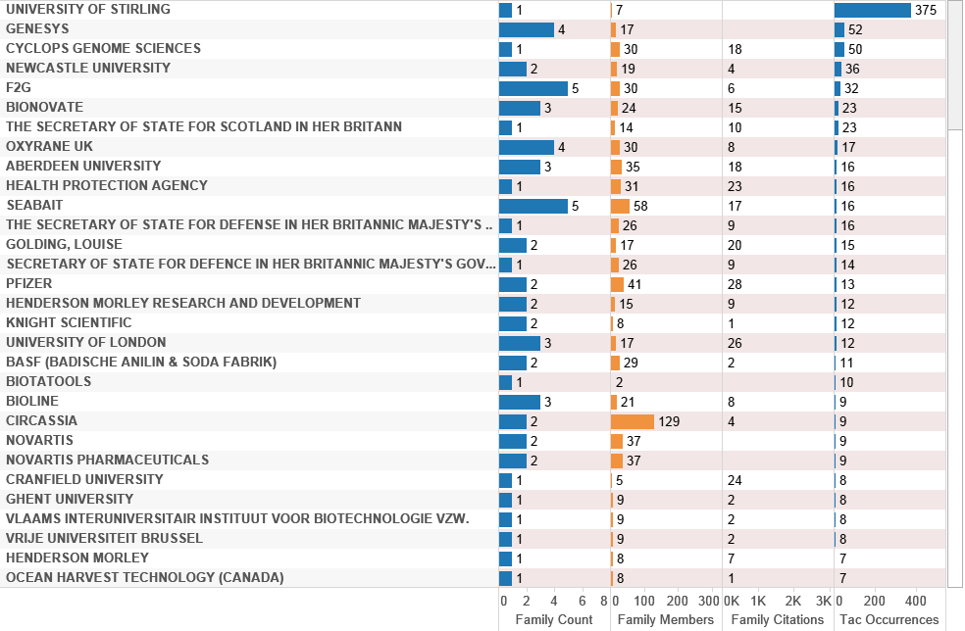

Figure 4.31: UK Activity with Marine Species in the Title, Abstract or Claims

In this case, the University of Stirling emerges top in the rankings for the filing noted above on vaccines. This is followed by Genesys (a management consultancy company) that references *Thermodesulfatator indicus* and *Thermotoga maritima* along with the Cambridge based biotechnology company Cyclops Genome Sciences focusing on Modified RNA Technology. The latter references *Pyrodictium occultum*, *Thermococcus litoralis*, *Thermoplasma acidophilum*, *Thermisipho africanus* and *Thermotoga maritima* in a patent family with 30 members. Family member US20050272679A1 focuses on an oligonucleotide consisting of mRNA, rRNA or viral RNA with modified ribose rings for use as a probe in gene expression analysis. References to marine species appear in Claim 9 where the applicant claims:

“(9) The nucleic acid polymerase comprises a DNA-dependent DNA polymerase; or wherein the DNA-dependent DNA polymerase is selected from the group consisting of DNA polymerase I; DNA polymerase I-Klenow fragment; T4 DNA polymerase; T7 DNA polymerase; Taq DNA polymerase, Tli DNA polymerase, Pfu DNA polymerase; Vent® DNA polymerase; DeepVent® DNA polymerase; Bst DNA polymerase; Tth; Pfu Turbo®, Pfu(exo-), Pwo, Pyra®, Tfu, KlenTaq, Taq2000®, AmpliTaq; Stoffel fragment, Sequenase®, Tma, Vent® (exo-), DeepVent® (exo-), and a DNA polymerase purified from an organism selected from the group consisting of: *Thermosipho africanus, Thermotoga maritima, Desulfurococcus mobilis, Methanobacterium thermoautotrophicum, Methanothermus fervidus, Pyrococcus furious, Pyrodictium occultum, Sulfolobus acidocaldarius, S. solfataricus, Thermococcus litoralis* and *Thermoplasma acidophilum…*”

As this example suggests, in perhaps the majority of cases UK patent activity will reference species and genetic material that are well known in the art, or modifications to existing structures, rather than applying for protection arising from novel organisms directly collected from marine environments.

We anticipate that with few exceptions this will constitute the dominant pattern in UK activity referencing or involving marine species. We now turn to analysis of UK activity involving species occurring outside the Exclusive Economic Zone (EEZ).

UK Patent Activity and the Deep-Sea

Figure 4.32 displays the results of breaking out the UK marine data by species (inset) and counts of family members. This data strongly suggests that UK activity mainly refers to species from inside the EEZ with 464 species occurring inside the EEZ and 272 species referenced from outside the EEZ (see Species Count). Once again we would note that data on species outside the EEZ by depth is affected by a lack of accurate depth records for bacteria and archaea that are grouped in the epipelagic zone.

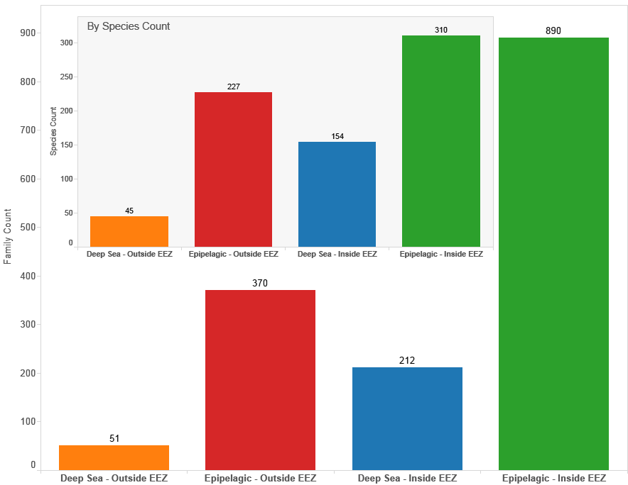

Figure 4.32: UK Patent Activity for Marine Species by Geographic Zone and Depth

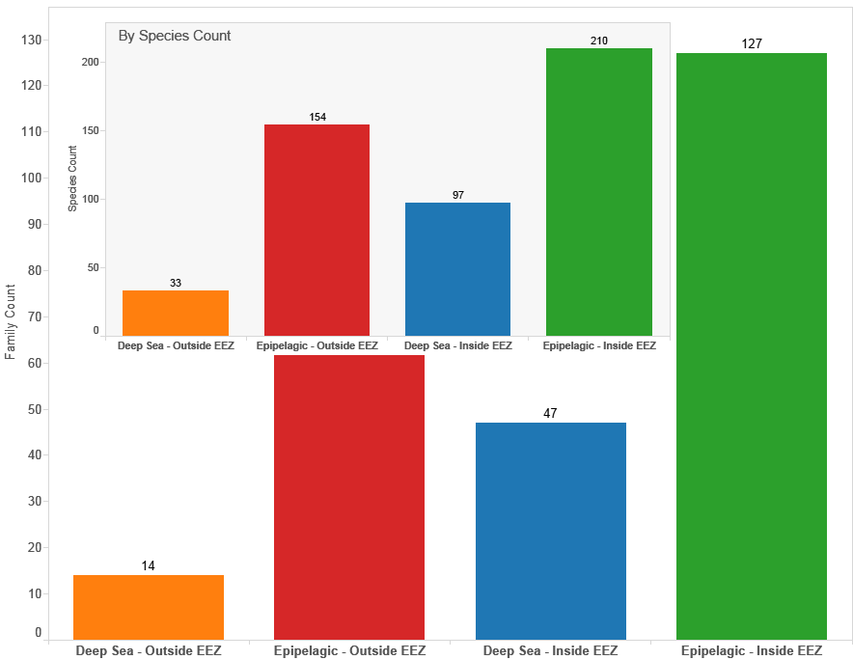

Figure 4.33: Displays the Same Data for Titles, Abstracts and Claims

Figure 4.34 demonstrates that UK activity referencing deep-sea species in the Title, Abstracts or Claims is limited with the total number of species from the deep-sea in patent data involved in an invention resting somewhere between the total number of species in the documents and species in the Title, Abstract or Claims.

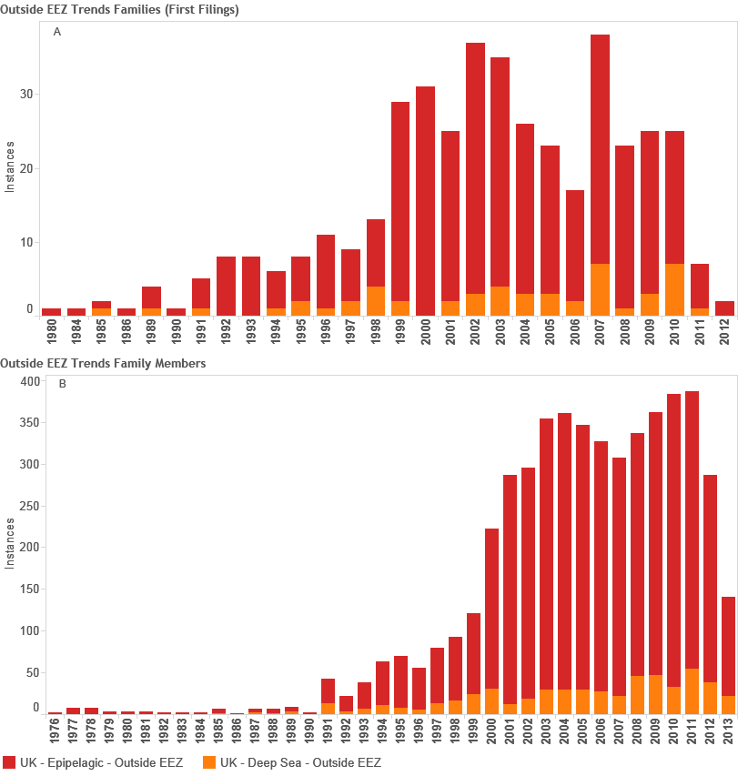

Figure 4.34: Trends in International UK Activity Referencing Deep-Sea Species

Figure 4.34 reveals a variable picture for UK international patent activity referencing deep-sea species in first filings and demonstrates that patent activity may go up or down over time. UK filings referencing deep-sea species presently do not exceed 50 filings per year and have been under 40 filings per year in recent years with the exception of a spike in 2007. Trends in family members as a measure of demand for protection for these inventions in multiple countries display a generally increasing trend with a marked drop in demand between 2007 and 2009.

Technology Areas

Figure 4.35 displays UK patent activity referencing deep-sea species using International Patent Classification Codes.

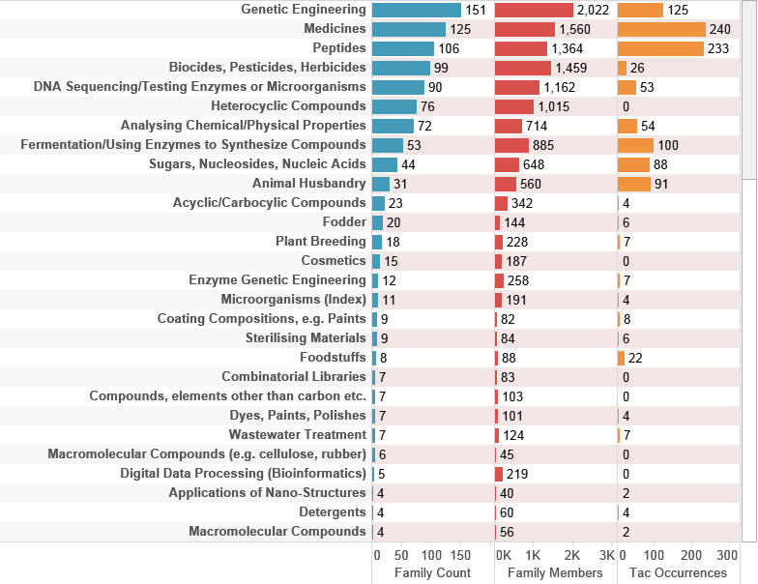

Figure 4.35: UK Activity Referencing Species Outside the EEZ

This data demonstrates that UK activity is mainly focused on genetic engineering and pharmaceuticals with emerging developments such as bioreactors and applications of nano-structures (nanotechnology) beginning to move into the picture albeit at low frequencies.

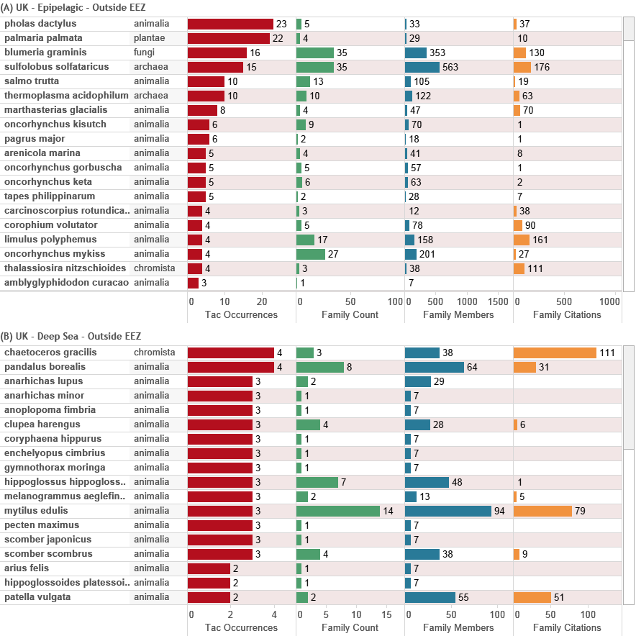

Figure 4.36: Top Species from GB Innovation (Outside the EEZ)

Figure 4.36 focuses on the top species appearing in UK international activity for the epipelagic (A) and deep-sea -200 m zones (B). The data is ranked on the number of occurrences of a species in the Title, Abstract or Claims to reveal the intensity of UK activity around particular species. Note that some of the bacteria and archaea in the epipelagic zone may belong in the deep-sea zone. Also note that some species may also be of terrestrial origin (e.g. *Sulfolobus solfataricus*). Figure 4.36 also demonstrates that individual species generally have relatively low patent family member counts signifying relatively weak international demand for protection in multiple countries and, with few exceptions, have generally attracted less than 100 citations.

UK Patent Applicants

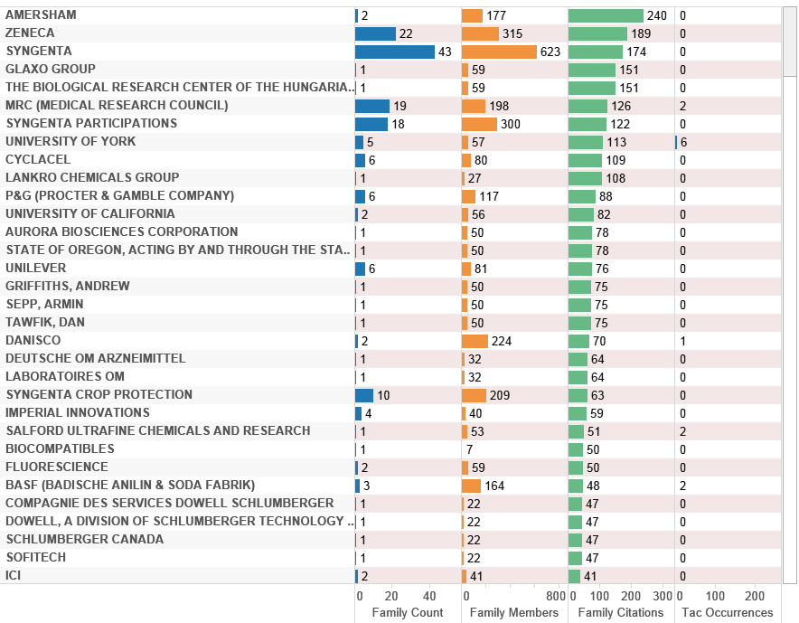

Figure 4.37: UK Patent Activity (Outside the EEZ)

Figure 4.37 displays the top UK applicants ranked on citation scores to expose the most important patent documents in the UK portfolio in terms of their impacts on other patent applicants (as opposed to family size as a measure of an applicant’s willingness to pay). The top ranking patent families for Amersham involve references to *Renilla reniformis* as a source of Green Fluorescent Protein for use as a marker in claimed inventions relating to a human myosin like polypeptide (US6686188B2) and isoforms of human pregnancy associated protein-E (US6656700B2). This forms part of a wider and common pattern involving enzymes or compounds from marine organisms that are now produced through fermentation rather than direct collection.

We can move closer to UK activity directly involving marine organisms from outside the EEZ by examining patent documents where an organism appears in the Title, Abstract or Claims ranked by citation scores. Figure 4.38 displays this data for the top ranking UK organisation by this measure, the University of York.

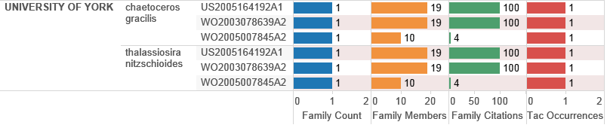

Figure 4.38: UK Patent Activity with Species in the Title, Abstract or Claims Ranked on Citation Scores.

*Cheatoceros gracilis* is a marine diatom and is referenced in the claims of three patent applications by the University of York that focus on transgenic plants that express enzymes involved in fatty acid biosynthesis. Specifically, these applications focus on the use of nucleic acid sequences from a variety of organisms for the expression of docosahexaenoic acid (DHA), an Omega 3 fatty acid, or its variants in transgenic plants. In marine organisms DHA is normally associated with krill or fish oils and has generated a significant market for Omega 3 products. In this case the applicants claim that the expression of DHA in plants would overcome the problem of increasing levels of pollution in fish. However, it is important to note that the applicants claim that the nucleic acid could be derived from a number of algal species in the following claims:

“3. The isolated nucleic acid molecule according to claim 1, wherein the isolated nucleic acid molecule is isolated from an algal species.

4. The isolated nucleic acid molecule according to claim 3 wherein said algal species is Amphidinium carterae, Amphiphora hyalina, Amphiphora sp., Chaetoceros gracilis, Coscinodiscus sp., Crypthecodinium coohnii, Cryptomonas sp., Cylindrotheca fusiformis, Haslea ostrearia, Isochrysis galbana, Nannochloropsis oculata, Navicula sp., Nitzschia closterium, Pavlova lutheri, Phaeodactylum tricornutum, Prorocentrum minimum, Rhizosolenia setigera, Skeletonema costatum, Skeletonema sp., Tetraselmis tetrathele, Thalassiosira nitzschioides, Thalassiosira heterophorma, Thalassiosira pseudonana, or Thalassiosira stellaris.” (US20050164192A1)

There is no evidence that the organism was collected by the applicants from a marine environment and the main focus of the invention appears to have been the cultivation of the marine haptophyte *Pavlova lutheri,* first described in 1953, in artificial seawater followed by cDNA library construction, sequencing and sequence analysis against existing libraries for identification of the relevant genes [25]. We therefore assume that the inclusion of the organism and other organisms in the claims reflects the identification of the target sequence in the invention in these organisms. As such, the applicants are covering the possibility that other applicants may seek to reproduce the invention using the same sequence in other organisms. Family members arising from the claimed invention include European Patent and US patent grants (e.g. EP1487985B1, EP2302060B1, US7705202B2).

In closing this discussion of UK patent activity this example usefully highlights that in what may prove to be many if not the majority of cases, patent applicants will not engage in direct collection of organisms but will rely on access to existing collections and or sequence databases. Furthermore, as in this case, an applicant may make claims to a DNA sequence from an organism on the basis that sequence analysis reveals that the sequence occurs in a particular organism to close off possible competition by others. In terms of debates on access to genetic resources and benefit-sharing this highlights the increasing importance of access to data about organisms in the form of DNA databases. At the same time it also highlights that applicants may make claims over the particular genetic components of organisms for the purpose of defending an invention from competitors seeking to work around the invention or because subsequent identification of polymorphisms associated with a particular gene or set of genes may prove advantageous for the realisation of the invention at a later data.

4.10 Conclusions

The aim of this chapter has been to clarify the presence of marine genetic organisms and deep-sea marine organisms in international patent data as a contribution to understanding trends in commercial research and development involving marine genetic resources. In particular, and building on growing attention to evidence-based quantitative analysis of patent data, we have sought to address the problem of scale in identifying marine organisms in millions of patent documents and progressively refining the analysis to focus on organisms known to occur in Areas Beyond National Jurisdiction.

In the course of this analysis a number of key issues have emerged that are directly relevant to the potential negotiation of an implementing agreement, or agreements, within the framework of the United Nations Convention on the Law of the Sea.

1. Marine organisms that appear in patents may also be found in terrestrial and terrestrial aquatic environments. It is presently very difficult to differentiate the source or origin of marine genetic material in patent documents (see chapter 5);

2. Marine organisms may be the targets of an invention or the source of a claimed invention. It is presently difficult to differentiate these types of references using computational methods and qualitative assessment is needed in future work;

3. Marine organisms in general are increasingly referenced in patent documents suggesting increasing interest in these species. However there is a need for care in interpretation of quantitative trends because:

a) Patent activity may be intensifying around a cluster of well known species;

b) Applicants may name species as a defensive measure to prevent competitors from working around a patent;

c) Patent claims may be constructed on the family or genus level that will not be adequately captured in the present research.

4. Our ability to identify marine species in patent data that originate from Areas Beyond National Jurisdiction (ABNJ) is presently limited. Further efforts to accurately geocode sample records should be encouraged. In particular, our ability to section data by pelagic zone is severely constrained by the absence of sample depth data in taxonomic databases for bacteria and archaea. In our view greater attention should be paid to actively promoting the recording of sample depths as a contribution to longer term monitoring and analysis of patent activity involving marine organisms and organisms from the deep-sea.

5. There is a need for clarity and caution in the interpretation of patent research using different methodological approaches. Trends in research and development involving marine species should be conducted using standard counts of patent families and related patent counts such as family members to measure global demand. At the same time, methodological development using a variety of approaches, including harmonisation, should be strongly encouraged to improve the accuracy of patent statistics to inform decision making over time.

6. On the balance of the available evidence, and taking into account the constraints identified above, we conclude that patent activity for genetic resources from the deep-sea is an emerging area of interest among patent applicants. However, significant uncertainty remains on the extent to which organisms known to occur in the deep-sea are actually collected from Areas Beyond National Jurisdiction.

7. In the case of the UK we find limited evidence for the presence of genetic material from marine organisms from Areas Beyond National Jurisdiction in UK patent activity. While UK applicants may be affected by any implementing agreement that may be agreed within the framework of UNCLOS involving access and benefit-sharing, the available evidence suggests that the impacts of such an agreement are likely to be limited. Proposals on conditions for access to samples or genetic data would merit careful consideration and further analysis.

We now turn to analysis of the origins and sources of marine genetic material in patent data.

References

1 Arico S, Salpin C (2005) *Bioprospecting of genetic resources in the deep seabed: scientific, legal and policy aspects*. Yokohama: United Nations University, Institute of Advanced Studies.

2 Leary D, Vierros M, Hamon G, Arico S, Monagle C (2009) Marine genetic resources: A review of scientific and commercial interest. *Marine Policy* 33: 183-194.

3 Arrieta JM, Arnaud-Haond S, Duarte CM (2010) What lies underneath: Conserving the oceans' genetic resources. *Proceedings of The National Academy of Sciences of the United States of America* 107: 18318-18324.

4 Arnaud-Haond S, Arrieta JM, Duarte CM (2011) Marine Biodiversity and Gene Patents. *Science* 331: 1521-1522.

5 Leary D (2012) Moving the Marine Genetic Resources Debate Forward: Some Reflections. *International Journal Of Marine And Coastal Law* 27: 435-448.

6 Oldham P, Hall S, Forero O (2013) Biological diversity in the patent system. *PLOS ONE* 8 (11): e78737. doi: 10.1371/journal.pone.0078737

7 Kamiyama S, Sheehan J, Martinez C (2006) Valuation And Exploitation of Intellectual Property. Statistical Analysis of Science, Technology and Industry. Paris: Organisation for Economic Co-operation and Development.

8 Le Calvez T, Burgaud G, Mahé S, Barbier G, Vandenkoornhuyse P (2009) Fungal diversity in deep-sea hydrothermal ecosystems. *Applied Environmental Microbiology* 75: 6415-6421.

9 Ivarsson M (2012) Subseafloor basalts as fungal habitats. *Biogeosciences Discussions* 9: 3625-3635.

10 Orsi W, Biddle JF, Edgcomb V (2013) Deep sequencing of subseafloor eukaryotic rRNA reveals active Fungi across marine subsurface provinces. *PLOS ONE* 8 (2): e56335. doi: 10.1371/journal.pone.0056335.

11 Service RF (2008) Nobel Prize in chemistry. Three scientists bask in prize's fluorescent glow. *Science* 322: 361.

12 Oldham P (2004) Global status and trends in intellectual property claims: microorganisms. *Global Status and Trends In Intellectual Property Claims* 2: 1-42.

13 Fujii T, Jamieson AJ, Solan M, Bagley PM, Priede IG (2010) A Large Aggregation of Liparids at 7703 meters and a Reappraisal of the Abundance and Diversity of Hadal Fish. *Bioscience* 60: 506-515.

14 Brock T, Brock K, Belly R, Weiss R (1972) Sulfolobus: A New Genus of Sulfur-Oxidizing Bacteria Living at Low pH and High Temperature. *Archiv für. Microbiologie* 84: 54-68.

15 Vieille C, Zeikus GJ (2001) Hyperthermophilic enzymes: Sources, uses, and molecular mechanisms for thermostability. *Microbiology And Molecular Biology Reviews* 65: 1-43.

16 Hartline K (1969) Visual Receptors and Retinal Interaction. *Science* 164: 270-278.

17 Tziveleka LA, Vaglas C, Roussis V (2003) Natural products with anti-HIV activity from marine organisms. *Current Topics In Medicinal Chemistry* 3: 1512-1535.

18 Darland G, Brock TD, Samsonoff W, Conti SF (1970) A Thermophilic, Acidophilic Mycoplasma Isolated from a Coal Refuse Pile. *Science* 170: 1416-1418.

19 Seemuller E, Lupas A, Stock D, Lowe J, Huber R, Baumeister W (1995) Proteasome from Thermoplasma acidophilum: a threonine protease. *Science* 268: 579-582.

20 Cormier MJ (1960) Studies on the bioluminescence of Renilla reniformis. I. Requirements for luminescence in extracts and characteristics of the system. *Biochimica et Biophysica Acta* 42: 333-343.

21 Brock TD, Freeze H (1969) Thermus aquaticus gen. n. and sp. n., a nonsporulating extreme thermophile. *Journal of Bacteriology* 98: 289-297.

22 Delegation of the United States of America (2002) Access to Genetic Resources Regime of the United States National Parks. World Intellectual Property Rights Organization.

23 ten Kate K, Touche L, Collis A (1998) Benefit-Sharing Case Study: Yellowstone National Park and the Diversa Corporation. Submission to the Executive Secretary of the Convention on Biological Diversity by the Royal Botanic Gardens, Kew, 22 April 1998.

24 NIH (1998) Report of the National Institutes of Heath (NIH) Working Group on Research Tools. Washington, D.C.: National Institutes of Health.

25 Green JC (1975) The fine-structure and taxonomy of the haptophycean flagellate Pavlova lutheri (Droop) comb. nov.(= Monochrysis lutheri Droop). *Journal of The Marine Biological Association of the United Kingdom* 55: 785-793.

5. Origins and Sources

5.1 Introduction

In the previous chapter we examined the issues involved in developing statistics on patent trends for marine genetic resources from the deep-sea. One of the key challenges that emerged from quantitative approaches is the difficulty of establishing whether genetic material was sourced from Areas Beyond National Jurisdiction or from inside the EEZ or terrestrial environments. In this chapter we present a brief summary of the results of efforts to identify the origins and sources of genetic material in patent data with detailed information provided in Annex 2.

International debates on access and benefit-sharing typically focus on the nature of the rights granted by patent protection. In practice, a fundamental purpose of the patent system is the disclosure of new and useful inventions that become freely available to the public following the expiry of the term of protection (typically 20 years). To enable the realisation of this purpose, the patent system includes rules on the type of information that must be provided in a patent document. Patent offices have also heavily invested in information technology to make patent data publicly available in electronic form. The most notable example of this is the European Patent Office esp@cenet worldwide database that provides access to over 60 million patent documents. Other important examples include the free availability of millions of patent records from the United States Patent and Trademark Office used in the present research.

Increasing interest in the governance of genetic resources and access and benefit-sharing under the Convention on Biological Diversity and at WIPO has focused on requirements for disclosure of the precise origin or source of genetic resources, or associated traditional knowledge, in patent applications [1,2]. These debates are informed by demand for greater recognition of the sovereign rights of states over natural resources and for benefit-sharing with states, and communities, from which genetic resources originate. Discussions on disclosure of origin are ongoing at the Intergovernmental Committee on Intellectual Property and Genetic Resources, Traditional Knowledge and Folklore (the IGC) at WIPO with a view to the potential adoption of a new instrument or instruments.

In contrast with debates grounded in the sovereign rights of states, or respecting the human rights of indigenous peoples and local communities, in debates on marine genetic resources from the deep-sea we are confronted by a situation where there are no individual sovereigns. This raises the question of the possibility of benefit-sharing arising from the commercial exploitation of marine genetic resources and is linked in existing debates on marine genetic resources from ABNJ with various proposals for some form of benefit-sharing mechanism [3-6]. In this chapter we set these important questions to one side and instead focus on clarifying the nature of existing information on the origins or sources of genetic material from Areas Beyond National Jurisdiction in patent documents.

In approaching the data presented below and in Annex 2 we would emphasise that applicants for patent rights are not required to provide precise information on the origin or source of genetic material except where this is required to meet the criteria of sufficiency of disclosure for the reproduction of the invention as a condition of patentability.[22] Given that applicants are not required to provide precise information on the origin or sources of material outside of these conditions, we must recognise that our analysis is confined to situations where applicants choose to provide information on origins or sources. However, as we will see, we can also learn a great deal about origins and sources by investigating existing information in patent documents.

In this chapter we begin with a description of the methodology for investigating origins and sources. We then present a comparison of the results of mapping named places in the scientific literature and the patent literature. Finally we discuss the main types of disclosure of origin and sources in patent documents and provide a series of reference examples in Annex 2. This data confirms many of the observations made in the existing literature about origins and sources but serves as a useful reference set of actual examples.

We conclude by arguing that, within the limitations noted above, on the balance of the available evidence the majority of genetic material appearing in patent documents is derived from locations inside the EEZ including deep-water sites. However, we also argue that greater knowledge and understanding of the role of marine genetic resources from ABNJ in innovation could be achieved by encouraging applicants to provide more precise information on the origins or sources of material [7]. When coupled with the statistical and network analysis presented in chapter 4 this could provide important insights into international cooperation, benefit-sharing, technology and knowledge transfer in patent activity. However, to be successful, encouraging applicants to provide more information will also require a very carefully considered approach to issues around patents and benefit-sharing.

5.2 Methodology

The identification of the potential origins or sources of genetic material in patent data requires the investigation of the names of habitats and places in the text of patent documents that are known to contain a marine species name. It is important to emphasise that the research was confined to patent publications from the European Patent Office, the United States Patent and Trademark Office and the Patent Cooperation Treaty published between 1976 and October 2013.

In total we identified 61,045 patent publications that contained a reference to a marine species of which 8,039 publications contained references to species known to occur in the deep-sea. As this suggests the challenge of identifying places and habitats in patent documents is not trivial and is inevitably limited by the availability of both resources and time. To approach searching the documents for information on origins or sources we used a strategy with five components:

1. We used 484,599 words and phrases from the scientific literature (chapter 3) and identified 93,454 phrases that also appeared in patent documents. These results were manually reviewed in VantagePoint software to build a thesaurus of 9,651 place, habitat, depth, time and genomics related terms for tagging in patent documents;

2. The General Bathymetric Chart of the Oceans (GEBCO) dataset consisting of 3,762 undersea feature names was used to search the patent data;

3. The InterRidge Vents database of known hydrothermal vents was used to search the patent data;

4. Specialist searches were conducted for 16S ribosomal DNA and related genomics references in patent data to investigate metagenomic information;

5. Additional specialist searches were conducted to cross-test data capture on issues such as hydrothermal vents, references to new species and new strains.

To control for the size of the document sets they were divided by depth and topic. In one case (hydrothermal vents) a specialist dataset was created to check for data capture. In order to minimise repetition of the same document, the tagging was performed by patent family (first filings). Details of the coded documents are provided in Figure 5.1. The computational tagging approach included a requirement that the document contained a marine species name and either a place or habitat name from the thesaurus as a condition for inclusion. This process excluded documents that contained a marine species name but did not contain a selected place or habitat name.

|  |  |
| --- | --- |
| Dataset | First Filing Counts |
| 1. Epipelagic (0-200 m) | 11,629 |
| 2. Deep-sea zone (-200 m) | 2,512 |
| 3. Hydrothermal Vents[23] | 118 |
| 4. WIPO Sequence Data | 2,530 |
| 5. 16S related | 1,455 |

Figure 5.1: Tagged First Filings

As this makes clear a very large number of documents were available that contained a species name in conjunction with a habitat or place name. However, habitat or place names frequently appear in documents for other reasons. In view of time constraints, we limited the review to those paragraphs where a marine species occurred (intersected) with either a place or habitat name in the same paragraph.

Given the size of the raw results set for the epipelagic zone and time constraints, attention focused on species listed outside the epipelagic zone. The whole patent texts for the selected documents were obtained from the Thomson Innovation database and patent publication numbers provided in this chapter are taken from Thomson Innovation.[24] The review was conducted using MAXQDA qualitative data analysis software. MAXQDA allows the whole text of patents to be loaded for manual review and manual tagging. The review was conducted using a weighting score 0 = exclude, 1= keep, 2 = review and 4 = interesting for other reasons. The results were reviewed and resolved by a second team member for the purpose of ensuring accuracy, particularly in complex cases.

In the final step of this stage of the research we mapped the references to places in the patent data using the GEBCO Gazetteer and InterRidge Vents Database. Map imagery is reproduced from the GEBCO_08 Grid, version 20100927, [www.gebco.net](http://www.gebco.net/). This permits comparison between research activities identified in chapter 3 with places referenced in the patent data. Because GEBCO data is provided as polygons and lines for larger geographical features, such as the Mid-Atlantic Ridge or the East Pacific Rise, the centre point of the polygon was used to generate marks on the map. For large features this will cluster results around a central point in the polygon rather than reflect actual points of collection (e.g. from widely dispersed hydrothermal vents or cold seeps across the feature). More importantly, the results using the GEBCO Gazetteer and InterRidge Vents database are confined to terms appearing in those datasets. The mapping exercise will not capture more general references to places (i.e. Antarctica, the Southern Ocean etc.) that appear in the main thesaurus. Approaches to mapping more general references could be improved in any future research.

5.3 Mapping Places in the Scientific Literature and Patent Data

In chapter 3 we presented a map of the main research locations referenced in the titles, abstracts and keywords of a dataset of 24,259 marine scientific publications. This map is reproduced in Figure 5.2 below with the EEZ marked in red. Numbers associated with place names refer to the number of publications in the scientific literature. Figure 5.3 presents the details of named places in the patent data. Named places from the GEBCO Gazetteer appear in circles with triangles representing hydrothermal vents listed in the InterRidge Vents database. In approaching Figure 5.3 note that F refers to patent families (first filings) and FM refers to global family members.

In considering the map of the patent data we would emphasise that there is room for improvement in terms of data capture across the marine data, notably in the dataset for the epipelagic zone (0-200 m). Furthermore, our analysis is confined to first filings with the United States Patent and Trademark Office, the European Patent Office and the World Intellectual Property Organization. Nevertheless, by approaching the data from multiple directions (e.g. WIPO documents containing sequence data, and patents referencing 16S data) we believe the data to be robust.

The most striking feature in comparing Figure 5.2 and Figure 5.3 is that named places in the patent literature are dominated by deep-sea sites inside the EEZ. Furthermore, and with the notable exception of the inclusion of the Great Barrier Reef, the number of patent filings that make reference to each place are typically under 5 filings. However, patent family sizes arising from the small number of filings can be significant.



Figure 5.2: Named places in the Scientific Literature

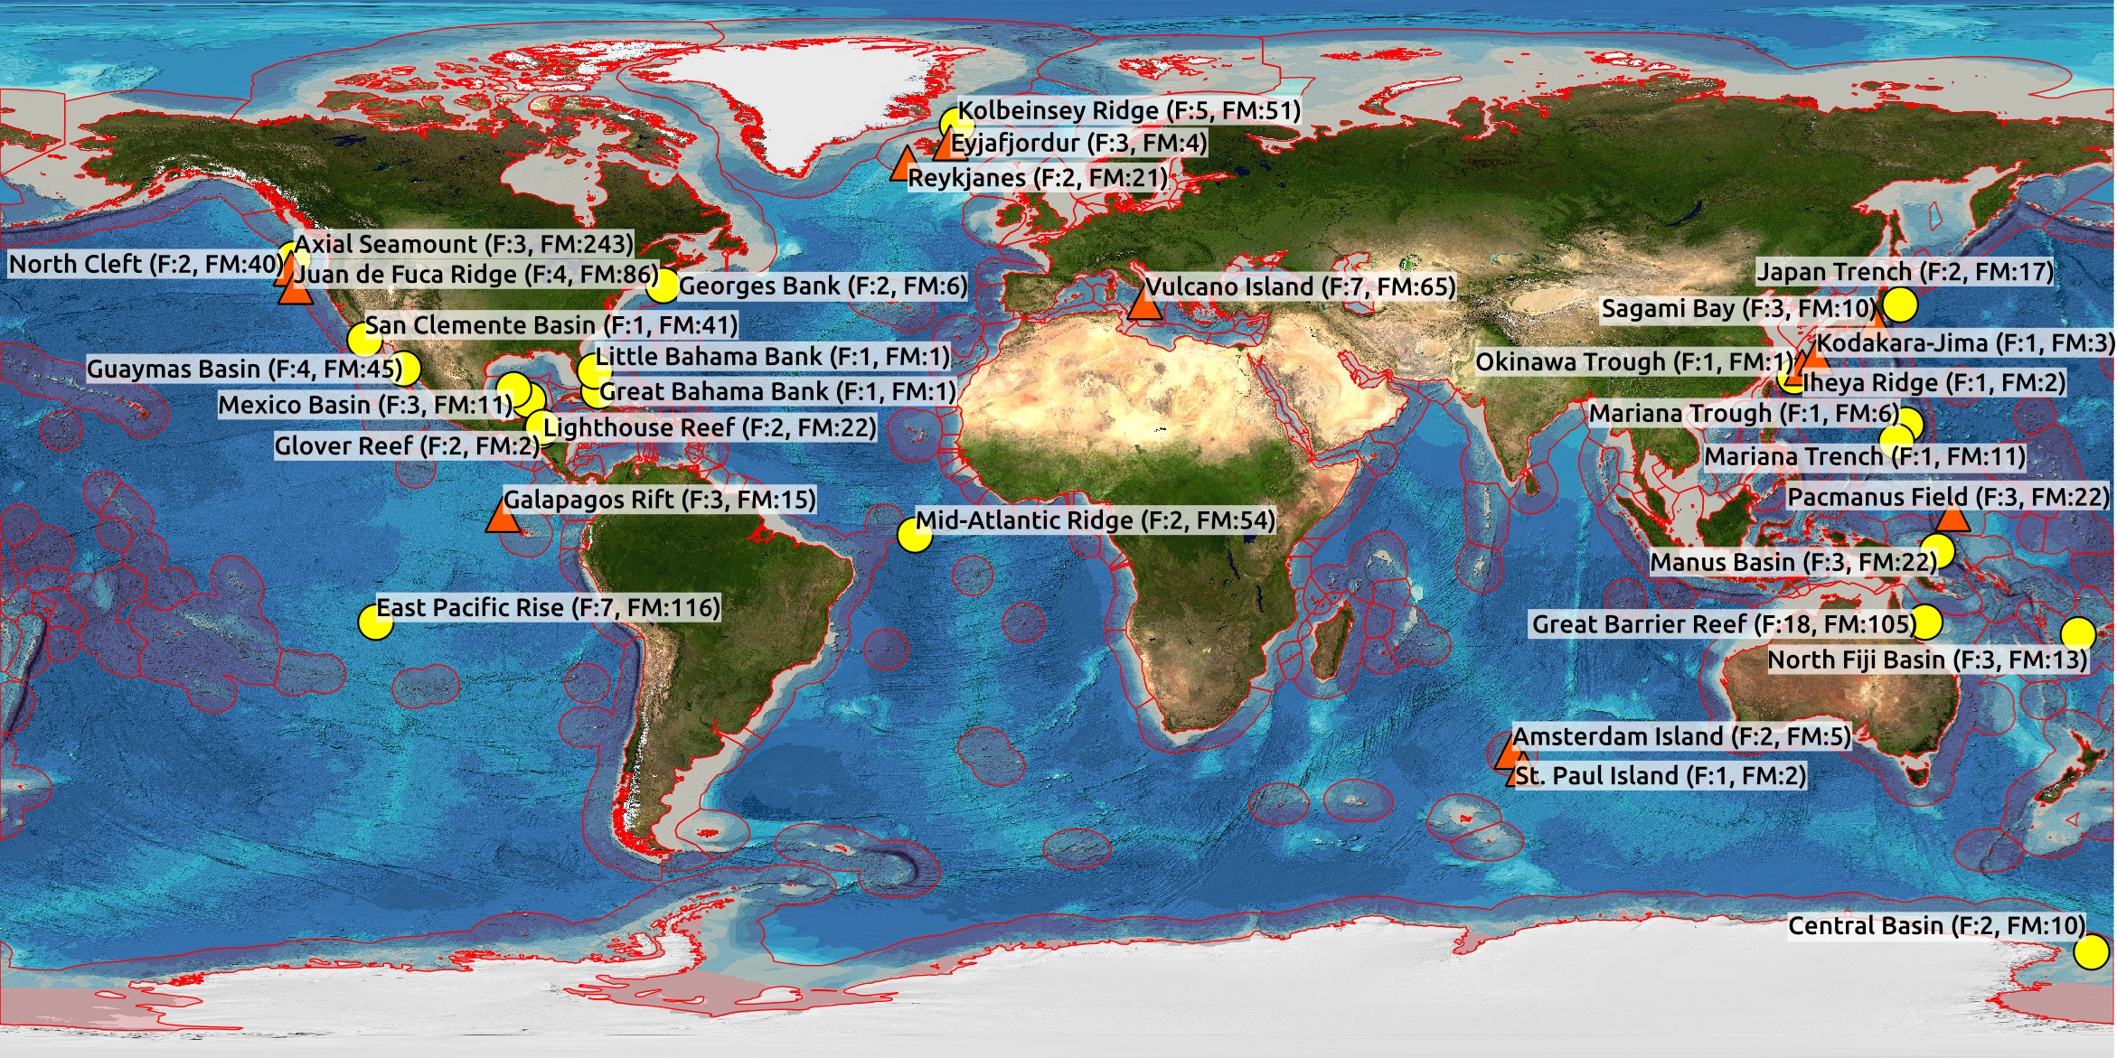

Figure 5.3: Named Places in the Patent Literature

While recognising the limitations of this approach noted above, the main outcome of the research to date is that marine genetic resources associated with deep-sea organisms are predominantly drawn from within national jurisdictions. This is logical when we consider the logistical difficulties and financial costs involved in research in the deep-sea. Furthermore, as both Figure 5.2 and 5.3 make clear there are major deep-water sites within the boundaries of the EEZ. As such it is unclear precisely why Areas Beyond National Jurisdiction (ABNJ) would be a priority for bioprospecting except as an offshoot from publicly funded research expeditions. Mapping helps to bring these issues into focus.

In Annex 2 we provide a set of examples from our research that illustrate the issues involved in patents making reference to places and habitats. The purpose of this exercise is to inform the policy debate around the range of issues involved in identifying the sources of patent data from the deep-sea. We would note that not all of these examples are from ABNJ but are instead intended to provide a representative overview for marine genetic resources. The reference examples in Annex 2 have been selected to illustrate the degree of clarity found in references to origins or sources by taking the paragraph or paragraphs which best describe the source of genetic material. In reviewing these examples we identified a number of clear themes:

*Samples isolated from named locations.* In these cases it is usually stated that a strain had been isolated from, or discovered at, a location such as the East Manus Basin or the Kolbeinsey Ridge, or that a specimen had been cultured from a species taken from a named location such as the Juan de Fuca Ridge. However, in these cases it is not clear whether the inventors themselves collected the samples or they had acquired the samples via a third party such as a commercial source.

*Samples from broad geographical areas.* Sometimes a species with wide distribution, such as krill or a fish, is described as having been obtained from a general location. This was usually the name of an ocean or sea such as the Mediterranean Sea or ‘seas around Japan’.

*Specific collection locations.* We identified one clear case where coordinates were given for the location of a collection (*Aplidium cyaneum* taken from the Weddell Sea). In other cases coordinates were provided but obscured by machine code from the translation of documents from .pdf format. In other cases more precise location names were used such as Georges Bank for the harvesting of fish and coastal areas within EEZs such as Arcachon Bay in France, the Gulf coast of Florida or Chesterfield Island in the Pacific. Also included in this category are cases where specimens have been collected after being stranded on beaches in Hawaii and Australia.

*Acquired through a third party.* Microorganisms in particular are often obtained via a culture collection or through commercial suppliers. In some cases this will be for a branded product such as DeepVent.

*Unspecified location habitat descriptions.* It is sometimes the case that a species is described as being from a habitat type such as a hydrothermal vent, a given water depth or from a high temperature environment. In these cases no further indication of the origin is given.

This analysis reveals that it is extremely difficult to ascertain the precise source of genetic material from Areas Beyond National Jurisdiction as used by patent applicants. The wording of a patent can often be read in a number of ways, in particular where a specimen is described as having been isolated from a given location. Thus, while an applicant may state that a specimen was isolated from a given location it does not necessarily follow that the applicant actually collected and isolated the sample. As these particular examples often involve species from extreme environments it is very probable that these specimens have been obtained through a third party, simply because of the difficulty of obtaining a specimen from its original source. Additionally it is widely recognised that pharmaceutical research typically relies on biobank and database samples rather than direct collection of specimens [8]. It is noteworthy that in cases where species were collected from beaches or near-shore locations more information is provided regarding the source location and whether it is the applicant (or an agent of the applicant) who harvested the specimens. This might indicate that where actual effort is required to obtain specimens it is mentioned in the patent document. However, in other cases, such as the Juan de Fuca Ridge, applicants appear to mention the original source of the material as a general point of interest even where it is a widely available from commercial sources.

5.4 New Species and Strains in the Patent Data

The present research has focused on the analysis of binomial species names in patent data. Given that new distinct strains of a specific species may be the focus of an invention we conducted additional exploratory research for references to new strains and new species. Figure 5.4 presents a summary of these results. The term WIPO refers to WIPO sequence data, 16S refers to patent documents containing references to 16S rDNA and related terms while Minus 200 m refers to the sectioning of documents into a dataset containing marine species known to occur below 200 metres in depth.

In considering this summary of results it is clear that the references to new strains or new species in the marine patent data predominantly refer to strains or species originating inside the EEZ. We would emphasise that a more comprehensive review of these references is merited in any future research.

Figure 5.4: References to New Species or Strains in Patent Data

|  |  |  |  |
| --- | --- | --- | --- |
| Genus/Species | Inside EEZ | Outside EEZ | Unknown |
| Oceanobacillus iheyensis  WO2012116230A (WIPO)  WO2013042900A (16s) Methodology |  |  | II |
| Psychrobacter pacificensis EP1193312A (16s) | I |  |  |
| Protolyngbya sp. EP2465515A (16s) - Not deep sea | I |  |  |
| Pseudomonas strain ChG 3-3 WO19970433A (16s) | I |  |  |
| Thermococcus gorgonarius (new strain) WO1998014590A (Minus 200 m) | I |  |  |
| Vibrio harveyi strain MM32  WO2003064592A (WIPO)  WO2004101826A (WIPO) |  |  | II |
| Clostridium ganghwense strain WO2011011683A (WIPO) |  |  | I |
| Dunaliella salina HT04 strain WO2010054325A (WIPO) (16s) |  |  | I |
| Aureobasidium pullulans strain NP1221 WO2009154320A1 (WIPO) |  |  | I |
| Aureobasidium pullulans strain ADK-34  EP1522282A (16s) |  |  | I |
| Microsporidium sp.  US20040047840A (Minus 200 m) (16s) | I |  |  |
| Olleya marilimosa VIG2317 strain EP2441433A (16s), US20120095108A (16s) |  |  | II |
| Aerococcus viridial P3-1 & P3-2 - or possibly new species  WO2005109960A |  |  | I |

5.5 Conclusions

This chapter has presented a brief summary of the results of research on the origins or sources of marine genetic resources in patent data from the European Patent Office, the United States Patent and Trademark Office and the Patent Cooperation Treaty. A set of reference examples from the research are provided in Annex 2. The main findings of this research can be summarised as follows.

1. On balance, references to origins or sources inside the EEZ dominate existing references within patent documents for marine genetic material. This includes deep-water locations inside the EEZ and reflects patterns in marine genetic research identified elsewhere in this research. This concentration is logical when we consider the financial costs and logistical challenges of research in deep water locations. Exceptions to this pattern include the East Pacific Rise and the Mid-Atlantic ridge.

2. References to places in patent documents display a pattern consisting of: a) samples originally isolated from named locations; b) samples taken from broad geographical areas (e.g. seas around Japan); c) specific collection locations, including rare instances of georeferenced coordinates; d) material acquired through a third party, notably a commercial source, a collection or a DNA sequence or protein database; e) habitats in unspecified locations such as hydrothermal vents.

3. Analysis reveals that it cannot be assumed that a reference to a sample originating from a particular location signifies that applicants actually collected the sample. The data suggests that more often than not the applicants obtained the material through an intermediary and that information on the origin or material is provided as a point of interest. An exception to this general observation are those instances where disclosure of the organism, or its genome data, is required to meet the sufficiency of disclosure requirement under patent law. This is typically met through reference to a deposit under the Budapest Treaty or reference to the relevant sequence data.

4. It would be a mistake to conclude that applicants are seeking to disguise the source of material to protect their commercial interest. In particular, we are struck that applicants are willing to provide information on the ultimate origin of genetic material (e.g. an industrial enzyme) even where this information is neither relevant nor required. That is, in the case of deep-sea material, applicants appear to be willing to offer information as a point of interest.

5. The willingness of applicants to offer additional information on the origins of deep-sea material suggests that a request to provide additional information, where known, on the geographic origin of genetic material could meet with a positive response. This would have the advantage of enhancing knowledge of the role of genetic resources from Areas Beyond National Jurisdiction in innovation as a contribution to understanding and recognising the value of genetic resources from the deep-sea. In contrast with debates at WIPO linked to disclosure of origin for genetic resources inside national jurisdictions, we assume that the provision of additional information would be voluntary and would not carry consequences for obtaining or maintaining patent rights. We recognise that substantive concerns exist on whether genetic resources from ABNJ should be the subject of patent rights. However, in our view the evidence for patent activity originating from marine genetic resources in Areas Beyond National Jurisdiction is presently limited. Much could be achieved in clarifying and valuing the role of marine genetic resources from ABNJ in innovation by encouraging voluntary action by patent applicants.

6. In recommending the increased provision of information by patent applicants we recognise that there will be a need to consider the relationship between enhanced provision of information on genetic material from Areas Beyond National Jurisdiction and debates on mandatory disclosure of origin for genetic resources and traditional knowledge from within national jurisdictions presently under discussion at WIPO.

References

1 Oldham P, Burton G (2010) Defusing Disclosure in Patent Applications. UNEP/CBD/COP/10/INF/44.

2 Oldham P, Hall S, Forero O (2013) Biological diversity in the patent system. *PLOS ONE* 8(11): e78737. doi:10.1371/journal.pone.0078737.

3 Leary D, Vierros M, Hamon G, Arico S, Monagle C (2009) Marine genetic resources: A review of scientific and commercial interest. *Marine Policy* 33: 183-194.

4 Leary D (2012) Moving the Marine Genetic Resources Debate Forward: Some Reflections*. International Journal of Marine And Coastal Law* 27: 435-448.

5 Tvedt M, Jorem A (2013) Bioprospecting in the High Seas: Regulatory Options for Benefit Sharing. *The Journal of World Intellectual Property* 16: 150-167.

6 Chiarolla C (2014) Legal and policy background: IP Protection and marine bioprospecting in areas beyond national jurisdiction. *Queen Mary Journal of Intellectual Property* (forthcoming).

7 Chiarolla C (2011) Intellectual Property, Agriculture and the World Food Crisis: The Privatisation of Crop Biodiversity. Cheltenham: Edward Elgar Publishing.

8 OECD (2013) Marine Biotechnology: Enabling Solutions for Ocean Productivity and Sustainability. Paris: OECD Publishing.

6. The Value of Marine Genetic Resources

6.1 Introduction

In this chapter we examine existing information on the actual and potential economic value of marine genetic resources drawing on the available scientific and market literature. As a starting point, we would emphasise that the value of marine organisms and habitats cannot simply be reduced to economic values. Rather our purpose is to assess existing information on the economic value of marine genetic resources from Areas Beyond National Jurisdiction as a contribution to evidence based analysis and debate on the economic value of these resources. Specifically, we argue that at present marine genetic resources fall into the domain of potential economic value rather than realised value. This has important implications for the design of a possible implementing agreement (or agreements) involving access and benefit-sharing within the framework of UNCLOS.

As a starting point important qualifications need to be made between the types of resources from marine organisms and between potential and actual values. With respect to the types of resources from marine organisms, we use the term marine genetic resources to mean genetic material from marine organisms falling into three broad categories:

1. DNA, RNA and amino acid sequences and metabolic pathways performing particular functions or expressing products of interest;
2. Chemical compounds which may be characterised (where the structure of the compound is fully described) or uncharacterised;
3. Raw extracts of marine organisms (i.e. fish oils).

Resources falling into the first category are most commonly associated with the term genetic resources and would include industrial enzymes and research tools and are expressed in informational form as sequence data. Resources in the second category are most closely associated with pharmaceuticals and medicines where the identification and use of a characterised or uncharacterised compound does not depend on the analysis of the underlying genetic structure and interactions within an organism. The third category of raw extracts from marine organisms is most closely associated with the commercial harvesting of marine organisms, such as Antarctic krill to produce Omega-3 fatty acid based products or the use of extracts in cosmetics and nutraceuticals. These broad distinctions are useful for descriptive purposes in approaching the economic value of marine genetic resources.

The first category of marine genetic resources typically focuses on a DNA and amino acid sequences used to encode information for the expression product of interest, such as an enzyme, that can then be synthesised in an industrial host organism such as a yeast or bacterium. Typically, this does not require large scale and repeated consumptive use of a marine organism once the synthesis process has been developed. For example, Green Fluorescent Protein (GFP) is widely used in biotechnology as an expression marker and is widely available as a synthesised commercial product for in the region of $250-300 per 300 micrograms (ug). The gene responsible for GFP was first isolated in the jellyfish *Aequorea victoria* but the protein is now produced in the engineered bacterium *Escherichia coli.*

In contrast, the second category may require repeated collections of the organism of interest (such as a sea sponge) until such time that a compound is fully characterised and a synthetic or semi-synthetic route is found to produce the compound of interest. This can raise conservation issues such as in the case of the best selling cancer drug Taxol, derived from the endangered Pacific Yew (*Taxus brevifolia*), which required government incentives to promote the quest for a semi-synthetic and fully synthetic means to produce the compound that did not require repeated collection of the bark of this tree.[25] In the case of Taxol it took over 20 years before the first complete synthesis of the compound was reported. This type of issue is particularly prevalent for organisms such as sea sponges and tunicates that produce highly complex compounds in low quantities.

The third category, raw extracts, usually depends upon repeated harvesting of an organism. In the case of marine genetic resources the best-known example is Omega-3 fatty acids that are extracted from fish, and more recently from Antarctic krill (*Euphausia superba*), to serve growing markets for Omega-3 products. Resources in categories 2 and 3 raise significant conservation issues, including in cases of apparently abundant resources such as krill.

It is important to recognise that different industry sectors make use of marine organisms as resources in a variety of ways with different consequences for conservation and sustainable use. Genetic resources used as informational resources in biotechnology based on small samples expressible as DNA, RNA and amino acid sequences do not have the same level of environmental impacts on source organisms as other uses of marine resources such as the collection of organisms using benthic trawls. Expert participants in the *Valuing the Deep* Delphi study noted a need for care in sampling activity but agreed that the environmental impacts of research sampling pale into insignificance compared with commercial fishing and mining.

The second major qualification relates to the distinction between the potential and actual commercial value of marine genetic resources. This distinction is important in debates on access and benefit-sharing because a failure to distinguish between actual and potential value can lead to misrepresentation of the economic value of genetic resources. This in turn can distort debates on policy options by presenting potential value as actual value. These values can be considered in three categories:

1. Marine genetic resources that are of actual value for research in advancing knowledge and understanding of marine biodiversity but do not possess a realised, or realisable, commercial value.
2. Marine genetic resources that are a focus of research and development directed to the potential development of new and useful products but have not yet resulted in commercial products that have passed through the regulatory approvals process and reached the market.
3. Marine genetic resources or products that are on the market.

The first two categories are associated with the potential economic value of marine genetic resources. Scientific literature and patent applications and grants typically fall into these categories: the former because they may suggest or directly point to potential commercial applications and the latter because patent applications are a public indicator of commercially oriented research and development that applicants believe has the potential to create a marketable application or product.

Existing reports on the value of marine genetic resources frequently refer to compounds in clinical trials as an indicator of economic value. In practice, compounds in clinical trials normally fail to become actual marketed products (see below). This may be because the promising compound of interest lacks efficacy or displays insurmountable toxicity in animals or humans. As such, while displaying clear intent to create a commercial product, clinical trials are an indicator of potential rather than actual value. As this makes clear, the only true indicators of economic value are gleaned from products that reach the market.

As we will see below, one of the reasons that existing analysis depends on indicators such as scientific publications, patents and clinical trials is the difficulty of identifying marketed products that originate from marine organisms. This in part reflects the considerable difficulties involved in tracing the origins of a marketed product back from a brand name to a compound, extract or sequence and the original organism. This problem cannot easily be overcome in the absence of a major research effort. A second aspect of this problem is the dispersed nature of data on products from marine organisms and a tendency for market related data to be locked up in commercial silos with significant barriers to entry. Finally, commercial sources of data do not typically display the methodological transparency required for scientific research. That is, the empirical foundations of calculations of actual or potential market valuations cannot be assessed. For this reason we have low confidence in market valuations from market research companies as a basis for informing international policy debates (see below). Nevertheless, in the absence of verifiable peer reviewed information we are obliged to use such information but invite the reader to take a sceptical position when considering market value estimates.

In considering the distinction between potential and actual value our purpose is not to neglect the importance of the pursuit of potential value in decision-making on marine genetic resources, rather, it is to promote clarity on the foundation for decision-making and whether it is based on existing evidence of economic value or on expectations and visions of potential economic value. For example, in 2010 the Marine Board of the European Science Foundation produced a position paper entitled *Marine Biotechnology: A New Vision and Strategy for Europe* (see below). This document entirely focuses on promoting the potential of marine biotechnology and has proved influential in shaping the European Union wide *Blue Growth Strategy*, the EU Horizon 2020 programme and its funding stream entitled *Blue Growth: Unlocking the Potential of Seas and Oceans.* In short, a focus on potential value can readily be transformed into investments directed to realising potential value.

In our view the debates on the economic value of marine genetic resources in Areas Beyond National Jurisdiction are primarily about *potential* rather than actual or realisable economic value. This has important ramifications for the potential design of an access and benefit-sharing component of any implementing agreement within the framework of UNCLOS. Specifically, debates on a possible implementing agreement on access and benefit-sharing for marine genetic resources are directed to the governance of the potential economic importance of marine genetic resources and possible arrangements for benefit sharing. In our view, this suggests that marine genetic resources from ABNJ can be grouped with new and emerging developments in science and technology such as nanotechnology or synthetic biology and debates on climate change adaptation in that they call for *anticipatory governance* [1,2].

In this chapter we examine evidence of actual and potential value for marine genetic resources. We approach this by focusing first on growing interest in the potential of marine biotechnology through a review of two recent reports on marine biotechnology. We then turn to a description of potential markets for marine biotechnology and provide a selection of illustrative examples from our patent data across areas such as lubricants, fuels, catalysts and nanotechnology linked with marine organisms. Finally, we consider the characteristics of trends in marine natural product discovery before turning to data on actual products across a range of sectors.

6.2 Marine Biotechnology and Potential Value

In this section we briefly summarise two influential reports: The 2010 position paper of the European Science Foundation *Marine Biotechnology: A New Vision and Strategy for Europe* and the 2013 OECD report *Marine Biotechnology: Enabling Solutions for Ocean Productivity and Sustainability.* Each report looks at biotechnology from a different angle. The Marine Board of the ESF draws up a road map to develop an EU-wide strategy for future development of marine biotechnology. The OECD considers current trends in biotechnology and how they can be managed for a sustainable future. Figure 6.1 presents a concise summary of the key points raised in these major reports.

|  |  |  |
| --- | --- | --- |
|  | ESF 2010 | OECD 2013 |
| Key Arguments | This report argues that marine biotechnology is able to make a significant contribution to global environmental, economic and social challenges.  The report recognises that steps have been taken to better coordinate research infrastructure, but calls for further action to improve collaboration. | This report discusses how marine biotechnology and associated advances in science and technology should be harnessed as solutions to global challenges.  The report calls for a global framework for the sustainable development of marine biotechnology. |
| Key areas | | |
| Food | The reports recognise the significance of molecular technology in aquaculture: using selective breeding, therapeutic methods and enhanced feed to produce a high quality sustainable supply of fish. | |
| Health | The reports recognise the potential of new healthcare products and drugs but acknowledge the challenges of poor taxonomic knowledge, technological limitations and lack of funding for R&D. | |
| Energy | The reports focus on the potential of algal biomass as a sustainable fuel. | |
| Industry | The reports consider marine micro-organisms a sources of ‘greener’ solutions for industrial processes (e.g. enzymes) | |
| Environment | The reports recognise the potential of marine biotechnology to monitor the marine ecosystem (e.g. biosensors) to protect it (e.g. non-toxic anti-fouling agents) and to remediate contaminated environments (bioremediation). | |

Figure 6.1: Key Points of Marine Biotechnology Reports

Figure 6.1: Key Points of Marine Biotechnology Reports (Continued)

|  |  |  |
| --- | --- | --- |
|  | ESF 2010 | OECD 2013 |
| Ecosystem  services | Not considered. | Uses a figure of $20.9 trillion per annum as an estimate of the value of marine ecosystem services.[26] It also recognises services that have no monetary value attached. The report is keen to recognise both the monetary and non-monetary value of ecosystem services provided by the marine environment. |
| Economic indicators | Not identified. | The report calls for input and output statistics similar to those already used in the pharmaceutical industry. It acknowledges that this will require a common definition of marine biotechnology and will need to factor in a number of socioeconomic indicators e.g. employment. The large scope of this undertaking is recognised by the suggestion that this is trialled initially in a few countries. |
| Environmental  indicators | Not identified. | The report suggests that the ‘health’ of the ocean be measured using internationally shared indicators that are benchmarked. Such indicators could include measures of biodiversity and pollution. |
| R&D  priorities | Systematic sampling; culturing methods; cultivation methods; bio-engineering; taxonomic knowledge; information exchange. | Sampling and observation vessels and collection equipment; high throughput screening of genomic sequences; new methods of culturing; new methods of preservation; biobanks and databases; real-time expedition information; taxonomic specialists. |
| R&D  collaboration | Calls for an urgent EU R&D policy.  This report focuses on the need for specific education and training to equip scientists with the interdisciplinary approaches necessary.  The report refers to multiple existing coordination networks and notes that the challenge is to build these into a coherent infrastructure. | Recognises the Joint Programming Initiative (JPI) as a model for facilitating cooperation and avoiding duplication. It also identifies a number of bodies offering a similar platform, some of which are international, and others regional; some of which are multidisciplinary and others specialised e.g. focusing only on marine eukaryotes. |

Figure 6.1: Key Points of Marine Biotechnology Reports (Continued)

|  |  |  |
| --- | --- | --- |
|  | ESF 2010 | OECD 2013 |
| Industry  collaboration | The report recognises the importance of industry-academic partnerships in marine R&D but acknowledges that SMEs currently take most of the financial risks associated with R&D and calls for larger organisations to take a greater role. | The report recognises how globalisation has led to greater collaboration between industry and external partners, particularly academia. It refers to examples of government funding initiatives to encourage such partnerships. It goes on to call for earlier and more focused collaborations, citing the biofuel industry as an example where earlier collaboration has resulted in greater commercial success. |
| Encouraging  collaboration | The report states that marine biotechnology suffers from a lack of identity in its own right. Like the OECD report, this report suggests that greater public awareness and engagement will raise its profile. The ESF paper gives strong priority to this area of identity and communication. | The report considers the Human Genome Project (HGP) as an example of a successful international initiative, or ‘mega project’ with shared goals. |
| Access and Benefit- Sharing | This report considers that industry and academia may have different objectives in relation to ABS. It recommends “simplification and harmonisation” of ABS but notes that there are significant issues to be overcome before a mechanism can be established, citing conflicting claims to Arctic waters as an example. | The report provides a descriptive account of current debates around ABS. It discusses the types of ‘benefits’ that may arise, using the Nagoya Protocol and Plant Treaty as a basis. However, the report emphasises that the focus on ABS should not overshadow conservation and sustainability. |
| Policy | Both reports call for the alignment of research policy and bioresource policy. They also emphasise the importance of a public engagement strategy. Both are focused on R&D as a priority with ABS as a secondary consideration. | |

These two reports focus upon and clearly demonstrate the importance given to the marine biotechnology sector by policy-makers and experts. The sector as a whole is regarded as having the potential to play a significant role in the broader arena of biotechnology, both in established medical biotechnology and the newer, emerging field of industrial biotechnology. It is increasingly being presented as a central feature of nations’ bio-economy strategies, offering green economic solutions to some of the major societal challenges of the coming decades.

Potential Markets and Patent Activity

Figure 6.2 provides a brief overview of the major industrial and medical fields of biotechnology. This is followed by illustrative examples of how marine genetic resources have been utilized by various technology fields in patent data. These examples demonstrate the wide range of applications involving marine genetic resources in different technology fields.

Figure 6.2: Summary of some Key Marine Biotechnology Sectors.

|  |  |  |
| --- | --- | --- |
| Technology Area |  |  |
| Medical Biotechnology | Pharmaceuticals | Drug Discovery |
| Drug Development |
| Drug Manufacture |
| Medical products | Medical Polymers |
| Wound dressings |
| Dental Biomaterials |
| 3D Tissue Culture Scaffolds |
| Diagnostic Tools |
| Other Health Products | Nutraceuticals |
| Industrial Biotechnology | Feedstocks | Algal derived biofuels |
| Products | Biodegradable Plastics |
| Food and Drink Additives |
| Cosmetics |
| Speciality Chemicals |
| Lubricants |
| Processes | Enzymes and catalysts |
| Agricultural Biotechnology | Fertilisers |  |

Lubricants:

Nissin Oil Mills Ltd and Nippon Steel Corporation (EP0193870A2, 1986) have claimed a new lubricant to be used in the production of steel sheets. The composition of the lubricant included oils from a deep-sea fish found off the coastal waters of South Africa, Australia and New Zealand. The fish used are from *Hoplostethus atlanticus*, H. mediterraneus, H. gilchristi, and H. intermedius - collectively known as roughies or slimeheads. The oils contain wax esters that have excellent thermal stability, which provide an advantage over other oils when used in a cold rolling environment. This example illustrates the potential for marine genetic resources to be used in industrial processes, but also highlights a conservation issue: the roughy is a late breeding, very long-lived fish, living up to 149 years, which has been an important fishery species. However, over exploitation has seriously reduced the population. Stocks are very slow to recover due to the late age at which the fish breed, which occurs when the fish is approximately 30 years old, and as a result the sustainability of this harvest is in doubt.

Oil recovery:

Another industrial use of deep-sea marine life can be illustrated by a 2012 claim by Geo Fossil Fuels LLC (WO2012116230A1) for “new, efficient, economical and environmentally safe microbial methods to enhance oil recovery, as well as microorganisms useful in such methods”. In this invention microbes that are naturally or engineered to be alkaliphilic, halo-alkaliphilic or alkaline tolerant are used to degrade hydrocarbons in oil reservoirs that subsequently makes the recovery of oil more readily achievable. The microbes that are used contain gene sequences from *Oceanobacillus iheyensis*, a deep-sea microorganism that was first isolated from deep-sea sediment collected at a depth of 1,050 m on the Iheya Ridge.

Fuels:

Microorganisms from deep-sea habitats feature prominently in the patent landscape. The Korea Ocean Research and Development Institute claimed in EP2333054A2 (2011) for a novel hydrogenase. This enzyme was isolated from a hyperthermophilic strain of *Thermococcus onnurineus*, which was isolated from a deep-sea hydrothermal vent at the PACMANUS field in the East Manus Basin of the South Pacific region. Such isolates are deposited in type culture collections, and the source of the strain for this invention was the Korean Collection for Type Cultures (KCTC) at the Korean Research Institute of Bioscience and Biotechnology (KRIBB) where it was assigned the accession number KCTC 10859BP. The claim includes a gene encoding the hydrogenase and the use of a culturing technique for the microorganism to produce hydrogen in a manner more efficient than existing methods such as the electrolysis of water, and the thermal-cracking or steam reforming of natural gas. “According to the hydrogen production methods of the invention, a large amount of hydrogen can be produced merely by culturing the strains in specific culture conditions. Thus, the methods of the invention have advantages in that they are more economic and efficient than existing hydrogen production methods and can produce hydrogen even at high temperature.”

The Craig Venter Institute is involved in similar activity related to producing oxygen-tolerant, hydrogen-evolving hydrogenase and for generating hydrogen from water (WO2008143630A2, 2008). The bacterium used in this example is the *Alteromonas macleodii* (str deep ecotype, ‘made’) was isolated from deep water (3500 meters) in the Uranian Basin (Crete, Ionian). “Alteromonas macleodii (str deep ecotype, ‘AmDE’) is one of 135 marine microbes sequenced at Venter Institute. It is a gram-negative, heterotrophic marine bacterium that grows under aerobic conditions.”

Yet another marine bacteria offering a potential biotechnological source for production of an energy alternative to fossil fuels is Thermotogae (US20120270297A1, University Bowling Green State, 2012).

Catalysts:

Novozymes AS has made an application to use thermophilic bacteria as a catalyst in the extraction of carbon dioxide (WO2010151787A1), the resulting enzyme having a wide range of potential uses. This application relates to use of carbonic anhydrases obtainable from Caminibacter in CO2 extraction. Carbonic anhydrases are useful in a series of applications, such as for CO2 extraction from CO2 emission streams such as power plants or exhausts and to remove CO2 in the preparation of industrial gases. The carbonic anhydrase or enzyme based bioreactors are also useful in less familiar environments such as in cockpits and fire fighting gear to keep breathing air free of CO2 or to remove from CO2 sensitive environments like museums and libraries to prevent excessive CO2 from causing acid damage to books and artwork.

Several bacterial strains belonging to the genus Caminibacter have been isolated from deep-sea hydrothermal vents. Novozymes’ application describes the cloning, expression and isolation of the mature carbonic anhydrase from C. mediatlanticus DSM 16658 and “confirms that the amino acid sequence gives rise to an enzyme with carbonic anhydrase activity. The characterization of the enzyme also revealed that it is thermostable to a level which could not have been expected based on the growth temperature of the bacterium.”

Polymerases and PCR:

In the fields of biotechnology new uses are being found for extremophilic organisms. In 2009 GE Healthcare Biosciences isolated and cloned a thermostable DNA polymerase gene from *Thermococcus barossi*, obtained from deep vent flange, Endeavor Segment, Juan de Fuca Ridge, in the U.S.A (WO2009085333A1). The Juan de Fuca Ridge is a tectonic spreading range between the Juan de Fuca Plate and the Pacific Plate. This newly isolated Tba DNA polymerase enabled an improved PCR method for amplifying long DNA fragments. Specifically, this improved method can be used for the rapid amplification of over 10 kb long DNA fragments. The ability to easily and rapidly obtain long DNA sequences was identified as a significant aid to disease gene discovery and analysis.

The Korea Ocean Research & Development Institute also claim a novel hyperthermophilic “DNA polymerase useful in precision analysis, precision diagnosis, identification and the like, which require accurate PCR” (WO2007043769A1, 2007). In this application, a new hyperthermophilic Thermococcus sp. strain was isolated from a deep-sea hydrothermal vent area at the PACMANUS hydrothermal field located along the crest of Pual Ridge in the East Manus Volcanic Zone, Papua New Guinea. A further example of this organisation’s work with enzymes is WO2008066350A1 (2008) from a Thermococcus sp NAl. strain also isolated from the PACMANUS hydrothermal field.

Another thermostable enzyme, derived from the hyperthermophilic archaeon *Thermococcus guaymasensis* (isolated from the Guaymas Basin), has utility as a biocatalyst for chiral compound biosynthesis and in biofuel production (WO2010034115A1, Ma Kesen and Ying Xiangxian, 2010).

Fish Feed & Oils:

Species within the patent landscape that are particularly worthy of note include krill, the small crustaceans of the order Euphausiacea that can be found across the world’s oceans. Krill oils and meal feature in numerous documents and across a variety of industries. One such industry is aquaculture, which is responsible for the supply of much of the fish products consumed by humans. Krill can be used as a component in feed for farmed fish and its use can be illustrated by a 2009 patent application from Nippon Suisan Kaisha Ltd for a “Feed using peeled krill as the starting material and method of preventing decrease in fish growth rate by using the same” (EP2095722A1). The background to this invention is that protein fed to carnivorous farmed fish would normally be in the form of fishmeal, but that the large biomass of Antarctic krill (*Euphausia superba*) and the increase in scale of the aquaculture industries made krill a potential substitute for fishmeal. The patent claims a composition in which the krill component provides optimum growth rates in the farmed fish, whilst removing the possibility of toxic levels of fluorine entering the food chain by removing the krill’s shell before manufacturing the meal.

Nutraceuticals:

Products manufactured from krill are also consumed by humans, usually in the form of Omega-3 fatty acids provided in what are termed ‘nutraceuticals’, a type of product advertised as having nutritional value as well as having an effect on biological functions. An internet search for krill oil preparations will reveal a large number of marketed products. These products are subject to continual research and development, and a recent example of an invention which hopes to improve the efficacy of a krill supplement is US20120321602A1 (2012) by Ronald E Rosedale in which he developed a new omega-3 function model based on the premise that certain phospholipid forms are better at enhancing membrane fluidity and permeability, while other forms of omega-3 fatty acids (e.g. free fatty acid forms) are better at stimulating biological receptors of interest. Using this model a new product was developed by which the inventor attempted “...to the greatest extent possible, to duplicate at least some of the beneficial effects of caloric restriction as a model for improved health.”

Nippon Suisan Kaisha Ltd has claimed “a sexual function improving agent” that “contains a lipid as an active ingredient, which includes a highly unsaturated fatty acid as a constituent fatty acid” (WO2012103692A1). This agent includes purified krill oil as the active ingredient.

Pharmaceuticals:

Bioprospecting for marine anti-tumour compounds has produced a number of successes, as demonstrated by the table of marketed marine derived drugs (below). Tunicates, also known as sea squirts, have been especially successful in yielding prospective anti-tumour cancer therapies. In 2007 the Spanish company PharmaMar SA claimed for an anti-tumour treatment produced from indole alkaloids derived from the tunicate *Aplidium cyaneum* (WO2007054748). The tunicates were collected by bottom trawling in the Weddell Sea at a depth ranging between 220 and 300 metres. This species is distributed around the Antarctic in waters of the continental shelf and slope from 75 down to about 1,000 metres. Compounds isolated or derived from tunicates have been and are being subjected to clinical trials and are perceived as being a potentially valuable part of the ongoing search for specific anticancer drugs.

A further relatively recent example of an organism with potential pharmaceutical application is found in WO2011076605A1. In this 2011 application, the French National Centre for Scientific Research (CNRS) and Lille University of Science and Technology claim the use of a deep-sea heat tolerant worm in aquaculture and with potential human pharmaceutical applications. It is claimed that the pharmaceutical composition can be used as an animal or human antibiotic therapy, in a dietary composition, particularly a food supplement, and in disinfectant. An antimicrobial peptide was isolated from a deep-sea worm, *Alvinella pompejana*. This worm is extremely heat-tolerant, surviving in temperatures up to 80 °C. The applicants disclose that “Twenty entire full-grown and sexually mature Pompeii worms were collected on the East Pacific Rise at 3,000 meters deep”.

Another example of potential pharmaceutical application of a marine derived product is from the mucus of the hagfish, *Myxine Glutinosa*. In a 2009 application from the Canada National Research Council (WO2009149554A1) the peptide myxinidin in the extract of extruded hagfish slime exhibited microbiocidal activity against a wide range of microbial pathogens and no toxicity to mammalian red blood cells. It is claimed that the antimicrobial peptide myxinidin is useful as an antibactericidal or bacteriostatic agent for the treatment of human and fish pathogens and for promoting wound healing. Atlantic hagfish are most commonly captured in muddy sediments on the ocean floor at depths between 150-250 m but have a much wider range of habitats and have been found at up to 1000 m depth.

Nanotechnology:

An example of a patent application with wide ranging potential across nanotechnology, pharmacology and drug synthesis is WO2005094543A2, Verenium Corp (formerly Diversa Corp), 2005. This example is based on a heat resistant protein Cannulae A (or CanA) that is capable of forming nanotubes. “Cannulae nanotubes are formed by Pyrodictium abyssi, a hyperthermophilic microorganism discovered in a high temperature environment (>100 °C). In its natural environment and in cell culture, Pyrodictium abyssi are linked together by a meshwork of these nanotubular fibers that both connect and entrap the cells.” According to the document, “these fiber networks are a unique feature of the genus Pyrodictium and they appear to be required for growth above 100 °C … While it remains speculative as to what the true role of the nanotubes is in nature, it has been suggested that the linkage of cells by these tubules could enable cells to exchange metabolites, genetic information, or signal compounds.” It is claimed that the potential uses of this application include heat resistant fabrics and coatings, plant growth, detoxification of soil and water and in human health.

Diagnostics:

WO2001009387A1 from 2001 by Northeastern University from the USA is an example of the use of novel genetic properties of marine organisms in diagnostics. Fish samples were collected from Antarctic waters near Low and Brabant Islands in the Palmer Archipelago by bottom trawling. The inventors discovered that a unique family of Antarctic fish, (the hemoglobin-lacking icefish *Chaenocephalus aceratus*, *Pseudochaenichthys georgianus* and *Chionodraco rastrospinosus*), failed to express hemoglobin, due to deletion of most of the juvenile and adult globin gene complexes. The so-called ‘white-blooded’ icefish also no longer produce red blood cells. The claimed invention is a method for identifying novel hematopoiesis-related genes, especially erythropoiesis-related genes, by screening for and identifying genes that are expressed by red-blooded fish but not by white-blooded fish. The invention is useful for the diagnosis and treatment of diseases such as sickle cell anaemia, thalassemia or clinical anaemia following chemotherapy.

Bioluminescence:

References can be found throughout the patent data to marine genetic resources that are no longer the focus of inventions but have become established and beneficial tools across a variety of technologies and industries. Prominent among these are the fluorescent proteins. These proteins were originally isolated from marine organisms. Green fluorescent proteins (GFPs) have been isolated from the jellyfish *Aequorea victoria*, the sea pansy *Renilla reniformis*, and the hydroid *Phialidium gregarium*. These proteins, which act as energy-transfer acceptors in bioluminescence, function as reporter genes in a variety of molecular or cell biology research techniques. Although originally isolated from *Aequorea victoria* GFPs have been successfully developed in the laboratory and now include a number of colour variations.

Research carried out to further explore bioluminescence in marine animals can be illustrated by EP1156103A2 in which Chisso Corporation (2001) claimed a polynucleotide or polynucleotides encoding Oplophorus luciferase from the deep-sea shrimp *Oplophorus gracilirostris*. The invention also included a method for recombinantly producing the proteins by culturing the host cell.

Biosensors:

Some patent activity relates to using deep-sea bacteria to monitor human activity such as disposal of waste in the deep-sea. EP1193312A1 (2002) illustrates the development of a 16S rDNA probe useful for species-specific detection of a microorganism as an indicator in studying and monitoring its growth and the circulation of deep-sea water. The National Institute for Advanced Industrial Science & Technology (Japan) application aimed “to provide a technique for species-specifically detecting a microorganism naturally inhabiting in the deep sea or an analog thereof, based on the characteristics of its genetic information.” Specifically a probe can detect *Psychrobacter pacificensis* at a molecular or cell level.

*Psychrobacter pacificensis* is a heterotrophic microorganism from seawater of the Japan Trench at a depth of 6,000 meters. There are concerns about water quality due to increased CO2 and other pollutants that find their way to deep-layer seawater. The focus of the application is to provide a technique for determining the risks of using deep-sea water and monitoring the health of the deep-sea.

Measuring Biodiversity:

Other patent activity involves the development of probes for measuring biodiversity. In 2003, the Council of Scientific and Industrial Research (CSIR) of India made an application for a probe to detect lantern fish as a measure of biodiversity in the ocean (US20030143534A1). “Among the mesopelagic fishes (200–1000 m), the lantern fishes (Family Myctophidae) are extremely common and numerous in both species and individuals in the open ocean midwaters of the world oceans”. Understanding the population levels and distribution of Myctophids can assist in the assessment and estimation of genetic resources, genetic variability and the level of gene flow between various stocks and populations in the world oceans. The invention applies recombinant DNA techniques to DNA extracted from the lantern fish for the preparation of the genetic probes that can identify specific species of fish.

Biofouling:

Another significant area of patent activity is the development of non-toxic anti-fouling agents. The value of the market for marine hull coatings is estimated to rise from $5 billion in 2011 to $10.2 billion in 2018.[27] Biofouling is the undesirable accumulation of microorganisms, plants, and animals on artificial surfaces such as ship hulls, docks, buoys, etc. More than 4000 organisms have been reported as being species causing biofouling, including bacteria, micro-algae, macro-algae, sea-grass, molluscs, crustacean, etc. Most fouling organisms have a swimming larval stage followed by a sedentary adult stage that remains attached to its substratum throughout the remainder of its life. The attached adult organisms can increase frictional resistance on the hulls of ships, increase the weight of buoys, block seawater pipes and compete for space and food with cultured shellfish, among other negative effects.

From the 1960s until recently, organotins, represented by tributyltin (TBT), were common anti-fouling agents. TBT is now regarded as one of the most toxic and hazardous compounds introduced into marine environments. The concerns about TBT and other antifouling biocides have resulted in extensive research and development to create non-toxic antifouling coatings.

An illustration of the type of product development and research is provided by the Hong Kong University of Science & Technology (US20110185944A1, 2011) which claims a non-toxic, environmentally friendly method for preventing or reducing biofouling caused by *Balanus amphitrite*, *Hydroides elegans*, and *Bugula neritina*. The application is for antifouling compounds produced from a *Streptomyces albidoflavus* strain UST040711-291 isolated from a sediment sample from 5000 m depth in the west Pacific Ocean. The product was developed by culturing the bacteria and then extracting a novel group of butenolides (a type of lactone) compounds. These compounds were found to repel various organisms at all stages of their life cycle when applied to a surface. The patent application describes the new compound as well as the production method and method of application.

UK Economic Potential of Marine Biotechnology

Translating the potential economic value of marine genetic resources into actual economic value is difficult. However, it is also important to recognise that biotechnology as a whole has followed a trajectory or pathway from potential to actual value over the last 30 years. While biotechnology as a sector continues to depend on *promises* of future products, the pursuit of potential has also translated into the creation of new companies, jobs and contributions to GDP. The UK biotechnology sector and markets for biotechnology products provides a good indication of this trajectory.

The UK Department for Business, Innovation and Skills, publishes an annual report relating to the landscape of medical and industrial biotechnology and the pharmaceutical sectors in the UK [3]. The annual report provides a snapshot of the state of the various UK biotechnology related sectors and how they are performing in global markets. Marine biotechnology does not feature in these reports, however, as we have seen in earlier chapters, marine genetic resources may contribute in various ways to activities and products developed in these technology areas.

According to UK government figures the three biotechnology related sectors employ approximately 122,000 people in the UK dominated by the pharmaceutical sector and followed by the medical biotechnology sector with 50,000 employees. The industrial biotechnology sector in the UK remains small, and employs approximately 1,800 people. The combined biotechnology sector in the UK has an annual turnover of over £38 billion.

Medical Biotechnologies Market

In the UK this sector employs nearly 27,000 people in 1,073 companies with a turnover of £4.2bn in 2012-2013. A third of these companies undertake R&D dominated by drug discovery and antibody and small molecule technologies. In addition to this core business there are a number of companies providing products and services, and this specialist services sector comprises 903 companies and employs 23,350 people. The total sector growth between 2009 and 2013 was 22%, but this was also marked by a 3.1% drop in employment. The majority of the companies in this sector are Small and Medium Sized Enterprises (SMEs) [3].

Global sales of biotechnology based pharmaceuticals were estimated at £105bn in 2012. Biologics account for 39% of global sales when the analysis is restricted to the top 100 selling drugs. The report estimates that 25% of all pharmaceutical sales will come from biotechnology based products by 2018 representing £130-£190bn [3].

Industrial Biotechnology Market

In the UK this sector employs approximately 1,790 people in a core group of 121 companies with an annual turnover of approximately £605m. Most companies employ less than 250 people and this is regarded as an emerging sector. Businesses within this sector mainly focus on biofuels, food and drink products, and specialist services that provide reagents and equipment. The largest of these companies specialise in enzymes and associated technologies. The global market value for industrial biotechnology in 2011 was estimated at £32bn. In Europe industrial enzymes are of significant importance and the global market for these products is estimated at £1.9bn. Biofuels using feedstock of corn, sugar cane and wheat are particularly important in the Americas with the USA as the main market [3].

Pharmaceutical Market

This is the largest of the three UK biotechnology sectors, with a turnover of £29bn and employing 70,300 people in the UK. 477 companies operate in this sector in the UK. 182 companies (excluding global top 20 companies) are concerned with drug discovery, development and manufacture of pharmaceuticals, employing 16,400 people. 189 specialist supply companies employ 6,200 people and provide clinical trials, equipment, production and regulatory services. Between 2009 and 2013 the workforce fell by 2.7%, driven by the 20 top global companies. Elsewhere the sector saw growth in employment and turnover [3]. The global market for medicines is predicted to grow to £770bn by 2016 with up to £256-275bn of this coming from over-the counter medicines.

As this makes clear, the biotechnology sector in the UK has emerged as a significant source of employment and increasingly makes an important contribution to the UK economy. What remains unclear, and will remain unclear for the foreseeable future, is the contribution that marine biotechnology will make to these sectors. As the OECD has recently highlighted, one reason for this is that in contrast with areas of biotechnology that focus on products and markets (e.g. health, industrial and agriculture), marine biotechnology does not focus on a particular market but is defined by the origin of organisms and genetic material [4]. The assessment of the actual or potential contribution of marine biotechnology to the UK economy would therefore depend on the ability to identify when marine organisms and genetic material are used and to quantify their final contribution to production and market sales.

Having considered issues around the potential value of marine biotechnology we now focus on trends in research on marine natural products as a basis for examining available data on marketed products and market values.

6.3 From Potential to Actual Value

Marine natural products are the focus of regular annual reviews in peer reviewed journals such as *Natural Products Reports* [5] and *Marine Drugs* [6]. Annual reviews typically focus on providing details of new compounds from marine organisms and, in some cases, the status of compounds in the clinical pipeline and approval process. In other cases specialist reviews focus on topics such as anti-cancer agents or classes of marine organisms such as invertebrates or macroalgae [7-9]. The specialist MarinLit database, developed at the University of Canterbury in New Zealand and now operated by the UK Royal Society of Chemistry, lists 24,000 compounds and 26,000 scientific articles.

These reviews provide invaluable information on trends in marine natural products research. However, in some cases the precise source organism for a compound or set of compounds is unclear. This presents problems for determining the origin of marine genetic resources inside the EEZ or from Areas Beyond National Jurisdiction. There are in fact good reasons for this. As one important recent review explains:

“We will also avoid using the source organism as the method of classification as it is now becoming quite evident that the majority of compounds reported from the marine environment are in fact produced by, or in concert with, single-celled organisms ranging from protists (frequently dinoflagellates) to bacteria, including a very significant number of as yet uncultured organisms.” (Newman and Cragg 2014: 256)

In short, marine compounds of interest for pharmaceutical development may arise from organisms hosted by other organisms or existing in a symbiotic relationship with other organisms. This complicates efforts to link particular compounds to a specific organism and particular places in the EEZ or ABNJ.

Recent reports reveal that since the 1960s more than 20,000 compounds have been discovered in marine organisms [10,11]. Prior to 1985 less than 100 marine natural products were described each year. However, with the advent of high speed nuclear magnetic resonance spectrometry (NMR), enabling easier identification of chemical structures, this situation changed significantly from the mid-1980s onwards with a fairly constant 500 new marine compounds described per year between 1990 and 2006 [10]. The main sources of new compounds between 1985 and 2008 were marine invertebrates such as sea sponges and corals with over 300 compounds per year described from 1995 to 2008 [10]. Marine algae have been the source of between 50 and 100 new compounds per year between 1985 and 2008 while microorganisms, including phytoplankton, rose from approximately 50 per year to just over 100 compounds per year between 2007 and 2008 [10]. Hu *et al*., (2011) state that up until 2008 “approximately 75% of the compounds were isolated from marine invertebrates belonging to the phyla Porifera (mostly sponge) and Coelenterate (mostly coral)” and remained constant between 1985 and 2008 (Hu *et al*., 2011: 517). In short, the substantive increase in interest in marine natural products reported in the literature is concentrated in a relatively narrow spectrum of organisms.

Research by Leal *et al*., (2012) on marine invertebrates as a source of 9,812 new natural products between 1990 and 2009 identifies trends in marine compounds from invertebrates and maps the data by the sources of compounds by EEZ [8]. Figure 6.3 displays the major trends for invertebrate phyla.

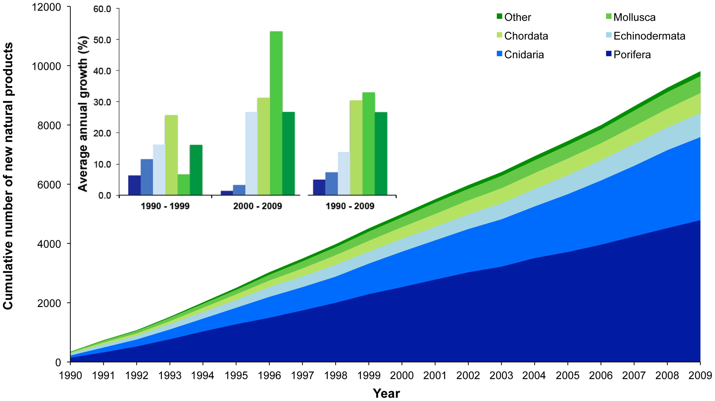

Figure 6.3: Trends in Natural Products from Invertebrates (doi:10.1371/journal.pone.0030580.g001)

Figure 6.3 displays trends in new natural products from marine invertebrates by phyla and demonstrates that the majority of new marine natural products are from Porifera and Cnidaria [8]. However, they highlight that since 1990 the majority of research has “focused on less than 1% of biodiversity currently recognised for marine invertebrates” (Leal *et al*., 2011: 5). In short, biodiscovery efforts are focused on a narrow segment of marine invertebrates. Figure 6.4 reproduces the results of research to map the distribution of new natural product discoveries from invertebrates by EEZ and also displays biodiversity hotspots for invertebrates [8].

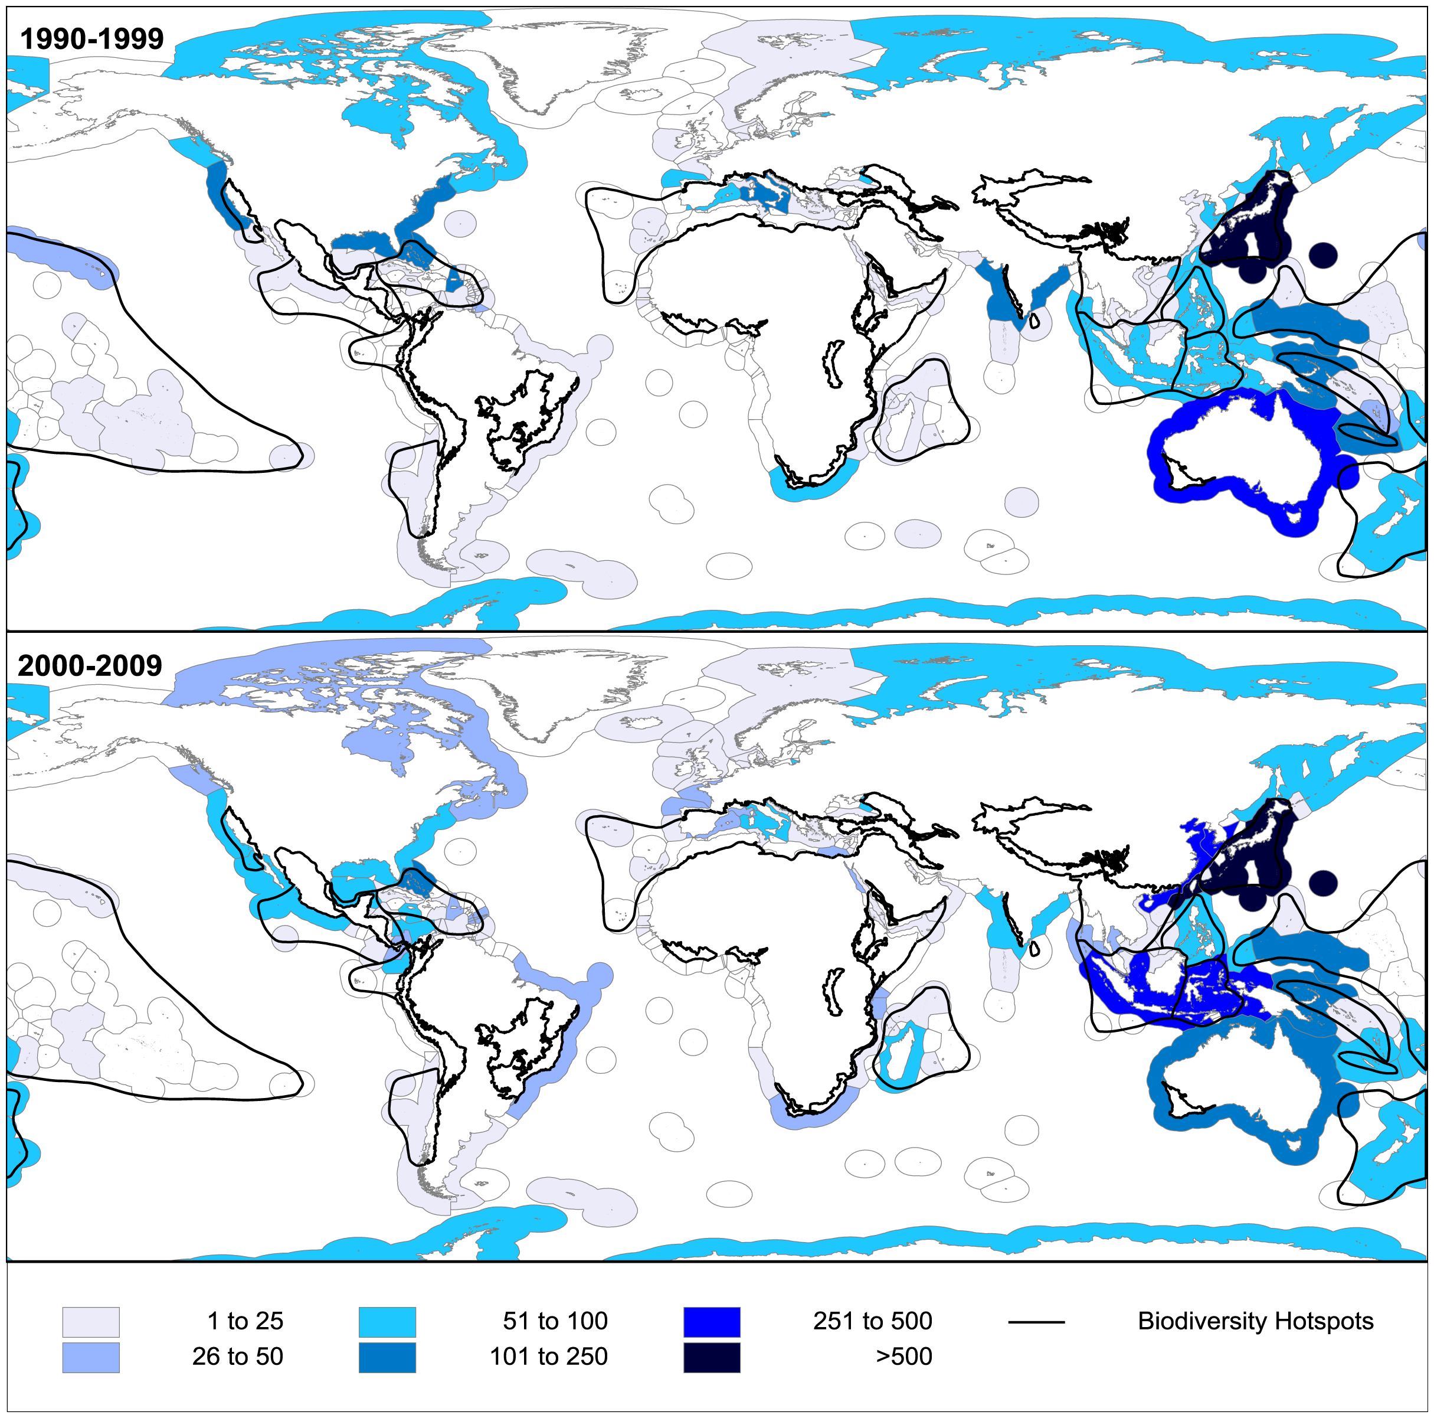

Figure 6.4: New Natural Products from Invertebrates by EEZ (doi:10.1371/journal.pone.0030580.g004)

Figure 6.4 presents the number of new natural products from marine invertebrates during the 1990s and from 2000–2009 including the EEZ boundaries and markers for biodiversity hotspots [8]. In seeking to explain the concentration of marine biodiscovery research in sponges and cnidarians (corals) they argue that this could be explained by their accessibility and the wide distribution of the target species. We would note that Leal *et al*., do not specifically address the subject of Areas Beyond National Jurisdiction. However, the available data on the distribution of invertebrates that have been the source of new natural products strongly suggests that they mainly occur inside the EEZ in coastal areas for the straightforward reason that they are accessible.

This does not mean that deep-sea natural products are not a focus of research effort. However, organisms from the deep-sea may be somewhat hidden in major reviews focusing on the description of compounds. The most detailed review of natural products from the deep-sea that we have been able to identify is the work of Danielle Skropeta from Wollongong University in Australia [12]. Skropeta’s review focuses on species recorded at depth, rather than Areas Beyond National Jurisdiction, and identifies 390 marine natural products ranging in origin from Antarctica to the Caribbean and Atlantic. Over 50% of the metabolites identified in the review were drawn from depths between 100-400 metres, with 10% from 500-600 metres and 8% below 1000 metres [12]. At the time of the review the deepest reported sample came from deep ocean sediment at 5065 metres in the Central Pacific Basin and involves an unidentified gram-positive bacterium that produces two cytotoxic compounds [12]. In common with the wider literature the review highlights that “Deep-sea sponges are by far the largest source of new deep-water metabolites, accounting for over 60% of those reported to date” at depths up to 1,000 metres, with echinoderms accounting for 15% of natural products to depths of 2,000 metres followed by microorganisms at 12% at depths up to 5,065 metres (Skropeta 2008: 1158). A review of the *Marine Drugs* journal for references to the deep-sea in the title, abstract or author keywords of articles revealed 31 new publications with 14 published in 2013 suggesting growing interest in deep-sea organisms. Given that this is confined to one journal it will represent an underestimate of wider publications.

As this makes clear, while there has been significant growth in interest in marine organisms as a source of new natural products this displays very particular characteristics with respect to a focus on coastal areas and marine invertebrates. We now turn to a discussion of the obstacles involved in developing marine natural products before considering data on actual products on the market and their origins. In this discussion we draw primarily on the most recent 2014 review of marketed marine natural products by Ana Martins *et al*., and complement this information with the results of our own research [13]. We would note that the evidence base for widely quoted market estimates is not generally accessible for validation.

Barriers to the Development of Marine Products

Martins *et al*., (2014) focus on the pharmaceutical and cosmeceutical (medical cosmetics) market and identify three main barriers to commercial success: a) accessibility of the biodiversity; b) supply and technical issues (sustainable production), and; c) the cost of bringing a product through to market [13].

The extent of these barriers comes into focus when we consider that approximately 20,000 structurally unique marine natural products have been described, with 1,241 being described in 2012 alone [13]. However, there are currently only eight approved drugs from marine natural products on the market (one of which, Vidarabine, has subsequently been withdrawn), and another ten in clinical trials [13]. At present, seven cosmeceuticals from marine natural products are commercially available [13].

Factors identified as key barriers for the development of marine natural products in the Martin review and the wider literature include:

1. Lack of taxonomic knowledge to reach an unambiguous taxonomic classification [13];

2. Variation in the nature of organisms across a species resulting from varying environmental stresses and other factors including the microbial environment [13];

3. Problems with culturing organisms;

4. Problems with obtaining a sustainable supply;

5. Low success rates in clinical trials (a common factor across compounds).

In considering these and other relevant barriers in relation to marine genetic resources from Areas Beyond National Jurisdiction it is logical to add the financial, logistical and technological costs and challenges involved in collecting and culturing organisms particularly at depth. While metagenomics is an important emerging area in marine research the ability to identify a DNA, RNA or amino acid sequence is not the same as the ability to identify a complex compound that is an expression product of multiple genetic interactions and environmental factors for which the ability to sample and culture the organism will be vital. In short, the barriers to the development of marine natural products from Areas Beyond National Jurisdiction, particularly at depth, are significant.

Marketed Pharmaceutical Products

Having considered some of the challenges facing developers who wish to bring a new product into the marketplace we now turn to those products that have become commercial products, taking in pharmaceuticals that have been approved as well as enzymes, nutraceuticals and other products. A number of the products presented below have been described in earlier research on marine genetic resources in Areas Beyond National Jurisdiction or in the marine natural products literature [11,14]. Here we focus on information provided by Martins *et al*., (2014) and add additional information from a range of sources including company websites.

Figure 6.5 below, presents the approved pharmaceutical products presently being commercially marketed. This is followed by brief descriptions of the development history and uses for each product. One approved product, Vidarabine, was withdrawn following approval and is not shown [13].

Figure 6.5: Approved Commercial Marine Pharmaceutical Products

|  |  |  |  |  |  |
| --- | --- | --- | --- | --- | --- |
| Product Name | Type | Species Name | Manufacturer | Sector | Market Value |
| Cytarabine (Cytosar-U®, Depocyt® & Tarabine PFS®) | NP | Cryptotethya crypta | Bedford (USA)  Enzon (USA)  Pfizer (USA) | Cancer | $93 million  (2007)[28] |
| Ziconotide  (Prialt®) | NP | Conus magus | Perrigo (IR) | Neuropathic pain | $29 million (2011)[29] |
| Omega-3-acid ethyl esters  (Lovaza®) | NPD | Omega-3-acids/fish | GlaxoSmith-Kline (UK) | Hyper-triglyceridemia | $975.8 million (2013)[30] |
| Trabectedin (Yondelis®) | NP | Ecteinascidia turbinata | PharmaMar (ES) | Cancer | €73 million (2013)[31] |
| Eribulin mesylte (Halaven®) | NPD | Halichondria okadai | Eisai (JP) | Cancer | €200 million (2012)[32] |
| Brentuximab vedotin (Adcentris®) | NP | Dolabella aucicularia | Seattle Genetics (USA)  Takeda GRDC (JP) | Cancer | $145 million (2011)[33] |
| Iota-carrageenan (Carragelose®) | NP | Eucheuma/  Cnondus | Marinomed (AUT)  Boehringer Ingelheim (D) | Antiviral | Not available |

NP = Natural Product. NPD = Derived from Natural Product

We now turn to a brief description of each approved pharmaceutical.

Cytarabine (Cytosar-U) Bedford (Bedford, OH, USA) and (Depocyt), Enzon (Piscataway, NJ, USA)

Cytarabine is an agent used mainly in the treatments of cancers of white blood cells such as acute myeloid leukaemia (AML) and non-Hodgkin’s lymphoma. It kills cancer cells by interfering with DNA synthesis. Having been discovered in a Caribbean Sea sponge *Crytotethia crypta*, cytarabine was first synthesised in 1959 and was approved by the FDA in 1969. It was initially marketed in the U.S. by Upjohn under the trade name Cytosar-U. DepoCyt is a slow-release form of cytarabine. Forty-five years after its approval, cytarabine is still at the forefront of cancer treatment [13].

Ziconotide (Prialt), Elan Corporation (Dublin, Ireland)

Prialt was granted approval for the management of severe chronic pain in 2004, Ziconotide having been synthesised in 1987 after the isolation of a peptide from the venom of the cone snail *Conus magus*, known as a conotoxin, originally collected from Indonesia. The process from discovery to approval took over thirty years. Ziconotide induces a blockade in the spinal cord that inhibits the release of pain-relevant neurotransmitters [13]. Other conotoxins are in various stages of development.

Omega-3-acid ethyl esters (Lovaza), GlaxoSmithKline (Brentford, UK)

Lovaza (formerly Omacor) was developed by Reliant Pharmaceutical and commercialised by GlaxoSmithKline. It is an anti-hypertriglyceridemia drug with omega-3 fatty acids sourced from fish oils.

Vascepa (Amarin, Ireland) was granted FDA approval in 2012 and is a major competitor to Lovaza, although it generated only $26 million in its first full year of sales. Amarin is currently in dispute with the FDA over the limited exclusivity rights they were granted for the product.

With sales of Lovaza approaching $1 billion, drugs from fish oils form a lucrative market.

Trabectedin (Yondelis), PharmaMar (Madrid, Spain)

Trabectedin (ET-743, Yondelis) is an anti-tumour agent. It was discovered in the colonial tunicate Caribbean sea squirt *Ecteinascidia turbinata* and is currently produced by chemical synthesis. Yondelis received FDA approval for treatment of advanced or metastatic soft tissue sarcoma in 2007 and in November 2009 received marketing authorisation from the European Commission for the part treatment of ovarian cancer. Yondelis has been designated an orphan drug by the European Commission and the FDA for soft tissue sarcoma and ovarian cancer. Phase II trials are also being carried out for breast cancer and for paediatric tumours. Another Phase III trial is reported to be ongoing for soft tissue sarcoma in first line treatment.[34]

Development of trabectedin was hampered by *E. turbinata* having a very low yield (0.0001%). Sufficient quantities for development were ensured by cultivating the tunicate, however this was impractical for commercial scale production and there remained significant problems with industrial manufacture until a semi-synthetic route was developed in 1996 [13].

Eribulin mesylate (Halaven), Eisai (Tokyo, Japan)

Halaven gained FDA approval for metastatic breast cancer in 2010. Halichondrin B was first isolated in 1986 from the sponge *Halichondria okadai*. Once again, the problem of insufficient yield hampered development until synthesis was achieved in 1991, followed by the development of a simplified analogue, Eribulin mesylate. Halaven fights cancer by inhibiting tubulin, a protein component of the cytoskeleton that is needed to support the rapid growth of cancer cells [13]. Halaven has recently been granted approval for the Russian market.[35]

Brentuximab vedotin 63, (Adcetris), Seattle Genetics (Bothwell, WA, USA)

Adcetris is the first new treatment for Hodgkin’s lymphoma for over thirty years. It won FDA approval in 2011 after a development period of forty years. Brentuximab vedotin 63 is based on a fully synthetic analogue of dolastatin 10, isolated from the sea hare *Dolabella auricularia* in 1972 [13] and later from the cyanobacteria *Symploca hydnoides* and *Lyngbya majuscula* which are part of the sea hare’s diet [13].

Adcetris is currently approved as a treatment for relapsing, post chemotherapy Hodgkin's lymphoma patients. It is also approved as a second-line treatment for anaplastic large-cell lymphoma (ALCL).

The drug has captured 70% of these markets, generating nearly $145 million in sales in 2013. Seattle Genetics estimate that the drug has potential to make up to $1b pa through expanding its use and has gained FDA orphan designation for large B-cell lymphoma (DLBCL).[36]

Iota-carrageenan (Carragelose), Marinomed Biotechnologie GmbH, (Austria)

Carrageloseis an anti-viral nasal spray for use against early symptoms of the common cold by creating a protective anti-viral barrier in the nasal cavity. The active component, a linear sulfated polysaccharide, was extracted from red edible seaweeds, mainly Rhodophyceae. Carragelose is an over-the-counter drug.

Marine drugs in clinical trials

Martins *et al*., identify ten marine derived pharmaceuticals in clinical trial stage, one at Phase III, four at Phase II and five at Phase I. A further 18 potential products were discontinued during clinical trial phases.

Spanish marine biotechnology company PharmaMar is closest to marketing the next marine derived drug, Aplidin, an antitumour agent originally isolated from the marine tunicate *Aplidium albicans*, and now obtained by chemical synthesis. Aplidinis currently in phase II clinical trials for solid and haematological malignant neoplasias like T cell lymphoma and in phase III clinical trials for multiple myeloma.

The FDA has accepted the proposal made by PharmaMar for the production process of the drug and it has been designated an orphan drug by the European Commission (EC) and the FDA for multiple myeloma (MM).

According to the company’s website, one third of all scientific patents and publications on anticancer drugs of marine origin are the result of the research carried out by PharmaMar.[37]

Potential pharmaceutical applications of marine natural products

One of the most significant areas of research for potential applications of MNPs is in substances with cytotoxic or anti-tumour properties. Organisms yielding potential compounds are a diverse group of marine animals, algae, fungi and bacteria [11]. The recent success of Yondelis, Halaven and Adecterin show the potential of this area of research.

Other areas of interest relate to treatments for pain and for HIV-Aids and other infectious diseases such as malaria, with sponges and marine fungi being widely used in these areas of research. Anti-inflammatories and anti-coagulants are other substances that may be developed from MNPs.

Cosmeceuticals

Cosmeceuticals blur the boundaries between cosmetics and pharmaceuticals. Anti-oxidants and anti-ageing products are in great demand, with a trend for those containing biologically active marine components derived from coastal plants, seaweed, algae and sea minerals [13]. Many of these products are high-end prestige products such as Creme de la Mer (Estee Lauder) retailing at £350 per 100 ml.

Cogent Skills for Science Based Industry estimate the global cosmeceutical market to be worth $30 billion (2011) and predicts the UK cosmeceutical market will be worth £2.17 billion by 2016. These figures include all cosmeceuticals, not just those derived from MNPs. However, being the fastest growing sector of the personal care industry, with a predicted annual growth rate of 7.7%, it is evident that those with MNPs will be subject to increasing demand.[38]

Many new cosmeceutical products have potential applications in the pharmaceutical arena. However, cosmeceuticals are a quicker, less expensive route to market.

The marine environment contains a wide variety of ingredients valuable to the cosmeceutical industry: polyunsaturated fatty acids (PUFAs), polysaccharides, vitamins and minerals [13]. Algae and sea mud are established sources of products such as the Oceanwell range of Baltic Sea aqua-cultured algae (OceanBasis, Germany) and the Fanghi d’Alga GUAM range based on seaweed from Guam (Lacote, Italy).

Microalgae extracts are incorporated in many skin care, sun protection and hair care products and are the source of recent advances in skin care technology, for example Dermochlorella DG (Codif, France) and XCELL-30 (Greensea, France) which act on the epidermal layer of the skin and Alguronic Acid (Algenist, CA, USA) and Alguard (Frutarom) which are protective anti-ageing products.

The following selection of recently launched or high profile products illustrates their marine origin.

Abyssine (Kiehl’s, New York, USA owned by L’Oreal)

EPS (exopolysaccharide) compounds are one of the most common molecular classes in personal care bioactives. Various marine microorganisms including proteobacteria, cyanobacteria and archaea produce EPS. Abyssine contains EPS HYD657 (deepsane) secreted by *Alteromonas macleodii subsp. fijiensis biovar deepsane*, which was collected from a polychaete annelid *Alvinella pompejana* close to a hydrothermal vent at 2600 m depth on the East Pacific Rise in 1987 [13]. Abyssine is marketed as a treatment for sensitive skin [13].

Resilience (Estée Lauder, New York, USA)

The Resilience skin care product range contains an extracellular extract from the Caribbean sea whip *Pseudopterogorgia elisabethae* (Gorgoniidae), the extract being mainly composed of pseudopterosins which are potent anti-inflammatory and analgesic agents. Pseudopterosins were previously trialled as wound healing agents. Resilience is marketed as effective in preventing irritation due to exposure to the sun or chemicals [13].

SeaCode (Lipotec, Barcelona, Spain)

SeaCode contains an exocellular polysaccharides (EPS) from a Pseudoalteromonas sp. isolated in intertidal coasts of Antarctic waters. Seacode is marketed to significantly enhance synthesis of key dermal proteins (collagen I) and reduce skin roughness. Lipotec produces a number of marine derived cosmetic skin care products in addition to Seacode, such as Antacticine and Hyadisine.

RefirMAR (BIOALVO, Lisbon, Portugal)

RefirMAR is a natural ingredient derived from an intracellular extract of a new bacterial strain of Pseudoalteromonas sp. isolated at a depth of 2300 m at the Rainbow hydrothermal vent in the Portuguese EEZ section of the Mid-Atlantic Ridge (MAR) near the Azores islands.

The ingredient displays activity similar to botulinum toxin A, inhibiting localised muscle contraction and is therefore marketed as an anti-wrinkle agent which has the advantage of topical application over competitor products which need to be injected.

BIOALVO has a number of other marine based cosmeceuticals in late stages of development. SunMAR and OxiMAR (an anti-oxidant) are both based on a set of strains isolated at hydrothermal vents in the Azores islands. In addition, the company is developing pharmaceuticals from strains isolated at the same source. BIOALVO state that they have 140 individual new strains isolated from hydrothermal vents in the Mid-Atlantic Ridge in their PharmaBUG library.[39]

Marine Microorganisms in Nutraceuticals

A nutraceutical is a food product that contains ingredients, recognised as being safe, which aim to prevent chronic disease. It has been estimated that the global market for nutraceuticals, or functional foods as they are also known, will exceed US$243 billion by 2015 [15]. Marine organisms are considered as good potential candidates for use in nutraceutical products due to their adaptations to extreme environments that result in them producing unique metabolites. Within the diversity of microbial marine species are compounds possessing a wide range of pharmaceutical uses [15]. A consideration for the use of marine organisms is whether the organism is ‘food-safe’. For many known microbes this can be based on historical information - where a food has been consumed for generations with no toxicological effect it is considered safe. With many new marine microbial ingredients, however, this sort of information is rare. In some cases, such as traditional fermentation of fish, such data has been available, but it remains important for researchers and relevant authorities to focus on safety for the future development of these products. Some of the bioactive ingredients with potential as nutraceutical ingredients are as follows.

1. Carbohydrates

Exocellular polysaccharides (EPS) are a potentially valuable product of microbes as they are constantly generated and easy to isolate and considered superior to plant polysaccharides [15]. They also have structural diversity, even within closely related phylogenetic strains. Some of these EPS are known to be immune-boosters, and others have potential to defend against tumours and metastasis. Laboratory tests have shown that EPS from marine lactic acid bacteria have very long lasting effects and are considered to be GRAS (generally recognised as safe) [15].

2. Polyunsaturated Fatty Acids (PUFA)

Well-known marine sources of PUFA include fish species such as herring, mackerel and sardines. A problem with some of these as commercial products is heavy metal contamination and an unpleasant taste, and so attention is now turning to microorganisms as the primary producer [15]. A large number of microorganisms have been identified as producers of PUFA, some of which are not suitable for commercial production due to the cost of advanced fermenters. Good candidates are heterotrophic algal species that can be grown in conventional fermenters. Additional research is being carried out into marine bacterial, fungal and yeast sources.

3. Pigments

Microbial bioactive pigments have recently received attention in nutraceutical products [15]. A number of carotenoids are produced by marine species such as ß-carotene, which is produced by the microalgae *Dunaliella salina* and is seen as a potentially useful source as it is already produced and used in cosmetics and dietary supplements [15]. Marine bacteria and fungi are also recognised as being producers of bioactive pigments. Some of these however, such as the fungus *Monascus purpureus*, are still not accepted as being toxicologically safe.

4. Proteins and Peptides

Many marine microalgal species are considered excellent sources of protein, being very productive, high quality, and with potential for nutraceuticals [15]. In the development of therapeutic proteins, marine microalgae have many cost advantages over traditional cell culture. In addition to proteins, bioactive peptides derived from the proteins have potential for disease risk reduction. These come from species such as *Chlorella vulgaris* and *Spirulina platensis*.

5. Probiotics

Live microorganisms can have a beneficial effect for human gut flora by suppressing the activity of disease causing bacteria. The microorganisms are referred to as being probiotic (probiotics being those which enable changes in the gut flora composition leading to health benefits). Probiotics are familiar in existing dairy products such as yoghurts. Research into the use of probiotics in aquaculture are finding that *Lactobacillus paracasei* is of potential use in fish where resistance to antibiotics has become established and this research has potential to find probiotics for use in humans [15].

The development of marine species to provide functional ingredients in nutraceuticals is a new field with current research being carried out through in vivo and in vitro studies. As yet these studies are not sufficient to enable their use in food products. There are legal barriers to be surmounted, notably that the products are recognised as being safe. In such a new field the established criteria of historical use cannot be applied and standards have not yet been defined. Additionally, advances in fermentation technologies will be necessary for cost effective commercial production.

Deep-Sea Derived Enzymes and Proteins

A number of marine enzymes, particularly those from extremophiles, are proving to be useful biocatalysts with a number of industrial applications. Figure 6.6 shows a selection of these products and illustrates the industrial sectors to which they apply.

Figure 6.6: A Selection of Commercially Available Enzymes

|  |  |  |  |  |  |
| --- | --- | --- | --- | --- | --- |
| Product Name |  | Species Name  (where known) | Manufacturer | Sector | Market Value |
| Fuel-zyme | Enzyme |  | Verenium (USA) | Ethanol Production | Total market value $100m+[40] |
| Pyrolase | Cellulase Enzyme |  | Verenium (USA) | Industrial Hydrolysis | Not available |
| Deep Vent | DNA Polymerase | Pyrococcus sp | New England Bio Labs Inc (USA) | PCR | Not available |
| CellLight | Green Fluorescent Protein | Aequorea victoria | Life Technologies (UK) | Biotechnology | Not available |
| Product Ingred-ient | Ice Structur-ing Protein | Zoarces americanus | Unilever | Foods | Not available |
| MF59 | Squalene | Deep-sea shark liver oil | Novartis | Pharmaceut-icals, adjuvant in influenza vaccines | Not available |

Fuelzyme (Verenium, USA) is a high performance enzyme for the liquefaction of starch-based mashes and slurries for use in fuel ethanol production. Verenium also markets Pyrolase and Pyrolase HT, broad-spectrum enzymes with varied industrial applications, useful for the breaking (or hydrolysis) of beta-linked carbohydrates such as guar gum. Verenium estimates the addressable market in the U.S. for guar breakers in hydraulic fracturing is up to $250 million, of which currently marketed enzyme products address approximately 10% or $25 million. The company believes Pyrolase HT represents an advancement in performance properties that can expand the share of this market addressable by enzymes beyond the current estimated ten per cent.[41] Fuelzymeand Pyrolasewere both sourced from hydrothermal vents.

Deep Vent (New England Bio Labs Inc, USA) was sourced from an E. coli strain that carries the Deep Vent DNA Polymerase gene from Pyrococcus species GB-D. The companies website highlights that “the native organism was isolated from a submarine thermal vent at 2,010 meters and is able to grow at temperatures as high as 104°C”.[42] Deep Vent is used in Polymerase Chain Reactions (PCR), a means to amplify DNA. It has been estimated that polymerase from hydrothermal vents represents 30% of a $500 million annual global market.[43]

CellLight (Life Technologies, Thermo Fisher Scientific) is a range of reagents to label specific structures in live cells with fluorescent proteins.

Other Natural Resources

Other key commercial products derived from marine organisms include fish oils, krill meal and oils and seaweeds. These three products have significant economic value, and their markets are briefly discussed here and summarised in Figure 6.7.

The increasing demand for Omega-3 products has seen the market for human consumption of fish oils increase, and this market is expected to increase still further as people incorporate Omega-3 into their regular diet. The principal market for fish oils, however, is that of feeds for the aquaculture industry. This accounts for more than 70% of the current market.[44] The ability to sustain supplies is under pressure due to fluctuating stock levels during El Niño periods.

The krill harvest is estimated to be at around 150,000 to 200,00 tonnes per year. As with fish oils, the majority of the harvest is directed at aquaculture feeds with a growing demand for human consumption. Krill prices have been steadily rising over recent years, averaging about $1,500 per tonne with some lots reaching as high as $2,250.[45]

Seaweeds are largely farmed and used for a variety of products with an estimated commercial value of US$ 5.5-6 billion. Most of this ($5 billion) is used as human food products. The remaining market is largely taken up with production of hydrocolloids, used as thickening and gelling agents, with fertilizers and animal feed taking a small proportion. The farming of seaweed has expanded rapidly as demand has outstripped the supply available from natural resources.[46]

Figure 6.7: Other Commercial Marine Natural Resources.

|  |  |  |  |
| --- | --- | --- | --- |
| Product | Uses | Scale of Harvest | Value of Market |
| Fish Oil | Used as aquaculture feed (about 70%) and as human health supplement (Omega-3 fatty acids).  Peru, Chile and Denmark are major players. Human consumption rising but demand likely not to rise due to factors such as El Nino which causes fluctuating harvests | Demand –1,035 kilotons (2011) rising to 1,130 kilotons in 2018. | US$ 1.1 Billion (2011) expected to reach US$1.8 billion by 2018.[47] |
| Krill Oil and Krill Meal | Used as aquaculture feed and as human health supplement (Omega-3 fatty acids).  Harvesting of krill in the Antarctic licensed by Commission for the Conservation of Antarctic Marine Living Resources (CCAMLR). | Global Harvest 150,000 - 200,000 tonnes. Average E. superba harvest in Antarctica is 130,000 tonnes against a CCAMLR catch level of 620,000 tonnes. | Krill meal price US $1,500 per ton.  Krill oil price US $7.5–30 per kg.[48]  Pharmaceutical grade oil higher price. |
| Seaweeds | Food, cosmetics and toiletries.  Fertilisers.  Industrial source of phycocolloids. | Total harvest of 14.7 million tonnes. 88% of commercial seaweeds are farmed. | Total market for seaweed products estimated at US $6 billion.[49] |

6.4 Conclusions

This chapter has provided an overview of the available data on the economic value of marine genetic resources with a particular focus on marine genetic resources from Areas Beyond National Jurisdiction. Our main conclusion is that at present the economic value of marine genetic resources from the deep-sea can best be described as potential value. The reason for this is that, based on available information, the majority of research on marine natural compounds is targeting a limited number of marine invertebrates that predominantly occur in national jurisdictions. While there is growing interest in marine natural products from deep-water areas inside and outside of national jurisdictions it is fair to conclude that the majority of interest focuses on coastal areas by virtue of their accessibility. Furthermore, and with the notable exception of a number of enzymes and omega-3 products involving krill, there is limited evidence of marine genetic resources from Areas Beyond National Jurisdiction on the market. Overall, a major limitation of existing data on the economic value of marine genetic resources is that current economic values are purely indicative. As we have also noted, existing estimates of the actual or potential market value of marine genetic resources are affected by a lack of methodological transparency.

As such, marine genetic resources from Areas Beyond National Jurisdiction primarily fall into the category of potential value. This is important for two reasons:

1. It is important that debates on a possible implementing agreement on access and benefit-sharing do not conflate estimates of potential value with actual value. In our view the conflation of potential value with actual value would probably lead to a highly restrictive agreement that would negatively and unnecessarily restrict marine scientific research and prevent the realisation of the potential economic value of marine genetic resources.

2. A growing number of countries and regions, notably the European Union, are developing strategies for the development of marine biotechnology. These strategies are directed to the realisation of the economic potential of marine genetic resources and, in the case of the work of the OECD, identify important issues for consideration in the development of a forward looking implementing agreement directed to realising the potential of marine genetic resources and contributing to conservation and sustainable use. In particular calls from the OECD for a global framework for the development of marine biotechnology have parallels with calls from the marine scientific community considered in the next chapter for a more strategic multi-decadal approach to marine scientific research in the deep-sea. While recognising the different drivers behind these proposals in our view any implementing agreement involving access and benefit-sharing could include a forward-looking framework plan on marine genetic resources.

It is important to recognise that the practices for the collection and use of marine genetic resources for different sectors identified in this chapter are likely to have different environmental impacts. For example, the use of benthic trawls for the collection of marine invertebrates or the large scale commercial harvesting of Antarctic krill have very different environmental impacts than small-scale collection of sea water or sea floor sediments. These issues are discussed in more detail in the next chapter on expert perspectives but need to be seriously considered in debates on any potential implementing agreement involving access and benefit-sharing.

Finally, the conclusion that the economic value of marine genetic resources from Areas Beyond National Jurisdiction primarily fall into the domain of potential value leads us to conclude that the most appropriate model for the governance of these resources under any implementing agreement is likely to require anticipatory governance. Put in simple terms, any implementing agreement would identify the international measures necessary to realise the economic potential of marine genetic resources from ABNJ while ensuring the conservation and sustainable use of marine genetic resources. That is, an agreement would anticipate, facilitate and enable the realisation of the potential economic value of marine genetic resources.

The concept of anticipatory governance is relatively recent and is increasingly applied to emerging trends in science and technology, notably nanotechnology and synthetic biology, public administration and environmental policy [1]. It is also increasingly applied to planning for adaptation to climate change. While the literature varies in its emphasis, Fuerth [16,17] defines anticipatory governance as follows:

“Anticipatory Governance is a system of institutions, rules and norms that provide a way to use foresight for the purpose of reducing risk, and to increase capacity to respond to events at early rather than later stages of their development.” (Fuerth 2009: 29)

Key elements in anticipatory governance include: a) anticipation and futures analysis; b) the creation of flexible adaptation strategies, and; c) monitoring and action [2]. This can also be expressed as Foresight, Engagement and Integration [1,16,17] where foresight involves scenario planning, engagement involves the development of adaptation strategies and integration with policy involves monitoring and action. While meriting further elaboration, we propose that the concept of anticipatory governance could be applied to the development of an implementing agreement on access and benefit-sharing not simply in terms of mitigating environmental risk but also as a broader framework for realising the economic potential of marine genetic resources from ABNJ in a way that supports and fosters marine scientific research, advances knowledge and understanding of the deep-sea and promotes economic growth.

References

1 Guston DH (2014) Understanding 'anticipatory governance'. *Social Studies Of Science* 44: 218-242.

2 Quay R (2010) Anticipatory Governance. *Journal of The American Planning Association* 76: 496-511.

3 Department for Business, Innovation & Skills (2013) Strength and Opportunity 2013: The landscape of the medical biotechnology, industrial biotechnology and pharmaceutical sectors in the UK. London: HM Government.

4 OECD (2013) Marine Biotechnology: Enabling Solutions for Ocean Productivity and Sustainability. Paris: OECD Publishing.

5 Blunt JW, Copp BR, Keyzers RA, Munro MH, Prinsep MR (2013) Marine natural products. *Natural Product Reports* 30: 237-323.

6 Mayer AM, Rodríguez AD, Taglialatela-Scafati O, Fusetani N (2013) Marine pharmacology in 2009-2011: marine compounds with antibacterial, antidiabetic, antifungal, anti-inflammatory, antiprotozoal, antituberculosis, and antiviral activities; affecting the immune and nervous systems, and other miscellaneous mechanisms of action. *Marine Drugs* 11: 2510-2573.

7 Newman DJ, Cragg GM (2014) Marine-sourced anti-cancer and cancer pain control agents in clinical and late preclinical development. *Marine Drugs* 12: 255-278.

8 Leal MC, Puga J, Serodio J, Gomes NCM, Calado R (2012) Trends in the Discovery of New Marine Natural Products from Invertebrates over the Last Two Decades - Where and What Are We Bioprospecting? *PLOS ONE* 7(1): e30580. doi:10.1371/journal.pone.0030580

9 Leal MC, Munro MH, Blunt JW, Puga J, Jesus B, et al. (2013) Biogeography and biodiscovery hotspots of macroalgal marine natural products. *Natural Product Reports* 30: 1380-1390.

10 Hu GP, Yuan J, Sun L, She ZG, Wu JH, et al. (2011) Statistical research on marine natural products based on data obtained between 1985 and 2008. *Marine Drugs* 9: 514-525.

11 Leary D, Vierros M, Hamon G, Arico S, Monagle C (2009) Marine genetic resources: A review of scientific and commercial interest. *Marine Policy* 33: 183-194.

12 Skropeta D (2008) Deep-sea natural products. *Natural Product Reports* 25: 1131-1166.

13 Martins A, Vieira H, Gaspar H, Santos S (2014) Marketed marine natural products in the pharmaceutical and cosmeceutical industries: tips for success. *Marine Drugs* 12: 1066-1101.

14 Arico S, Salpin C (2005) Bioprospecting of genetic resources in the deep seabed: scientific, legal and policy aspects. Yokohama: United Nations University, Institute of Advanced Studies.

15 Kim S-K, Dewapriya P (2013) Active Ingredients from Marine Microorganisms for Modern Nutraceuticals. In, Marine Nutraceuticals: Prospects and Perspectives, edited by Kim Se-Kwon. New York: CRC Press.

16 Fuerth LS (2009) Foresight and anticipatory governance. *Foresight* 11: 14-32.

17 Fuerth LS, Faber EMH (2013) Anticipatory Governance: Winning the Future. *Futurist* 47: 42-4+

7. Valuing the Deep – Expert Perspectives

7.1 Introduction

This chapter presents the results of the qualitative research undertaken during the *Valuing the Deep* project. One of the most important challenges facing the project was investigating the ‘who, what and where’ of marine genetic research and understanding the current and potential value of marine genetic resources in Areas Beyond National Jurisdiction. Given the low level of available public information on these issues we decided to identify and consult with experts in the field of deep-sea research and marine natural products. In doing so we also recognised the importance of consulting with experts in this area about biodiversity, sustainable use and priorities for the future.

In designing the consultation process we selected the Delphi study method over other approaches, such as a survey, because it involves the development of a structured conversation with experts in a particular field. The Delphi method dates back to the 1950s and was originally developed by the RAND Corporation as a tool for forecasting military capability requirements in the context of the Cold War based on the consensus views of experts [1-3]. The term Delphi is a reference to the Oracle of Delphi. The Delphi method has been widely applied across a range of fields, notably health planning, education, information technology and market forecasting, but has seen very limited use in environmental decision-making [4-6]. The method basically involves recruiting experts to engage in a structured conversation about complex questions, typically involving the future, and ultimately aims to build consensus around particular issues.

A Delphi study is distinguished from more familiar survey methods because it involves multiple rounds of questions in which expert responses from earlier rounds are fed back to the group to elicit further responses and build a conversation. In order that participants may speak freely, a Delphi study is entirely anonymous. The end result of a Delphi study is typically one or more scenarios that represent the consensus views of the group as a whole on a topic. For readers familiar with international policy debates, a Delphi study is closest in nature to a series of expert group meetings or contact groups with the exception that the participants do not know the source of the statements that they respond to and do not meet each other. In the *Valuing the Deep* study we concentrated on eliciting a range of responses from marine research experts relating to a potential implementing agreement within the framework of UNCLOS. At the time of writing we have stopped short of pursuing a full set of consensus statements on possible elements of an implementing agreement from the experts and this may be addressed at a future date.

In planning the Delphi study we identified email addresses in the Web of Science data discussed in chapter 3. We divided expertise by topic (e.g. hydrothermal vents etc.). In the case of industry we sought contacts in the scientific literature to ensure involvement of the private sector. However, contact details in the scientific literature were typically email addresses for public sector researchers with whom companies were collaborating. We then searched outside the literature for companies and business associations involved in the deep-sea.

In total 258 individual experts from countries around the world were contacted by email with invitations to participate in the study. The most common problem encountered with survey and Delphi study methods is the recruitment and retention of participants. Furthermore the use of email addresses from publications was expected to produce problems with out-dated information. In selecting a large group of invitees the intention was to enhance recruitment.

We used Survey Monkey as the software for managing the invitation process and running the successive rounds of the Delphi study. One advantage of this software is that it allows for quantitative style questioning (e.g. to what extent do you agree with the following statement) and open-ended responses. We initiated research with a set of 53 open-ended starter questions developed by the research team. These included administrative enquiries on issues such as prior informed consent followed by a detailed set of questions on bioprospecting, habitats, threats, ecosystem services, access, benefit-sharing, intellectual property, technology transfer, research and funding priorities and protected areas. The aim of these questions was to elicit statements *from* experts that could start a conversation *between* experts based on their statements in later iterations of the study. From this point onwards the questions in later rounds were entirely based on statements from experts on particular topics. Interventions by the research team as chairs of the conversation were limited to selecting the statements on particular topics for the next round and ensuring that the balance of views on a topic were fairly represented.

One feature of the Delphi study was that the total number of participants differed from the total number of participants who completed all answers. Thus, in the starter round a total of 28 participants joined the study but 11 completed all answers. We therefore decided that only responses from participants who completed all questions would be taken into account. In the course of the first round we were contacted by the International Network for Scientific Investigation of the Deep-Sea (INDEEP) who kindly offered to assist by sending invitations to their network of deep-sea researchers. The remainder of the study proceeded with invitations to the wider group and through the INDEEP network.

In total 52 people from 18 countries participated in four rounds of question and answer sessions. With the exception of the starter round all questions took the form of quotes from participating experts on a topic. The other participating experts were invited to signal levels of agreement with these statements on a scale from strongly disagree, neither agree nor disagree, to strongly agree to provide a quantitative indicator of levels of agreement in the group. At the same time participants were encouraged to provide their own comments on the statements. These comments were then selected for inclusion in later rounds.

One feature of the results of this Delphi study that is worthy of note is that no effort is made to segment participants by type in the summary of discussion that follows. The basic principles that informed the process for summarising the discussion were that it should respect the diversity of views expressed by experts and reflect the balance of agreement on a particular topic. That is, we seek to provide a fair and accurate account of the range of views expressed. We begin with a break down of the participants by discipline, country and organisation.

7.2 Participation

Of the 258 experts initially invited to participate, 52, from 18 countries, participated across the four rounds of the Delphi study. Note that in a small number of cases the information provided below has been edited to avoid the possible identification of individuals. Of those providing details of their professional role, 38 described themselves as being either a scientist or scientific researcher in academia or industry, three as lawyers or legal researchers, four were policy advisors and one was an economist. All experts participated in an individual capacity rather than as representatives of their organisation.

The principal areas of expertise as described by the participating scientists were as follows:

* Pelagic & benthic ecology
* Physical volcanology and marine geophysics
* Evolutionary biology
* Marine ecology
* Coastal and ocean management strategies
* Chemosynthetic ecosystems
* Biological oceanography
* Natural product chemistry
* Marine genetic biology and taxonomy
* Microbial ecology
* Deep-sea marine biology & ecology
* Cephalopod biology
* Population genetics
* Seabed seeping fluids
* Geology
* Macrofaunal ecology
* Molecular ecology of deep-sea invertebrates
* Zoology
* Molecular biology
* Mid-water ecology
* Marine species population connectivity
* Nematology
* Macrofaunal biodiversity
* Tropical marine biology
* Oceanography
* Marine geochemistry

Other experts described their expertise and experience as follows:

* Environmental law
* International legal and policy associated with marine genetic resources
* International environmental policy such as UNCLOS, CITES & CBD
* Environmental and international law for biological governance
* Government science policy advisor
* Negotiator for the Nagoya Protocol
* Secretariat of a regional organisation
* Marine minerals mining
* Advisor to an international conservation organisation
* Deep-sea environmental impact assessment for the mining industry
* Commercial law
* Marine survey consultancy

Figure 7.1 displays the breakdown of participating countries. The majority of the participating experts were from the UK (16 experts representing 31% of the total) and the USA (14 experts representing 27% of the total). Three were from Australia and two were from Belgium, France and Japan respectively. The remaining countries were represented by one participant and included a participant from Brazil, Chile, Namibia, Fiji and Palau.

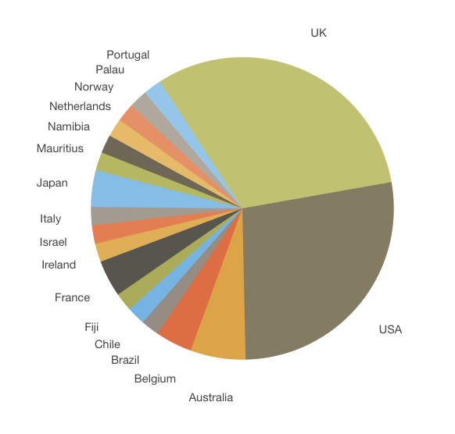

Figure 7.1: Distribution of Delphi Study Participants by Country

All participants in the Delphi study participated strictly in an individual capacity. The institutional affiliations of participants consisted of 28 universities and research institutes (including museums) from 18 countries. The organisations from which individual participants were drawn are summarised in Figure 7.2.

Figure 7.2: Participants by Organisation Type

|  |  |  |  |  |
| --- | --- | --- | --- | --- |
| Country | University/  Institute | Conservation Organisation | Government | Private Sector |
| Australia | 2 |  |  |  |
| Belgium | 1 |  |  | 1 |
| Brazil | 1 |  |  |  |
| Chile | 1 |  |  |  |
| Fiji |  |  | 1* |  |
| France | 2 |  |  |  |
| International |  | 1 |  |  |
| Ireland | 1 |  |  |  |
| Israel | 1 |  |  |  |
| Italy | 1 |  |  |  |
| Japan | 1 |  |  |  |
| Mauritius |  | 1 |  |  |
| Namibia |  |  | 1 |  |
| Netherlands |  | 1* |  |  |
| Norway | 1 |  |  |  |
| Palau |  |  | 1 |  |
| Portugal | 1 |  |  |  |
| UK | 7 | 1 |  | 2 |
| USA | 8 |  | 1 | 1* |
|  | 28 | 4 | 4 | 4 |

* Denotes a regional or international organisation

7.3 Results

The Delphi study was designed to elicit responses on the actual and potential economic value of marine genetic resources. The precise aims of the study were as follows:

1. Review marine genetic resources that are being harvested in Areas Beyond National Jurisdiction and by whom;
2. Assess current and potential applications of marine genetic resources;
3. Assess the current and potential economic value of marine genetic resources;
4. Assess the non-market benefits of marine genetic resources in terms of their value to ecosystem services or non-use values;
5. Highlight cases of best practice with respect to using and managing marine genetic resources;
6. Consider the potential contribution of marine genetic resources from Areas Beyond National Jurisdiction to economic growth over a 10 to 30 year period.

As such the main aims of the study were directed to elucidating answers to questions on the who, what, and where of marine genetic resources from Areas Beyond National Jurisdiction and in particular to soliciting views on actual and potential economic value. However, as the first known study of its type with the marine research community and stakeholders we were also keen to open up the questions to consider wider potential elements of an implementing agreement within the framework of UNCLOS to reflect the range of experts’ interests.

An important feature of a Delphi study is that questions are designed to elicit open-ended answers from participants. Questions on topics are also split across a round, rather than grouped together, to limit repeat answers. Direct quotes from respondents are then fed back to the participants in the next round as questions that participants are invited to agree with, disagree with and comment on. The core topics covered by the Delphi study were:

1. Whether there is increased interest in marine genetic resources from ABNJ for research or commercial purposes.

2. What marine genetic resources from ABNJ are being sampled, in what locations, by whom and for what purposes.

3. Known or potential applications or products from marine genetic resources from ABNJ.

4. Ecosystem services provided by the deep-sea in Areas Beyond National Jurisdiction.

5. The impact of the knowledge deficit about marine genetic resources on scientific and policy decision-making and how this deficit might be addressed.

6. Research and funding priorities over the next 10-20 years.

7. Whether there is a need for rules on access to marine genetic resources in Areas Beyond National Jurisdiction.

8. Whether there is a need for rules on benefit-sharing for marine genetic resources from Areas Beyond National Jurisdiction.

9. Existing experiences of, and perspectives on, benefit-sharing.

10. Perspectives on intellectual property rights.

11. Perspectives on capacity building needs.

12. Perspectives on technology transfer.

13. Monitoring and Indicator requirements.

14. Technologies that could advance understanding of marine genetic resources (including habitats), barriers to technology development or deployment, and the timelines for technology development and potential technology spill overs into other areas.

15. Key impacts and threats to biodiversity in the deep-sea.

16. Key habitats and habitats that have been neglected in existing debates on conservation, sustainable use and management of marine genetic resources.

17. Challenges to conservation and sustainable use in ABNJ focusing on instruments such as protected areas and Ecologically or Biologically Significant Areas (EBSAs).

18. The adequacy of regulations on extractive activities.

In addressing these topics it immediately became clear that experts were much clearer on some topics than others. Two areas stood out:

1. A lack of detail on actual products from marine genetic resources from Areas Beyond National Jurisdiction;

2. A lack of detail on ecosystem services from marine habitats in Areas Beyond National Jurisdiction beyond those usually ascribed to the marine environment.

In the case of the lack of detail on actual products from ABNJ we came to the conclusion that this reflects a general international lack of knowledge about actual products. More importantly this lack of detail appears to reflect a more fundamental difficulty in distinguishing national territorial waters from ABNJ. In the second case we think that the question of whether there are distinctive ecosystem services from ABNJ habitats relative to the marine environment as a whole could appropriately be addressed by more detailed consultation with marine experts.

Two types of data are available in the results from the Delphi study. The first is levels of agreement by experts with a particular statement on a topic made by another expert on a scale running from strongly agree to neither agree or disagree to strongly disagree. For the purpose of this summary we have clustered the strongly agree and agree categories and the disagree and strongly disagree categories into a simple “agree” or “disagree” format. We present levels of agreement with a particular statement as a percentage followed by the number of respondents e.g. (90% n=26) where n equals the number of participants agreeing with a statement from that round. In cases where there was a wider spread of views we provide the full information. It is also important to note that participation across the rounds varied. Thus, in round 2 and round 4 there were 28 and 29 full responses respectively. However, in round 3 there were 14 full responses. The purpose of a Delphi study is not statistical, as such the purpose is not to make statements such as “99% of marine experts think”. Rather, we use percentage scores across the rounds as indicators of the balance of agreement on a particular subject. To preserve the integrity of the statements from experts we adopted a policy of minimal editing. Where necessary spelling has been corrected and the start of full sentences capitalised. Where additional text is necessary to contextualise a statement for ease of reading these additions are placed in square brackets. The use of the acronym MGRs by participants stands for marine genetic resources.

In presenting a summary of the results we have organised the results by elements of a potential implementing agreement involving access and benefit-sharing as follows.

*Context*

1. Economic Interest and Potential

2. Habitats and Human Impacts

*Governance*

3. Access to marine genetic resources

4. Benefit Sharing, Capacity Building & Technology Transfer

5. Monitoring and Indicators

6. Research Priorities

7.3.1 Context

7.3.1.1 Economic Interest and Potential

Participants almost unanimously agree that access to and exploitation of marine genetic resources has become easier due to advances in technology meaning that a large amount of genetic material has become available (97% n=28). However, they are concerned that this potentially huge volume of data will lead to bottlenecks where data analytic techniques and demonstration of the efficacy of derived products will not keep pace with discovery (92% n=12). There is significant support for the idea that the deep-sea contains vast natural wealth, which will lead to new medicines, cosmetics and biofuels (83% n=24). Scientists have become particularly interested in the potential for genetic materials from microorganisms, which can be stored and cultured in laboratories (62% n=18) while noting that “keeping most marine bacteria alive is still extremely problematic”. However, some participants are also unsure whether there is sufficient accessible peer reviewed data to support speculation about the extent of current harvesting of marine genetic resources (48% n=14 agree, 38% n=11 neither agree nor disagree, 14% n=4 disagree).

In respect of organisms from the deep-sea, responses acknowledge that samples are often collected by researchers in collaboration with industry (83% n=24). Despite the widespread agreement that there is increasing interest in marine genetic resources, some participants caution that greater biodiversity in the deep does not necessarily equate to greater chemical diversity or novelty suggesting that a greater understanding of the biodiversity of coastal areas is still needed to establish whether deep-sea resources really are of greater value than those that are more accessible (83% n=24). It is agreed that species from extreme habitats have revealed unique properties of actual and potential use in industry and biotechnology (82% n=23) although there is a lack of agreement that extreme environments such as trenches and hydrothermal vents are the principal sites for harvesting of marine genetic resources (24% n=7 agree, 31% n=9 neither agree nor disagree, 45% n=13 disagree). Similarly, in considering novel enzymes or proteins for industrial processes and diagnostics participants questioned whether there is evidence of marine genetic resources from ABNJ providing sufficient novelty to warrant the costs of sampling and analysis (46% n=6 agree, 31% n=4 neither agree nor disagree, 23% n=3 disagree). The following quotes reflect the range of views expressed by experts.

“Most of the work in ABNJs is classical biology trying to learn more about the oceans and the life within them.”

“Most samples are collected where a cruise happens to go (or locally). The deep sea hydrothermal stuff just gets more publicity because it’s unusual.”

“European funding (FP7, Horizon 2020) for marine resources often has an extremophile flavour to it. It is automatically assumed (incorrectly) that extreme environments produce novelty.”

“It is much easier [to collect in EEZs] and these environments are not specific to ABNJ. Scientists are interested in biodiversity which occurs in unique environments and maritime boundaries do not define environmental conditions.”

“It is automatically assumed that there is greater biodiversity and therefore greater novelty in the deep sea but in fact there is significant biodiversity even around the coast. A better understanding of the deep sea would establish if it is in fact better than what is available locally. I accept that some things will be specific (e.g. pressure tolerance) but others (thermal tolerance) can be sourced equally well within national waters or on land.”

“A lot of the species that have proved to be technologically useful have come from shallow-water vents and increasingly the same species is being found in both shallow and deep hydrothermal vents.”

“I don’t think we know enough about the novelty in our own backyard to be able to say that deeper and hotter mean better.”

Participants believe that current sampling effort is greatest in EEZs (75% n=21) with sampling from ABNJ being prohibitively expensive and restrictive and having limited productivity in terms of samples suitable for further marine bio-discovery work (75% n=21). Participants agreed that most ABNJ field expeditions have been undertaken by research institutions with limited involvement from industry, thus most discovery work has been carried out by academic and government researchers (72% n=21). As one participant observed:

“…there is limited industry involvement in the initial discovery phase, and it is mainly academic and government researchers that have been involved in the discovery of new genes and biomolecules. In terms of laboratory analysis, this has been mainly financed by state agencies and industry.”

There is no clear understanding of the geographical locations where most current harvesting, extraction or sampling is taking place. For example, a statement that marine genetic resources are mainly obtained from the Atlantic area down to 4,000 metres and on the abyssal plain or deep-sea troughs elicited a 79% (n=23) neither agree or disagree response. This appears to reflect wider uncertainty among experts with respect to bioprospecting locations with the following quotes reflecting wider views:

“There is patchy and largely anecdotal evidence from other areas such as deep sea hydrothermal vents. It may be that in fact most samples are actually being collected within areas of national jurisdiction.”

“Despite the potentially lucrative returns from marine genetic discoveries, there has been little bioprospecting activity in the deep sea, mainly because of the cost associated with sample collection and the long development time.”

Some participants were keen to broaden the debate beyond the current focus on deep-sea locations and charismatic extreme habitats such as hydrothermal vents:

“The midwater contains a plethora of species that are almost always overlooked at policy and management level and in popular treatments of the deep sea. The miniscule volume of the seabed is dwarfed by the vast expanse of the ocean’s midwater realm.”

Opinion varies on which applications of marine products are of most interest at present. The proposal that some markets, such as nutraceuticals and cosmeceuticals, can offer a quicker return on investments when compared with drug discovery is generally accepted (46% n=6 agree, 38% n=5 neither agree nor disagree, 15% n=2 disagree). However, there was significant scepticism about nutraceuticals and their consequences for conservation.

“The nutraceutical and health industry represents the ‘low hanging fruit’ of this area where the development time and regulation are likely to be the least.”

“Nutritional markets are short-sighted and have over-exploited marine environments purely for profit with little or no proven health benefit.”

Some participants consider the most interesting area of current research to be enzymes for industrial processes. In summarising responses on future prospects, one participant captures the feelings of many, stating:

“The key word is ‘potentially’. There is a big difference between potential and reality. I have a lot of potential in my -80 degree freezer [of samples] collected off the UK coastline.”

The Delphi study also tackled the subject of whether policy-makers, as opposed to scientists, believe there is a growing economic interest in marine genetic resources from Areas Beyond National Jurisdiction. The majority of participants believe that policy makers perceive an increase of commercial interest in the “blue gold of marine biotech” (69% n=20) but point out that there has been little ABNJ bioprospecting due to the effort and costs involved and long product development times (69% n=20). Most bioprospecting would appear to be taking place within the EEZ and on continental shelves (68% n=19). In connection with the perceptions of policy-makers:

“I think there is a big fear of missing out and biotechnology is one of the worst culprits (unfortunately). This is illustrated by the number of regions and countries which promote biotechnology as a key future development - the knowledge based bio-economy!”

“Some policy makers and diplomats would like their scientists to be able to participate on equal footing in this growing field - using both MGR from within and beyond national jurisdiction. Other policy makers and diplomats recognize that their scientists may never have the capacity to exploit MGR in ABNJ, but feel that their country should benefit from exploitation of what many of them believe to be part of the ‘Common Heritage of Mankind’.”

“There is a real paranoia about missing out on something big in the marine ocean because no-one has control.”

A number of participants share a perception that there has been an increase in patent activity involving marine genetic resources (62% n=8 agree, 38% n=5 neither agree nor disagree, 0% n=0 disagree). This increased activity indicates that business interest in marine genetic resources is steadily rising, although participants only narrowly agree that this is the case (54% n=15 agree, 25% n=7 neither agree nor disagree, 21%n=6 disagree). Varied opinions on the level of current industry involvement are illustrated by the quotes below.

“The huge growth in the number of marine genetic resources being discovered, as well as being patented, illustrates that the use of marine genetic resources is no longer an obscure operation limited to a small number of purely research organisations, but one which is becoming an important business operation based on the development of new technologies.”

“I would say it’s a business prospect at the moment, not an operation.”

“…there is limited industry involvement in the initial discovery phase, and it is mainly academic and government researchers that have been involved in the discovery of new genes and biomolecules. In terms of laboratory analysis, this has been mainly financed by state agencies and industry.”

“They are being harvested for both academic and commercial reasons. The increasing pressure on academic organisations to produce value for money and demonstrate added value is driving this. Again, as observed in FP7 and Horizon 2020 calls.”

“…there is increased commercial interest but that does not necessarily translate into investing in the risk. Provide a marine derived product and they will take it but they won’t spend up front.”

“There is a big drive by the EU for exploitation of the marine environment rather than being industry driven. You generally go to them. If they come to you it is usually as part of a government-funded academic-industry project.”

7.3.1.2 Habitats and Human Impacts

There is consensus that lack of knowledge of species and habitats makes it difficult to assess the impacts of anthropogenic disturbance on marine ecosystems (100% n=29). Cold-water corals are an example of how lack of knowledge means that they have been under-protected and subsequently destroyed by trawling (90% n=26). However, participants think that the low levels of sampling required to develop products from marine genetic resources will not result in the same level of damage as that associated with major industries like mining and fisheries (93% n=26). In fact, a number of responses consider that the potential disruption caused by marine genetic resources sampling for research is minor in comparison to fishing and mining activity (89% n=25).

“If the sampling is small and controlled then the impacts could be negligible but the removal of large structures wholesale (e.g. active ‘black smoker’ stacks) where there is considerable biodiversity in place could have more serious repercussions. Limiting the size and number of samples which can be taken from a given habitat would help mitigate long-term or significant damage.”

“Collection of marine genetic resources is undertaken for research purposes, but pales into insignificance compared with harvesting such as fisheries, and other anthropogenic impacts.”

“[This is like] comparing apples and oranges. I don't think anyone believes that collection of MGR is a huge threat to biodiversity, but unregulated collection of specimens of certain types of organisms that cannot be replicated in a lab may pose a threat to unique or rare species or ecosystems.”

“There is very little known about the conservation status of most of the species used so far as Marine Genetic Resources. We do not have a clear overview of where the samples are being taken from, how they are being taken or how many are being taken, or what is being done with them. It will only be possible to ensure that bio-prospecting is sustainable if we first have an overview of activities taking place.”

Deep-sea bottom trawling is considered the most destructive activity at present and it is compared with clear-cutting a forest in the way that it can completely destroy unknown and unexplored habitats (77% n=10). The removal of major structures, like black smoker chimneys, causes concern due to serious repercussions for local biodiversity (90% n=26). This sort of scenario has led to concerns that species will be lost before they have been discovered (86% n=25). These species may include valuable ones with properties that could lead to medical advances (75% n=9). Deep trenches are attracting interest and participants agreed that these rare habitats need to be protected from over exploitation (67% n=18).

“Biodiversity hot spots, such as coral reefs and seamounts, and in extreme environments, such as polar and hydrothermal vent ecosystems, are extremely vulnerable.”

“The small-scale insular seafloor habitats that host marine life endemic to those particular types of habitats (e.g. hydrothermal vents, cold seeps, and seamounts) are particularly vulnerable, because human activities can potentially remove entire "nodes" in their metapopulation networks.”

“Deep trench environments should be monitored as they may also host unique biodiversity.”

Participants generally agree that climate change will affect the marine carbon cycle in ways that are not yet fully understood or anticipated (69% n=9).

“Anthropogenic forcing of global climate will have effects on the marine carbon cycle and on the physical state of the oceans over this timescale, which will impact marine ecosystems in still not completely understood ways. Human activities (particularly resource extraction) are already perturbing local environments and are being conducted without concern as to microbial community integrity.”

In particular there was a widely held view across the Delphi study participants that mining will have a great impact on ecosystems – far greater than targeted sampling of microbial life (69% n=9).

“I consider the main threat to be deep-sea mining and chemical pollutants spread by ships and discharge from coastal states and via the atmosphere. It appears unlikely that we will be able to prevent biodiversity loss through ocean acidification so the prospect of effective action through UNCLOS is unlikely.”

The understanding of chemosynthetic community structure and functions and extremophile metabolism is seen as very important in developing new applications for marine genetic resources (85% n=11), as are those from biodiversity hotspots such as seamounts and coral reefs. These habitats are susceptible to harm from unsustainable fisheries, pollution, shipping, mining, climate change and acidification and therefore, participants agreed that a precautionary approach should be taken in sampling and exploitation (79% n=23). One participant highlighted plastics as an emerging issue in marine pollution.

“Today plastic is the major pervasive pollutant of the deep ocean, and its consequences are poorly understood.”

The future impacts of bioprospecting are unclear as this is a relatively new development and there is uncertainty around how much material will eventually be taken and whether it can be replicated synthetically. Participants agree that there must be careful assessments of any impacts that do occur (79% n=23). At present the conservation status of species used as marine genetic resources is largely unclear, as are the methods and locations of bioprospecting activity. It is felt that an overview of activities is needed to acquire this understanding (75% n=21).

There is also uncertainty about approaches needed for managing fisheries, with general agreement that fisheries activities have increased (48% n=14 agree, 24% n=7 neither agree nor disagree, 28% n=8 disagree) and that overfishing will lead to stocks that are unable to adapt to climate change (46% n=6 agree, 38% n=5 neither agree nor disagree, 15% n=2 disagree). Some participants suggested that fish should be managed as a genetic resource rather than as harvestable stock (46% n=6 agree, 38% n=5 neither agree nor disagree, 15% n=2 disagree).

“If allowed to continue, the bottom trawlers of the high seas will destroy deep sea species before we have even discovered much of what is out there. Facilitated by advances in technology, deep sea mining for polymetallic nodules, manganese crusts and polymetallic sulfides poses a major threat to our oceans, which are already suffering from a number of pressures including overfishing, pollution, and the effects of climate.”

“Fishing is the big environmental issue not MGRS.”

“…the small budgets of academia result in small scale collections at relatively long intervals giving the ecosystem time to recover in between collections. Harvesting for fisheries tends to have time and economic pressures leading to ignoring conservation guidelines.”

“I don’t think anyone believes that collection of MGRs is a huge threat to biodiversity but unregulated collection of specimens or different types of certain organisms that cannot be replicated in a lab may pose a threat to rare species or ecosystems.”

7.3.2 Governance

7.3.2.1 Access to Marine Genetic Resources

In response to questions on access participants tended to divide responses into comments on the regulation of access and practical issues involving access. We mainly deal here with the regulation of access and turn to practical issues involving access below.

One participant argues that there is currently a “wild west” mentality concerning the high seas:

“In order to ensure that the ‘wild west’ mentality that now prevails in the high seas is addressed, and that marine biodiversity is preserved for its own sake and for future generations, a new agreement under UNCLOS is needed to ensure healthy and productive marine ecosystems across the world’s oceans. Such a global agreement is urgently needed in order to make clear the obligation of countries to protect ocean life that is found both in high seas waters and the seabed in areas that are beyond the jurisdiction of any one country.”

However, we see a completely different interpretation of this same “gold rush” mentality from another participant:

“This debate has been fuelled by speculation and a "gold fever" mentality that has taken hold in the minds of policy makers and diplomats who don't even know if there is sufficient commercial interest. This whole debate is one based on speculation conflated by speculation. Where is the hard, as opposed to speculative data to support argument for need for [a] regime?”

Somewhere between these divergent responses, a large majority of experts agree that current rules and regulations concerning the management and conservation of the high seas are inadequate to ensure the survival of marine life and marine genetic resources for future generations, and that a new agreement under UNCLOS is required to protect ocean life in open waters and on the seabed (93% n=27). A number of participants refer to a plethora of bodies with specific areas of responsibility in this area but lack of coordination.

“The way we manage our oceans looks like a patchwork quilt – one with many holes. There are a wide array of different organisations and agreements responsible for managing parts of the high seas, specific activities, or particular fish species. However, there is little or no coordination or cooperation between these different bodies.”

Participants also acknowledge that any regime to regulate access to marine genetic resources would require robust data on commercial activity and research, and as yet this data does not exist (77% n=10). An implementing agreement is considered essential to provide an umbrella framework to coordinate a coherent and integrated approach, and inform individual countries of their obligations in monitoring and managing activities in areas beyond national jurisdiction (76% n=22). There is some disagreement as to the body that would oversee such regulation with no universal support for it being a body established within the framework of UNCLOS which was perceived by some participants to have resulted in institutions which are heavily influenced by vested interests. The Global Ocean Commission was suggested as an alternative body that can ensure public engagement and make informed, transparent and independent decisions (58% n=7 agree, 25% n=3 neither agree nor disagree and 17% n=2 disagree).

“Certainly not under the auspices of UNCLOS. In my view the ISA, created under UNCLOS to administer deep-sea mining, has structures that would be utterly unacceptable in any public body in a democracy (i.e. the committee awarding licences is constituted by those who benefit financially from the award of licences; and a major petitioner for licences currently pays the travel expenses of delegates from developing nations who then assess its licence applications). Rather than ape the ISA (or worse still in my opinion, extend its mandate to genetic resources), we need something fresh that enshrines transparency, public engagement, and independence in decision-making, informed by the best research. The Global Ocean Commission perhaps has potential in that area.”

“Even if all the sectoral organisations were functioning efficiently, they still would not be able to provide a systematic approach to conservation that is needed for the largest biome on Earth. Global and regional cooperation and coordination are needed. This is very difficult to achieve when sectoral organisations have no duty or obligation to take on board biodiversity considerations and no accountability for poor or non-performance. Legally binding shared principles, common goals, improved transparency and global level accountability can keep the momentum for progress going forward into the future far better than guidelines and market forces where efforts lag when attention wanes.”

“Even a change under UNCLOS will not provide enforcement: that is what should be addressed first, before more verbiage is put out. New use of technologies for enforcement is critical otherwise there will be no 'Protection' of 'Protected' areas: we already see this.”

“The burden to prove "no impact"/"no significant impact" should be with the party that wishes to utilise / sample the sea floor, not with the authorities - as I believe it is under the current UNCLOS and ISA wording.”

“Everything required for sufficient environmental protection exists within UN CBD principles; guidelines could be derived from that specific for this sector, for every nation that has signed UN CBD to adhere to, and then activity driven by market forces within that framework. However, regional-scale management of specific insular habitats (i.e. MPA network for particular insular habitats, to ensure viable metapopulations of their endemic species within a region) will be required, and an oversight organisation would be needed to administer that.”

In connection with access to marine genetic resources in Areas Beyond National Jurisdiction most participants agree, however, that any access regulations should not be such that there is a negative impact on research and development (54% n=7 agree, 38% n=5 neither agree nor disagree, 8% n=1 disagree). The monitoring of access and activity by researchers is considered sufficient under present protocols whereby national agencies, which dominate research, keep records. Some participants believe that the tagging of materials thus acquired and which are subsequently used for bio-discovery would be a sufficient addition to present practices (54% n=7 agree, 31% n=4 neither agree nor disagree). There is no clear consensus as to the ease of monitoring whether the location of samples obtained was within or beyond EEZs (54% n=7 agree that it would prove difficult, 31% n=4 disagree). The quotes below reflect a range of views on this subject.

“Yes, it should be monitored, but this is already done as most collections are carried out by large national agencies which record cruises and sampling online. Therefore, samples that are intended to be used for Marine Biodiscovery can be recorded as such. Others which are collected for other purposes, but are subsequently used for Biodiscovery should be tagged as such in the database. I think a simple addition to current self regulation is sufficient.”

“I think it would be difficult to monitor and verify whether samples were collected inside or outside national jurisdiction. We have enough problems on land with "blood diamonds" and ivory - the oceans are vast and empty. The issue of removing artifacts from the Titanic are an example. How are professional salvagers "treasure hunters" regulated?”

“Data is the valuable resource not biota samples. Do people really want to regulate data? How would they do that?”

“Placing monitoring requirements on oceanography vessels that collect in ABNJs should not be too onerous. Self regulation should work in this instance, given workable guidelines.”

Similarly, there are mixed views on the position that sufficient environmental protection already exists within the UN CBD principles, and that within that framework market forces could be allowed to dictate activity but with the addition of protection for marine protected areas (48% n=12 agree, 48% n=14 neither agree nor disagree, 10%, n=3 disagree).

“UN CBD principles may and should be envisaged like a starting point but this does not mean that these principles do not require regular updates.”

“It is true that what is in UN CBD is adequate, but the problem is and will continue to be enforcement. The International Seabed Authority depends on industry for its budget and so is clearly not going to get the monitoring job done. The authority for high seas monitoring will require a specific non-national organisation.”

“ABNJ is no longer [solely] at UNCLOS but is subject to CBD as well. Both UN organisations need to collaborate or mainstream their efforts in the safeguarding of the ABNJ.”

“There are other reasons for a new agreement under UNCLOS, such as certainty, levelling the playing field so that responsible players do not lose out to unscrupulous operators, and to promote the orderly development of new activities, avoid conflicting uses and prevent duplication of effort.”

There is some disagreement about the management of marine genetic resources, particularly whether it is possible to make policy decisions based on inadequate data on the extent of biodiversity. 52% (n= 15) feel that it is not possible, while 41% (n=12) believe that a lack of current knowledge should not stand in the way of precautionary policy. Some respondents, however, argue that there is no need for access regulation, suggesting that the debate is based on speculation rather than evidence (31% n=4 agree, 31% n=4 neither agree nor disagree, 38% N=5 disagree).

“I think we can follow the precautionary principle and insist that impact assessments, where biodiversity is measured, precede activities.”

“Policy decisions can be made now that can evolve as additional information becomes available. There is much to be gained by creating a regular forum for governments and others to meet and discuss the evolving science, technology and health of the ocean in ABNJ. A conference of Parties to a new agreement would be one way to create such a forum. To say we need complete baseline information is just to use lack of certainty as an excuse for inaction.”

7.3.2.2 Benefit Sharing

Discussions on benefit-sharing among participants were closely linked with capacity building and technology transfer. We focus first on benefit-sharing with more detailed discussion of capacity building and technology transfer below.

There is universal agreement that more infrastructure and access to financial resources are needed to enable training and research exchanges between developing and developed countries (100% n=13). There is also a high level of agreement that there is scope for improved coordination of research cruises to provide and share knowledge of biodiversity and training similar to that suggested by the CBD and Nagoya Protocol (92% n=12).

“Coordination of research cruises so that adequate coverage is made of biodiversity in Areas Beyond National Jurisdictions. Development of simpler, cheaper and more rapid sampling devices. Training aspects similar to that suggested in the CBD/Nagoya Protocol.”

“…the political debate should not focus only on monetary benefit sharing but also on non monetary ones, the ones that can really bridge the gaps between the capabilities of countries in undertaking research and profit from them.”

“…another aspect to consider is the disparities in scientific capabilities among countries.”

“There are opportunities for a more collaborative effort to collect samples which should be explored and encouraged. I am sure most researchers would be willing to help each other out if there was a centralised repository of exploration needs/gaps.”

“The scientific community seems to be more collaboratively inclined with cruise time and resource sharing, so perhaps collections and access to them will actually increase.”

It is agreed that benefits derived from marine genetic resources should be equitably shared, with an emphasis on ensuring these resources are obtained in a sustainable way, and that limited commercial interests are not permitted to take ownership of marine genetic resources (86% n=24). The cost of drugs raises issues about benefit sharing with suggestions of not-for-profit drug distribution to poorer nations and government funding for product development (48% n=14 agree, 48% n=14 neither agree nor disagree). Less certainty is expressed about the notion of a royalty paid from profits from marine genetic resources derived products going towards maintaining collections, monitoring and research (38% n=5 agree, 46% n=6 neither agree nor disagree, 15% n=2 disagree). Participants did not agree with the argument expressed by one participant that a tax on commercially successful pharmaceuticals paid to poorer nations would kill innovation and product development, due to the enormous costs of developing products which do not reach the market (14% n=4 agree, 31% n=9 neither agree nor disagree, 55% n=16 disagree).

“To "tax" any successful natural products resulting from marine genetic resources (i.e. insisting on payment via UNCLOS, to then be distributed to developing nations etc. under similar arrangements to those for seafloor mining via the ISA, for example) would probably kill activity in this area; there are plenty of other sources of possible natural products other than the deep ocean.”

“I have worked for a large US pharmaceutical company, and despite the costs of this research, I am sure the potential rewards would encourage investment, even with some sort of levy (at a reasonable rate).”

“I think the financial payments currently collected by the ISA are modest in comparison to the potential billion dollar gains in the mining industry. I’m not sure if it’s a fair comparison with MGR extraction however, I have a feeling that it would be; pharmaceutical companies make large profits after all.”

“Even assuming there is a lack of substantial financial return now, it would seem to be better to discus this topic sooner rather than later when stakes would be greater. At this point, no one would want to hamper commercial research or development but would prefer to facilitate it, if there is some expectation of a fair return to both the developer and the international community. Industry itself may prefer certainty rather than the potential for future regulation.”

“Benefit sharing arrangements have not killed interest in deep seabed mining--indeed a US company Lockheed Martin is now operating through the UK for access to mineral resources in the Area. A properly designed benefit-sharing scheme could facilitate access to samples, stimulate collaborative research and provide real non-monetary benefits, in addition to allocating some yet to be specified percentage of a possible future revenue stream. There is a precedent in UNCLOS already for sharing revenue from oil and gas exploitation beyond the continental shelf. A similar formula could be developed for MGR that is considered fair from all sides.”

“We accept that market forces deliver economic benefits to wider society in our national government; that principle is also worth considering at international scale. In response to the argument: what about nations that do not have a deep-sea capacity, in terms of their share? I would say: here is an incentive to develop technologically in the long term, if you want those rewards. Hand-outs (e.g. as administered for seafloor mining via the ISA) perhaps have a parallel to domestic benefit-dependency, rather than stimulating aspiration.”

The view that market forces should be accepted as the driving force to provide benefits and that those benefits should provide incentives to countries to develop deep-sea capabilities in order to share the benefits did not generate significant support (8% n=1 agree, 54% n=7 neither agree nor disagree, 38% n=5 disagree). With respect to how benefit-sharing from marine genetic resources might be generated one participant suggested:

“In a way similar to the way plant crops are used. In this case if a signatory to the crop plant treaty makes an improved crop plant and commercialises this, a royalty is paid into a central fund which is used for maintaining the collections, monitoring and research.”

38% n=5 of participants agreed with this suggestion with 46% n=6 neither agreeing nor disagreeing and 15% n=2, disagreeing. This could suggest the need for further discussion on possible options for benefit-sharing, including discussion of experiences with existing models.

Issues surrounding intellectual property rights (IP) generated a range of views. The investments made in developing a product from marine resources are seen as a legitimate reason for pursuing IP, however perceived pressure to pursue these rights is seen as having a negative effect on deep-sea research due to the pressure to show value (77% n=10 agree, 23% n=3 neither agree nor disagree, 0 disagree). In principle it is felt that samples should be made freely available (77% n=10 agree, 23% n=3 neither agree nor disagree, 0 disagree). An additional perspective is that research scientists and their funding bodies should have primary rights to intellectual property but that the time period for ownership of basic knowledge should be limited and normalized around the world (69% n=9 agree, 15% n=2 neither agree nor disagree, 15% n=2 disagree). Most participants agreed that the monitoring of collections is already in place, and this should be strengthened with infrastructure to ensure that the origin of samples remains clear for end users (77% n=10 agree, 23% n=3 neither agree nor disagree, 0 disagree).

“I think the cost of development of a product (as opposed to just seeking protection based on perceived value) is significant and thus Intellectual Property Rights in those instances is justified. I think there is a big difference between something being patented and actually making money. The cost of deep-sea research is considerable and researchers are increasingly under pressure to show value so it does not surprise me at the level of IPR protection being sought. If academic research must demonstrate added value then IP protection is going to become an increasing issue. In principle, samples should be made available freely and there are already significant quantities of freely available genetic information in the databases. The clever bit is identifying what is valuable and turning it into a product.”

“Scientists conducting the research have the primary right to intellectual property, along with the entity that funded the research. The policies of those entities should be normalized around the world to limit the time period over which such basic knowledge can be kept proprietary. Commercial applications should be covered by the same international law system that covers other commercial activities.”

“All intellectual property should remain in the public domain where it pertains to natural environmental processes. Synthesized outputs should remain the IP of the research consortium producing/funding them.”

“I do not consider that 'genes' should be patentable.”

“The open oceans are the commons and should be used for the benefit of all mankind.”

“Any future legal regime must be consistent with intellectual property rights otherwise there will be no commercial incentive for investment in R&D.”

“Whoever invests in their development has the right to profit from them.”

“[Common Heritage of Mankind] CHM discussions are quite necessary since they prevent the obstruction of scientific progress by those withholding IP on commercial grounds.”

“It is essential that a regime is put in place that ensures marine genetic resources are not grabbed by a few in a gold rush to patent life and privatise their ownership. Having clear international rules that set out how species and habitats must be protected and how the benefits must be shared will not only benefit developing countries that do not have the technology or resources to explore such potential discoveries, but will also protect the companies involved by providing a stable framework within which they can develop the future of their businesses.”

“I suspect there needs to be some balance and intelligent recognition of (a) when the intrinsic knowledge has a commercial value so needs reasonable protection and (b) that the protection has a reasonable relationship to the costs of getting it in the first place and then using it later on.”

7.3.2.3 Capacity Building and Technology Transfer

In summarising responses on capacity-building and technology transfer we also draw in responses relating to the practical issues involving access to genetic resources from Areas Beyond National Jurisdiction. Here we focus on presenting a selection of quotes that relate to technology related issues involving research in the deep-sea. In conjunction with the points raised above on benefit-sharing and future research priorities (below) these suggestions form potential building blocks for a longer term approach to capacity building and technology transfer for further discussion.

“It is not only technological advance in accessing the deep sea, but it is also the technology advancing that allows scientists to use DNA extraction and duplicate it, or to use genomics, that made it easier to work on MGR.”

“The scientific community seems to be more collaboratively inclined with cruise time and resource sharing, so perhaps collections and access to them will actually increase.”

“The future is sampling principally by unmanned vessels, not ships.”

“Routine operations in the deep (<1000 m) sea have improved only in the increased availability of tethered or autonomous vehicles. Navigation is still challenging. And there are many instances of instrument and vehicle failure. My impression is that academia still has more experience operating in the deep sea than commercial interests.”

“We are severely limited in the access we have to the deep seas. The further development of observatories with a suite of biological and genomic sensors is sorely needed.”

“There are opportunities for a more collaborative effort to collect samples which should be explored and encouraged. I am sure most researchers would be willing to help each other out if there was a centralised repository of exploration needs/gaps.”

“Deep-sea research requires national-level facilities (e.g. research ships and deep-water vehicle), so this is the level required for targeted action, e.g. national research programmes focused on this issue.”

“Improvements in human-directed vehicles, however, do not just include the capabilities of the vehicles themselves (i.e. depth capability, samplers that maintain in situ environmental conditions, imaging technologies etc), but in telecoms capabilities that enable researchers ashore to direct their operations, rather than just a small research team aboard their mother ship.”

“This requires a long-term plan for investment in large-scale facilities (i.e. ships and deep-sea vehicles), which have finite lifespans in use (and development of versions with better capabilities). Instead of chasing money from government every few years in fire-fighting fashion, there should be an agreed long-term strategy for this area.”

“The development of pressure-resistant corrosion resistant materials especially if very deep sea hydrothermal vents are investigated where pressure, temperature and pH all potentially come into play.”

“There have been numerous advances in Autonomous Underwater Vehicles which do not require constant human directed presence. AUVs can collect photographic, video, oceanographic, and geological samples along pre-determined survey lines, all of which lead to greater understanding of the ecology of the deep ocean and allow a more targeted (and therefore more cost effective) human-directed follow up surveys/sampling.”

“Some kinds of questions need a lot of detailed measurements over a large area – the AUVs can or will be able to do this. Other questions need immediate decision making during the measurement or sampling process – then you need a human in the loop so a ROV or HOV is necessary.”

7.3.2.4 Monitoring and Indicators

Monitoring activity is seen as problematic due to the vast size of the oceans and because only established shipping lanes have any monitoring presence (86% n=25 agree, 3% n=1 neither agree nor disagree, 10% n=3 disagree). Some respondents refer to the need for intensive monitoring regimes such as satellite technology to monitor ship movements and the need for ports to investigate suspect ships. Other participants believe there is little need for such intensive monitoring infrastructure. A majority agree that monitoring will create major difficulties (55% n=16 agree, 31% n=9 neither agree nor disagree, 14% n=4 disagree).

“…websites now report on transects of boats, a lot of blogs or even facebook pages are associated to scientific cruises, publicly available data on the name of cruises and site they visited are even possible to access through institutional websites.”

“It is already possible to trace the origin of MGRs used for patent applications, it is just really difficult. Databases are being maintained by the UN University. If patent applications were required to disclose origin of the material, then it would not be so difficult to monitor the origin. Could also require self-reporting by scientists and companies as part of their EIA applications and reporting to national authorities. Don't really need expensive at sea monitoring or port state control for bioprospecting alone, but do need improved at sea monitoring and port state controls for fisheries management and conservation.”

“…although we are focused on using unmanned aircraft and autonomous surface vessels, there is also an important component for new non-governmental satellite technologies. The idea is indeed to deal with violators 'at the dock' as it is cost-prohibitive to board them at sea for the most part.”

“It would be helpful to ensure that we have an overview of activities taking place but EIA requirements, sample collections and benefit sharing mechanisms can also help to gain that overview while enhancing sustainability.”

“It is a question of motivation. How many vessels are equipped to do this work, and how many would intentionally misreport their sampling locations and amounts? Placing trust in cruise leaders to report findings accurately should be possible to maintain a low impact, but effective monitoring system.”

“It will only be possible to ensure that bioprospecting is sustainable if we first have an overview of activities taking place, and one that it is based on sound internationally accepted governance and conservation mechanisms.”

“I do not see how additional regulation could be effectively monitored in the deep sea without using satellite technology to monitor ship movements but then any follow-up would only work if the next port-of-call had signed-up to investigating a ship identified as suspect and the ship did not off-load the samples before entering the port.”

7.3.2.5 Research Priorities

Participants consider the priority for research to be improving our basic knowledge:

“…the majority of major advances in our understanding of deep sea ecology have come from ‘exploration’ rather than targeted studies (which largely confirm what we already know). In the deep ocean, what we don’t know is still of major significance.”

This exploration effort is regarded as the current main research priority by a significant number of participants (85% n=11). There is also agreement that research effort should be focused on understanding the deep-sea ecosystem and habitat dynamics in areas where human activity is anticipated (92% n=12). There is a strong positive view that investment in technologies such as deep-sea submersibles is essential and that video and sonar equipment is vital for understanding the ecology of larger organisms (93% n=27). The development of human directed vehicles (whether remote or manned) is seen as essential (90% n=26) and autonomous underwater vehicles should not be seen as an alternative due to their different capabilities (69% n=9 agree, 23% n=3 neither agree nor disagree, 8% n=1 disagree). A suggestion that without new ships for sampling there will be no increase in the scale of collection met with limited agreement (31% n=9 agree, 31% n=9 neither agree nor disagree, 38% n=11 disagree). This is perhaps because there is now increased interest in long term *in-situ* studies and more emphasis on cooperative research meaning that what is needed is not more ships but more efficient use of ships.

“…coordination of research cruises is a weak link in all deep sea research. It is very easy to show up at a site and find someone else there or to accidentally disturb a sensor or experiment in progress.”

Looking ahead, most respondents expect the focus over the next 10 years to be on microbial culture and genomic analysis to discover whether marine genetic resources represent genuine novelty or simply variations on a theme (62% n=8 agree, 31% n=4 neither agree nor disagree, 8% n=1 disagree). Over the next 20 years the research priorities are seen as less clear with the study of new organisms with new bioactive properties being considered a focus (54% n=7 agree, 31% n=4 neither agree nor disagree, 15% n=2 disagree).

“Yes, training, research exchanges and participation of researchers from either developed or developing countries are all good ideas, such as required courses in ethics and international law. Frankly, we need far more infrastructure and access to financial resources if we hope to ever properly survey the oceans for a remotely accurate census of life.”

“Coordination of research cruises so that adequate coverage is made of biodiversity in ABNJs. Development of simpler, cheaper and more rapid sampling devices. Training aspects similar to that suggested in the CBD/Nagoya Protocol.”

“There are opportunities for a more collaborative effort to collect samples which should be explored and encouraged. I am sure most researchers would be willing to help each other out if there was a centralised repository of exploration needs/gaps.”

Looking even further ahead, participants found it difficult to predict what might be the focus of marine research thirty years from now. One participant suggested that “…in 30 years “the ‘game’ may have changed so much that bioprospecting for novelty in the marine environment may not be as big an issue” while another participant emphasised that “…fast moving developments in synthetic biology may make sampling from the wild redundant in future.”

7.4 Conclusions

This chapter has presented the results of a multi-round expert Delphi study focusing on questions about access and benefit-sharing and wider issues involving a potential implementing agreement within the framework of UNCLOS. Delphi studies are typically directed towards the achievement of a consensus view among experts on a future oriented topic. In the context of the present research we have deferred the pursuit of a final consensus scenario or set of scenarios in favour of mapping out areas of broad agreement, disagreement and the range of views expressed by experts.

However, in the course of the Delphi study we repeatedly asked the experts the question “what would you say to a policy audience?” on the conservation, sustainable use and fair and equitable sharing of the benefits arising from the utilisation of marine genetic resources. Twenty seven (93%) of our experts in the final round of the Delphi study agreed with the following statement proposed by a participant while only two (7%) disagreed:

“Current rules and regulations covering the high seas are simply inadequate to address these questions and to ensure that marine life and the precious genetic resources that they contain are preserved for future generations, including through establishing sanctuaries at sea. Therefore a new agreement is needed under the UN Convention on Law of the Sea to protect ocean life found both in high seas waters and the seabed in areas that are beyond the jurisdiction of any one country, as well as ensure the access and equitable sharing of benefits of marine genetic resources.”

As such, there is a clear view among the participating experts that a new agreement is needed within the framework of UNCLOS. As can be seen in the range of responses from experts, while there is broad agreement there are also a range of proposals on how this might best be achieved and its possible elements.

In connection with access and benefit-sharing in particular, experts expressed limited concern about the environmental impacts of biological prospecting compared with other human interventions while noting the need for care to ensure environmental damage was not caused by research activities. Experts also considered it likely that the majority of existing bioprospecting activity takes place in areas inside national jurisdictions while calling for further baseline data to improve the evidence base about these types of activity. Above all, we take seriously the proposal that there should be measures on access and benefit-sharing. However, we note that these are essentially anticipatory and could be allowed to evolve over time in response to emerging developments in the context of improved baseline information and monitoring of activity in cooperation with the marine research community.

We therefore conclude that issues involving access to genetic resources can appropriately be addressed by working with existing practices among research teams. In our view the main focus of attention should be benefit-sharing in the context of a longer term and strategic approach directed towards expanding human knowledge and understanding of the diversity of the life in the deep-sea and promoting its conservation and sustainable use in all our interests.

References

1 Linstone HA, Turoff M (1975) *The Delphi Method: Techniques and Applications*. Addison-Wesley Publishing Company, Advanced Book Program Boston, MA.

2 Landeta J (2006) Current validity of the Delphi method in social sciences. *Technological Forecasting and Social Change* 73: 467-482.

3 Diamond IR, Grant RC, Feldman BM, Pencharz PB, Ling SC, et al. (2014) Defining consensus: A systematic review recommends methodologic criteria for reporting of Delphi studies. *Journal of Clinical Epidemiology* 67: 401-409.

4 Keeney S, Hasson F, McKenna H (2006) Consulting the oracle: ten lessons from using the Delphi technique in nursing research. *Journal of Advanced Nursing* 53: 205-212.

5 Westby MD, Brittain A, Backman CL (2014) Expert Consensus on Best Practices for Post-Acute Rehabilitation After Total Hip and Knee Arthroplasty: A Canada and United States Delphi Study. *Arthritis Care & Research* 66: 411-423.

6 Marggraf R (2003) Comparative assessment of agri-environment programmes in federal states of Germany. *Agriculture Ecosystems & Environment* 98: 507-516.

Annex 1

Literature Review Method Description

A literature review was conducted using the Thomson Reuters *Web of Science* database to identify relevant scientific literature and expertise.

In the initial phase of the literature review a series of exploratory searches were carried out to build a working dataset of 6,287 scientific publications. Using VantagePoint analytics and natural language processing software from Search Technology Inc. we reviewed all words and phrases from the title, abstract and author keywords and cited titles (keywords plus) to identify additional search terms for specialist topics. For example, while our original search included hydrothermal vents and cold seeps, it did not include methane seeps or mud volcanoes. This approach therefore allowed us to identify additional important reference terms for deep-sea features and research. Additional searches were then conducted on specialist topics (e.g. mud volcanoes or ecosystem services) and sub-datasets were created on these specialist topics. The results of different searches are provided in Table 1 below.

To contextualise the literature for use in the research we conducted a general search for marine literature. This revealed a universe of approximately 385,278 scientific publications across all fields and all years that make reference to marine or deep-sea topics (Table 1). Approximately 29,689 publications make reference to the deep-sea and ocean floor related topics (Table 1) as of December 2013.

Because the scientific literature covers a wide range of topics involving the deep-sea e.g. engineering, geology etc. we restricted the 29,689 results on the deep-sea by the subject category of the journal to focus in on those topics of direct relevance to biology and conservation. This produced a dataset of 10,356 records (Table 1). These records were downloaded for use in a reference set.

In the next step the 10,356 records were combined with the sub-datasets on specialists topics listed in Table 1. In some cases because of the size of the results sets the sub-datasets had also been restricted by journal subject category in Web of Science. Because the datasets could contain overlapping records, the combined dataset was deduplicated on the unique document identifier (ISI Unique Article Identifier) to produce a core dataset of 24,259 publications for use in the research.

The purpose of this iterative approach was three fold:

1. To generate a dataset of specialist literature to inform the report including analysis of trends in specific areas;
2. To generate a thesaurus of terms for use in searching patents containing known marine species or locations for evidence of collection from Areas Beyond National Jurisdiction;
3. To identify relevant specialists for potential participation in the Delphi study.

The main strength of this iterative approach is that it focuses on identifying terms actually used by specialists in the field of deep-sea research across disciplines to develop a core reference dataset rather than using predictive guesswork.

Viewed in terms of the approximate universe of marine related publications this dataset comprises approximately 6% of that universe but is targeted towards deep-sea, biological, conservation and economic topics. A second advantage of this approach is that it allows for the identification of specialists in particular areas of research (i.e. hydrothermal vents or cold seeps or marine ecosystem services) for participation in the Delphi segment or consultation on specific topics arising in the research. This approach also allows for the identification of the key organisations and institutions involved in scientific publications on genetic resources in the deep-sea. The main weakness of the approach is that it is confined to data in Web of Science. Web of Science mainly focuses on journal articles with very limited coverage of books and book chapters. Furthermore, the approach will underestimate industry participation in research except where published in peer review journals. For example, additional research proved necessary to identify companies interested in mining the deep-sea bed and hydrothermal vents.

Table 1: Search Results Web of Science 1900-2014 (January 2nd 2014)

| Search Terms | Retained Records | Totals  (December 2013) | File Name |
| --- | --- | --- | --- |
| Topic=("marine" or "deep sea" or "deep-sea" or "ocean" or "oceans" or "sea bed" or "seabed") | - | 385,278 | Not used |
| Topic=("deep sea" or "deep sea" or "deep-sea" or "sea bed" or "seabed" or “sea-bed” or sea floor" or "seafloor" or “”sea-floor” or “ocean floor" or "oceanfloor" or “ocean-floor”) | see below | 29,689 | N/A |
| Topic=("deep sea" or "deep sea" or "deep-sea" or "sea bed" or "seabed" or “sea-bed” or sea floor" or "seafloor" or “”sea-floor” or “ocean floor" or "oceanfloor" or “ocean-floor”)  Refined by: Web of Science Categories=( ANATOMY MORPHOLOGY OR BEHAVIORAL SCIENCES OR BIOCHEMICAL RESEARCH METHODS OR ENVIRONMENTAL SCIENCES OR OPHTHALMOLOGY OR BIOCHEMISTRY MOLECULAR BIOLOGY OR ENVIRONMENTAL STUDIES OR BIODIVERSITY CONSERVATION OR EVOLUTIONARY BIOLOGY OR BIOLOGY OR FISHERIES OR PARASITOLOGY OR BIOPHYSICS OR FOOD SCIENCE TECHNOLOGY OR PHARMACOLOGY PHARMACY OR BIOTECHNOLOGY APPLIED MICROBIOLOGY OR GENETICS HEREDITY OR CELL BIOLOGY OR CHEMISTRY ANALYTICAL OR CHEMISTRY APPLIED OR CHEMISTRY MEDICINAL OR CHEMISTRY MULTIDISCIPLINARY OR PHYSIOLOGY OR CHEMISTRY ORGANIC OR PLANT SCIENCES OR POLITICAL SCIENCE OR INTERNATIONAL RELATIONS OR LAW OR LIMNOLOGY OR MARINE FRESHWATER BIOLOGY OR SOIL SCIENCE OR ECOLOGY OR TOXICOLOGY OR WATER RESOURCES OR MICROBIOLOGY OR ZOOLOGY )  Timespan=All years. Databases=SCI-EXPANDED, SSCI, A&HCI, CPCI-S, CPCI-SSH. | 10,356 | see above | WOS_deepsea_SCrestricted_ |
| Topic=("marine natural products") | 2,255 | 2,255 | WOS Marine Natural products 30122013_2258 |
| Topic=(marine) AND Topic=("deep sea") AND Topic=("biodiversity" or "conservation" | 323 | 413 | WOS_deep sea biodiversity conservation.ciw |
| Topic=("cold seep") | 703 | 714 | WOS cold seep 703 |
| “deep sea” Web of science “biotechnology applied microbiology” category only | 504 | 20,247 | WOS deep sea biotechnology applied microbiology 504 |
| Topic=("hydrothermal vent") | 2,731 | 2,755 | WOS hydrothermal vent 2731  WOS_hydrothermalvent 2731.vpt |
| Topic=("marine biodiversity") OR Topic=("marine biological diversity") | 900 | 917 | WOS marine biodiversity biological diversity 900 |
| Topic=("marine biotechnology") | 112 | 118 | WOS_marinebiotechnology.ciw copy |
| Topic=("marine genetic resources") | 9 | 9 | WOS_marinegeneticresources1_9.vpt |
| Topic=("seamount" or "seamounts")  Refined by: Web of Science Categories=( MICROBIOLOGY OR ENGINEERING MARINE OR MICROSCOPY OR ENGINEERING OCEAN OR BIOCHEMICAL RESEARCH METHODS OR BIOCHEMISTRY MOLECULAR BIOLOGY OR ENVIRONMENTAL SCIENCES OR BIODIVERSITY CONSERVATION OR ENVIRONMENTAL STUDIES OR BIOLOGY OR EVOLUTIONARY BIOLOGY OR BIOPHYSICS OR FISHERIES OR PALEONTOLOGY OR BIOTECHNOLOGY APPLIED MICROBIOLOGY OR FOOD SCIENCE TECHNOLOGY OR PARASITOLOGY OR CELL BIOLOGY OR GENETICS HEREDITY OR PHARMACOLOGY PHARMACY OR CHEMISTRY ANALYTICAL OR GEOCHEMISTRY GEOPHYSICS OR CHEMISTRY APPLIED OR CHEMISTRY INORGANIC NUCLEAR OR CHEMISTRY MEDICINAL OR CHEMISTRY MULTIDISCIPLINARY OR CHEMISTRY PHYSICAL OR PLANT SCIENCES OR INTERNATIONAL RELATIONS OR LAW OR DEVELOPMENTAL BIOLOGY OR MARINE FRESHWATER BIOLOGY OR REMOTE SENSING OR ECOLOGY OR ENERGY FUELS OR SOIL SCIENCE OR TOXICOLOGY OR WATER RESOURCES OR MEDICINE GENERAL INTERNAL OR ZOOLOGY OR ENGINEERING ENVIRONMENTAL ) | 2,591 | 4,581 (overall) | WOS Seamount Category restricted 2591 |
| Topic=("deep sea") AND Topic=("environmental impact" or "environmental impacts") | 114 | 114 | WOS deep sea and environmental impact or environmental impacts 114.vpt |
| Topic=("seafloor" or "sea-floor" or "sea bed" or "sea-bed")  Refined by: Web of Science Categories=( ENGINEERING ENVIRONMENTAL OR MICROBIOLOGY OR NANOSCIENCE NANOTECHNOLOGY OR BIOCHEMISTRY MOLECULAR BIOLOGY OR BIODIVERSITY CONSERVATION OR BIOLOGY OR ENVIRONMENTAL SCIENCES OR BIOPHYSICS OR ENVIRONMENTAL STUDIES OR BIOTECHNOLOGY APPLIED MICROBIOLOGY OR EVOLUTIONARY BIOLOGY OR CELL BIOLOGY OR CHEMISTRY ANALYTICAL OR GENETICS HEREDITY OR CHEMISTRY APPLIED OR CHEMISTRY MULTIDISCIPLINARY OR CHEMISTRY PHYSICAL OR PLANT SCIENCES OR POLITICAL SCIENCE OR PUBLIC ENVIRONMENTAL OCCUPATIONAL HEALTH OR INTERNATIONAL RELATIONS OR LAW OR MARINE FRESHWATER BIOLOGY OR SOIL SCIENCE OR ECOLOGY OR ECONOMICS OR MATHEMATICAL COMPUTATIONAL BIOLOGY OR TOXICOLOGY OR WATER RESOURCES OR ZOOLOGY ) | 2,524 | 16,090 (all records) | WOS Seafloor Seabed restricted 2524 |
| governance |  |  | Not used |
| Topic=("water column") AND Topic=("ocean" or "sea") |  | 11,860 | Not used |
| Topic=("methane seep" or "methane seeps") |  | 510 | WOS methane seep or methane seeps 510 |
| Topic=("mid-ocean ridge" or "mid-ocean ridges" or "mid ocean ridge" or "mid ocean ridges")  Refined by: Web of Science Categories=( EVOLUTIONARY BIOLOGY OR FISHERIES OR OCEANOGRAPHY OR ECOLOGY OR ZOOLOGY OR MARINE FRESHWATER BIOLOGY OR CHEMISTRY MEDICINAL OR BIOLOGY OR ENVIRONMENTAL SCIENCES OR MICROBIOLOGY OR ENVIRONMENTAL STUDIES OR INTERNATIONAL RELATIONS OR LAW OR NANOSCIENCE NANOTECHNOLOGY OR WATER RESOURCES OR BIODIVERSITY CONSERVATION OR PARASITOLOGY OR BIOTECHNOLOGY APPLIED MICROBIOLOGY OR BIOCHEMISTRY MOLECULAR BIOLOGY OR CHEMISTRY MULTIDISCIPLINARY ) | 257 | 3,799 (all records) | WOS_midocean ridges restricted 257.ciw |
| Topic=("hydrothermal systems") AND Topic=("ocean" or "sea" or "marine") | 767 | 767 | WOS hydrothermal systems sea ocean marine 767 |
| Topic=("mud volcano" or "mud volcanoes") AND Topic=("ocean" or "sea" or "marine") | 626 | 626 | WOS mud volcano or mud volcanoes 626 |
| 1. Topic=("sediment") AND Topic=("ocean" or "sea" or "marine")  2. Refined to Topic=("sediment") AND Topic=("deep ocean" or "deep sea")  Then further refined on categories as provided below | see below | 45,684  (4,886) |  |
| 3. Topic=("sediment") AND Topic=("deep ocean" or "deep sea")  Refined by: Web of Science Categories=( MYCOLOGY OR ENVIRONMENTAL SCIENCES OR ONCOLOGY OR ENVIRONMENTAL STUDIES OR EVOLUTIONARY BIOLOGY OR FISHERIES OR FOOD SCIENCE TECHNOLOGY OR PARASITOLOGY OR BIOCHEMICAL RESEARCH METHODS OR GENETICS HEREDITY OR BIOCHEMISTRY MOLECULAR BIOLOGY OR BIODIVERSITY CONSERVATION OR BIOLOGY OR BIOPHYSICS OR BIOTECHNOLOGY APPLIED MICROBIOLOGY OR CELL BIOLOGY OR PHYSIOLOGY OR CHEMISTRY MEDICINAL OR MARINE FRESHWATER BIOLOGY OR PLANT SCIENCES OR PUBLIC ENVIRONMENTAL OCCUPATIONAL HEALTH OR SOIL SCIENCE OR ECOLOGY OR MICROBIOLOGY OR TOXICOLOGY OR WATER RESOURCES OR ZOOLOGY ) | 1,219 | see above | WOS sediment deep sea restricted 1219 |
| Topic=("hydrocarbon seep") | 255 | 255 | WOS_hydrocarbonseep_1_255.ciw |
| Topic=("benthic community" or "benthic communities") AND Topic=("deep sea" or "deep ocean" or "sea bed" or "sea floor") | 418 | Restricted to deep sea etc. because general results were 5,117 and include shallow waters and surf zones etc. | WOS_benthiccommunity_benthiccommunities_restricted_1_418.ciw copy |
| Topic=("black smoker" or "black smokers") AND Topic=("sea" or "marine" or "ocean") | 314 | 314 | WOS black smoker 314 |
| Topic=("deep-sea animals" or "deep sea animals" or "deep-sea animal" or "deep sea animal") | 95 | 95 | WOS_deep sea animals or animal 1_95.ciw |
| Topic=("subsurface biosphere" or "sub-surface biosphere") AND Topic=("sea" or "ocean" or "marine") | 56 | 85 | WOS_subsurface biosphere restricted 1_56.ciw |
| Topic=("subsea floor" or "sub-sea floor") | 79 | 79 | WOS_subseafloor_1_79.ciw |
| Topic=("deep sea benthos") | 170 | 170 | WOS_deepseabenthos_1_170.ciw |
| Topic=("deep sea" or "sea bed" or "high seas" or "areas beyond national jurisdiction" or "marine") AND Topic=("patent" or "patents" or "intellectual property") | 82 | 82 |  |
| Topic=("ecosystem service" or "ecosystem services" or "economic valuation" or "economics" or "economic value" or "economic values") AND Topic=("marine" or "deep sea" or "deep sea" or "ocean" or "oceans" or "seabed" or "sea bed") | 1,303 | 1,303 | WOS Marine ecosystem services 1303 |
| “marine genetic resource” or “marine genetic resources” | 9 | 9 | WOS_marinegeneticresources1_9.ciw |
| Total (Deduplicated on Article Identifier) | 24,259 | - | WOS compiled references 24,259 |
| Search Data: Timespan=All years. Databases=SCI-EXPANDED, SSCI, A&HCI, CPCI-S, CPCI-SSH. | | | |

Annex 2

In this annex we provide a series of reference examples from the data on origins and sources.

Named Locations in Patent Data

The East Pacific Rise

Sample Isolated from a Named Location - **East Pacific Rise**

*Example 1.* “The native DNA polymerase is purified from a strain of E. coli that carries a modified DNA Polymerase gene (see Southworth *et al*., (1996) Proc. Natl. Acad. Sci. USA 93:5281-5285) from the extremely thermophilic marine archaea Thermococcus species, strain 9°N-7. The archaea is isolated from a submarine thermal vent, at a depth of 2,500 meters, north of the equator at the East Pacific Rise. The native DNA polymerase has proofreading exonuclease activity.” (US20070048748A1)

*Example 2.* “Thermococcus 9N-2 is from the genus Thermococcus 9N-2 was isolated from diffuse vent fluid in the East Pacific Rise. It is a strict anaerobe that grows optimally at 87°C. 100561 Thermotoga maritime MSB8 and MSB8 (Clone # 6GP2 and 6GB4) from the genus Thermotogo, isolated from Vulcano, Italy. MSB8 grows optimally at 85°C, pH 6.5 in a high salt medium (marine) containing starch and yeast extract as substrates and N2 in gas phase.” (WO2003072717A2)

*Example 3.* “20 entire full-grown and sexually mature Pompeii worms were collected on the East Pacific Rise, at 3,000 meters deep. These adult worms were crushed, and the homogeneous resulting mixture was acidified to pH 3 by addition of HCl 1M. Then the solution was centrifuged at 10,000g during 30 minutes. Proteins were thus concentrated in the centrifugation pellet and eliminated.” (WO2011076605A1)

Juan de Fuca Ridge

Sample Isolated from a Named Location - **Juan de Fuca Ridge**

*Example 4.* “A Thermococcus species was cultured from submarine samples taken from the Juan de Fuca ridge. Genomic DNA was isolated and used to prepare a genomic DNA library in ZAP II 5 (Stratagene) using standard procedures. The lambda library was plated on XL1-Blue MRF' E. colt and screened for clones with DNA polymerase activity using a variation of the method described by Sagner *et al*., (Sagner, G., Ruger, R., and Kessler, C. (1991) Gene 97:119-123). Plaques containing active polymerase were cored and stored in SM buffer. Positive primary plaques were re-plated and re-assayed to allow purification of isolated clones. Secondary clones were excised according to the 10 instructions provided with the ZAP II system (Stratagene), and the DNA sequence of the insert determined (Figure 1).” (WO2003054139A2)

*Example 5.* “A thermostable DNA polymerase gene for Tba DNA polymerase was isolated and cloned from Thermococcus barossii, a thermophilic organism obtained from deep vent flange, Endeavor Segment, Juan de Fuca Ridge, off the coast of Washington State in the U.S.A. (Duffaud GD, Syst Appl Microbiol. 21(l): 40-49 (1998)). Characterization of the purified Tba DNA polymerase showed that it possesses an active proofreading function in addition to its DNA-dependent DNA polymerase activity.” (WO2009085333A1)

East Manus Basin

Sample Isolated from a Named Location - **East Manus Basin**

*Example 6*. “In a first aspect, the present invention provides hydrogenases which are produced by the novel hyperthermophilic strain Thermococcus onnurineus NA1 (accession number: KCTC 10859BP) that produces hydrogen in anaerobic conditions. The strain was isolated from a deep-sea hydrothermal vent area at the PACMANUS field in the East Manus Basin. The isolated strain was deposited in the Korean Collection for Type Cultures (KCTC) at the Korean Research Institute of Bioscience and Biotechnology (KRIBB) on October 7, 2005 and assigned accession number KCTC 10859BP on October 20, 2005. The characteristics and culture methods of the strain are described in Korean Patent Application No. 1020070127255KR10-2007-0127255 on which the present invention is based.” (EP2333054A2)

*Example 7*. “PCR, which uses the thermostable DNA polymerase, is one of the most important contributions to protein and genetic research and is currently used in a broad array of biological applications. More than 50 DNA polymerase genes have been cloned from various organisms, including thermophiles and archaeas. Recently, family B DNA polymerases from hyperthermoph ilic archaea, Pyrococcus and Thermococcus, have been widely used since they have higher fidelity in PCR based on their proof reading activity than Taq polymerase commonly used. However, the improvement of the high fidelity enzyme has been on demand due to lower DNA elongation ability. The present inventors isolated a new hyperthermophilic strain from a deep-sea hydrothermal vent area at the PACMANUS field. It was identified as a member of Thermococcus based on 16S rDNA sequence analysis, and the whole genome sequencing is currently in process to search for many extremely thermostable enzymes. The analysis of the genome information displayed that the strain possessed a family B type DNA polymerase. The present inventors cloned the gene corresponding to the DNA polymerase and this was then expressed in E. coil. In addition, the recombinant enzyme was purified and its enzymatic characteristics were examined.

Accordingly, the present inventors have isolated and prepared DNA polymerase from hyperthermophilic archaebacterium Thermococcus sp. NAI, thereby completing the present invention.” (WO2007043769A1)

“Cloning and primary sequence analysis of TNAI p01 gene Thermococcus sp. NAI was isolated from deep-sea hydrothermal vent area at the PACMANUS field (3° 14' 5, and 151° 42' E) in East Manus Basin. An YPS medium [see reference 10] was used to culture Thermococcus sp. NAI for DNA manipulation, and the culture and maintenance of Thermococcus sp. NAI were io conducted according to standard methods [see reference 11]. To prepare a Thermococcus sp. NAI seed culture, an YPS medium in a 25-mi serum bottle was inoculated with a single colony formed on a phytagel plate, and cultured at 90°C for 20 hours. The seed culture was used to inoculate 700 ml of an YPS medium in an anaerobic jar, and was cultured at 90°C for 20 hours.” (WO2007043769A1)

*Example 8.* “[Background Art] The present inventors isolated a new hyperthermophilic strain from a deep-sea hydrothermal vent area at the PACMANUS field. It was identified as a member of Thermococcus based on 16S rDNA sequence analysis, and the whole genome sequencing is currently in process to search for many extremely thermostable enzymes. The analysis of the genome information displayed that the strain possessed a family B type DNA polymerase. The present inventors cloned the gene corresponding to the DNA polymerase and expressed in E. coli. In addition, the recombinant enzyme was purified and its enzymatic characteristics were examined. Therefore, the present inventors applied for a patent on the DNA polymerase having high DNA elongation and high fidelity ability (Korean Patent Application No. 2005-0094644). But because of strong exonuclease activity and low processivity, high fidelity DNA polymerases need to improve in various applications of PCR.” (WO2008066350A1)

“Example 1… Cloning of TNAl HAM-I genes and expression of recombinant proteins Strains and culture conditions Thermococcus sp. NAl was isolated from a deep-sea hydrothermal vent area in the East Manus Basin. YPS medium was used to culture Thermococcus sp. NAl for DNA manipulation. Culture and strain maintenance were performed according to standard procedures. To prepare a seed culture of Thermococcus sp. NAl, YPS medium in a 25-ml serum bottle was inoculated with a single colony from a phytagel plate and cultured at 900C for 20 h. Seed cultures were used to inoculate 700 m l of YPS medium in an anaerobic jar and cultured at 90°C for 2O h . E . coli strain DH5± was used for plasmid propagation and nucleotide sequencing. E. coli strain BL21-CodonPlus (DE3) -RIL cells (Stratagene, LaJoIIa, CA) and the plasmid pET-24a( +) (Novagen, Madison, WI) were used for gene expression. E . coli strains were cultivated in Luria-Bertani medium with 50µg/ml kanamycin at 37°C.” (WO2008066350A1)

Sample Isolated from a Named Location /Acquired Through a Third Party – **East Manus Basin**

*Example 9*. “In a first aspect, the present invention provides hydrogenases which are produced by the novel hyperthermophilic strain Thermococcus onnurineus NA1 (accession number: KCTC 10859BP) that produces hydrogen in anaerobic conditions. The strain was isolated from a deep-sea hydrothermal vent area at the PACMANUS field in the East Manus Basin. The isolated strain was deposited in the Korean Collection for Type Cultures (KCTC) at the Korean Research Institute of Bioscience and Biotechnology (KRIBB) on Oct. 7, 2005 and assigned accession number KCTC 10859BP on Oct. 20, 2005. The characteristics and culture methods of the strain are described in Korean Patent Application No. 10-2007-0127255 on which the present invention is based.” (US20100311142A1)

Uranian Basin (Mediterranean) and Hawaii

Sample Isolated from Named Locations - **Uranian Basin (Ionian Sea) and Pacific Ocean (Hawaii)**

*Example 10*. “Characterization of Native NiFe-hydrogenase from Marine bacterium Alteromonas macleodii Alteromonas macleodii (strain deep ecotype, "AmDE") is one of 135 marine microbes sequenced at Venter Institute. It is a gram-negative, heterotrophic marine bacterium that grows under aerobic conditions. The Alteromonas macleodii strain deep ecotype (AmDE) was isolated from deep water (3500 meters) in Uranian Basin (Crete, Ionian), has an optimal growth temperature of 20C, and contains only one hydrogenase in its genome. (In contrast, Alteromonas macleodii strain 107 (Am107) from the ATCC was isolated from superficial water in the Pacific Ocean (Oahu, Hawaii), has an optimal growth temperature of 20C, and contains no hydrogenase.) The hydrogenase is illustrated in Figure 8.” (WO2008143630A2)

Kolbeinsey Ridge

Sample Isolated from a Named Location - **Kolbeinsey Ridge**

*Example 11*. “Methanococcus igneus KOL5 is a Euryarchaeoca isolated from Kolbeinsey Ridge in the north of Iceland. It grows optimally at 85C and pH 7.0 in a high-salt marine medium with H2/CO2 in a gas phase. Aquifex pyrophilus KOL 5A is a marine bacteria isolated from the Kolbeinsey Ridge in the north of Iceland. It is a gram-negative, rod-shaped, strictly chemolithoautotrophic, knall gas bacterium, and a denitrifier. It grows optimally at 85C in high-salt marine medium at pH 6.8 with 02 as a substrate and H,/CO, + 0. 5% 0, in gas phase.-Thex-mococcus alcaliphilus AEDII12R.A is from the genus Thermococcus. AEDII12RA grows optimally at 85C, pH 9.5 in a high salt medium (marine) containing polysulfides and yeast extract as substrates and N2 in gas phase.” (WO1997048416A1)

North Fiji Basin

Sample Isolated from a Named Location/Acquired Through a Third Party - **North Fiji Basin**

*Example 12*. “The strains Pyrococcus furiosus (DSM 5262) and Thermococcus litoralis (DSM 5474) were obtained from the collection of the German Collection of Microorganisms (DSM) Braunschweig--Stocheim, Germany. The strains Pyrococcus sp. G 23 and G 5 were isolated from vents of deep hydrothermal springs discovered in the Starmer Franco-Japanese campaign occurring in 1989 at 2000 m depth in the North-Fiji basin.” (US6673585B1)

*Example 13*. “La souche Thermococcus fumicolans obtenue aupres du laboratoire de Microbiologie Marine (de CC Barbier (IFREMER-DRV-VP-CMM) Ã  Brest, France. Cette souche, Thermococcus fumicolans obtenue par purification Ã  partir de fragments de chemines hydrothermales receuillies dans le bassin nord-Fidgien lors de la campagne franco-japonaise STARMER effectue en 1989-2000 metres de profondeur.” (WO1998049274A1)

Multiple Locations

(Mid-Atlantic Ridge, Kolbeinsey Ridge, Juan De Fuca Ridge, Guaymas Basin)

Samples from Multiple Named Locations/Acquired Through a Third Party

*Example 14.* “The polynucleotides of this invention were originally recovered from genomic gene libraries derived from the following organisms: Pyrodictium TAG I I is a thermophilic sulfur archaea which was isolated in the Middle Atlantic Ridge. It grows optimally at 103"C (T,,,, = 110'C) at pH 6.5. Archaeoglobus venificus SNP6 was isolated in the Middle Atlantic Ridge and grows optimally at 75'C (Tmax 92*C) at pH 6.9. Aquifex pyrophilus KOI 5a was isolated at Kolbeinsey Ridge, North of Iceland. This marine organism is a gram-negative, rod-shaped, strictly chemolithoautrophic, knall gas bacterium. It grows optimally at 85'C (Tmax = 95'Q at pH 6.8’ ‘Thermococcus CL-2 was isolated in the North Cleft Segment of the Juan de Fuca Ridge from a severed alvinellid worm residing on a "black smoker" sulfide structure. This marine archaea forms pleomorphic cocci, and grows optimally at 88C.” (WO1997030160A1)

*Example 15.* “The polynucleotides of this invention were originally recovered from genomic gene libraries derived from the following organisms: Thermococcus GUSL5 is an Euryarchaeota isolated from the Guaymas Basin in Mexico. It grows optimally at 850C and pH 6.0 in a high-salt marine medium containing 1% elemental sulfur, 0.4% yeast extract, and 0.5% peptone as substrates with N2 in gas phase…

Thermococcus CL-2 is an Euryarchaeota isolated from the North Cleft Segment in the Juan de Fuca Ridge. It grows optimally at 88C in a salt medium with an argon atmosphere…

Methanococcus igneus KOL5 is a Euryarchaeoca isolated from Kolbeinsey Ridge in the north of Iceland. I t grows optimally at 85C and pH 7.0 in a high-salt marine medium with H2/CO2 in a gas phase. Aquifex pyrophilus KOL 5A is a marine bacteria isolated from the Kolbeinsey Ridge in the north of Iceland. It is a gram-negative, rod-shaped, strictly chemolithoautotrophic, knall gas bacterium, and a denitrifier. It grows optimally at 85C in high-salt marine medium at pH 6.8 with 02 as a substrate and H,/CO, + 0. 5% 0, in gas phase.-Thex-mococcus alcaliphilus AEDII12R.A is from the genus Thermococcus. AEDII12RA grows optimally at 85C, pH 9.5 in a high salt medium (marine) containing polysulfides and yeast extract as substrates and N2 in gas phase…

Many of these organisms grow at temperatures up to about 103C and are unable to grow below 70C. These anaerobes are isolated from extreme environments. For example, Thermococcus CL-2 was isolated from a worm residing on a "black smoker" sulfite structure.” (WO1997048416A1).

Broad Geographical Areas

Broad Geographical Areas - **Seas Around Japan**

*Example 16.* “In the present specification, it is sufficient that the "krill" be an arthropod belonging to the phylum Arthropoda, subphylum Crustacea, class Malacostraca and includes arthropods belonging to the phylum Arthropoda, subphylum Crustacea, class Malacostraca, order Eucarida, family Euphausiacea such as, for example, Euphausia superba, and arthropods belonging to the phylum Arthropoda, subphylum Crustacea, class Malacostraca, order Euphausiacea, family Euphausiidae such as, for example, Mysidacea caught in the seas around Japan, and the like. However, from the perspective of stability of catch volume and uniformity of the lipid component, Antarctic krill are particularly preferable. In the present specification, "lipid of krill origin" refers to a lipid obtained from the krill described above.” (WO2012103692A1)

Broad Geographical Areas - **Norwegian Waters and Southern Ocean**

*Example 17.* “Table 1. Typical chemical composition of three different marine oils: (A) Copepod oil from Calanus finmarchicus caught in Norwegian waters, (B) cod liver oil from Atlantic cod Gadus morhua, and (C) krill oil from Euphausia superba caught in the Southern ocean, given in mg/g oil.” (WO2010143977A1)

*Example 18.* “Table 1. Typical chemical composition of three different marine oils: (A) Copepod oil from Calanus finmarchicus caught in Norwegian waters, (B) cod liver oil from Atlantic cod Gadus morhua, and (C) krill oil from Euphausia superba caught in the Southern ocean, given in mg/g oil.” (WO2010077152A1)

Broad Geographical Areas - **Norwegian Waters and Weddell Sea**

*Example 19.* “Table 2. Fatty acid composition of three different marine oils: (A) Copepod oil from Calanus finmarchicus caught in Norwegian waters, (B) cod liver oil from Atlantic cod Gadus morhua, and (C) krill oil from Euphausia superba caught in the Weddell Sea, given in mg/g oil.” (WO2010077152A1)

Broad Geographical Areas - **Antarctica**

*Example 20.* “Antarctic krill (Euphausia superba) was captured and brought on board alive, before it was processed into krill meal, an oil (asta oil), and stickwater. During the krill meal processing a neutral oil (asta oil) is recovered.” (WO2010136900A2)

Broad Geographical Area - **Arctic Marine Sediments and Indian Ocean**

*Example 21.* “Colwellia psychrerythraea is a non-pathogenic, obligate psychrophile and Gram-negative bacteria. C. psychrerythraea is a member of the proteobacteria phylum, class gammaproteobacteria. This bacterium is rod-shaped, red in pigment, possesses flagella and can be found in cold marine environments such as the Arctic and Antarctic sea ice. Strain 34H, in particular, was isolated from Arctic marine sediments. Strain 34H of C. psychrerythraea has a growth temperature range of from’1° C. to 10° C. Optimal growth appears at 8° C., with maximum cell yield occurring at the subzero temperature of ’1° C. Cells are able to survive in temperatures as low as ’10° C. Growth can occur under deep sea pressure as well.” (US20100184156A1)

*Example 22*. “Four new lamellarins: E-H were isolated and characterized from the marine ascidian Didemnum chartaceum obtained from the Indian Ocean. The structure of lamellarin E was determined by an X-Ray crystallographic study.” (US20060287529A1)

Broad Geographical Areas - **Mediterranean Sea**

*Example 23.* “Example 1 A) Animals (Sepia officinalis) were caught in the Mediterranean sea for subsequent isolation of filled ink sack and parts of the organs being arranged closely to the ink sack. The ink sacks were isolated after opening the abdomen with a scalpel. The whole isolated ink sacks were then pressed mechanically and the natural ink sack liquid was collected into a recipient at room temperature. Parts of the accessory nidamental gland, the nidamental gland and the overy including gages were also derived from the above mentioned animals, homogenized and mixed with ink sack liquid in a weight ration of 30:70. Afterwards, this mixture was frozen and stored for 6 days for later processing. The unfrozen, undiluted mixture was then used for subsequent treatment.” (WO2008000454A2)

Specific Collection Locations

This data refers to cases where an applicant specifies that they collected the sample.

Specific Collection Locations - **Collected on beaches of Hawaii and Australia**

*Example 24.* “Carybdea alata. Freshly beached, post-spawning Alatina moseri were collected in the early-morning hours along specific leeward Oahu (Hawaii) beaches during synchronized spawning cycles, occurring 8-10 days after each full moon. Tentacles were excised beachside and placed immediately into chilled 1 M citrate at approximately 1 :4 (v:v) in 50-mL tubes and agitated at 4°C for up to 8 weeks to recover all tentacular cnidae through a process of hypertonic mesogleal tissue contraction and intact cnidae sloughing. Contents were sieved (using 0.5-mm plankton sieves) to recover undischarged cnidae from the cnidae-free tentacles…

Chironex fleckeri were collected in North Queensland Australia. Tentacles were excised beachside and frozen at -80°C. Aliquots of frozen tentacles were resuspended in 1 M citrate at approximately 1 :20 (v:v) in 50-mL tubes and agitated at 4°C for up to 2 weeks to recover all tentacular cnidae through a process of hypertonic mesogleal tissue contraction and intact cnidae sloughing. Contents were sieved (using 0.5-mm plankton sieves) to recover undischarged cnidae from the cnidae-free tentacles.” (WO2011038157A2)

Specific Collection Location - **Weddell Sea**

*Example 25.* “Aplidium cyaneum was collected by bottom trawling in Weddell Sea (Longitude: -10.533333, Latitude: -71.933333) at a depth ranging between 220 and 300 m. Two samples of the specimen were deposited in the Department of Environmental Sciences (Marine Biology Unit) of the University of Alicante (Spain). Their reference codes are ASC.ANT.EQ.433-1 and ASC.ANT.EQ. 1097- 1.” (WO2007054748A1)

Specific Collection Location - **Georges Bank**

*Example 26*. “Wild Atlantic cod were obtained from three sites off North America in late 2006 for ambient spawning in 2007. Broodstock were caught off Georges Bank (Northwest Atlantic Fisheries Organization division 5Z) and Cape Sable, Nova Scotia (NAFO Division 4X). Cod broodstock were transported to the Department of Fisheries and Oceans, St. Andrews Biological Station, Canada (SABS). A third site was located off New Hampshire (NAFO division 5Y) and cod broodstock were transported to Great Bay Aquaculture (GBA), New Hampshire, United States. All broodstock were maintained in tanks on a mixed ration of Atlantic mackerel (Scomber scombrus) and northern shortfin squid (///ex illecebrosus) with vitamin and mineral supplement twice weekly. Prior to spawning, broodstock were tagged with Passive Integrated Transponders (PIT, Sokymat, Switzerland) and fin clip tissue was collected.” (WO2010115275A1)

Specific Collection Location - **Arcachon Bay, French Atlantic Coast**

*Example 27.* “Corynactis viridis specimens were collected off the French Atlantic coast Arcachon Bay, France). Whole animals were frozen for total RNA extraction. Total RNA was extracted using RNAbIe buffer (Eurobio).” (WO2008085502A2)

Specific Collection Location - **Gulf Coast of Florida**

*Example 28.* “Lemon sharks (Negaprion brevirostris) were caught off the Gulf Coast of Florida using hook and line. Epigonal tissue was obtained from fresh specimens and conditioned media were prepared as in Example 1. The conditioned media showed anti-proliferative activity on all tumor cell lines tested (A375.S2 and WEHI 164) and the effects of growth inhibition on dose are shown in FIGS. 6 and 7. Growth inhibition of WEHI 164 cells of >90% was achieved using a dose of approximately 3 mg/mL.” (US20050220893A1)

Specific Collection Location - **Chesterfield Island, New Caledonia**

*Example 29.* “Example 1: Material and Methods Materials Specimens of Conus consors were collected in Chesterfield Island (New Caledonia) and immediately frozen at 80°C. The venom was obtained from freshly dissected venom duct apparatus, and extracted with 0.08% trifluoroacetic acid (TFA) in water. Extracts obtained from several venom ducts were centrifuged to remove insoluble particles. Supernatants from all extractions were combined, lyophilised, weighed, and stored at - 80C until required for use.” (WO2007054785A1)

Specific Collection Location - **Palmer Station (Antarctica)**

*Example 30.* “"Palmerolide," as used herein, refers to a multi-membered macrocyclic polyketide bearing carbonate and amide functionality. In one embodiment, the Palmerolide is isolated from the tunicate Synoicum adareanum; collected from the vicinity of Palmer Station on the Antarctic Peninsula.” (WO2005079471A2)

Specific Collection Location / Acquired Through a Third Party – **Florida, Panama and Commercial Source**

*Example 31.* “Table 1: Comparison of Characteristics of Nicks Pdl and Dstl Mick Pdl Dstl Excitation Maximum: 492 nm 482 nm 438 nm Emission Maximum: 502 nm 494 nm 482 nm Nucleotides: 681 666 681 Amino Acids: 227 222 227 Materials and Methods Species collection and animal husbandry. Single, bright green colonies of Montastraea cavernosa and Montastraea faveolata colonies were collected from reefs in the South Florida area. A single branch from a large colony of Pocillopora damicornis was collected from the Pacific coast of Panama. Colony of Discosoma striata was purchased at a local aquarium store. All corals were maintained in flow through aquariums using filtered sea water at the Rosenstiel School of Marine and Atmospheric Sciences (University of Miami) until tissue processing could occur.” (WO2004094597A2)

Commercial Sources

Acquired Through a Third Party - **Commercial Source**

*Example 32.* “EXAMPLE 1: Isolation of Eleutherobin, nucleic acids and protein from cultured Erythropodium caribaeorum D0128] Approximately 2 kg of cultured Erythropodium caribaeorum is obtained from a commercial source, such as Ocean Dreams Inc. in Tampa, Florida. This is shipped in chilled seawater to retain the coral viability. This sample is divided and used for three purposes: 1) to verify the presence of eleutherobin within the sample, 2) to obtain genomic DNA and mRNA to be used in hybridization and PCR-based identification of terpene syntheses, and 3) to obtain cell lysates to be used in the functionally-based covalent modification of diterpene syntheses.” (WO2005057176A2)

Acquired Through a Third Party - **Branded Commercial Product**

*Example 33.* “3. Thermostable (useful for PCR assays)-e.g., Pyrococcus species Curious, species GB 5 D, species strain KODI, woesii, abysii, horikoshii), Thermococcus species (litoralis, species 9° North-7, species JDF-3, gorgonarius), Pyrodictium occultum, and Archaeoglobus fulgidus. It is estimated that suitable archaea would exhibit maximal growth temperatures of >80-85°C or optimal growth temperatures of >70-80°C. Appropriate PCR enzymes from the archaeal pot a DNA polymerase group are commercially available, including KOD (Toyobo), Pfx (Life 10 Technologies, Inc.), Vent (New England BioLabs), Deep Vent (New England BioLabs), and Tgo (Roche). Additional archaea related to those listed above are described in the following references: Archaea: A Laboratory Manua (Robb, F.T. and Place, A.R., eds.), Cold Spring Harbor Laboratory Press, Cold Spring Harbor, NY, 1995 and Thermophilic Bacteria (Kristjansson, 15 J.K., ed.) CRC Press, Inc., Boca Raton, Florida, 1992.” (WO2003052116A2)

Unspecified Location with Habitat Description:

Unspecified Location Habitat Description- **High temperature environment**

*Example 34.* “Cannulae nanotubules are characteristically formed by Pyrodictium abyssi, a hyperthermophilic microorganism discovered in a high temperature environment (>100 °C). In its natural environment and in cell culture, Pyrodictiun abyssi are linked together by a meshwork of these nanotubular fibers that both connect and entrap the cells.” (WO2005094543A2)

Unspecified Location Habitat Description - **Hydrothermal Vents**

*Example 35.* “The proof-reading DNA polymerases currently available commercially for PCR are derived from species within either the Pyrococcus genus or the Thermococcus genus of hyperthermophilic euryarchaeota. Archaea are a third domain of living organisms, distinct from Bacteria and Eucarya. These organisms have been isolated predominantly from deep-sea hydrothermal vents ("black smokers") and typically have optimal growth temperatures around 85-99C. Examples of key species from which proof-reading DNA polymerases for use in PCR have been isolated include Thermococcus barossii, Thermococcus litoralis, Thermococcus gorgonarius, Thermococcus paciÃŽÂ² cus, Thermococcus zilligii, Thermococcus 9N7, Thermococcus fumicolans, Thermococcus aggregans (TY), Thermococcus peptonophilus, Pyrococcus furiosus, Pyrococcus sp. and Thermococcus KOD….

Palaeococcus ferrophilus is a barophilic, hyperthermophilic archaeon isolated from a deep-sea hydrothermal vent chimney, and has a reported temperature range for growth of 60-880C and an optimum growth temperature of 83°C (see Takai et al., 2000, Int. J. Syst. Evol. Microbiol. 50: 489-500). This organism was reported to be the first member of the Palaeococcus genus of hyperthermophilic euryarchaeota, and to date there are no known published reports of the identification and characterisation of a DNA polymerase from this genus. Genomic DNA (gDNA) from P. ferrophilus has been isolated by the inventors, who used a sophisticated gene walking technique to clone a DNA polymerase, considered to be a DNA polymerase II encoded by a DNA polymerase II (polB) gene.” (WO2009112867A1)

*Example 36.* “An exemplary purified enzyme is a polymerase derived from an organism referred herein as "Pyrolobus fumaria," a hyperthermophile that grows in the walls of hydrothermal vents through which superheated, mineral-rich fluids erupt. Pyrolobus fumaria reproduces best in an environment of about 105°C and can multiply in temperatures of up to I 113°C, but stops growing at temperatures below 90°C. This exemplary enzyme (sequence shown in Figure 1 B) may be used to polymerize DNA where desired. The polymerase enzyme of the present invention has a very high thermos/ability and processivity. The Pyrolobus fumaria polymerase remains robustly active even after four or more hours at temperatures as high as 95°C to 113°C. Therefore it is particularly useful and reliable for PCR amplification of template molecules greater than 20 kb in length and/or having a GO! content of greater than about 90%, templates which typically require longer amplification times and higher temperatures.” (WO2003023029A1)

*Example 37.* “The 16S rDNA was used to define the association of strain N4-7 to other cultured organisms. Interpretatively, alone and after synthesis of all other tests, we feel confident that a 92% identity value, as in the case of S. maltophilia, is sufficiently divergent to exclude any relatedness at a genus level. However, this argument is not true for a 98% identity value found to the three hydrothermal vent eubacterium. In some instances, a high similarity value such as this is appropriate for species level grouping when comparing organisms which share phenotypic qualities, however, given the uniqueness of habitat in which the vent eubacterium DNA was isolated, it seems unlikely that strain N4-7 fits into this taxa.

The value of 16S rDNA sequence is only as good as the quality of sequence entered in the database. Often, sequences are incomplete or inaccurate, clearly skewing the alignments. To diminish error introduced from the database sources, we have confirmed regions in S. maltophilia by our own sequencing and also eliminated bases within the constant, non-variable domains of the 16S rDNA that were incomplete for all isolates tested by filtering with the Clustal method.” (WO1999055833A2)

*Example 38.* “As has been noted, environmental conditions such as temperature may affect the chemistry and properties of extracellular precipitates produced in accordance with the present invention. Other environmental conditions may be used to control or alter the products that are formed as well. For example, pressure may also be a useful parameter in controlling the type of nanophase material that is produced in accordance with the present invention. Barophilic manganese-oxidizing bacteria have been isolated from ferromanganese nodules from the deep sea and around hydrothermal vents. Such microbes possess unusual means for interacting with inorganic ions and may be exploited in the production of novel nanophase materials with unusual properties.” (US20050013759A1)

Unspecified Location Habitat Description – **Deep Hydrothermal Ecosystems/Habitats**

*Example 39.* “The invention relates to the use of a polysaccharide which is excreted by the Vibrio diabolicus species for the re-generation and protection of the non-mineralised connective tissue of the periodontium…

The present invention relates to the regeneration of the non-mineralized connective tissue of the periodontium. Exopolysaccharide (EPS)-producing bacteria have been isolated from microorganisms originating from deep hydrothermal ecosystems. HE800 is an EPS produced by the Vibrio diabolicus strain. Its weight-average molecular mass is approximately 800 000 g/mol in the native state. It is characterized by an original linear repeating oside sequence consisting of 4 oside residues.” (US20090028924A1)

*Example 40.* “The invention relates to certain low-molecular weight sulphated polysaccharide derivatives of marine native exopolysaccharides (EPSs) excreted by mesophilic marine bacteria from a deep hydrothermal environment, wherein said derivatives can be obtained by means of a method which comprises a step of free radical depolymerisation of said native EPSs followed by a step of sulphating the resulting depolymerised derivatives. The present invention further relates to the use of said low-molecular weight sulphated polysaccharide derivatives as a wound-healing agent, particularly for preparing pharmaceutical compositions suitable for treating or preventing diseases of the connective tissues and particularly skin and gum tissues. The figure demonstrates how polysaccharide derivative GY 785 DRS according to the invention can stimulate fibroblast proliferation in latticed or reconstructed connective tissues at a concentration of 10 Î¼g(m)g/ml.” (US20080131472A1)

Unspecified Location Habitat Description - **Depth of 300–600 m**

*Example 41.* “Hoki (Macruronus novaezealandiae) is New Zealand's most important commercial fish species. It lives mainly in the middle water depths and is taken by mid-water trawling, usually at depths of around 300-600 metres. Most hoki are between 60-100 cm long. Other names include blue hake, blue grenadier, whiting (incorrectly) and whiptail.

The oil extracted from the livers of hoki has been found by the applicant to exhibit several potent biological modulatory activities. It shows strong anti-inflammatory activity. It also suppresses superoxide production by activated neutrophils. Although there is increased inhibitory response with increasing doses of hoki liver oil, this increase does not follow a linear pattern. Additionally, when the oil is diluted 10-fold and re-assayed the inhibition remains but again the linearity of response is not strong.” (WO2006004438A1)

Unspecified Location habitat Description – **Chemoautotrophs - List of Habitats**

*Example 42.* “The different chemoautotrophs that can be used in the present invention may be native to a range environments including but not limited to hydrothermal vents, geothermal vents, hot springs, cold seeps, underground aquifers, salt lakes, saline formations, mines, acid mine drainage, mine tailings, oil wells, refinery wastewater, coal seams, the deep sub-surface, waste water and sewage treatment plants, geothermal power plants, sulfatara fields, soils. They may or may not be extremophiles including but not limited to thermophiles, hyperthermophiles, acidophiles, halophiles, and psychrophiles…

A method according to any preceding claim, wherein the obligate and/or facultative chemoautotrophic microorganisms include one or more of the following: Acetoanaerobium sp.; Acetobacteriumsp.; Acetogenium sp.; Achromobacter sp.; Acidianus sp.; Acinetobacter sp.; Actinomadura sp.; Aeromonas sp.; Alcaligenes sp.; Alcaliqenes sp.; Arcobacter sp.; Aureobacterium sp.; Bacillus sp.; Beggiatoa sp.; Butyribacterium sp.; Carboxydothermus sp.; Clostridium sp.; Comamonas sp.; Dehalobacter sp.; Dehalococcoide sp.; Dehalospirillum sp.; Desulfobacterium sp.; Desulfomonile sp.; Desulfotomaculum sp.; Desulfovibrio sp.; Desulfurosarcina sp.; Ectothiorhodospira sp.; Enterobacter sp.; Eubacterium sp.; Ferroplasma sp.; Halothibacillus sp.; Hydrogenobacter sp.; Hydrogenomonas sp.; Leptospirillum sp.; Metallosphaera sp.; Methanobacterium sp.; Methanobrevibacter sp.; Methanococcus sp.; Methanosarcina sp.; Micrococcus sp.; Nitrobacter sp.; Nitrosococcus sp.; Nitrosolobus sp.; Nitrosomonas sp.; Nitrosospira sp. ; Nitrosovibrio sp.; Nitrospina sp.; Oleomonas sp.; Paracoccus sp.; Peptostreptococcus sp.; Planctomycetes sp.; Pseudomonas sp.; Ralstonia sp.; Rhodobacter sp.; Rhodococcus sp.; Rhodocyclus sp.; Rhodomicrobium sp.; Rhodopseudomonas sp.; Rhodospirillum sp.; Shewanella sp.; Streptomyces sp.; Sulfobacillus sp.; Sulfolobus sp.; Thiobacillus sp.; Thiomicrospira sp.; Thioploca sp.; Thiosphaera sp.; Thiothrix sp.; sulfur-oxidizers; hydrogen- oxidizers; iron-oxidizers; acetogens; and methanogens; consortiums of microorganisms that include chemoautotrophs; chemoautotrophs native to at least one of hydrothermal vents, geothermal vents, hot springs, cold seeps, underground aquifers, salt lakes, saline formations, mines, acid mine drainage, mine tailings, oil wells, refinery wastewater. Coal seams, deep sub-surface; waste water and sewage treatment plants; geothermal power plants, sulfatara fields, and soils; and extremophiles selected from one or more of thermophiles, hyperthermophiles, acidophiles, halophiles, and psychrophiles.” (WO2011056183A1)

1. Areas Beyond National Jurisdiction as defined by UNCLOS include the water column (the High Seas) and the seabed (the Area).
2. Status of the United Nations Convention on the Law of the Sea, of the Agreement relating to the implementation of Part XI of the Convention and of the Agreement for the implementation of the provisions of the Convention relating to the conservation and management of straddling fish stocks and highly migratory fish stocks. Table recapitulating the status of the Convention and of the related Agreements, as at 10 January 2014. <http://www.un.org/depts/los/reference_files/status2010.pdf>. Accessed 06/05/2014.
3. A. Number of OBIS records against ocean depth (grey symbols); the general trend is illustrated with a lowess smooth (solid line). Horizontal dashed lines indicate the divisions into regions A-E defined by depth at 200, 1000, 4000 and 6000 m (see Table 1). B. The proportion of all OBIS records occurring in the different depth zones identified in Table 1, against the proportion of the global ocean that occurs at those depths. The 1:1 line identifies those areas of the ocean with proportionately more (points above the line) or fewer (points below the line) records than expected given their area. This gives a conservative view of under- and over-representation based on the volume of each habitat. doi:10.1371/journal.pone.0010223.g001
4. <http://www.ngo.grida.no/wwfneap/Projects/Reports/Offshore.pdf> p17-18 Accessed 30/07/2014
5. Adapted from NOAA/OER 2002 <http://oceanexplorer.noaa.gov/explorations/02fire/background/vent_chem/media/chemistry.html> Accessed 30/07/2014
6. <http://www.naturalengland.gov.uk/ourwork/marine/mpa/default.aspx> Accessed 30/04/2014
7. Governing Marine Protected Areas – Getting the Balance Right, Technical Report UNEP. Accessed 26/05/2014 via http://www.mpag.info/governing-mpas-final-technical-report-web-res.pdf
8. Guidelines for Applying the IUCN Protected Area Management Categories to Marine Protected Areas – IUCN Switzerland 2012. Accessed 26/05/2014 via http://www.iucn.org/about/work/programmes/gpap_home/gpap_capacity2/gpap_bpg/?11131/Guidelines-for-Applying-the-IUCN-Protected-Area-Management-Categories-to-Marine-Protected-Areas
9. Azores scientific Criteria and Guidance or identifying ecologically or biologically significant marine areas and designing representative networks of marine protected areas in open ocean waters and deep sea habitats – IUCN 2009 Accessed 09/05/2014 via http://www.iucn.org/about/work/programmes/marine/marine_our_work/marine_mpas/mpa_publications.cfm?uNewsID=4374
10. Data sources: <http://www.cbd.int/ebsa/>. Accessed 30/07/2014. Shape files were downloaded from the CBD EBSA website and complemented by shapefiles for proposed European EBSAs provided by DEFRA.
11. See Annex 1
12. See Annex 1
13. See Annex 1
14. We would emphasise that journal subject categories provide a rough guide because they are developed by Thomson for use in Web of Science and will underplay important publications in major interdisciplinary journals such as Nature and Science.
15. The rankings are affected by variations of organisational names within Web of Science records that require cleaning. The data presented here has been subjected to basic cleaning.
16. <http://www.interridge.org/IRvents> Accessed 30/07/2014
17. For the European Patent Office counts of patent grants may potentially be affected by situations where the first publication is through the Patent Cooperation Treaty and results in patent grants in Contracting States but does not involve a regional patent grant publication by the EPO. This issue merits further clarification in consultation with the EPO in future work.
18. Members of the genus Thermococcus are important deep-sea organisms. However, with two exceptions depth data is absent from GBIF and OBIS.
19. The total count of first filings is lower than the stacked charts dividing the data by depth zone. The reason for this is that species from different depth zones may appear in the same document.
20. Arnaud-Haond *et al*., (2011) list 677 international claims in their article. The raw data provided in the supporting information contains 594 actual documents. Because of the raw application number format used by WIPO these documents could not be readily retrieved in PATSTAT without extensive work on harmonisation. We therefore used Thomson Innovation.
21. DK14486D0 can be accessed as publication number DK19861448A in Thomson Innovation.
22. In the case of microorganisms this requirement is typically met through the deposit of a sample with a type culture collection serving as an International Depositary Authority under 1980 Budapest Treaty on the International Recognition of the Deposit of Microorganisms for the Purposes of Patent Procedure. In addition, on a voluntary basis, Article 27 of the European Biotechnology Directive (98/44/EC) specifies: “Whereas if an invention is based on biological material of plant or animal origin or if it uses such material, the patent application should, where appropriate, include information on the geographical origin of such material, if known; whereas this is without prejudice to the processing of patent applications or the validity of rights arising from granted patents.”
23. This dataset represents a cross check for data capture consisting of two datasets with 80 and 38 documents respectively.
24. Documents with these publication numbers can readily be retrieved from the esp@cenet database using Advanced search. However, in a small number of cases number formats may vary for the same document across databases. Typically this involves additional zeros used as padding or a truncated year e.g. 86 for 1986.
25. http://www.nature.com/nature/journal/v367/n6464/abs/367630a0.html
26. The figure of $20.9 trillion cited by the OECD is taken from Costanza, R et. al. (1997) The value of the world’s ecosystem services and natural capital. This article is a focus of significant critique and commentary.
27. <http://shipandbunker.com/news/world/373428-marine-hull-coatings-market-to-double-to-102-billion>. Accessed 30/04/2014
28. Martins et a 2014: 1081
29. <http://www.evaluategroup.com/Universal/View.aspx?type=Entity&entityType=Product&id>=

    1021&lType=modData&componentID=1002
30. <http://www.fiercepharma.com/story/amarin-sues-astrazeneca-ahead-launch-vascepa-competitor/2014-03-05> Accessed 30/07/2014
31. <http://www.bloomberg.com/news/2014-03-06/zeltia-said-to-explore-spinoff-of-cancer-unit-pharmamar.html> Accessed 30/07/2014
32. <http://www.pmlive.com/pharma_news/eisai_launches_halaven_in_russia_503246> Accessed 30/07/2014
33. http://www.fool.com/investing/general/2014/03/27/is-it-time-to-buy-these-2-cancer-fighting-companie.aspx
34. <http://www.pharmamar.com/yondelis.aspx>
35. http://www.pmlive.com/pharma_news/eisai_launches_halaven_in_russia_503246
36. http://investor.seattlegenetics.com/phoenix.zhtml?c=124860&p=irol-newsArticle&ID=1899107&highlight=
37. <http://www.pharmamar.com/patents.aspx> <http://www.pharmamar.com/products-professionals.aspx>
38. <http://www.cogent-ssc.com/Publications/KADA_Research_Report_-_Cosmeceutical_and_Nutraceutical_Markets.pdf>
39. http://www.crescimentosustentavel.org/documents/HelenaVieiraBioalvo.pdf
40. http://files.shareholder.com/downloads/ABEA-2SX1A7/0x0x576551/BFDB05AB-D282-4FBE-AD1F-21C52FC30B92/Verenium_Jeffries_FINAL.pdf
41. <http://www.prnewswire.com/news-releases/verenium-announces-commercial-launch-of-pyrolase-ht-product-189637831.html>
42. <https://www.neb.com/products/m0258-deep-ventr-dna-polymerase>
43. <http://www.isa.org.jm/files/documents/EN/Seminars/2011/Hydrothermal-KJuniper.pdf>
44. Fish Oil Market for Aquaculture, Direct Human Consumption, Hydrogenation and Industrial Applications - Global Industry Analysis, Size, Share, Growth, Trends and Forecast, 2012 - 2018 <http://www.transparencymarketresearch.com/fish-oil.html> accessed 05/05/2014
45. Tharos Limited, 2013. Update Krill Industry Overview (v.April 2013) accessed 22/04/2014via <http://www.tharos.biz/update-krill-industry-overview-v-april-2013/>
46. McHugh, D.J. A guide to the seaweed industry. FAO Fisheries Technical Paper. No. 441.Rome, FAO. 2003. 105p. Accessed 20/04/2014via <http://www.fao.org/docrep/006/y4765e/y4765e03.htm#TopOfPage>
47. Fish Oil Market for Aquaculture, Direct Human Consumption, Hydrogenation and Industrial Applications - Global Industry Analysis, Size, Share, Growth, Trends and Forecast, 2012 - 2018 Accessed 05/05/2014 via <http://www.transparencymarketresearch.com/fish-oil.html>
48. Tharos Limited, 2013. Update Krill Industry Overview (v.April 2013) accessed 22/04/2014via <http://www.tharos.biz/update-krill-industry-overview-v-april-2013/>
49. McHugh, D.J. A guide to the seaweed industry. FAO Fisheries Technical Paper. No. 441.Rome, FAO. 2003. 105p. Accessed 20/04/2014via <http://www.fao.org/docrep/006/y4765e/y4765e03.htm#TopOfPage>